How to set out a Building using profiles.
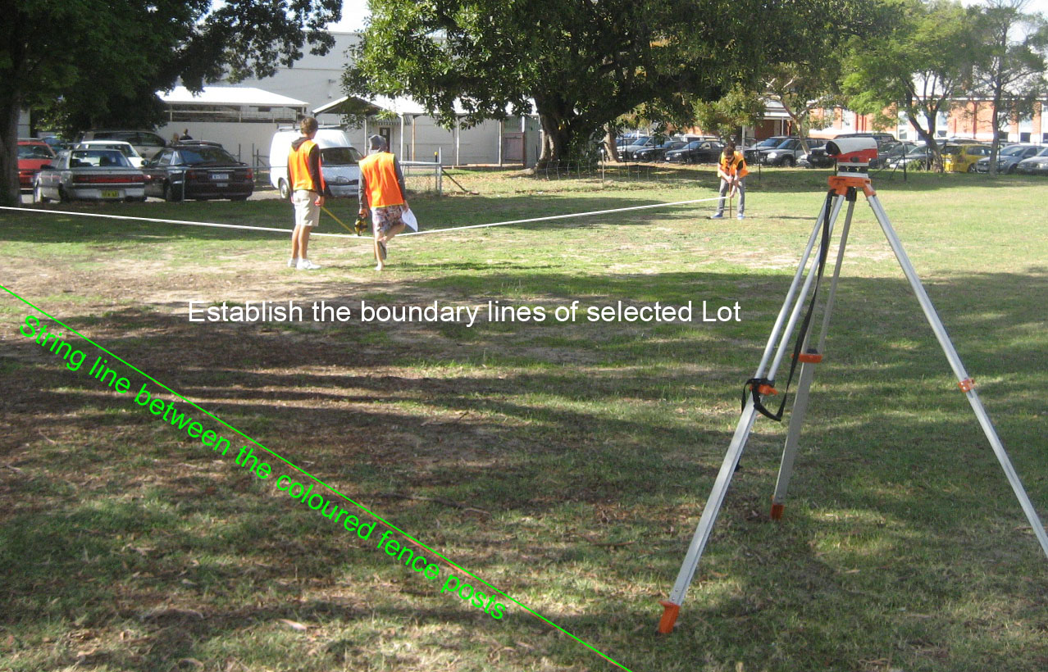
Refer to your written Project Notes for particular instructions.

Ensure you have the necessary equipment.

All safety requirements must be adhered to.
Safety checks are frequently done

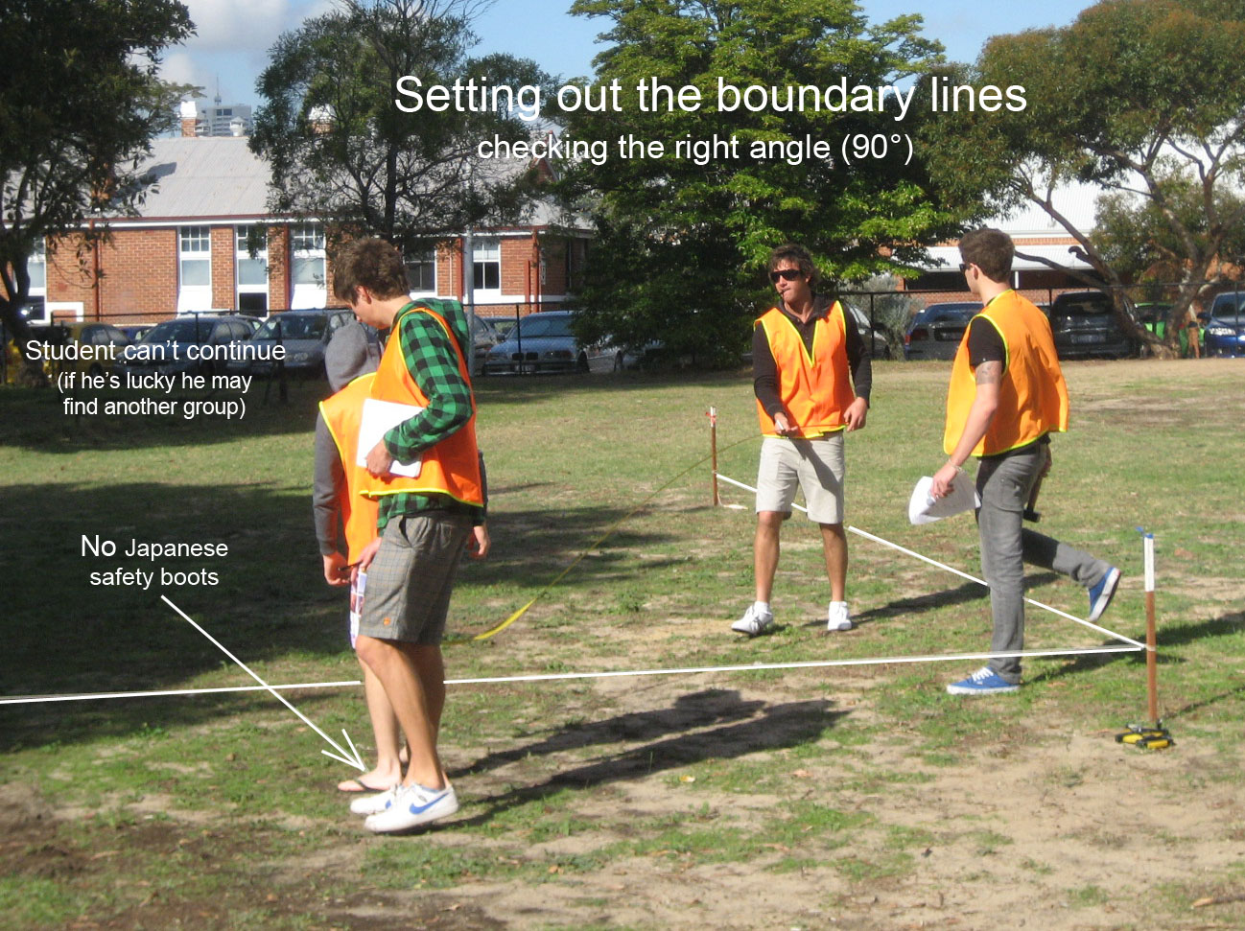
Students without closed and proper shoes won't be assessed.

The record in your field notes must state whether all group member complied with the safety rules.

Boundary lines set up at right angle and checked with 3, 4 & 5 rule

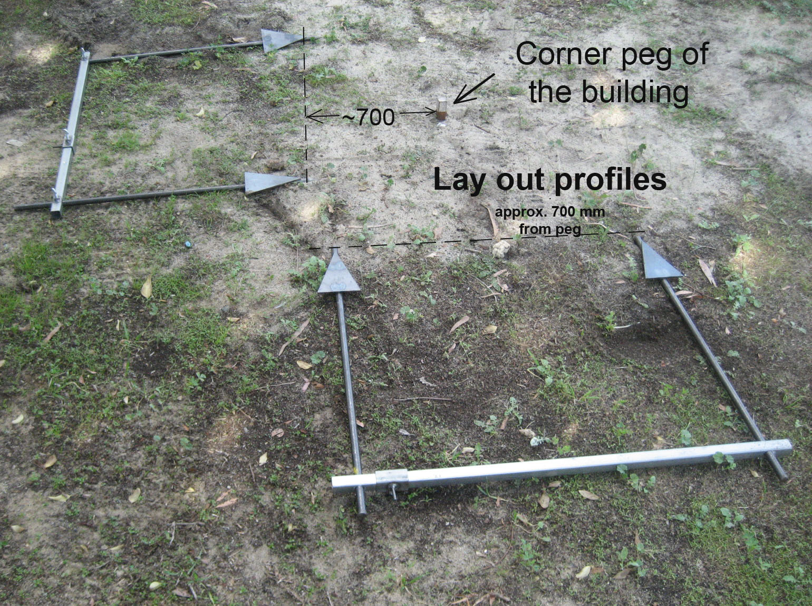
As soon as you have establish the four corner pegs, lay out the profiles .

Please handle the surveying equipment with care.
Keep the steel bar vertical when you hammer them in.
(you may use a staff bubble).

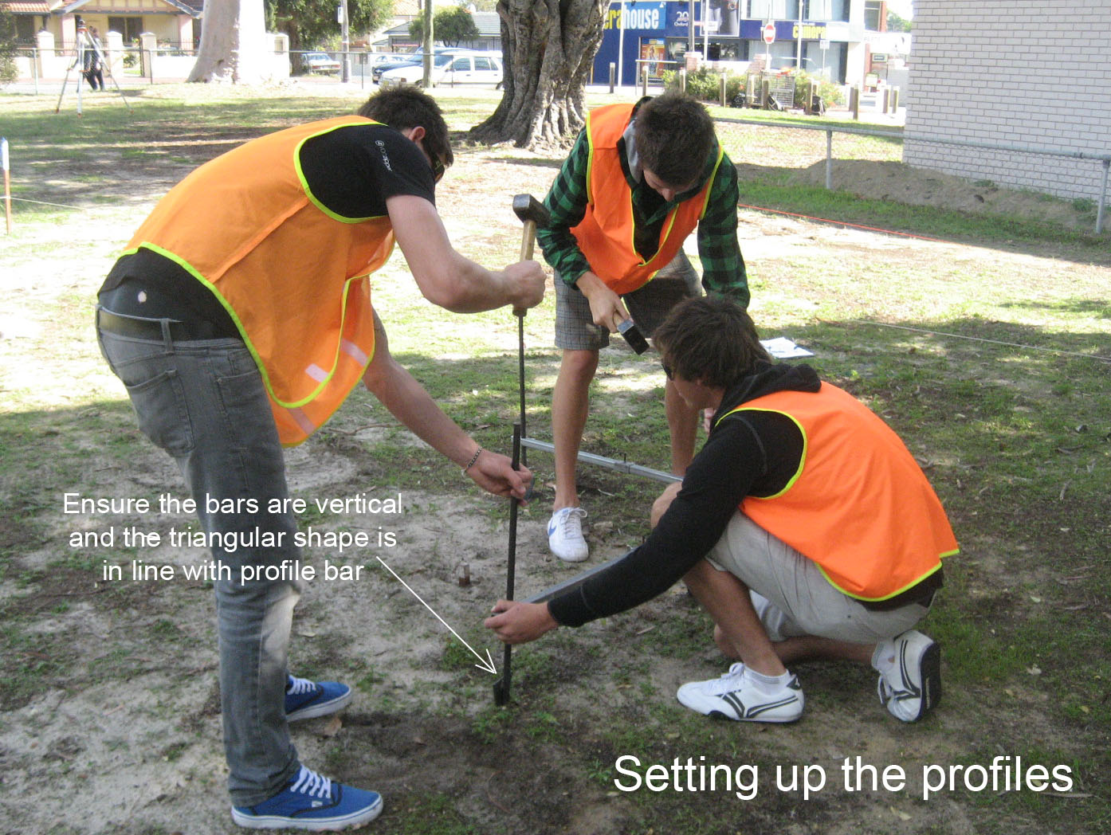
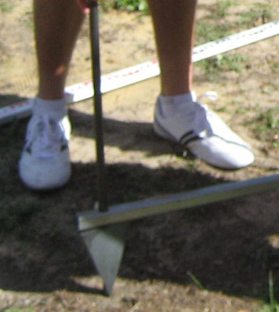
Triangular shape is in line with the profile bar.
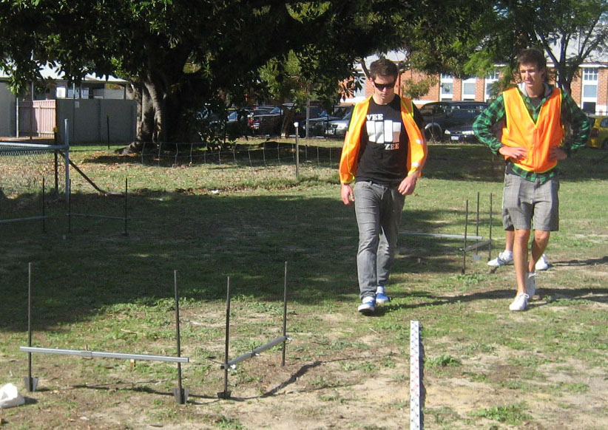

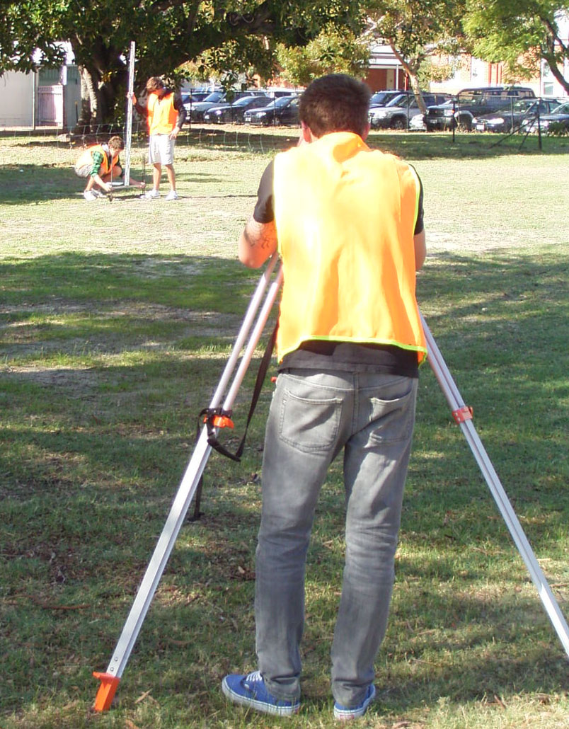
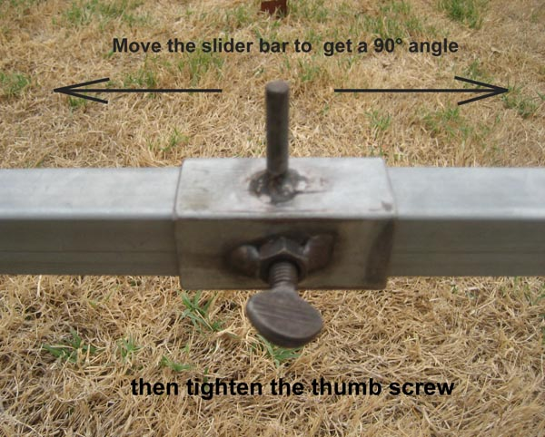
All profile crossheads are levelled and set up at the reduced level (RL) 400 mm (or 400 + 50 mm increments) above the benchmark 93.670 m
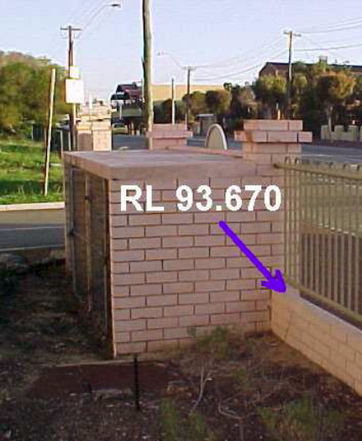

When you have finished checked everything mentioned on your Assessment sheet then contact your lecturer to assess your work

