Central Institute of Technology
Building Studies
Campus East Perth

Practical Project 3
Site set out procedures

Candidates Name:
TAFE ID Number:

This project is done during class time under supervision of the lecturer.
The set out exercise is carried out in Week 13 & 14. Due to limited equipment only two groups of three can do this project. Please note that students who do not attend the project session on the set date cannot be assessed and therefore cannot pass this unit.
Field notes
Field notes must be prepared for this project. It should provide evidence of all the conditions at the time of the survey. All activities (hand written notes) need to be recorded at the time the fieldwork is being done.

Project notes
- Project considerations
Before you start any project work ensure you are familiar with the project task. Are you ready to do the project and is the equipment organized? Ensure that all group members aware what to do. Use a clip-board to record your field notes.
Team members should select a team leader. This will ensure task completion in shorter time.
- Instrument Level checking (2 Peg test)
Not required for this task.
- Set-out the building, to the sizes given, in the area shown on the “Location Plan”. Take the datum from the benchmark (BM 10.000 m), and specified by you lecturer.
- Setup profiles cross heads at a Reduced Level (R.L) as indicated in the ‘set out procedure’ below.
- When the group has finished the exercise ask the lecturer to assess the required task. All group members need the Assessment Sheet ready to be check against the criterion.
- A group who finished the project should dismantle the profiles and return all borrowed gear to Level IV and place level, staff, tripod & tapes in the lockers including the booking form and place the trolley in the drawing store room.
Location Plan
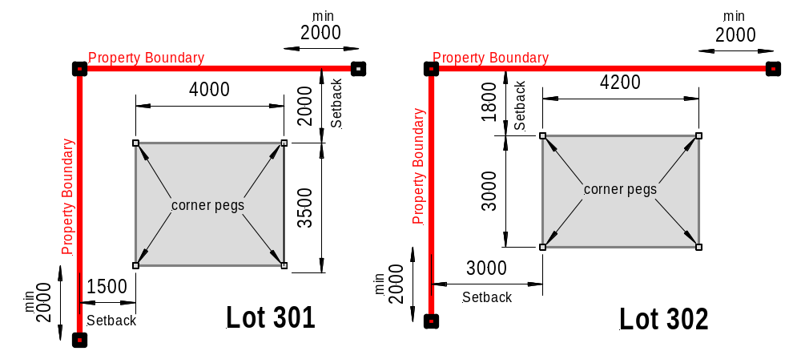

Figure 1
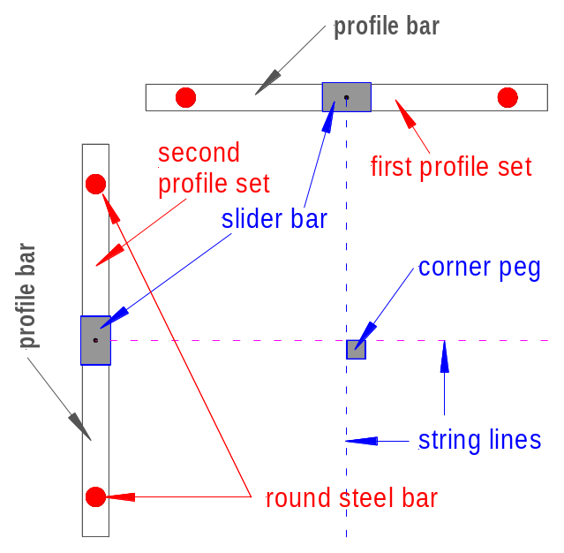
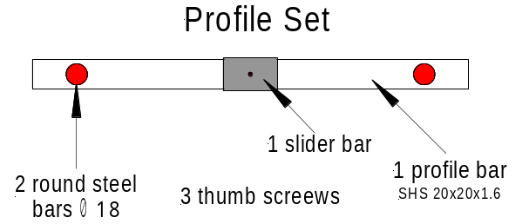 A profile set consist of a Profile bar, two (2) round steel bars and a slider bar. String lines to be fasten to the pins of the slider bar.

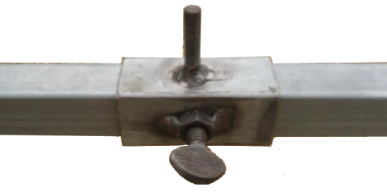

You need a pliers to loosen/tighten
the thumb screw. Pliers are not supplied.
Figure 2
Equipment needed
8 Profile sets, stringline, mallet, 8 metre tape, optical level, tripod & staff
Set Out Procedure
The procedure used is as follows:
Step 1
- Peg two (2) boundary lines at 90° (right angle) as shown in Figure 1 & 2. Each boundary line peg should pass the building at a minimum of two (2) metre.
- Set up the building corner pegs at the required setbacks (quick check whether pegs are square).
- Place two (2) Profile sets at a distance of 700 to 1000 mm from each corner peg (see Figure 2 above.
- Ensure the triangular plate on round bars is in line with the profile bar and keep the round bars vertical using a staff bubble.
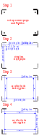 | Step 1  - Hammer both steel bars vertical into the ground to a depth of approx. 50 to 100 mm and ensure the profile bar can easily slide up and down.  - Then hammer both round bars into a stable depth (ensure profile bar can slide up & down)  - Use the optical level to determine the level of all profiles bars relative to the datum. The Lecturer will inform you about the required RL-height.  - Use a plier to tighten the thumb screws to secure the height (RL) of all profile bars. (pliers not supplied)  Step 2  - If all profile sets have the required height datum then put up the string lines as shown in Step 2. Use builder’s triangle (3-4-5 method) to put up the string lines at 90° angle. With the aid of an Artline writing pen mark the measurements on the string lines and place the slider move the slider bar to obtain the right angle.  - Make sure the angle is exactly 90° before you proceed to the next step.  Step 3  - Measure the offset dimension as indicated in Lot 301 or 302. Make sure this dimension is correct and within the limit of ± 2 mm  Step 4  - This step is similar to step 3. Again measure the offset dimension as indicated in Lot 301 or 302 and make sure this dimension is also correct and within the limit of ± 2 mm  Step 5  Now it’s time to check the measurement of the diagonals.  If the diagonal have the same measurement then the building is squared.  If all checks according to the assessment sheet have been satisfied the call your lecturer to assess your work.
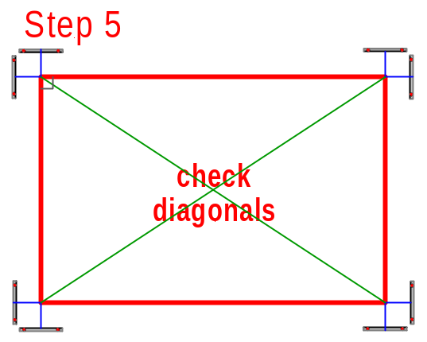
Field Notes
Project considerations
Before you start any project work ensure you are familiar with the project task. Are you ready to do the project and is the equipment organized?
You should use a clip-board to record your Project notes.
- Record the following field notes:
Date: Start time: Finish time:
Weather conditions,

Group members,

Instruments (model & serial number),
B Two Peg Test
Not required for this Project
C Project Report
Refer to the project notes for the scope of the practical project. Projects need to be submitted on due date, if not stated otherwise. Each student must individually submit a report. Write the reports as soon as possible after the field exercise Individual group members will also be orally assessed to verify that the competencies have been achieved.
How the activities were distributed between the team members and who did what activity like:
- writing field records
- Setting out boundaries at right angle
- measuring and placing building peg
- setting up profiles
- levelling of profiles to require RL etc

Report notes:

Assessment Sheet

Lot No:

Group Leader

Team member 1

2

3

After completion of the exercise collect all equipment and return it to Level 4 or store it in the locker with your booking form. Key for the locker can be obtained from the receptionist or your lecturer.

Make sure you handle all equipment with care.

Accuracy Criteria | Assessment
Two peg test | Satisfactory  Unsatisfactory
Field notes | Satisfactory  Unsatisfactory
Building setback from property boundary | Satisfactory  Unsatisfactory
All profile crossheads are level | Satisfactory  Unsatisfactory
Profiles correct height relative to datum | Satisfactory  Unsatisfactory
String lines are stretched tight | Satisfactory  Unsatisfactory
Corner of lines square (3,4,5) | Satisfactory  Unsatisfactory
Size is as per specification | Satisfactory  Unsatisfactory
Diagonals are equal length | Satisfactory  Unsatisfactory

When finished contact a Lecturer who will check whether the assessment criteria satisfy the requirements.

The lecturer will mark the criteria by ticking the appropriate box Satisfactory/Unsatisfactory in the table

Date: Lecturer:

