Use of the Theodolite

Care of the Instrument
The Theodolite is a precision scientific instrument. It is fairly robust, but care should be taken to avoid harsh treatment. There are several moving parts and it is quite heavy, so it is easy to inadvertently drop it when removing it from its case.

It is designed to be used in all weathers, but if it gets wet it should be dried out at the earliest opportunity (best by leaving in a warm room). The case lining also holds water, so don’t forget to dry the case as well.

Please remember to unlock a clamp before you try to rotate it.

The Controls
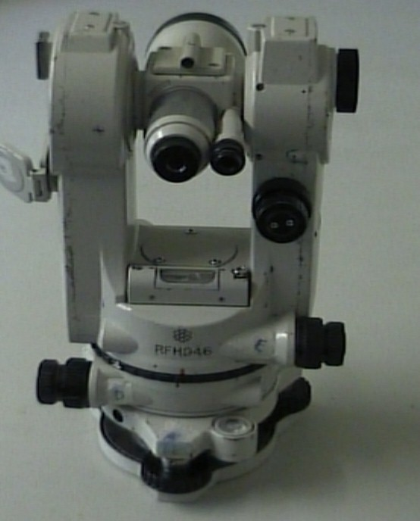
Upper rough sight
I minutes and seconds adjuster

Small eyepiece (scales)
Main eyepiece (viewing)
G vertical clamp and fine adjuster
The mirror light source for the scale can be seen on the left of the picture
Horizontal bubble [Fine adjustment]

E upper horizontal clamp and fine adjuster
D lower horizontal clamp and fine adjuster

Circular spirit level [Rough adjustment]

A levelling screw

The theodolite’s controls are labelled A to I and are as follows

A ,B,C three levelling screws.
D lower horizontal clamp (outer ring) and fine adjuster (inner). Used to align on the reference north.
E upper horizontal clamp and fine adjuster. Used to align on the object to be measured.
F vertical sighting to align the theodolite over a set point on the ground.
G vertical clamp and fine adjuster. Used when measuring vertical angles.
H mirror. Supplies a source of light to the internal scales.
I minutes and seconds adjuster. Used to align the degree scale so angles to a resolution of minutes and seconds of arc can be made

In addition, the telescope has upper and lower rough sights and a small eyepiece on the right to view the scales.

Setting up the Theodolite.
The Theodolite is mounted on a tripod. First, extend the tripod legs, splay them fully and push the ends firmly into the ground. Next look at the Theodolite mounting platform. This should be reasonably level and not too high nor too low for the users. Adjust the leg lengths until it is right then screw the theodolite onto the platform.

You may wish to set the theodolite up over a reference point on the ground. In this case, you can use the sight (F) on the front of the instrument to view the point and adjust the theodolite’s position by slightly unscrewing the mounting screw and moving the theodolite sideways. Alternatively, you can ask a helper to push a nail or peg into the ground under your guidance to fix a new reference point.

Levelling the Theodolite.
There are 3 levelling screws (labelled A, B and C) at the base of the instrument. These should be used with the round spirit level to obtain a coarse adjustment. When this is done, line the long spirit level with 2 of the levelling screws and make the first fine adjustment. Then turn the theodolite through 90 degrees so the long spirit level is pointing at the 3rd levelling screw and adjust that until it is level. Recheck the fine adjustment if necessary. If there is not enough adjustment in the levelling screws, then the theodolite table is not level enough and you will have to adjust the leg heights until it is.

This method for levelling also applies to the EDM.

Zero the scales
Release clamps D and E. Align the red mark on the upper part of the theodolite with the white mark on the black ring and lock the upper horizontal clamp (E). This roughly sets the theodolite optics to zero on the horizontal scale.
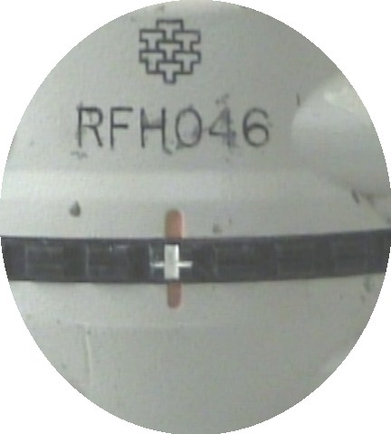

Open the mirror (H) and adjust until you see a bright patch of light falling on the window underneath it. Now if you look through the small eyepiece, you will see some illuminated scales.

A view through the small eyepiece shows the vertical and horizontal degree scales and the minutes and seconds scale.

0
.
.
♦ . 0’ 00”
. 0’ 20”

95 93
| | | |
|| |

V

HH

Adjust the fine adjuster (I) so the mark in the right hand scale is aligned with 0’00”. Using the fine adjuster on the upper horizontal clamp (E) adjust the 0 so the single vertical line which moves with it on the bottom scale is between the double vertical lines (as above) as near central as possible. Now clamp (E). Movement now on the bottom plate will move the whole instrument without changing the reading. From now on clamp (D), rotate by loosening (E) and read the change.

This completes the horizontal zero adjustment. There is no adjustment for vertical angles. That is done internally and is correct if the theodolite is properly levelled

Align on a reference North
All your theodolite measurements are made relative to a reference baseline, which by definition is oriented at 0 degrees. This does not need to be true north, but could be a line to a convenient feature such as a chimneystack or telegraph pole. With the upper horizontal clamp (E) still on, rotate the theodolite until the arrow in the upper or lower rough sight is in line with the selected feature. Gently lock the lower horizontal clamp (D) and, looking through the main eyepiece (you may need to focus it) use the lower horizontal clamp fine adjuster to line the vertical lines on the feature.

Once this is done, the theodolite is set to zero on the reference line and the lower horizontal clamp (D) should not be touched again.

To take a measurement
Unlock the upper horizontal clamp (E). Rotate the theodolite until the arrow in the upper or lower rough sight points to the feature of interest and lock the clamp. Look through the main eyepiece (you may need to refocus) and use the upper horizontal adjuster to align the vertical lines on the feature. To take the reading, you should look through the small eyepiece. Using the minutes and seconds adjuster (I) set the one of the degrees on the horizontal scale so the single vertical line on the bottom scale is between the double vertical lines under the selected degree. The reading is the degree you have aligned and the minutes and seconds read from the right hand scale and is the horizontal angle (in degrees, minutes and seconds) from your reference line.
To measure a vertical angle, unlock the vertical clamp (G) and tilt the eyepiece until the feature is aligned on the horizontal lines. Gently lock the clamp and use the vertical adjuster to make fine adjustments. Now looking through the small eyepiece, use the minutes and seconds adjuster (I) to align one of the degrees on the vertical scale with the double lines just below it. The reading is the degree you have aligned and the minutes and seconds read from the right hand scale. This is the angle from the vertical; where vertical is 0 degrees.
To complete the reading, you may now need to measure the distance from the theodolite to that feature.

To use the measurement.
Often, your two measurements, an angle from your reference line and the distance from the object have to be converted into Eastings and Northings. These are distances East from the reference line and along (North) the reference line. Once you know these, you can produce a scale drawing. If you get negative values you have to change direction; for negative Easting go West by that amount, for a negative Northing you have to go South. You need to know 2 equations:-

Easting = sin(angle) times distance
Northing = cos(angle) times distance

There are programmes available (on the WAG web) site for doing these calculations. They can also be done on hand held calculators, but beware some of these need the degrees entered in radians. You can easily check, sin(45) = cos(45) = 0.707.

If you have access to Turbocad, you can produce your scale drawing by entering the degrees and distances directly and you don’t need to do the calculations. This will give you a set of lines radiating from a point. You will need to join up the ends appropriately to produce the final picture.

