Chain
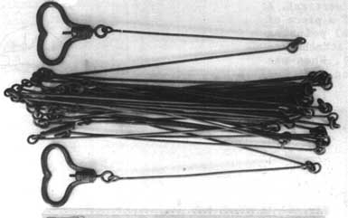
Plum bob
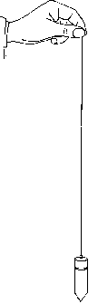

Boundary Peg RED Top Chamfered 375mmx75mmx75mm ( Bundle 25 ) | Price: $132.00

Boundary Peg WHITE Top Chamfered 375mmx50mmx50mm ( Bundle 25 ) | Price: 49.50

The red pegs marked where explosives would be placed in 'shot holes' and detonated. The seismic shock wave would be recorded in receiver holes, marked by the white pegs.
It was explained that the red and white pegs
discussed at the last meeting represent markers for survey
stations. The survey stations are required until the completion of
the project to determine the location of particular works. This
action item is now closed.
The Titles Office accepts land boundaries defined by height differences, related to the
Australian Height Datum (A.H.D.). Surveys conducted under the Surveying Act 2004,
which include defining boundaries in this manner, must do so in accordance with the
cadastral regulations. Local Councils rely on surveyors conforming to standards of
presentation of survey information on plans.
References are made to standards in local government guidelines, for instance many
Councils now compel surveyors to provide height levels (based on the A.H.D.) for
boundary corner pegs.

