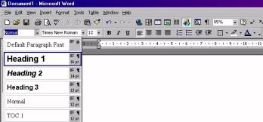
Example MS-Word 97-2003
What you have to do is the following:
For each heading and subheading in your assignment you need to allocate a style (H1,H2 etc).
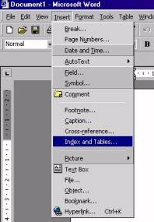
You do this by clicking on the arrow next to Normal in the Formatting Bar. Then a submenu appears from which you can select an appropriate style for your heading. (see opposite figure)

When you have allocated a style for all headings in your document then a contents page can easily be inserted.
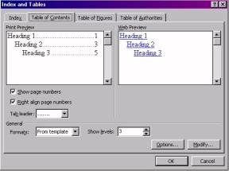
However, before you insert a contents page make sure your cursor is at the beginning of your document. (push and hold Ctrl-key and then press Home-key).
Now click on Insert. Then, a submenu pops up as shown opposite.
Select Index and Tables and another submenu pops up as shown below.
Click on the Table of Contents tab `and select a contents page layout of your choice.
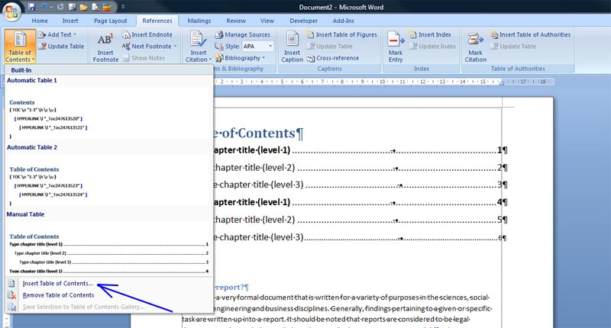
(If you want you can modify Tab leader, Formats and Show level (number of headings)). Click OK and whoop the contents page is done for you
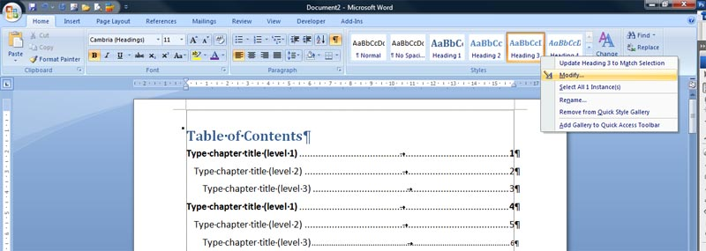
Example MS-Word 2007

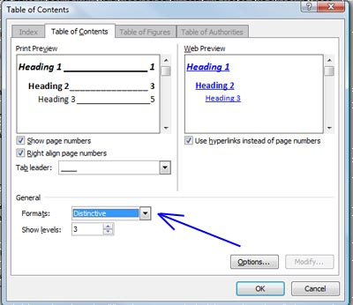
Very similar to MS-Word 97-2003. Style Headings are shown on the right side of the Home ribbon (see figure below)
For each heading and subheading in your assignment you need to allocate a style (Heading1, Heading 2, Heading 3 etc). I f you are not satisfied the the default style then you can modify the Heading style quite easily by right mouse-click and click Modify in the po-up window. Another po-up window appears where you can the modify the fromat of the heading type.
As soon as all types of headings are allocated in the document then click on the References ribbon. Then Click Table of Contents icon (far left side). In the po-up window click Insert Table of Conytents and select Insert Table of Contents.
In the po-up window select the format of the Table of Contents.
There are seven (7) different formats from the template:
1 Classis
2 Distinctive
3 Fancy
4 Modern
5 Formal
6 Simplex
Show levels ► selection of three (3) different Tab leaders

