Project notes
Two Peg Test
Before you start any project work your first task will be to carry out a two peg test to ensure your level is properly calibrated. Record in your field notes the process and state whether the test results are within the calibration limits...

Collimation error occurs when the collimation axis is not truly horizontal when the instrument is level. The effect is illustrated in the sketch below:
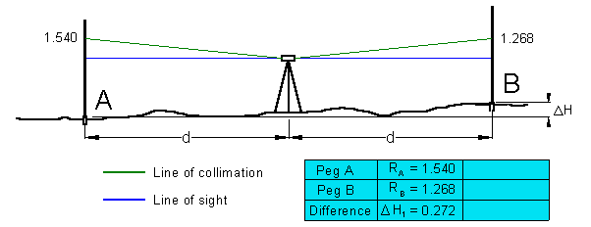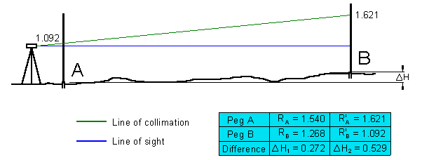
- Set out and mark on the ground (with wooden pegs driven into the earth, or roofing nails in tar) two point some 40 m apart. Set up the level exactly mid-way (within 0.5m) between them.
- Take measurements of backsight and foresight for this first setup. The height difference DH will be free of the effects of collimation error.
- Next, move the level to a position just beyond the fore staff position (about 5m).
The difference between the readings of the two level positions should be zero. If more than 5 mm the instrument need to be calibrated.
Instrument Level checking (2 Peg test)

1 Setup and test the Instrument ( Inst. No.________ )

0.0 m 40.0 to 50 m Difference
Recording from centre spot : 1 ________ 2 ________ ________

Recording from 5 or 45 m spot : 1 ________ 2 ________ ________
For each field exercise a level check is required.
This check must be carried out each time before you do levelling.
Instead of the two peg test you may do a quick check close to the old survey store
between G Block and F Block.

Groups & equipment booking
Three students should form a group of three to carry out the project work. It's the responsibility of the group to arrange a suitable date and time to do a project. If a group member doesn’t participate the remaining group member may not be able to complete the projects. For a successful completion of projects all students should be committed and keep in touch (exchange your mobile numbers).
The project work need not necessarily be done during class time. It can be done any week day and any time during the day. You need to book the equipment that is needed for your project at least one week in advance. Please remember you can't get the equipment if you haven't booked it. Booking can be done during class time or with Nicky from 9:00 to 14:00. Due to limited resources and number of students project submission doesn't need to be in the prescribed order of the Learning Plan (e.g. Project 3 can be submitted in Week 13 or 15). The submission of the projects can be in any order (you may submit Project 3 as your first or second submission) but you must submit a Project (whether No 3, 1 or 2) on a due date.
A booking form must be handed in to your lecturer or receptionist at least one week before the start of your project work. If this isn't done equipment will not be handed out!

1st (first) submission is due: | Week 9
2nd (second) submission is due: | Week 13
3rd (third)t submission is due: | Week 17
No submission will be accepted after 13:00. If your submission is not complete or not handed in at 13:00 then you won't pass the unit.

Project Submission Requirements
1) Field notes
One of the most important parts of your levelling task is keeping accurate and comprehensive field notes. Field notes form an integral part of your assessment. Field notes are all hand written records that you use to complete the task. When your project is finished copied the field note and distributed to the student in your group to enable them to write the report independently. Refer to Field Note Sheet for additional instructions.
2) Project Report
Refer to your Learning Plan Assessment Summary for the due date of the Project submissions. Any submission on the due date after 13:00 hour cannot be accepted. Please make sure you don't miss this important date.
Please note:
Each student must submit a report as outlined in the submission requirements

PROJECT 1

This is a closed level run. Make sure you close the traverse. Ensure Station A has a Backsight and Foresight reading.
1) Setup and record the levels of each of the YELLOW stations 1 to 24 marked on the roadway in the area shown on the “Location Plan” (start with Station 1 and close at Station 1). Take Station 1 as datum 10.000 and convert staff readings to Reduced Levels, using the rise and fall method. Make sure you close the traverse. Check your maximum allowable misclosure (mm) = 24 x distance (in km). Each student of the group needs to record a level-run including a Backsight & Foresight reading. Clearly indicate in the Remark column of your R&F sheet which level readings you took.
2) Measure all distances between the stations. Slope measurements must be converted to horizontal distances. Include all calculations, which must be logical set out and easy to check.
3) Draw a plan to a scale of 1:500 of the level run and indicate the position of the instrument on your plan. All measurements between stations must be show
4) Draw profiles from corner to corner using a horizontal scale of 1:500 and a vertical scale of 1:50.
Remember to make a copy of the field notes for group members to enable students to write a personal report. Your report must cover all of the above four points.

Project 1 Location Plan
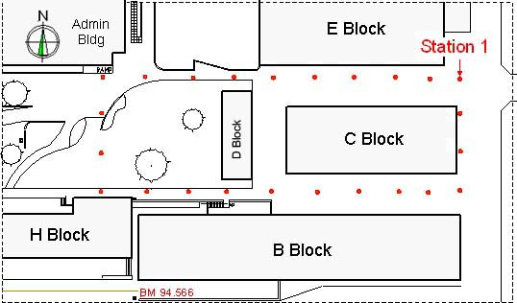

PROJECT 2
1) Setup and record the levels of each of the grid points, marked in the area shown on the "Location Plan". Take Station 1 as datum 10.000 and convert staff readings to Reduced Levels, using the rise and fall method.
2) Grid three (3) equal spaces between walls and five (5) spaces of approximately five (5) metre down (24 grid points, see sketch below). Prepare a grid-sketch showing the dimensioned of grid lines.
3) Prepare a scaled sketch (1:100) and display all 24 RL's and the position of trees and draw contours lines at 0.2 m intervals. All drawings must have a title and unmistakably labelled.
4) Calculate the volume of fill required using the datum at Station 1 (RL=10.000 m). Select one of the two methods of volume calculations, rectangular prisms or grid levels. All calculations must not only unmistakably but also logical set out.
Remember to make a copy of the field notes for group members to enable students to write a personal report. Your report must cover all of the above four points.
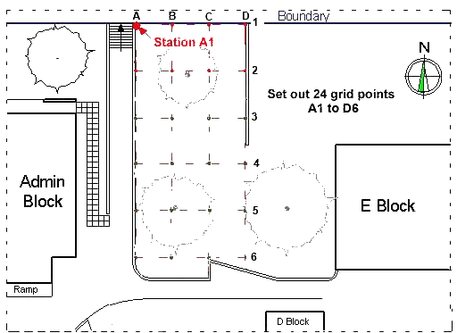
Project 2 Location Plan

PROJECT 3
1) Set-out the building, to the sizes given, in the area shown on the “Location Plan”. Take the datum from the benchmark (BM 93.670 m; see pictures below), and setup profiles cross heads at the Reduced Level (R.L) 400 mm or in increments of 50 mm above the BM).
2) Refer to your Project 3 Assessment Sheet and check all set out criteria.
3) When you have finished the exercise get your lecturer to assess you against the criteria at the back of this sheet and hand over your field notes.
4) Have the Practical Project 3 sheet ready for lecturer's check.
Set out the building on the grass area at the south west corner of the college property (on Oxford Street).
Project 3 Location Plan
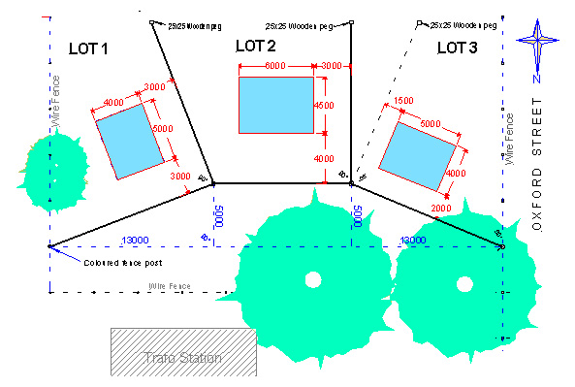
Establish the property boundaries for the selected Lot and then set-up the building to the required set-backs. The front of the building must be parallel to the front boundary. Place pegs to locate position of corners of the building and then set-up the profiles at least 700mm from each corner.

Take the datum from the bench mark (BM 93.670). to set-up profiles at the required level. Make sure all profiles are at the same RL.

Tie a string line to profile boards. Set up a right angle (3, 4, & 5) to determine the other building side. Make sure the building corner is a right angle. As soon as this is correct use offsets to string the other sides of the building. Check the building for the “Assessment” criteria.

Submission date: ► refer to your Learning Plan
Be careful when setting the Profiles. Please make sure you don't damage this equipment.
Refer to Set up Photos before you attempt Project 3.

