Practical Projects Submission Requirements
1. Student Field notes (hand written)
Field notes must be prepared for all of your surveying projects. They should provide evidence of all the conditions at the time of the survey projects and need to be recorded at the time the fieldwork is being done.
Make sure before you start a project you are aware of the scope of the project. A clipboard will also be required for writing field notes. Prepare all necessary things that you need in advance, like standard items for field notes, R&F-template, sketches, etc.
Field notes should contain: the date, the weather conditions, group members doing the survey, identification of the instruments & equipment. Do not forget to check the instrument (two peg test). Brief description of the site and necessary sketches (properly labeled) are required. Add any other conditions to field notes that help writing your report. Level recordings must be made on R&F template. Please make sure data for distances and remarks like change points, level run directions, etc. are recorded in the appropriate columns on the R&F sheet. In the remark column you must also indicate which level readings each student of the group did. If a misclosure (project1) is more than the permissible you need to repeat the leveling. When the task is completed photocopy the field notes for all remaining group members. Keep in mind the report submission date. It will be beneficial if you write the report as soon as possible.
2. Report Submission (typed using word & excel)
Refer to the project notes for the scope of the three practical projects. Projects need to be submitted on due date; refer to 'Assessment Summary' on the Learning Plan. Please remember there are very strict submission requirements.
A report need to be submitted for Project 1 & 2. Please make sure your project is logical set out, correctly referenced, tables and figures appropriately labelled and the field notes are attached as annex. Lack of information will result in the submission not being accepted.
Each student must individually submit a report.
The main purpose of a report is to provide information so that other persons can make a decision or take action if required. Knowing how to organise information and ideas is of great importance.
All projects reports must be made up of the following:
- Assignment Attachment form. (do not forget to sign the declaration)
- Cover sheet (see outlay below).
- Contents page
The Table of Contents should outline the different sections of your report, and showing the reader where to find them. (don’t forget to number the pages and use word to create contents page)
- Report writing
Plain English is a new name for an old, essential part of effective communication. It simply means using clear, easily understood words to communicate.
  - Introduction
Type a brief description of the task. State the subject and purpose as clearly and concisely as possible
4.2 Disssion
This section is the most important part of your report. It takes many forms and may have subheadings of its own. The basic components are your results, and evaluation.
Diagrams, sketches, tables, etc should be included but must be properly labeled and referenced. If you have any problem with report writing, see your lecturer.
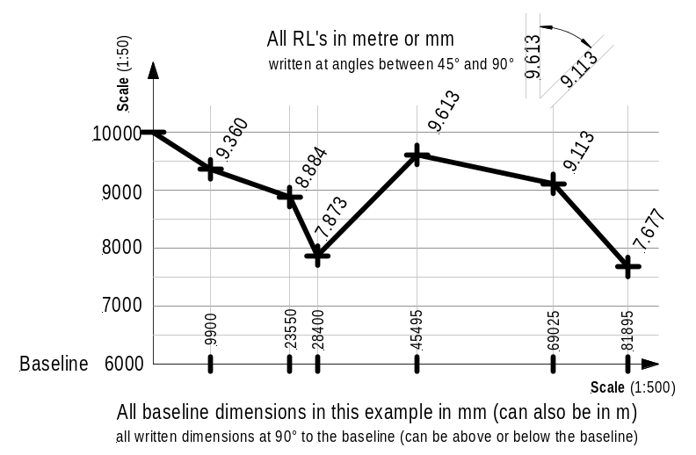(You may include in your discussion whether it was it easy to carry out the activity and had you sufficient technological skills in report writing?
Where there any problems with computer usage (word & excel)?
Did you gain valuable skills in data recording and presenting? Transferred data Rise & fall from field notes onto an excel sheet and calculate all RL's.)
Drawings/sketches (profiles, contours etc.) must be neatly drawn to scale.
Information on Profile drawings in accordance with the opposite sketch

4.3 Conclusion
What knowledge comes out of the report? As you draw a conclusion, you need to explain it in terms of the preceding discussion

4.4 Annex/Attachments
These should include field notes and references attached to the end of your report.

Cover sheet layout for your typed submission.

Central Institute of Technology (normal16 points)

Apply site surveys and set out procedures
to building and construction projects
(normal 12 points)

Project Title (bold, 16 points)
Project No (normal 14 points)

◄ Left side margin ≥ 2.5 cm
(Text Font Arial (10) or New Times Roman (12))

Student Name: ID:
Group No: Group leader:

Date: Date:
of field work of submission:

Every student need to submit Project 1, 2 and 3.

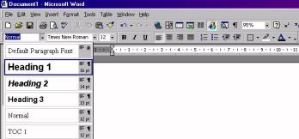
Contents Page Example MS-Word 97-2003
What you have to do is the following:
For each heading and subheading in your assignment you need to allocate a style (H1,H2 etc).
You do this by clicking on the arrow next to Normal in the Formatting Bar. Then a submenu appears from which you can select an appropriate style for your heading. (see opposite figure)
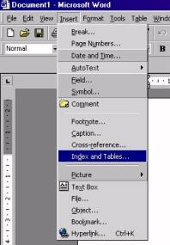
When you have allocated a style for all headings in your document then a contents page can easily be inserted.
However, before you insert a contents page make sure your cursor is at the beginning of your document. (push and hold Ctrl-key and then press Home-key).
Now click on Insert. Then, a submenu pops up as shown opposite.
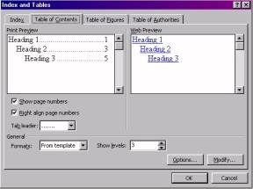
Select Index and Tables and another submenu pops up as shown below.
Click on the Table of Contents tab `and select a contents page layout of your choice.
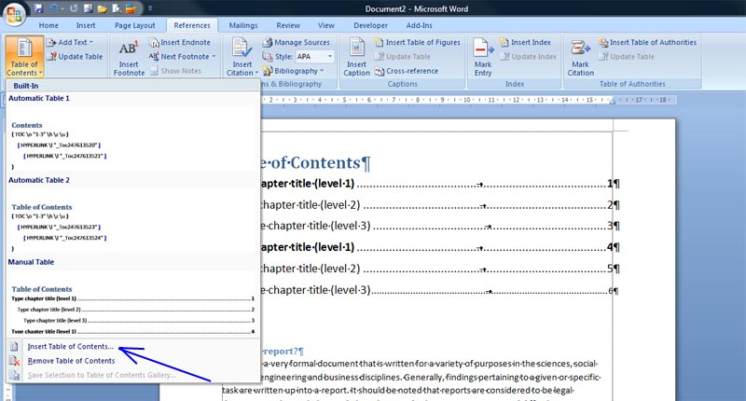
(If you want you can modify Tab leader, Formats and Show level (number of headings)). Click OK and whoop the contents page is done for you

Contents Page Example MS-Word 2007
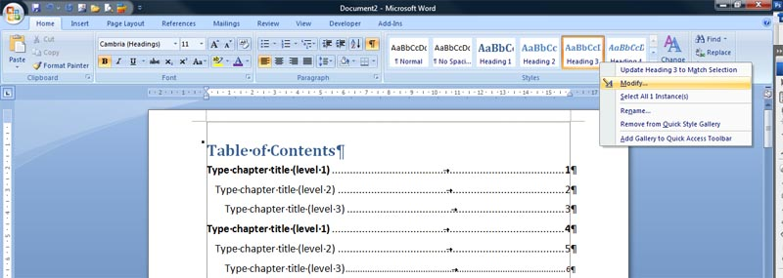

Very similar to MS-Word 97-2003. Style Headings are shown on the right side of the Home ribbon (see figure above)
For each heading and subheading in your assignment you need to allocate a style (Heading1, Heading 2, Heading 3 etc). I f you are not satisfied the the default style then you can modify the Heading style quite easily by right mouse-click and click Modify in the po-up window. Another po-up window appears where you can the modify the format of the heading type.
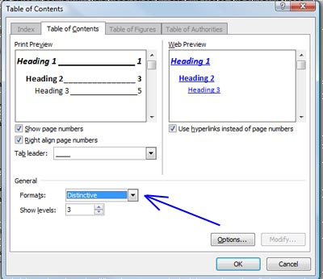
As soon as all types of headings are allocated in the document then click on the References ribbon. Then Click Table of Contents icon (far left side). In the po-up window click Insert Table of Contents and select Insert Table of Contents.
In the po-up window select the format of the Table of Contents.
There are seven (7) different formats from the template:
1 Classis
2 Distinctive
3 Fancy
4 Modern
5 Formal
6 Simplex
Show levels ► selection of three (3) different Tab leaders

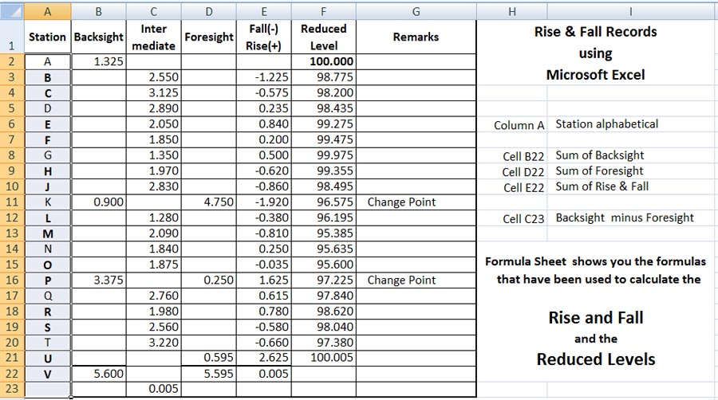
Instruction to record Rise & Fall data in Microsoft Excel
Remember first activate the cell in which the formula goes
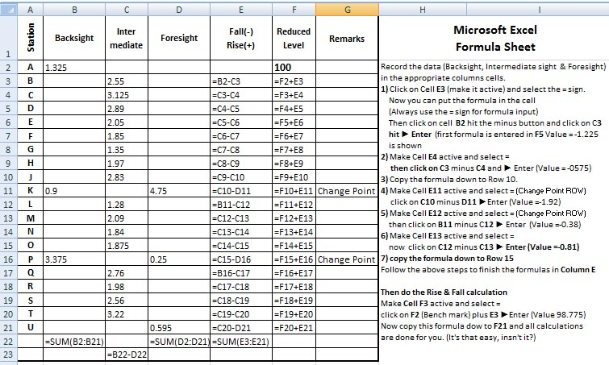
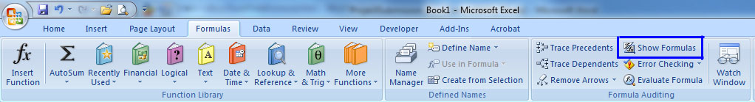
then type = and select the data cell and the oprerand (+, -, x or /)

