Semester 1 - 2010
CPCCBC4018A Apply site surveys and set out procedures to building and construction projects

Project notes
Two Peg Test
Before you start any project work your first task will be to carry out a two peg test to ensure your level is properly calibrated. Record in your field notes the process and state whether the test results are within the calibration limits.

Collimation error occurs when the collimation axis is not truly horizontal when the instrument is level. The effect is illustrated in the sketch below:
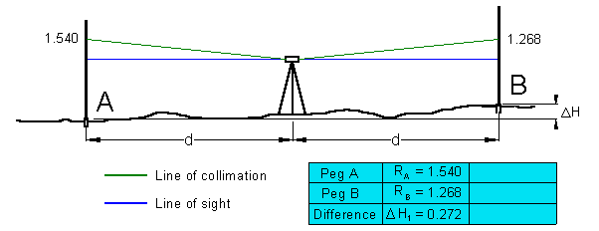
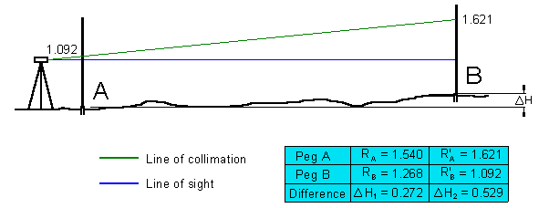
- Set out and mark on the ground (with wooden pegs driven into the earth, or roofing nails in tar) two point some 40 m apart. Set up the level exactly mid-way (within 0.5m) between them.
- Take measurements of backsight and foresight for this first setup. The height difference DH will be free of the effects of collimation error.
- Next, move the level to a position just beyond the fore staff position (about 5m).
The difference between the readings of the two level positions should be zero. If it is more than 5 mm the instrument need to be calibrated.

Instrument Level checking (2 Peg test)

1 Setup and test the Instrument ( Inst. No.________ )

0.0 m 40.0 to 50 m Difference
Recording from centre spot : 1 ________ 2 ________ ________

Recording from 5 or 45 m spot : 1 ________ 2 ________ ________

For each field exercise a level check is required. This check must be carried out each time before you do levelling. Instead of the two peg test you may do a quick check close to the old survey store. There is a special set up for this check!
Three students should form a group to carry out the project work. The project work need not necessarily be done during class time. It can be done any week day and any time during the day. You need to book the equipment that is needed for your project in advance. Please remember you can't get the equipment if you haven't booked it. Booking should be done during class time or with Nicky from 9:00 to 14:00.
Field notes
One of the most important parts of your levelling task is the keeping accurate and complete field notes. Field notes form an integral part of your assessment.
Project Submission Requirements
Refer to your Learning Plan Assessment Summary for the due date of the Project submissions. Any submission on the due date after 13:00 hour cannot be accepted. Please make sure you don't miss this important date.

PROJECT 1
This is a closed level run. Make sure you close the traverse your first and the very last reading should be at Station A)

Setup and record the levels of each of the YELLOW stations, 1 to 24 inclusive 25 (make sure you close the traverse) marked on the roadway in the area shown on the “Location Plan”. Take Station 1 as datum 10.000 and convert staff readings to Reduced Levels (R.L.’s), using the rise and fall method. Check your maximum allowable misclosure = 24 x distance (in km)
Level Run Accuracy
The National Mapping Council of Australia has published standard specifications and recommended practices for vertical control surveys. These surveys must conform to the following standards of accuracy:
- First Order: Differential levelling. Misclosure not to exceed mm ► 4 √k
(where ‘k’ is the distance in kilometres of a circuit or between bench marks)
- Second Order: Differential levelling. Misclosure not to exceed mm ► 8.4 √k.
- Third Order: Differential levelling. Misclosure not exceed mm ► 12 √ k.
- Fourth Order: Sufficient to control contouring of the area to be mapped either by differential, trigonometric levelling. 24 √ k.

Project 1 Location Plan
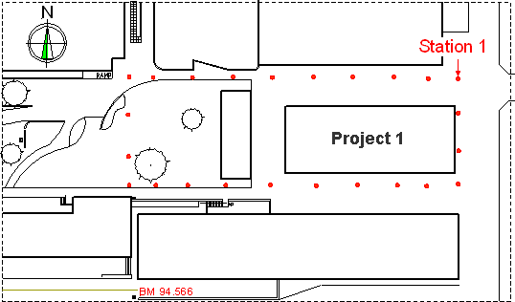
Submission date: ► refer to your Learning Plan

PROJECT 2

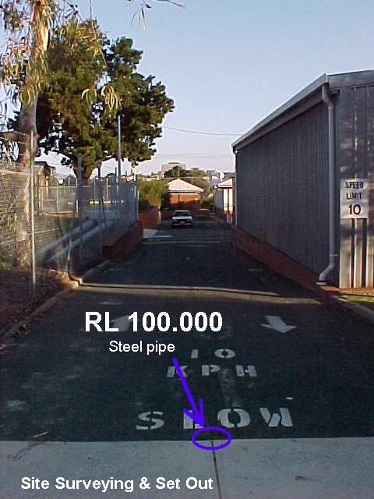 |  | Setup and record the levels of each of the grid points, marked in the area shown on the "Location Plan".  Grid three (3) equal spaces between walls and five (5) spaces of approximately five (5) metre down (24 grid points, see sketch below).  The RL for Station 1 is derived from BM - RL100.000 on the northeast corner of the college site. Use this BM to establish the temporary bench mark (TBM) for Station 1.  This new benchmark for station 1 will be used to determine all grid levels for your volume calculation.  Prepare a scaled sketch (1:100) and display all 24 RL's. Then draw contours lines at 0.2 m intervals. Calculate the volume of fill required using the TBM at Station 1. All volume calculations must be clearly set out, use a logical method to show all results.

Project 2 Location Plan

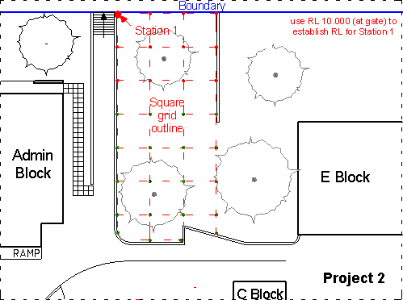
Submission date: ► refer to your Learning Plan

PROJECT 3
Set out the building, to the sizes given, in the grass area at the south west corner on Oxford Street.
A building line should be set-up as shown in the site plan.

If two groups working at the same time a boundary line has to be set up as shown in the diagram. The setback to the buildings must be 3.4 m for Building 1 and 3.8 m for Building 2. Place pegs to locate position of the corners of the building and then set-up the profiles at least 700mm from each corner.

Be careful when setting the Profiles. Please make sure you don't damage this equipment. Read 'How to set-up Profiles' before you attempt Project 3.

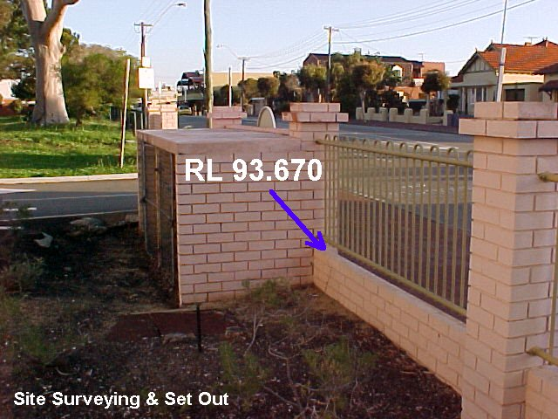
Take the datum from the bench mark (BM 93.670). Make sure all profiles are at the same RL.

Tie a string line to profile boards in line with the building line. Set up a right angle (3, 4, 5) to determine the next string line. Make sure the building corner is a right angle. As soon as this is confirmed use offsets to string the other sides of the building. Check the building for squareness (diagonals must be of equal length) and the set out requirements as shown on the “Assessment” sheet.

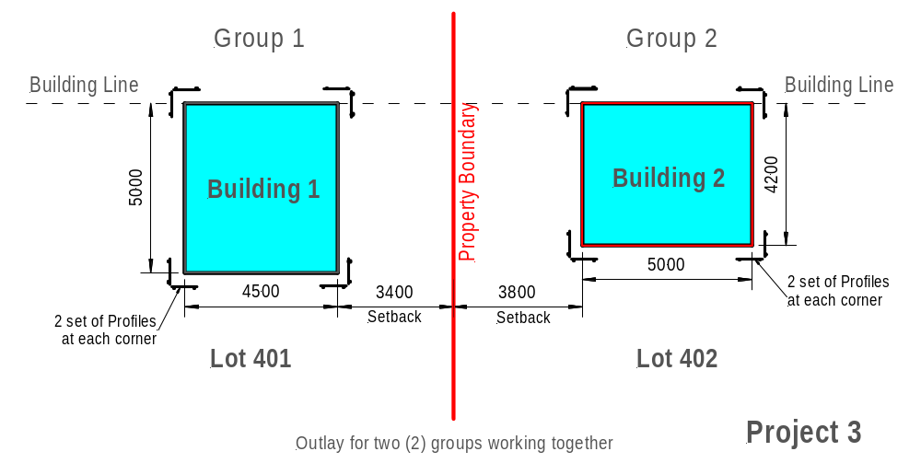 Project 3 Location Plan

Site Plan
Submission date: ► refer to your Learning Plan
Your job needs to be checked whether the set out satisfied the assessment requirements.
So on completion of the set out contact your lecturer to assess your work. Please note that I’m only two days in the college Tuesdays and Wednesdays. If you work on other days ask any lecturer in the Building Department whether he will check your work.

I will be available during class times to help you with any queries regarding the set out. I will not be in class but you can't find me outside on the College ground. However, if you can’t find me there I will be in the staff room. Please knock at the door (Staff room 1303) if you want to se me.

