Practical Projects Submission Requirements
1. Student Field notes (hand written)
Field notes must be prepared for all of your surveying projects. They should provide evidence of all the conditions at the time of the survey projects and need to be recorded at the time the fieldwork is being done.
Field notes should contain: the date, the weather conditions, group members doing the survey, identification of the instruments & equipment. Do not forget to check the instrument (two peg test). Brief description of the site and necessary sketches (properly labeled) are required. Add any other conditions that assist in clarification of the field notes. Level recording must be made on R&F template. Please make sure data for distances and remarks like change points, level run directions, etc. are recorded in the appropriate column. If the misclosure is more than that is allowed you need to do the leveling again. When the task is completed photocopy the field notes for all remaining group members. Keep in mind the report submission date. Each student in should start writing the report as soon as possible as everything is fresh in your mind.
2. Report Submission (typed using word)
Refer to the project notes for the scope of the three practical projects. Projects need to be submitted on due date; refer to 'Assessment Summary' on the Learning Plan. Please remember that there are very strict submission requirements.
A report need to be submitted for each field exercise that you carry out. Please make sure all items on the coversheet are enclosed and your field notes are attached as annex. Lack of information will result in the submission not being accepted.
Each student must individually submit a report.
The main purpose of a report is to provide information so that others can make a decision or take action. Knowing how to organise information and ideas logically is of great importance.
All projects reports must be made up of the following:
- Assignment Attachment form. (do not forget to sign the declaration)
- Cover sheet (see outlay below).
- Contents page
The Table of Contents should outline the different sections of your report, and showing the reader where to find them. (don’t forget to number the pages and use word to create contents page)
- Report writing
Plain English is a new name for an old, essential part of effective communication. It simply means using clear, easily understood words to communicate.
  - Introduction
Type a brief description of the task. State the subject and purpose as clearly and concisely as possible
4.2 Disssion
This section is the most important part of your report. It takes many forms and may have subheadings of its own. The basic components are your results, and evaluation.
Diagrams, sketches, tables, etc should be included but must be properly labeled and referenced. If you have any problem with report writing, see your lecturer.
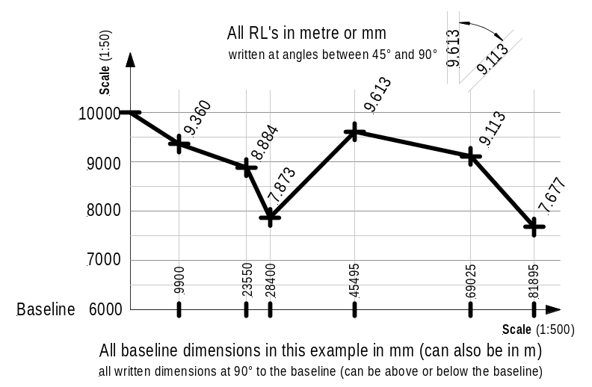

(You may include whether it was it easy to perform the activity and did you had have sufficient technological skills in report writing? Where there any problems with computer (usage of word & excel)? Did you gain valuable skills in data recording and presenting? Transferred data Rise & fall from field notes onto an excel sheet and calculate all RL's.)

Drawings/sketches (profiles, contours etc.) neatly drawn to scale. Profile layouts in accordance with the opposite sketch

4.3 Conclusion
What knowledge comes out of the report? As you draw a conclusion, you need to explain it in terms of the preceding discussion

4.4 Annex/Attachments
These should include field notes and references attached to the end of your report.

Cover sheet layout for your typed submission.

Central Institute of Technology (normal16 points)

Apply site surveys and set out procedures
to building and construction projects
(normal 12 points)

Project Title (bold, 16 points)
Project No (normal 14 points)

◄ Left side margin ≥ 2.5 cm
(Text Font Arial (10) or New Times Roman (12))

Student Name: ID:
Group No: Group leader:

Date: Date:
of field work of submission:

Every student need to submit Project 1, 2 and 3.
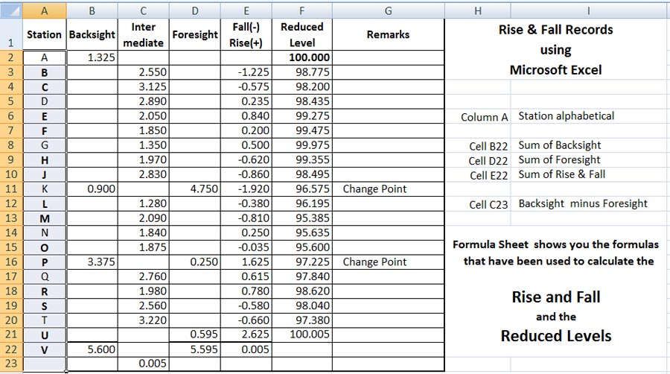
Instruction to record Rise & Fall data in Microsoft Excel
Remember first activate the cell in which the formula goes
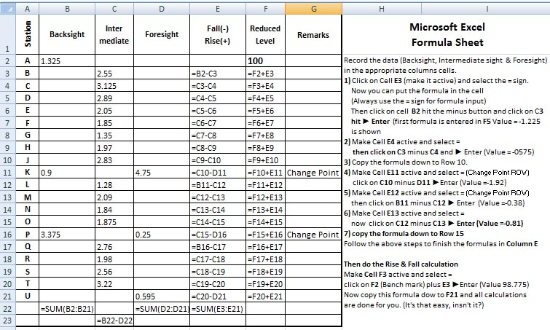
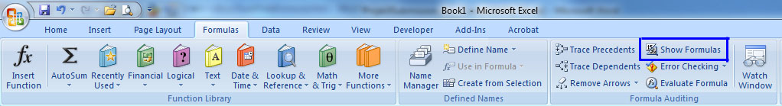
then type = and select the data cell and the oprerand (+, -, x or /)

