Resit

Apply Site Surveys and Set Out Procedures to Building and Construction Projects
W5904 (BCGBC4018A)

Second Test Semester 1 - 2009-07-01

Assignment (Volumes, sections and contour lines)
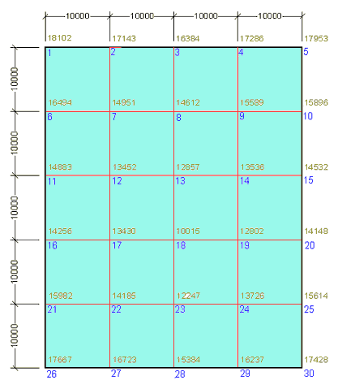
The opposite figure shows a building site.

The lot is 50 × 40 metres and has spot levels at 10×10 metre grid points as indicated.

1) For this site draw all contour lines at 1 metre interval. The distance on the grid lines must be calculated using the formula for similar triangles.

2) Find the reduced level to establish a finish ground level (FGL) by utilising the cut and fill method (cut equals fill)

3) How much soil is required if the RL of the building pad (FGL) is to be 16.300. Calculate the volume

Draw a section along the line of point 3 to 28. Use a horizontal scale of 1;200 and select a suitable vertical scale that fits on your A4 page.

Please submit this assignment by Monday 6 July not later than 12:30

