2-3. Generic Considerations Applicable to all Drawings and Maps
There are some differences between topographic maps and plans (or engineering drawings). In general, maps are usually developed at a smaller scale, whereas detailed site plan drawings are at much larger scales. The following table (from Kavanagh 1997) illustrates this distinction:
Table 2-1. Map Scales Used for Various Engineering Drawings
Scale Typical Uses
1" = 1' to 1" = 8' Large scale detail drawings, architectural plans
1" = 20' -30'- 50' to 1" = 100' Engineering site plans, facility design
1" = 100' to 1" = 800' Intermediate scale: planning studies, drainage, route planning
1" = 1,000' and smaller Small scale: topographic maps, USGS quad
maps, NOAA charts
In general, map scales greater than 1 inch = 100 ft are intended for detailed design purposes. Smaller scales between than 1 inch = 100 ft and 1 inch = 1,000 ft are used for general planning purposes. To assure convenience of use and to derive full benefit from maps

a. State Plane Coordinate System. It is desirable that the surveys and construction drawings for different projects be correlated with each other and with other Federal agencies. This is accomplished by the use of the State Plane Coordinate System as the coordinate system of the project, and insuring that this grid reference is adequately tied in to a nationwide geodetic reference system. In some cases, an arbitrary or artificial coordinate system may be used.
b. Coordinate grid lines. To enable proper correlation between the various project maps and plans, there must be drawn on all project maps (or CADD sheet files) the coordinate grid lines of the project coordinate system. These lines should be spaced five (5) inches apart; the outside coordinate lines should be the match lines for adjacent map sheets.
c. Determination of plan scales. The scale of topographic maps should be chosen so that these maps may serve as base maps over which subsequent project drawings can be drawn at the same scale. Reference Table 6-1 for guidance on selecting map scales. Thus, the scale of a reconnaissance topographic survey is chosen at a convenient scale so that it may serve as base over which the preliminary site studies and approved site plan may be prepared. The detailed topographic maps will also serve as a base upon which to prepare detailed utility maps.
d. Outside sources of information. Full use should be made of surveying and mapping information available in the various Federal, state, local agencies, and geospatial data clearinghouses prescribed in Corps regulations. USACE Commands are required by ER 1110-1-8156 to perform clearinghouse searches.
e. Accuracy. The type of survey, map scale, and contour interval should be selected in each case to interpret the character of the terrain most suitably for the purpose, and the tolerance of permissible error should be prescribed in each instance. It is not necessary that reconnaissance topographic surveys be of the same degree of accuracy as detailed topographic surveys, nor should they show the topographic data with the same degree of detail.
f. Control to be shown on Plans. The coordinate grid, horizontal control stations, benchmarks, and related reference datums should be shown on all maps and plans--see Chapter 5 for specific details. This is of particular importance in detailed layout plans of building areas drawn at the larger scales of 1 inch = 100 ft or 1 inch = 50 ft. The data are vital to speed and accuracy in subsequent location survey work.

2-20. Total Stations
Total stations were first developed in the 1980s by Hewlett-Packard (Brinker and Minnick 1995). These instruments sensed horizontal and vertical angles electronically instead of optically, and combined them with an EDM slope distance to output the X-Y-Z coordinates of a point relative to the instrument's X-Y-Z coordinates. Electronic theodolites operate in a manner similar to optical instruments. Angle readings can be to 1" with precision to 0.5". Digital readouts eliminate the uncertainty associated with reading and interpolating scale and micrometer data. The electronic angle-measurement system eliminates the horizontal- and vertical-angle errors that normally occur in conventional theodolites. Measurements are based on reading an integrated signal over the surface of the electronic device that produces a mean angular value and eliminates the inaccuracies from eccentricity and circle graduation. These instruments also are equipped with a dual-axis compensator, which automatically corrects both horizontal and vertical angles for any deviation in the plumb line. An EDM device is added to the theodolite and allows for the simultaneous measurements of the angle and the distance. With the addition of a data collector, the total station interfaces directly with onboard microprocessors, external PCs, and software. The ability to perform all measurements and to record the data with a single device has revolutionized surveying. Total stations perform the following basic functions:
Types of measurements:
- Slope distance
- Horizontal angle
- Vertical angle

Operator input to total station data collector:
- Text (date, job number, crew, etc.)
- Atmospheric corrections (PPM)
- Geodetic/grid definitions
- HI & HR
- Descriptor/attribute of setup point, backsight point, sideshot point, stakeout point, etc

In general, there are three types of total station operating modes:
- Reflector--total station requires a solid reflector or retroreflector signal return from the remote point to resolve digital angles and distances. Prisms are attached to a pole positioned over a feature. Requires two-man field crew--operator and rodman.

- Reflectorless--the total station will resolve (and coordinate) signal returns off natural features. Distances may be far more limited than those obtained from reflectors ... typically less than 1,000 ft. Allows for more economical one-man field crew operation.

- Robotic--total station self-tracks single operator/rodman at remote shot or stakeout points. One-man crew operation, with operator normally based at remote rod point.

Additional details on total stations are covered in Chapter 8. Total stations are also extensively covered in the text references listed at Appendix A-2--e.g., Wolf and Ghilani 2002.
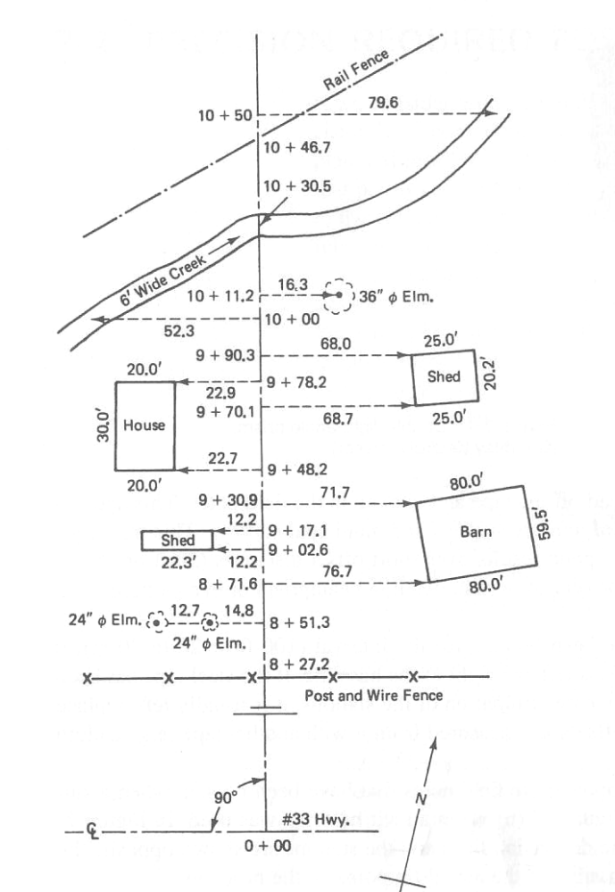

http://www.usace.army.mil/publications/eng-manuals/em1110-1-1005/c-2.pdf

Contour lines
http://fathoniu.googlepages.com/11_UELSurveyingMeasurement.pdf

