Apply site surveys and set out procedures to building and construction projects
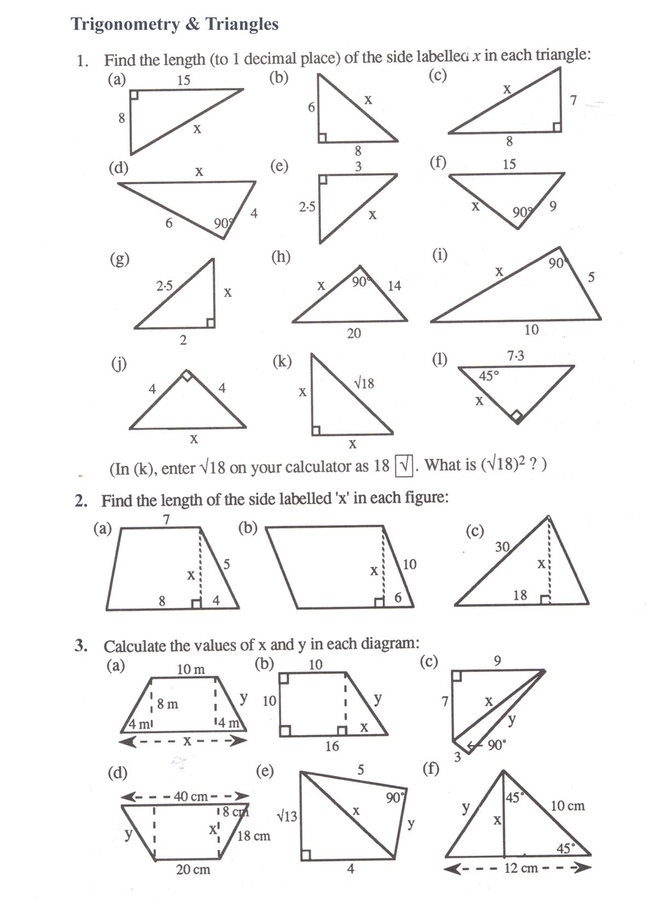
WA-SIN W5904 - (BCGBC4018A)

