Fundamentals of area determination

Using Known Geometric Shapes to Determine Area
There are several commonly known methods used to calculate areas of regular and irregular shapes. These include, but are not limited to:
Geometric shapes method
Trapezoid or offset method
Counting squares
Coordinate method

The following sections will briefly describe each of these methods. Regardless of the method used, the value of the final results depends on the equipment accuracy and the skill of the personnel making the required measurements. It is very important to have some means of checking the final answers. Completing the work without checking the values threatens the reliability of the results.
Geometric Shape Method
If a common geometric shape (i.e., circles, rectangles, trapezoids, and/or triangles) or some combination of these shapes represents a landscape area, then area computations are very simple. Basic dimensions of the geometric shape can be measured and the data used with the appropriate equation that defines that area. An example using a circle is given below. Examples of using geometric shapes to compute landscape areas are shown in the following pages. Applying geometric shapes to simple rectangular, circular, and triangular areas can be a very accurate and relatively simple method to determine landscape areas. This can be done either working in the field or on maps or aerial photographs if they exist. Even complex shapes composed of more than one geometric shape can be done with very little extra effort when working on maps or aerial photograph. This technique requires that the geometric shape is a reasonable approximation of the shape of the landscape area. The greater the divergence between the two shapes, the greater the error.

Reducing the width of the trapezoids increases the accuracy. This example not only demonstrates the power of the method, but the necessity for impeccable computations and record keeping. If the computations are not approached in an organized manner it is possible to make significant errors.
Counting Squares
Grid paper is placed over the photograph and the number of squares in the landscape area is counted. If the image scale and the number of squares per unit area are known, then area can be calculated. This method’s accuracy depends on the size of the squares and the worker’s ability to accurately count squares in each area. The higher the number of squares per unit area, the greater the accuracy, but also the more time required to count the squares.

Polar Coordinate method
The Polar Coordinates Method determines the location of all boundary points from a fixed reference point. The location of the reference point is arbitrary. Two measurements are made to locate boundary points
1. Distance from the reference point to the boundary point, and
2. Horizontal angle between the line from the reference point to the boundary point and a reference line (usually true or magnetic north).

The following figure shows a reference point located inside the area of interest. Distances from the reference point to boundary points 1-5 are made. Additionally, angle measurements A-E are also made. This information is used by commercial software to locate the boundary points in relation to each other and determine the point coordinates.
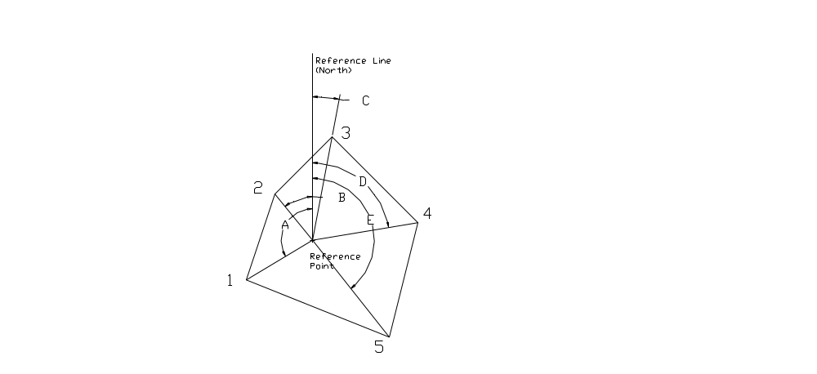
Polar coordinates used to locate points representing an area’s boundary.

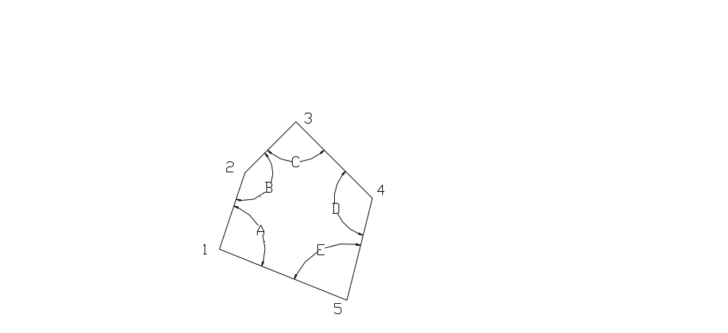
The Closed Traverse Method determines the location of boundary points in relation to the previously measured boundary point. The process starts a convenient boundary point, which is occupied by the survey equipment. The distance to the next boundary point is measured as well as the interior angle formed between the lines created between the occupied point and the previous boundary point and the next boundary point. For example the instrument is located on point 1, the distance between point 1 and 2 is measured as well as angle A. These measurements are taken at each point on the boundary. The distances between boundary points and the interior angles are used by commercial software to determine the boundary point coordinates in relation to each other.
Coordinates computed using the Closed Traverse Method.

Once the boundary's coordinates have been computed, the areas can also be computed. The computations of the coordinates and area are not difficult for trained personnel, but the process can become very tedious. Fortunately, there is a full range of calculator and computer software available. This software is capable of taking collected field data, Polar Coordinate or Closed Traverse data, and computing the area of the polygon defined by the data.

The Hewlett-Packard HP-48GX is capable of running general surveying programs (e.g., TDS Survey Pro®). This software has the capability of computing areas from the typical field data described above. In advanced applications, it is possible to pass data from the hand held calculator to a desktop computer and display a map of the area measured using software such as Foresight®

A sophisticated ground surface modeling program (TerraModel®) is capable of doing both two- and three-dimensional terrain surface modeling. Polar or rectangular coordinates are entered into the software, which then generates a map and calculates the area. This program can also apply several types of error correction methods to data. This has the advantage of minimizing the effect of errors and mistakes. This program requires extensive training for successful use.

One of the most widely used computer aided drawing/design programs, AutoCad®, can create maps and calculate areas. AutoCad® is quite complex and generally requires extensive training. The amount of training required to execute the fundamentals required to compute areas will depend on the computer skills of the personnel doing the work.

http://www.usbr.gov/mp/watershare/documents/files/Appendix_A-Shape.doc

