End of Semester Examination

Answer all questions succinctly to the point. If the space provided is not sufficient for your explanations/calculations then use back (see ◄) of the previous page.
The lay-out of all calculation must be logical and understandable. Legible writing is required and the letter height should not be less than 3 mm.

Question 1 ►Surveying methods
The property shown in Figure 1 will be redeveloped.  All the survey pegs of the boundaries are found.  The owner of the property requires a scaled site plan showing all existing buildings and trees. | 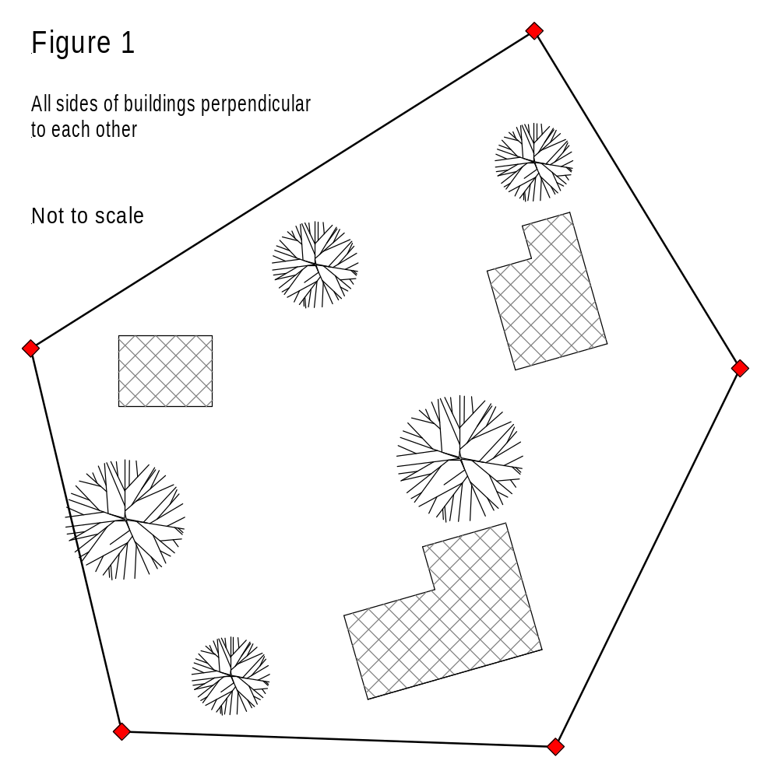
- In the above sketch below indicate your preferred surveying method that you would use.
(The exact location of all trees and buildings (side length) of must be determined to enable the draft person to draw the scaled site plan.)
- Briefly describe the reason why your selected this method.

◄

Question 2 ►Reduced Levels
The set-out building project asked you to set the profiles to a specific RL. Determine the Reduced Level (RL) of the set-out profiles derived from the bench mark 93.67 given the following readings:
Benchmark 93.670 reads 1.684; reading on profiles is 1.960.
With the aid of a sketch show how you would calculate, using the collimation method, the RL of the profile.
Sketch the collimation height and staff readings: Calculation:
(for bench mark and profiles)
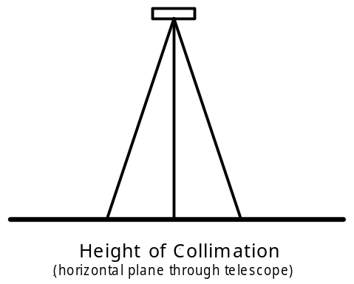

The Reduced Level of the profiles is ► RL ?

Question 3 ►Data presentation
A reader of a project report will appreciate if a comparison between given data with the measured figures from your field exercise is made.
- Briefly explain how you would present these figures in a future report submission.

◄
- Why is it necessary to reference diagrams, charts, figures etc in the discussion of your report?

◄

Question 4 ►Conversion
- Covert the polar coordinates (4, 50°) to rectangular coordinates (x = r cosF, y = r sinF)

2) Covert rectangular (6, 8) coordinates to polar coordinates (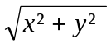, tan⁻¹( y/x ) ) ► ( r, F)

(Write clearly all numbers using the appropriate formulas)

Question 5 ►Theodolite
- The reading microscope that can only read degrees, minutes and seconds and cannot read decimal degrees. Convert an angle of 134.365° into degrees, minutes and seconds (show all calculations, (logical process toward a final answer is mandatory).

- A theodolite has a reading microscope which horizontal and vertical circles which can read degrees, minutes and seconds. There are three windows that you saw in the reading microscope.
  - Explain what is viewed in the upper, middle and lower window

◄
  - In the reading microscope a horizontal angle of 53° 47' 20" is shown. Unambiguously write and display this angle, as you would see in the reading microscope when you did project 3,

Question 6 ►Report presentation
Having submitted the survey report and discussed the matter with your fellow students you may now have a better and clearer idea how to present a report.
- Describe in detailed the significance of field notes and the different parts of the report (report structure, table, charts, sketches references etc).

◄
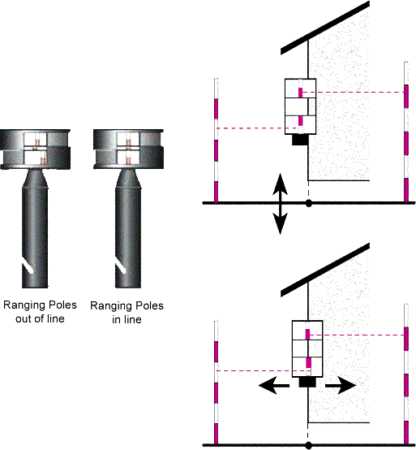
You have included calculations, sketches, diagrams figures etc that were not properly labelled nor referenced and not appropriately placed within your report.

2) Opposite figure shows three parts. In the text are three references made in your report to this sketch. Label this figure so that the reader of the text can refer to the particular part of the sketch.
3) List some reasons why the labelling is important.

◄
End of Examination

