End of Semester Examination
The property shown in Figure 1 will be redeveloped. All the survey pegs of the boundaries are found. The owner of the property requires a scaled site plan showing all existing buildings and trees.
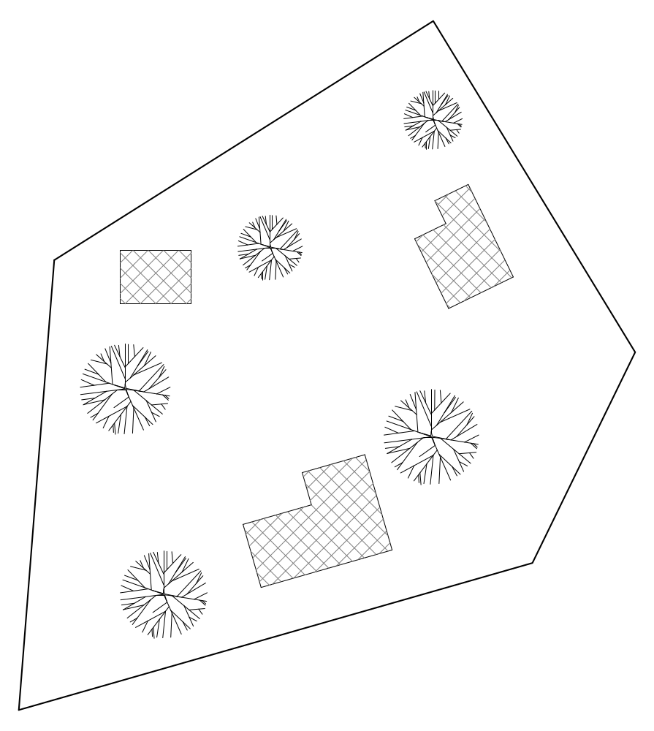 Figure 1

Question 1 ►Site Plan
- Describe in detail the survey method you would use to locate accurately the buildings and trees on the property and what equipment would be required for this survey?

- Can you suggest any alternative (easier) survey method that could be used?

- In Figure 1 indicate your survey method that has been described in 1).

Question 2 ►Reduced Levels
Determine the Reduced Level (RL) at ground level (the centre of the Trafo-Station)
Reading at Benchmark 93.670 is 1.794; reading centre Trafo-Station is 1.960.

The Reduced Level is ► RL ?

Question 3 ►Data presentation
In your Assignment Polar coordinates you needed to compare the given data with the measured figures from your field exercise.
- Show an example how you would present these figures in a report that are presented to management.
- Why is it necessary to reference diagrams, charts, figures etc in the discussions?

Question 4 ►Conversion
- Covert the polar coordinates (4, 50°) to rectangular coordinates (x = r cosF, y = r sinF)

2) Covert rectangular (6, 8)coordinates to polar coordinates (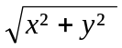, tan⁻¹( y/x ) ) ► ( r , F)

Question 5 ►Theodolite
A theodolite has a vertical circle (V-window) and a horizontal circle (H-window) reading scale which can read degrees, minutes and seconds.
1) With the aid of a diagram explain how an angle is read in degrees, minutes and seconds.

2) Describe how the height of a building can be determined with a theodolite.

Question 6 ►Report presentation
Having submitted the survey report and discussed the matter with your fellow students you may now have a clearer idea how to present a report.
1) Describe in detailed the different parts of the report and list the main headings of the report that are show on a contents page.

You have included calculations, sketches, diagrams figures etc that are not labelled nor referenced and not appropriately placed within your report.
2) Below is a figure showing three parts. In the text are three references made to this sketch. Label this figure so that the reader of the text can refer to the particular part of the sketch
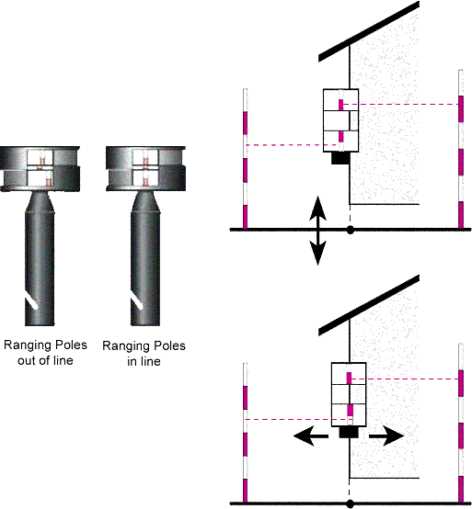

List some reasons why the labelling is important.

End of Examination

