Activity
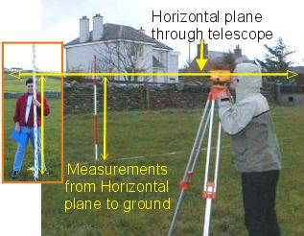
HELP
Height of Collimation is the height of the horizontal plane through the telescope. In order to see the staff on the BM the instrument must be higher. To find the Height of Collimation (Instrument Height) add the staff reading to the level of the Bench Mark.
Height of Collimation = BM + staff reading
The survey station is below the horizontal plane through the instrument, so to find reduced level, or ground height, take the staff reading away from Height of Collimation.
Redu
ced level = Collimation - staff reading

Revision for Examination
Week 17 - 9th June 2010

Question 1 ►Surveying methods
Chain line
Off-set

Question 2 ►Reduced Levels
Height of collimation

Question 3 ►Data presentation
Project notes – field notes; diagrams, charts, figures tables

Question 4 ►Conversion
Polar & rectangular coordinates,
angles degree, minutes, seconds, decimal

Question 5 ►Theodolite
Reading microscope

Question 6 ►Report presentation
Field notes
Report writing
Labelling and referencing

