Introduction (Extract from webpage http://www.sokkia.com.au/about/)
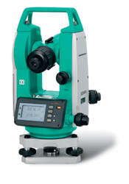
Digital Theodolites
The DT210, DT510 and DT610 are the most versatile entry-level instruments you can buy. With an IP66 waterproof rating the theodolites operate dependably even where conventional theodolites do not, such as sudden showers, continuous drizzling rain or the high humidity of underground construction sites.

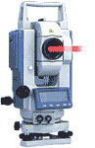
Laser Theodolites
Cope with both Parallel beam and focused beam applications with the LDT50 in a One touch switch.
Parallel beam: for directional control during excavation
Focused beam: for precise aligning and positioning.
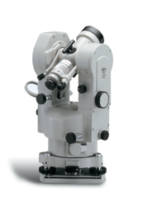
Optical Theodolites
Both horizontal and vertical circle graduations are displayed by means of a special patented method known as "co-incident image projection". This method employs the technique of projecting opposite side circle readings into the read-out through a special prism thereby assuring optimum and equal light intensity and entirely eliminating parallax. Circle graduation, indexing and micrometer graduations are thus displayed with an accuracy of 0.5 seconds of arc. Quick readings are obtained after sighting, as the micrometer eyepiece is aligned parallel with and close to the telescope. The observer makes readings easily and rapidly without changing his position.

Total Stations
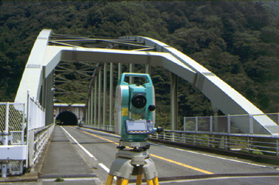
are devided in the following groups: Surveying Total Stations
Construction Total Station Industrial Total Stations
The Surveying and Construction Total Station groups cover our main Total Stations. Within these groups you will find various series of instruments which can be used in many application areas. A lot of the on-board functionality will be similar if you make a comparison. However, each serie has its specialty whether it is comprehensive on-board software, reflectorless functions or the possibilities to extend memory capacity with popular memory carriers of today.
Besides the regular Total Stations, we offer the high accuracy MONMOS system for industrial applications, the Gyro Station for very typical applications like tunneling and low-temperature models.

