Course Outline, Projects & Assessment Plan
BUILDING SITE SURVEY AND SET OUT 2
Assessment 2 | Assessment 3 | Assessment 4

PREREQUISITES: Building Site Surveying and Set Out 1
INSTRUCTIONS TO STUDENTS:
The aim of this module is to extend the students knowledge of basic measuring and levelling techniques to include instruments and calculations necessary in the set out and control of large residential developments, commercial and industrial construction.
a) This module is designed to be carried out over one Semester at 1.5 hours each class.
b) There are four assignments to be submitted. For the field surveying the class will be divided into groups to carry out three individual assignments
c) The task is based on a TEAM effort and it is the responsibility of each student in the group to maintain this perspective (refer to key competencies).
TASK:
A range of surveying techniques used for commercial building applications will be explored. A theodolite will be used for the measurements of vertical and horizontal angles (bearings). Chain lines and offsets with an optical square are utilised for area measurements.

Assignment 2 - Field work
Part A
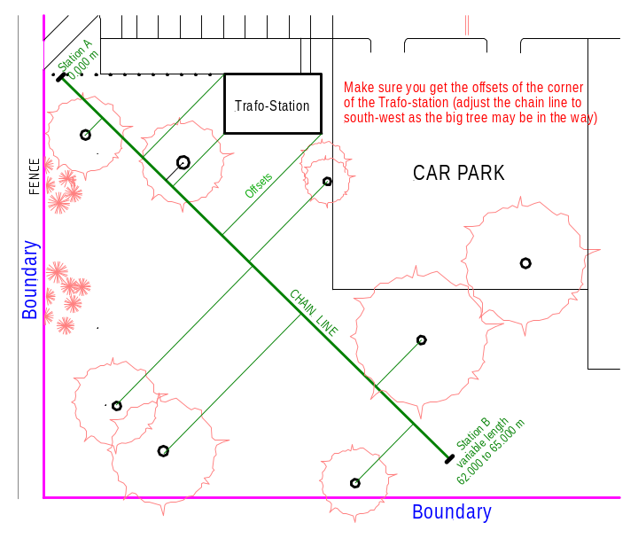
With aid of a chain line and offsets determine the position of trees and the corner of the Trafo Station
Surveying field notes need to be recorded for work done in the field. Make sure all measurements are correctly recorded in the field notes.
Each student must submit
- the field records:
- a plan scale 1:200, showing the position of the trees and Trafo Station corners.

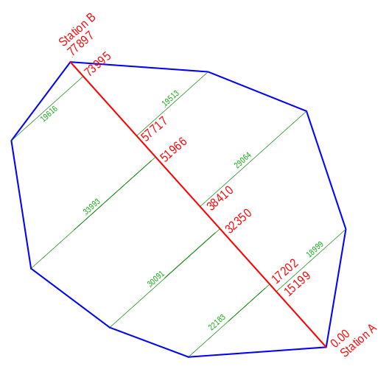Part B – Theoretical exercise

A chain line is set up across an existing polygonal shaped lot running from Station A to Station B with given measurements along the chain line as well as the offsets measurements to all other corner pegs of the lot.

From the given survey data find the area of the lot and the perimeter (running metre of fencing required).
Accurately measure and/or plot the layout of all:

Assignment 3 - Field work
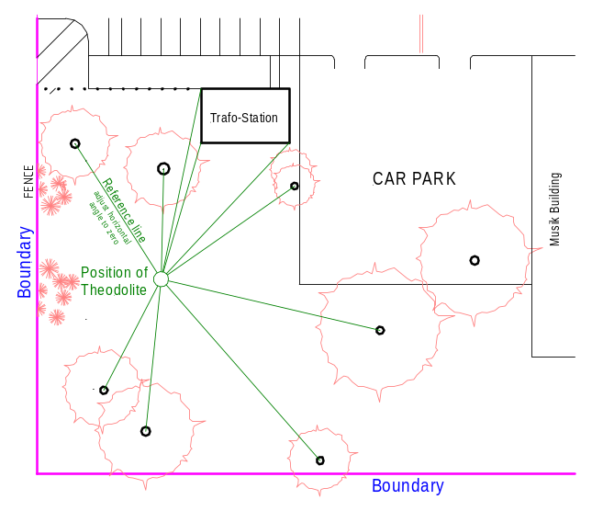This assignment uses polar coordinates to establish the position of site features.
Using the theodolite determine horizontal bearing angles. The theodolite should be set up in an appropriate position to measure the horizontal angles to trees and corners of the Trafo-Station.
Each student must submit
- the records taken in the field (polar coordinates)
- a plan scale 1:200, showing the position of the trees and Trafo Station corners.

Assignment 4 - Field work
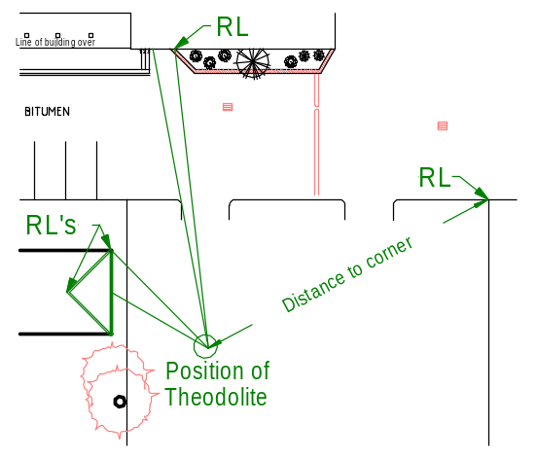This assignment uses theodolite to determine vertical angles to calculate height measurements.
Height measurements must be determined. (Two at Trafo Station (top & bottom bargeboard) and two at main building (gable top & bottom bargeboard) and one at the corner of the music building.
The height measurements and RL’s for these location including the lintel & sill heights of the windows in the gable of main building must be determined.
Each student must submit:
- All field notes and height calculation
- Elevation of gable with windows scale 1:100
Each group is responsible for the booking of all relevant equipment required for the surveying task. All gear must be returned to the store room (Locke room access No CZ160).
Safety regulations must be followed at all times. Safety vests and proper footwear are to be worn for all field-work. Safety signs Surveyor on Road are required if you work in trafficable areas.
ATTENDANCE:
Attendance during class time is compulsory. Refer to delivery schedule for attendance dates. Students are not required to attend other classes. Students may work for longer hours on any day of the week to get the job done quickly.
I will be available during non attendance class times for assistance, but not necessarily at other times. If you can't find me in class or outside please knock at the door (Staff room 1303).

Assessment Plan
Date | Assessment Tasks | Assessment Method | Learning Outcomes
Week 4  14/08/07  Resubmission  28/08/07 | Assessment 1)  Prepare and submit an Assignment covering the various documents and plans incorporated in land titles. | Suitable report structure  Contents of the report  Compliance with guidelines  Scope of work | 5
Week 9 18/09/07  Resubmission  16/10/07 | Assessment 2)  Establish a chain line and use an optical square to determine offset measurements | Correct use of equipment, field notes, simple site plan work  Observation, Teamwork performance | 1 to 4
Week 12 23/10/07 Resubmission  16/11/07 | Assessment 3)  Measure site features using theodolite and bearings (polar coordinates distance & horizontal angles) | Correct use of instruments, reading scales to an accuracy of minutes & seconds  Teamwork performance | 1 to 4
Week 17  20/11/07 Resubmission  4/12/07 | Assessment 4  Measure site features using theodolite and vertical angles | Correct use of instruments, reading scales to an accuracy of minutes & seconds | 1 to 4
Assessment(s) with an H-grade must be resubmitted within a fortnight (14 days). If you do not pass the ASSESSMENT in the Weeks nominated you need to re-enrol. FailureAn H-grade can be converted into a CO if the resubmission indicate competency. An H-grade in an Assessment is required to pass the module. If all assessments have been passed you will receive a CO-grade as your final results

back to Building Surveying contents page

