Surveying for architectures

This document contains the basics of subject surveying for architectures. It tries to give a hand for the students at Budapest University of Technology and Economics with summarizing the most important points of the practices and lessons.

Author: Bence Takács (bence@agt.bme.hu), last modified at 10/09/2007.

Introduction
Surveying, to the majority of engineers, is the process of measuring lengths, height differences and angles on site either for the preparation of large-scale plans or in order that engineering works can be located in their correct positions on he ground. The correct term for this is engineering surveying [Uren and Price, 199?].

Beside engineering surveying there a lot of other fields where surveying is needed, without going into the details, just a list:
  - Geodesy: theory, like determining the shape and dimensions of the Earth
  - Cadastral surveying: which is to establish and record the boundaries and ownership of land and property.
  - Photogrammetry: using photographs to produce three-dimensional models of land, buildings and other objects.
  - Topograpchical surveying: establish the position and shape of natural and man-made features over a given area, usually for the purpose of producing a map of an area. Typical scales are from 1:100 000 to 1:10 000.
  - and so on.

Why is surveying important for architectures? What are the purposes of this subject?
  - There are so many planning tasks where a small surveying is needed. These can be carried out by architectures themselves.
  - Most of the cases surveying exercises are carried out by professional surveyors; however architectures must know the basics of surveying. Because they have to define the task, so they must be aware of both possibilities and limitations.

Basic calculations

Calculations with angles
    - In a triangle somebody measured the three angles. The following details were noted. Are these measurements correct?
    - In a triangle somebody wants to know the third angle (γ). He measured the other two angles (α and β).

Calculations with angles and distances
    - In a rectangular triangle the following details were measured. How long is the side h?
    - Somebody sighted a point with a theodolite and probably missed the angle measurement with an error 6”? The sighted object is 100 m far from the station point. How much is the so called linear error?
    - In a triangle the following details were measured. How long are the two other sides?

Calculations with coordinates
    - Two points are given with their horizontal coordinates. How much is the distance between the points?
    - Two points are given with their three dimensional coordinates. How much is the distance between the points?

Theodolites and their use
Theodolites are precision instruments for measuring angles in the horizontal and vertical planes.

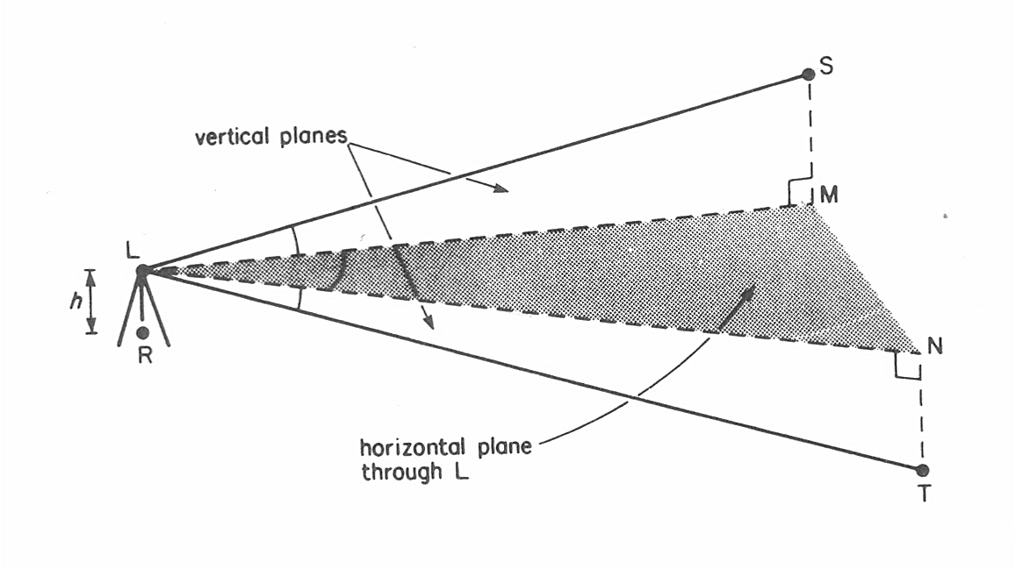
Figure 1. Horizontal and vertical angles [Uren and Price, 199?].

Most important elements of a theodolite
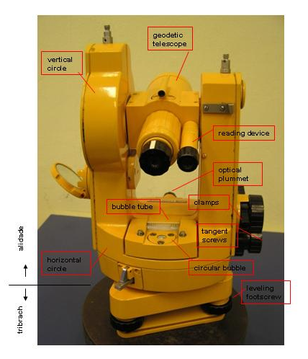
Figure 2. Theo 020 theodolite and its most important elemt

Setting up a theodolite
Theodolite must be centred and leveled.

Proposed step:
- Setting up the tripod (the head of the tripod should be approximately horizontal) above the station point
- Fix the instrument on the tripod.
- Sight the station point in the optical plummet using the footscrews of the instrument.
- Level the instrument by adjusting the length of the legs of the tripod using the circular bubble.
- Find the normal point of the bubble tube.
- Level the instrument accurately using the bubble tube and the three levelling screws.
- Finally loosen the instrument on the tripod, and slide it above the station point on the head of the tripod.
- Fix the instrument on the tripod.

Circle reading
We use only graduated microscope (Zeiss Theo 020). For example:
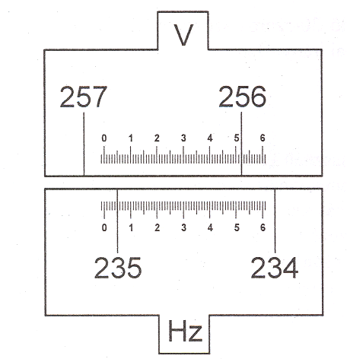  Figure 3. Readings on a graduated microscope | Vertical circle reading 256°52,0’  Horizontal circle reading 235°05,2’

Measurement of horizontal and vertical angles
Station W
Horizontal circle
Point | Face left |  |  | Face right |  |  | Mean |  |  | Reduced  direction |  |  | Horizontal collimation
X | 0 | 03 | 48 | 180 | 04 | 30 | 0 | 04 | 09 | 0 | 00 | 00 | +21
Y | 17 | 22 | 12 | 197 | 23 | 12 | 17 | 22 | 42 | 17 | 18 | 33 | +30
Z | 83 | 58 | 54 | 264 | 0 | 0 | 83 | 59 | 27 | 83 | 55 | 18 | +33

Clockwise XWY = 17°18’30” or XWZ = 83°55’10”
Station W
Vertical circle
Point | Face left |  |  | Face right |  |  | Sum |  |  | Zenith angle |  |  | Vertical collimation
X | 88 | 10 | 30 | 271 | 50 | 18 | 360 | 0 | 48 | 88 | 10 | 06 | -24
Y | 89 | 32 | 48 | 270 | 27 | 30 | 360 | 0 | 18 | 89 | 32 | 39 | -9

Exercises:
- Set up a theodolite! Sight some points in different distances! Read on the horizontal and vertical circles (in face left)! Repeat reading in face right! Compute mean values and horizontal and vertical collimation errors!
- Set out a general triangle in the garden and measure its angles! Check your measurements with adding the three angles!
- Rotate the horizontal circle to have a given reading to a given direction!

Measuring the height of a building
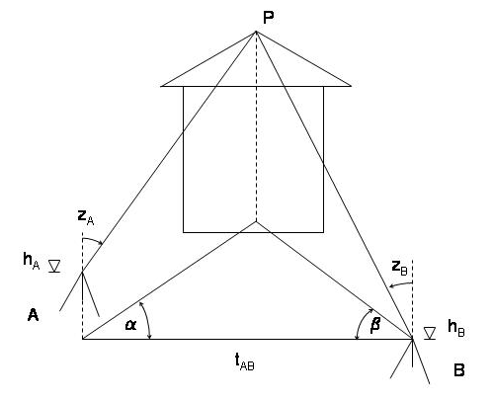
Figure 4. Concept of measuring the height of point P on a building

An example (measurements in red):

Station A
Horizontal circle
Point | Face left |  |  | Face right |  |  | Mean |  |  | Reduced  direction |  |  | Horizontal collimation
P | 25 | 12 | 24 | 205 | 12 | 48 | 25 | 12 | 36 | 0 | 00 | 00 | +12
B | 79 | 09 | 12 | 259 | 08 | 54 | 79 | 09 | 03 | 53 | 56 | 27 | -9

Station A
Vertical circle
Point | Face left |  |  | Face right |  |  | Sum |  |  | Zenith angle |  |  | Vertical collimation
P | 53 | 15 | 30 | 306 | 44 | 27 | 359 | 59 | 57 | 53 | 15 | 32 | +2

Station B
Horizontal circle
Point | Face left |  |  | Face right |  |  | Mean |  |  | Reduced  direction |  |  | Horizontal collimation
A | 354 | 27 | 06 | 174 | 26 | 54 | 354 | 27 | 00 | 0 | 0 | 0 | -6
P | 73 | 44 | 42 | 253 | 44 | 42 | 73 | 44 | 42 | 79 | 17 | 42 | 0

Station B
Vertical circle
Point | Face left |  |  | Face right |  |  | Sum |  |  | Zenith angle |  |  | Vertical collimation
P | 47 | 39 | 42 | 312 | 20 | 36 | 360 | 0 | 18 | 47 | 39 | 33 | -9

      - Distance between A and B = 34.71 m
      - Instrument height at A = 1.89 m , at B = 1.77 m
      - Distance between A and P = 46.81 m, B and P = 38.52 m
      - Height difference between A and P = 34.94 m, B and P = 35.10 m
      - Height of P from A = 36.83 m, from B = 36.87 m
      - Height of P = 36.85 m

Exercises:
- Set up a theodolite and find the horizontal position of the telescope! Read on a leveling staff in both face left and right! Calculate the height of the trunnion axis!
- Measure the distance of two points using the missing line measurement program of a total station!
- Measure the height of a building using the above concept!

Levelling
Levelling is the name given to process of measuring the differences in elevation beween two or more points. In engineering surveying, leveling has many applications and is used at all stages in construction projects from the initial site survey through to the final setting out.

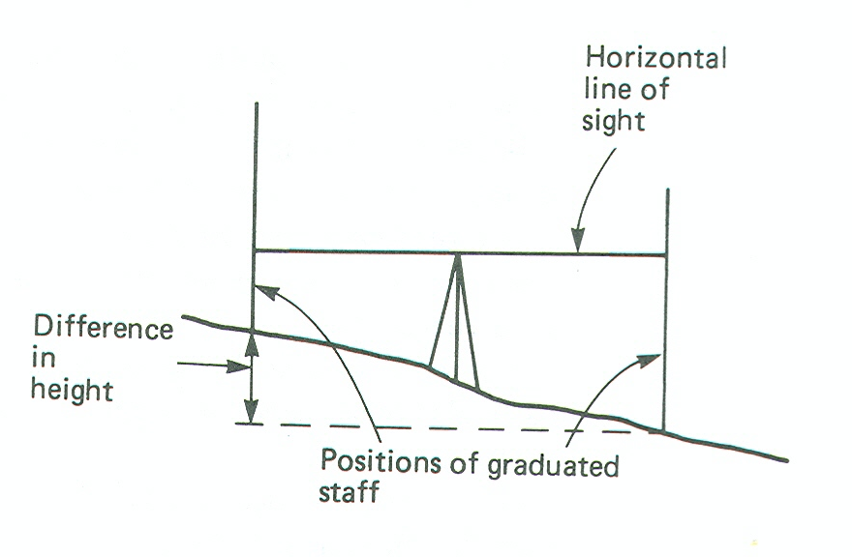
Figure 5. Concept of levelling
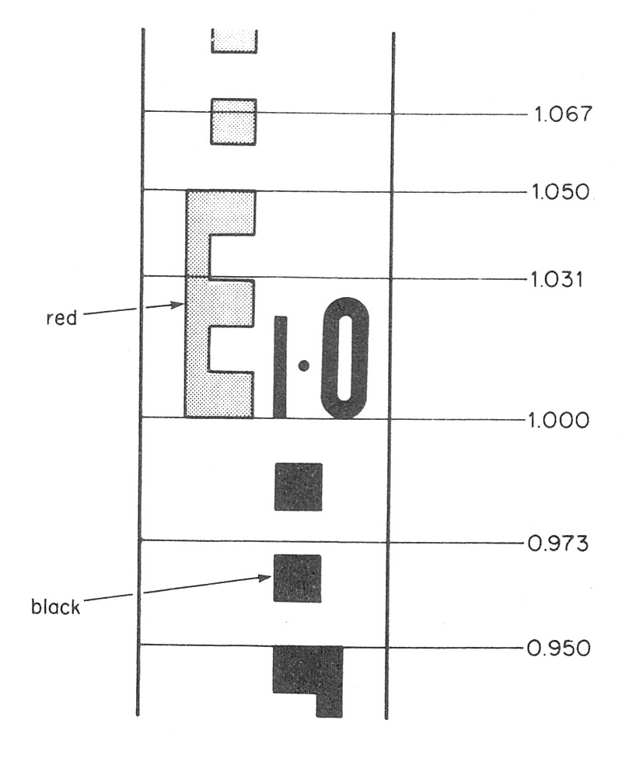
Figure 6. Reading on the levelling staff

Bookkeeping (measurements in red, known heights in blue):

Point | Distance | Backsight | Foresight | Height difference | Height
1230 |  | 1224
1 |  | 1524 | 1856 | -632
2 |  | 1526 | 967 | +557
3 |  | 1848 | 1711 | -185
17 |  |  | 1538 | +310
 |  | 6122 | 6072 | +50

Point | Distance | Backsight | Foresight | Height difference | Height
17 |  | 1081
3 |  | 1451 | 1388 | -307
2 |  | 1475 | 1264 | +187
1 |  | 1956 | 2030 | -555
1230 |  |  | 1320 | +636
 |  | 5963 | 6002 | -39

Point | Distance | Forward | Reverse | Mean | Correction | Height
1230 |  |  |  |  |  | 104.517
1 |  | -632 | +636 | -634 | 0 | 103.883
2 |  | +557 | -555 | +556 | +1 | 104.440
3 |  | -185 | +187 | -186 | +1 | 104.255
17 |  | +310 | -307 | +308 | +1 | 104.564
 |  |  |  | +44 | +3 | +47

Point | Backsight | Intersight | Foresight | Collimation level | Height
1 | 1456 |  |  | 105.339 | 103.883
101 |  | 1022 |  | 105.338 | 104.316
102 |  | 999 |  |  | 104.339
103 |  | 1111 |  |  | 104.227
2 |  |  | 897 | 105.337 | 104.440

Tacheometry, total stations
The most common type of electronic instruments now available are termed Total Station instruments. These incorporate a theodolite with electronic circles and an Electronic Distance Measurements (EDM). Total Stations can store their measurements and have a microprocessor with a number of inbuilt routines allowing basic calculations, like coordinates, missing lines, data for setting out…

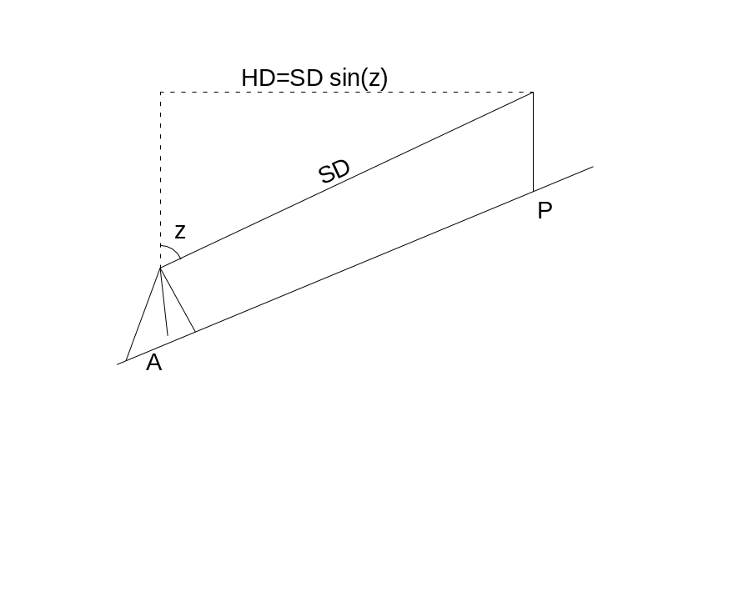
Figure 7. Slope and horizontal distance

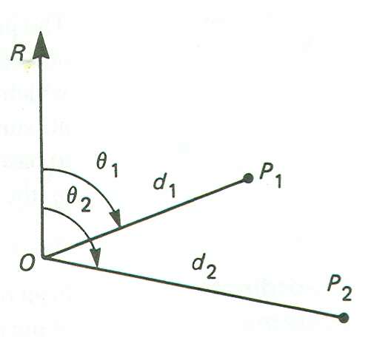
Figure 8. Polar coordinates

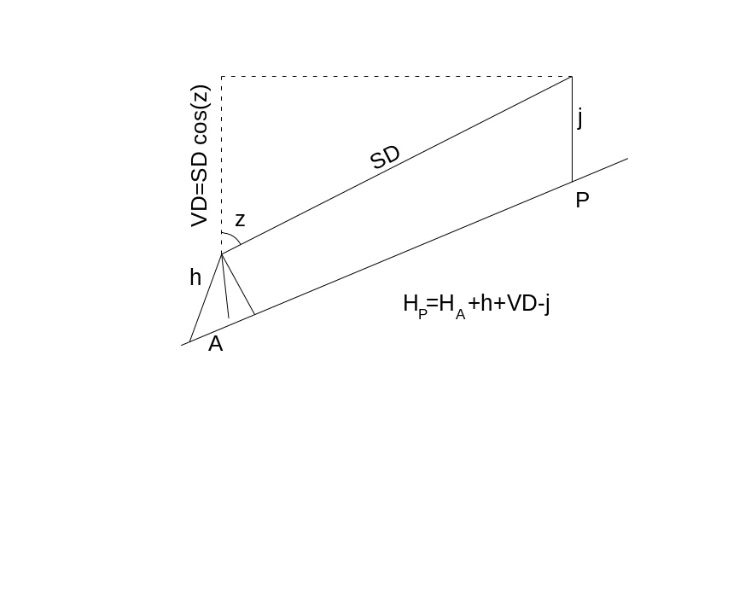
Figure 9. Determination of heights with total station

Setting out heights
Setting out is the establishment of the marks and lines to define the position and level of the elements for the construction work so that works may proceed with reference to them. This process may be contrasted with the purpose of surveying which is to determine by measurements the positions of existing features.

1st exercise: setting out a horizontal plane. A base point is given with its known height. There is a target level what we have to mark at different locations.

An example: there is a given point, called 01. Its elevation above mean sea level is 101.311m. In the nearby of point 01 a new house will be built. Its ground floor level is designed to be at 100.567 above mean sea level. The task is to mark the +1m level above designed ground floor at different locations.

First a traditional levelling instrument is set up. The leveling staff is put to the known point, the reading is 1023. So the collimation level is 102.334 (101.311+1.023) above sea. The target level is 101.567 (100.567+1.000) above see. The target reading on the leveling staff is 0767 (102.334-101.567). So the leveling staff should be moved up and down in the position when the reading is 0767.

In a second case a rotating laser is used. It has got a special tripod, wherewith it can be set precisely to a required level. After marking the target level using the traditional technique at some locations, the instrument is set up in a way that its collimation level coincides to the target level. Use different markers to control yourself! Using the laser other points in the target level can be set out and marked.

2nd exercise: setting out a slope line. Its inclination is given, for example 1 percentage. One point of this line is also given/marked.

Steps:
  - Measure the distance between the known point and the point where a new marker will be placed using a commercial tape!
  - Compute the height difference from the distance and inclination!
  - Put a leveling staff to the know point, have a reading!
  - Compute the target reading! Be careful with signs!
  - Set out the target level!

Horizontal setting out
Set out the points 1..4 according to the following setting out sketch:

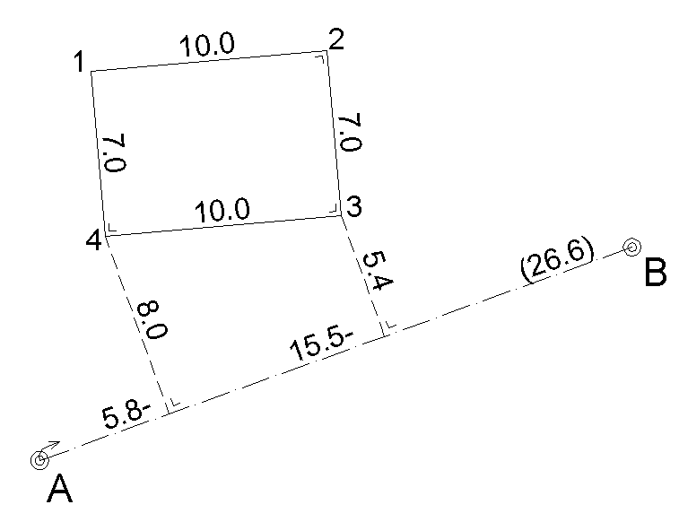
Figure 10. Setting out sketch

Use two different techniques:
  - Set out the points with rectangular coordinates using prism square!
  - Set out the points with polar coordinates using a total station!

Possible questions in the tests
- Draw a theodolite, give the name of its most important elements!
- Describe the steps how can you set up a theodolite!
- During an angle measurement the followings can be seen on the reading device. How much is the horizontal and vertical angle?
- During a theodolite survey the following details were noted. How much is the ABC horizontal angle?
- During a theodolite survey the following details were noted. How much is the zenith angle from A to P?

- Draw the concept how can be measured the height of an unreachable point, for example on a building!
- During measuring the height of the point P on a building the following details were noted. How much is the height of P?

- Draw the concept of levelling!
- Describe the steps how can you set up a level?
- How can you measure the collimation level? Give an example!
- Draw what you can see in a levelling instrument when the reading on the staff is … !
- During a levelling exercise the following books were kept. Compute the unknown heights!

- What can you measure with a total station?
- How can you compute three dimensional coordinates of a point from the measurements of a total station?

- There is a given point, its height is … There is a target level … How can you set out this level? Give an example with numbers!
- A setting out sketch is given., like at figure 10. Give a list which instruments/tools do you need for setting out point 1..4! Shortly describe how can you set out 1..4 with rectangular or polar coordinates!

Further readings
Bannister A., Raymond S. Baker R.: Surveying
Uren J. and Price W. F.: Surveying for Engineers
www.geod.bme.hu

