Site Surveying & Set Out 2

Exercise 4
Using the vertical angles and distances to determine heights.
The measured vertical angle combined with the distance to any object can be used to determine the height of an object. Most modern theodolites will automatically set the reference direction for the vertical circle once the theodolite is levelled. Zero degree for the vertical circle is usually set at the zenith (vertically above the theodolite). The vertical angle is then the angle from the zenith down to the line of observation. Points on equal elevation (horizontal plane) to the theodolite will therefore be at 90 degrees. Basically the precision for our vertical angle measurement will determine the accuracy of measured positions.
Procedures to measure vertical and horizontal angles
Aim at the first specified corner of the building and zero the horizontal circle reading. Readings for horizontal angles should be either in a clock wise or anti clock wise direction. Do not change directions and close the circle at 360°. Then read the vertical angles (angle of elevation & angle of depression) to determine the height of the corner of the building. Make sure the sighting points are vertical above each other. After that sight the next specified corner and read the horizontal angle, and note the reading of the vertical angles. The horizontal distance between all specified building corners must be exactly measured. (Note the distance to angle A is different to angle A.) Continue reading horizontal and vertical angles as well as distance measures until the specified corners of all buildings are completed.
Height calculations

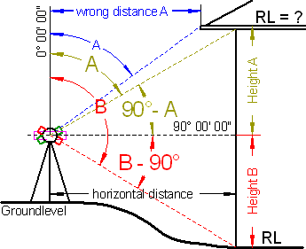  Figure 1 | We use the tan-function to calculate the height. As shown in the figure above the height is determined by measuring two angles (angle of elevation & angle of depression). To calculate the Height A multiply the horizontal distance on for your first height reading by the tan of the related angle.

Height A = horizontal distance x tan 90°- A°
Height B = horizontal distance x tan B°- 90°
Now add both distances together. Add this measuring to the known reduced level (RL) at the bottom to obtain the new height level (RL gutter or fascia) at the top.
Use a template for recording angles and measurements.
The reading precision of the instrument and the accuracy of your angle reading and horizontal measured distance will determine the correct height distance.
Height measurements for AREA 4
The Figure 2 below displays the position of the theodolite and the building corners for which the height measurements (RL's) are required.
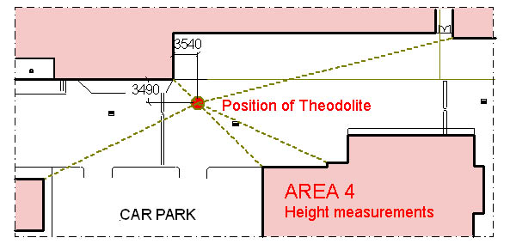
Figure 2
Use the RL at the bottom of the corner from exercise 2 to determine the RL’s of the buildings shown in the above figure. Set up the theodolite at the exact position as indicated. Measure the vertical angles of five corners from ground-level up to the top as indicated below.
- Building to the north side 2 corners – measure vertical angle from ground-level to top of brick course just below the eaves lining (see Figure 1 & 2) and
- Building to the south 3 corners – measure vertical angle from ground-level to the top flashing on the parapet walls.
- Record all horizontal angles for each vertical measurement. Measure the horizontal distance to all corners. Zero the horizontal angle to the corner (with measurements) and take the bearings for all other corner angles in a clockwise direction (full circle 360°)
- Draw a sketch similar as shown in Figure 1 indicating the measurements of all vertical angles of all corner including the RL’s at bottom and top.
- Plot all corner of the buildings onto a drawing sheet (scale 1:100) as shown in Figure 2 include the distance measurements and the bearings of all horizontal angles as well as the RL’s of the top corners.

Note:
Nathan David
For safety reason and not to obstruct the vehicular traffic on college ground this exercise need to be move to a different location at the college. Additional information can be obtained from my web site www.boeingconsult.com
Please get in touch with me if Sydney TAFE accepts this alternative field exercise so that I can make the necessary arrangement for you to carry out this exercise.
Karl Boeing
TAFE Lecturer

