Semester 1 - 2010
BCGBC4018A Apply site surveys and set out procedures to building and construction projects

Project notes
Two Peg Test
Before you start any project work your first task will be to carry out a two
peg test to ensure your level is properly calibrated. Record in your field notes
the process and state whether the test results are within the calibration limits..

Collimation error occurs when the collimation axis is not truly horizontal when the instrument is level. The effect is illustrated in the sketch below:
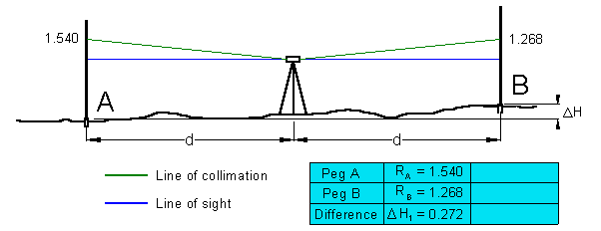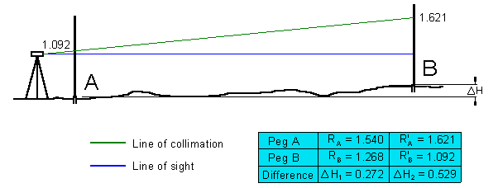
- Set out and mark on the ground (with wooden pegs driven into the earth, or roofing nails in tar) two point some 40 m apart. Set up the the level exactly mid-way (within 0.5m) between them.
- Take measurements of backsight and foresight for this first setup. The height difference DH will be free of the effects of collimation error.
- Next, move the level to a position just beyond the fore staff position (about 5m).
The difference between the readings of the two level positions should be zero. If more than 5 mm the instrument need to be calibrated.
Instrument Level checking (2 Peg test)

1 Setup and test the Instrument ( Inst. No.________ )

0.0 m 40.0 to 50 m Difference
Recording from centre spot : 1 ________ 2 ________ ________

Recording from 5 or 45 m spot : 1 ________ 2 ________ ________

For each field exercise a level check is required.
This check must be carried out each time before you do levelling.
Instead of the two peg test you may do a quick check close to the old survey store.
There is a special set up for this check!

Groups & Submissions
Three students should form a group to carry out the project work. The project work need not necessarily be done during class time. It can be done any week day and any time during the day. You need to book the equipment that is needed for your project in advance. Please remember you can't get the equipment if you haven't booked it. Booking should be done during class time or with Nicky from 9:00 to 14:00. Due to limited resources and number of students project submission doesn't need to be in the prescribed order of the Learning Plan (e.g. Project 3 can be submitted in Week 13 or 15). The submission of the projects can be in any order (you may submit Project 3 as your first or second submission) but you must submit a Project (whether No 3, 1 or 2) on a due date.
your first submission is due: 13th May 2010 (Week 13) not later than 13:00
your second submission is due: 27th May 2010 (Week 15) not later than 13:00
your third submission is due: 10th June 2010 (Week 17) not later than 13:00

No submission will be accepted after 13:00. If your submission is not complete or not handed in at 13:00 then you won't pass the unit.

Field notes
One of the most important part of your levelling task is the keeping accurate and complete field notes. Field notes form an integral part of your assessment.
Project Submission
Comply with the submission requirements
Refer to your Learning Plan Assessment Summary for the due date of the Project submissions. Any submission on the due date after 13:00 hour cannot be accepted. Please make sure you don't miss this important date.

PROJECT 1
This is a closed level run. Make sure you close the traverse your first and the very last reading should be at Station A)
Setup and record the levels of each of the YELLOW stations, 1 to 24 inclusive 25 (make sure you close the traverse) marked on the roadway in the area shown on the “Location Plan”. Take Station 1 as datum 10.000 and convert staff readings to Reduced Levels (R.L.’s), using the rise and fall method. Check your maximum allowable misclosure = 24 x distance (in km)

Project 1 Location Plan
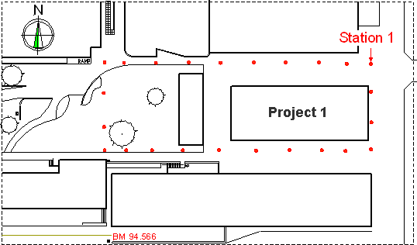
Submission date: ► refer to your Learning Plan

PROJECT 2
Setup and record the levels of each of the grid points, marked in the area shown on the "Location Plan". The RL of Station 1 which is derived from TBM - RL100.000 on the northeast corner of the college site . Use this TBM to establish the BM (RL) for Station 1 and convert all other staff readings to Reduced Levels (R.L.'s), using the rise and fall method.
Grid three (3) equal spaces between walls and five (5) spaces of approximately five (5) met re down (24 grid points, see sketch below).
Prepare a scaled sketch (1:100) and display all 24 RL's. Then draw contours lines at 0.2 m intervals. Calculate the volume of fill required using the datum at Station 1. All volume calculations must be clearly set out, use a logical method to show all results.
Project 2 Location Plan
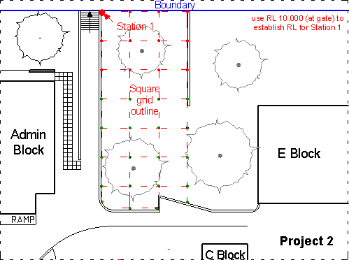
Submission date: ► refer to your Learning Plan

PROJECT 3
Project 3 Location Plan
Set out the building, to the given sizes in the grass area at the south west corner on Oxford Street.
Site Plan

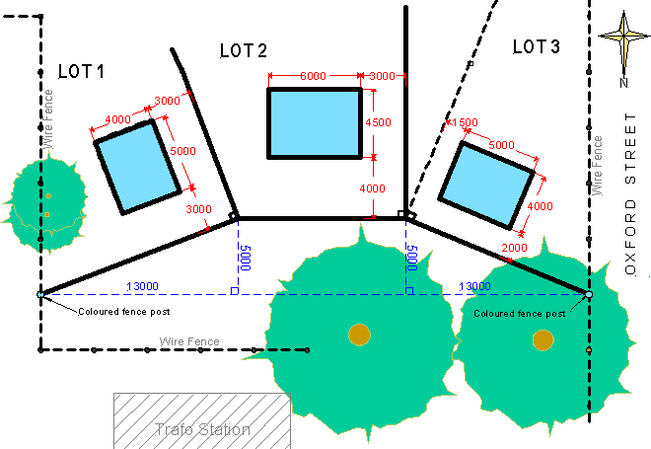

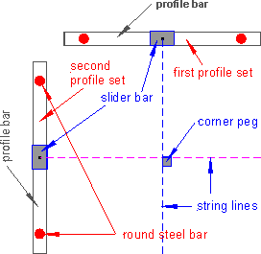 |  | Establish the property boundaries for the selected Lot and then set-up the building to the required set-backs. The front of the building must be parallel to the front boundary. Place pegs to locate position of corners of the building and then set-up the profiles at least 700mm from each corner.  Take the datum from the bench mark (BM 93.670). to set-up profiles at the to profile boards. Set up a right angle (3,4,5) to determine the other building side. Make sure the building corner is a right angle. As soon as this is correct use offsets to string the other sides of the building. Check the building for squareness (diagonals must be of equal length) as well as the listed set out requirements on the “Assessment” sheet.

Get your lecturer to check your work

Be careful when setting the Profiles. Please make sure you don't damage this equipment.
Read 'How to set-up Profiles' before you attempt Project 3.
Submission date: ► refer to your Learning Plan
I will be available during class times for assistance. If I’m not in class and you can't find me outside on the College ground I will be in the staff room. Please knock at the door (Staff room 1303) if you want to se me.

