Site Surveying & Set Out 1

Worksheet: 1

Complete this exercise at home and submit it in Week 4.
The diagrams on the worksheet represent notes taken by a surveyor in the field. The surveyor began by dividing the area to be surveyed into two sections. This was the base-line and perpendicular distances were measured and jotted down along the base-line ( the open centre-line in the diagrams 1.-AC, 2.-MP, 3.-FI and 4.-TW ) in a notebook.
Using trigonometric function and find perimeters and areas of the land surveyed.
Calculate the perimeter and the area of the shapes below.
Assume all measurements are in metres.
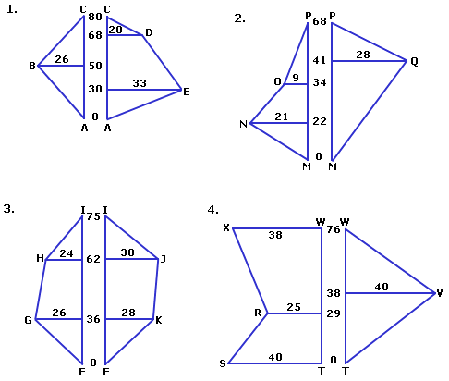

Results can be checked on my web site www.boeingconsult.com
Password bldg-stud - hit the OK button. (hitting ENTER won’t work)

