Chain line and offsets

Using the figures given below
- Draw to a scale of 1:100 the building outline,
- Calculate the site length of the building sides (using the cos rule) and
- Use a table to compare the scaled measurements with the calculated measeurements

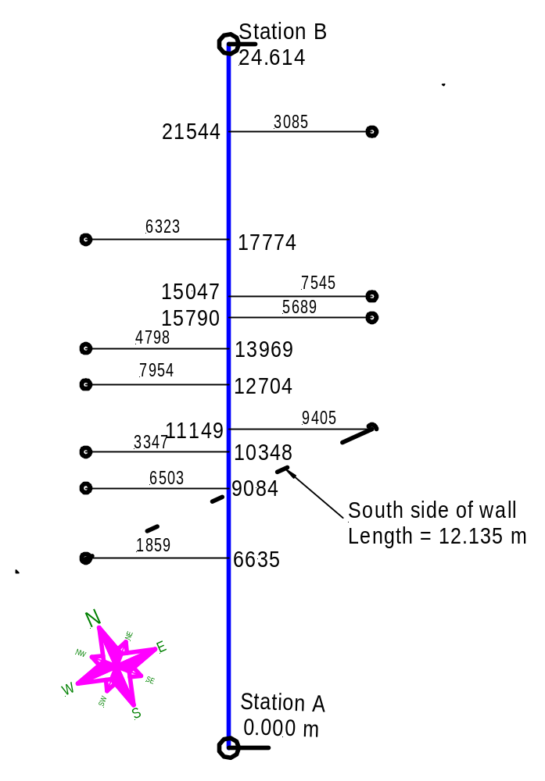

This exercise must be submitted 28. 4. 2010

