Structures 1

Lesson 1

In structures there are 2 group of quantities:
- Scalar quantities and
- Vector quantities

Scalar quantities are defined by a number e.g.
10 kilograms (10 kg) 7 square metres (7 m²)
5 metres (5 m) 3 cubic metres (3 m³)
25 seconds (25 s) 2 litres (2 L)

Vector quantities need more description than magnitude alone. Forces are vector quantities. These quantities possess magnitude and direction.

Forces
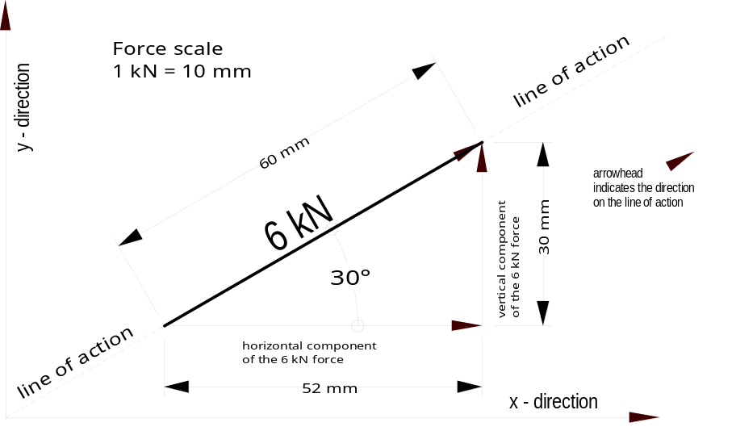Forces are represented by a line drawn to a force-scale in a certain direction with an arrowhead indicating it sense as shown below.

Coplanar force systems
Coplanar means in the same plane like the force shown above drawn on a sheet of flat paper. Forces that lie in the same plane are two-dimensional with a x-direction and a y-directions.

Structures 1

A force is completely defined by its:
Magnitude
The unit for the magnitude or size of a force is the newton (N) and multiples or sub-multiples of the newton.
e.g. kilonewton (kN), meganewton (MN) and giganewton (GN)

Line of Action and Direction
The line of action of the force (usually indicated with reference to the horizontal or vertical lines) and an arrowhead (indicating the way it acts along the line of action) must be clearly indicated.

Point of Application (Position)
The point of application or position (the location) is the point where a force is applied to the body. It could be described as four metres to the left of the support.

Geometrical Coordinate
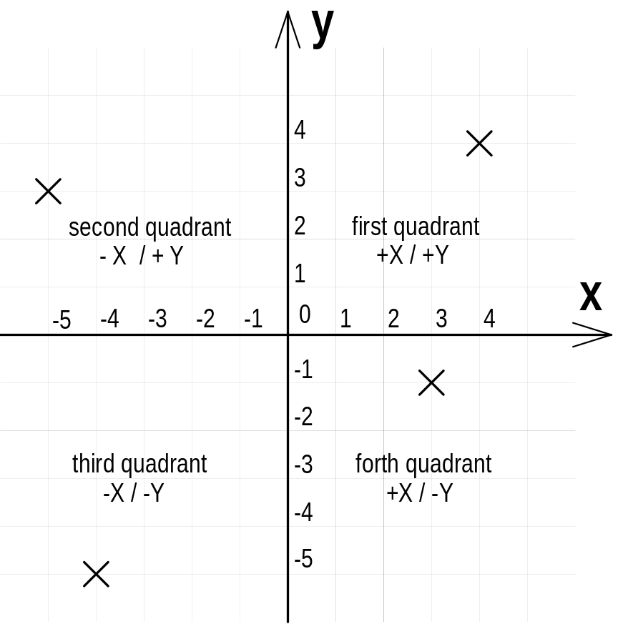Coordinates refer to a set of numbers to place a fixed point in space. For example, a point in the Cartesian plane is uniquely determined by its X-axis coordinate and its Y-axis coordinate. The Cartesian plane is used to resolve a force system or to manipulate forces.

Zero (0) is at the origin of the Cartesian plane and the coordinates are shown along the x-axis and y-axis. The point in the first quadrant has the coordinates
X = +4; Y = +4,
in the second quadrant has the coordinates
X = -5; Y = +3,
in the third quadrant has the coordinates
X = -4; Y = -5
and in the fourth quadrant has the coordinates
X = +3, Y = -1.

The Cartesian plane is used for the graphical “resolution” of forces. As all forces are vectors their magnitude and direction is easily recognised if they are drawn to scale in the Cartesian plane as shown above.

Concurrent coplanar force system
A concurrent coplanar force system is a system of two or more forces whose lines of action all intersect at a common point. However, all of the individual vectors might not actually be in contact with the common point.
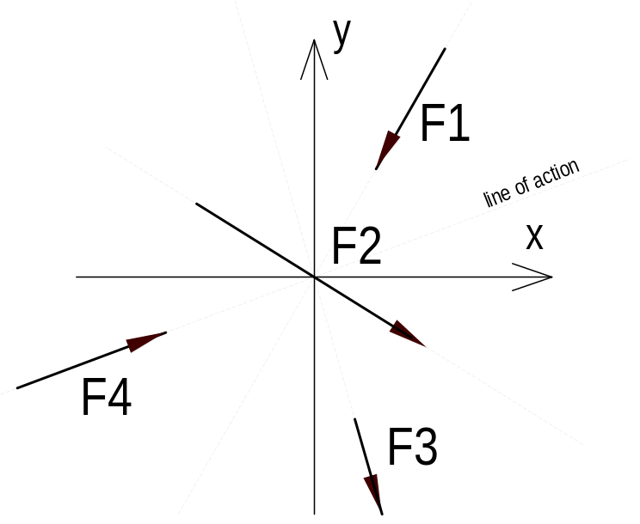

Non-concurrent coplanar force system

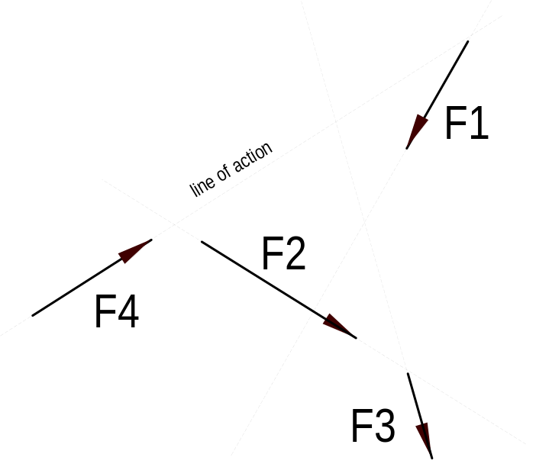Non-concurrent coplanar force system consists of a number of vectors that do not meet at a single point. These systems are basically a jumble of forces and take considerable care to resolve.

Parallel coplanar force system
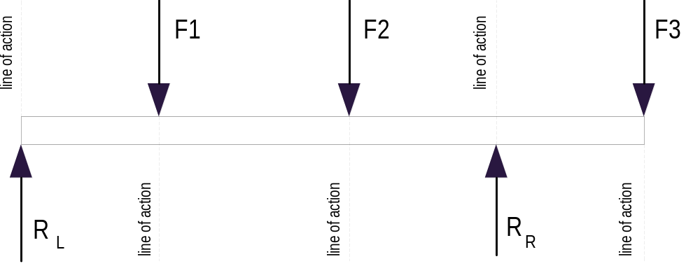A parallel coplanar force system consists of two or more forces whose lines of action are all parallel. This is commonly the situation when simple beams are analysed under gravity loads. The resolution of the forces can be done graphically but the preferred method is the analytical method.

Forces associated with levers

The force associated with a lever is a moment of a force (the turning effect of a force. The moment of a force, with respect to a given point, in the same plane, is the product of the force and the perpendicular distance from the point (hinge) to the line of action of the force.

Moment = Force x lever arm
or = Force x distance

M = F x d

Where M = moment of the force about the hinge.
F = force (must be in newtons)

d = perpendicular distance from the hinge to the line of action of 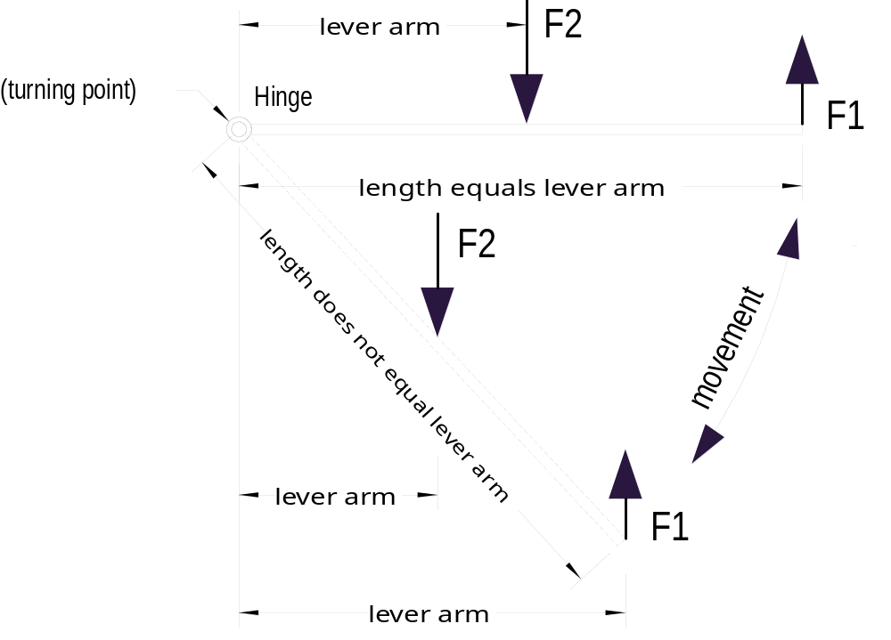the force

Gravity retaining walls

The function of a retaining wall is to resist lateral forces whereby its stability depends largely upon gravity. The transmission of the lateral forces, like wind or earth pressure, of the wall to the soil or footings depends on
- The stress from the weight of the wall, and
- The stress due to the overturning moment as a result of lateral force
We need to look at the combined affect of vertical and horizontal forces on the wall. As a result of that actions the wall may fail in five ways:
1. Overturning
(rotating about the toe of the wall if lateral force moment is greater than stabilising moment of the weight of the wall)
2. Tension in the joint
(bending stress (tension component) in the wall due to the lateral force)
3. Bearing pressure on the ground
(combined effect of the weight of the wall and the active earth pressure on the wall)
4. Sliding along the base
(depends on the interaction of the weight of the wall and the friction between the material of the wall and the soil.)
5. Rotational slip
(occurs when the total moment of the weight of the wall and the soil mass exceeds the moment of the shearing resistance of the soil)

- 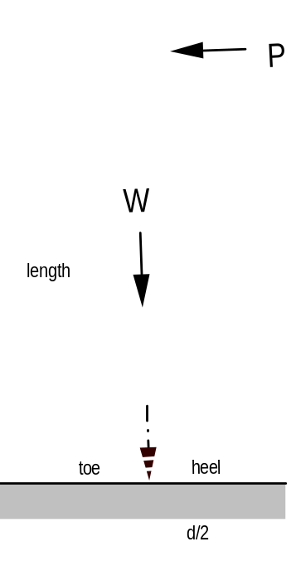OH
Stability of free standing walls

Free standing walls are always subjected to wind pressure. Usually they have quite a sufficient resistance to sliding, but lateral forces may overturn it about the toe (see opposite figure)
The overturning moment due to the lateral force (P x l) must be balanced by the moment due to the weight of the wall (W x d/2)
P x length < W x d/2
In practice a safety factor of 1.5 to 2 is needed to provide adequate stability. That means the overturning effect of the lateral force equals  to ½ of the balancing moment of the wall.

Rule of thumb for gravity retaining walls
The height of a gravity wall should not exceed 1.5 metre, as it becomes uneconomical. The ratio between the height and width at the base is roughly two to one.

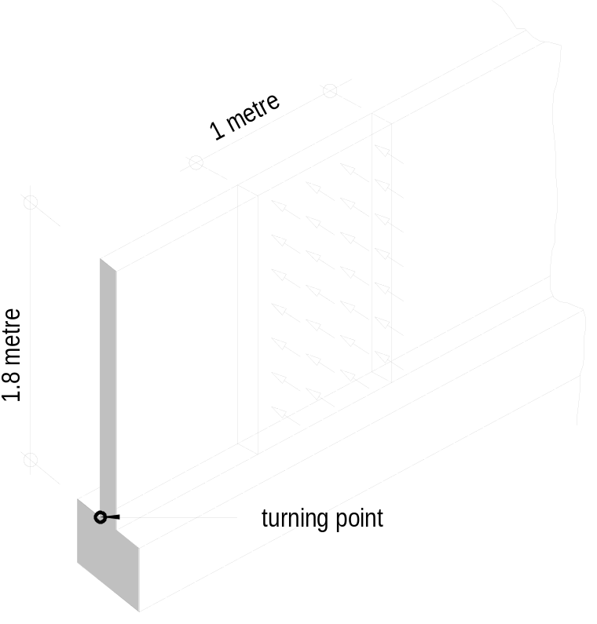Example
A boundary brick wall 1.8 metre high and 110 mm thick is subjected to a wind pressure of 400 N/m².
(weight of brickwork is 20 kN/m³)
Calculate the factor of safety against overturning. Neglect the bond between the brickwork and the footing.

Solution
Weight of wall (1 metre strip)
W = 1.80 × 1.00 × 0.11 × 20
= 3.96 kN
Wind pressure (1 metre strip)
Convert 400 N/m² to 0.4 kN/m²
Wind load = 1.80 × 1.00 × 0.4
= 0.72 kN
The resultant wind pressure can be taken as acting at the centre of the height of the wall (1.8/2 = 0.9 m).
Moment due to the weight = 3.96 × 0.11/2
=0.218 kNm
Moment due to wind = 0.72 × 1.80/2
=0.648 kNm

Factor of safety = 0.218/0.648
against overturning = 0.336

The factor of safety is less than 1.0, therefore the wall will not withstand the wind loading. The weight of the wall must be increased.
Lets increase the thickness to 230 mm and see whether this wall is strong enough to resist the wind load.
Weight of wall = 1.80 ×1.00 × .230 × 20
= 8.28 kN
Moment due to weight = 8.28 × 0.230/2
= 0.952 kNm

Factor of safety
against overturning = 0.952/0.648
= 1.469

Now the wind resisting moment of the wall is 68% greater than the moment due to the wind.

As can be seen the stability of a free standing wall needs to be considered very carefully.

Homework
- 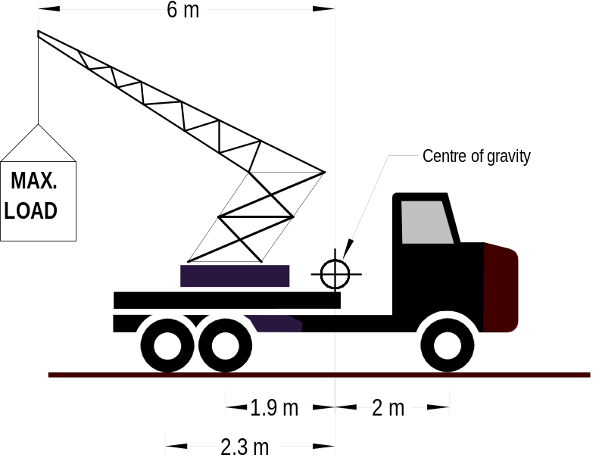Determine the maximum load that a 12.5 tonne lifting truck can carry before the front wheels will be on the point of lifting off the roadway.

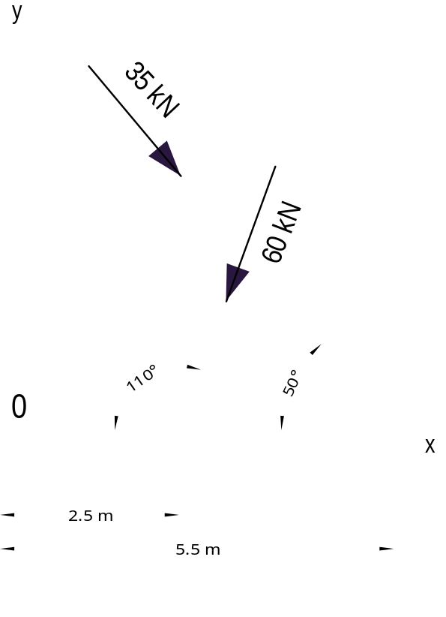2. Determine the total turning moment about point 0 of the two-force system shown below using the sin and cos function.

