Stress – Strain

Stresses and strains will be set up in any material that is subjected to an external load.

Stress: Force per unit area within materials that arises from externally applied forces. It is the internal reaction force in a material created by an external loading.

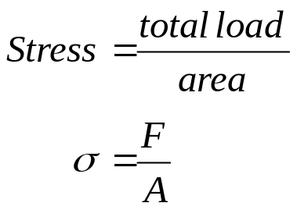

Using symbols

Where σ = stress (σ_{t} = tensile stress)
(σ_{c} = compressive stress)
(σ_{y} = yield stress)
F = total load in newton (N) or kilo-newton (kN)

A = cross-sectional area usually in millimeter squared

The unit of stress is pascal (Pa), and multiples of the pascal i.e. kilopascal (kPa), megapascal (MPa) and the gigapascal (GPa).

Note: 1 Pa = 1 N/m² ⇒ this must be memorised
1 MPa = 1 N/mm² ⇒ is derived from above

Tensile stress
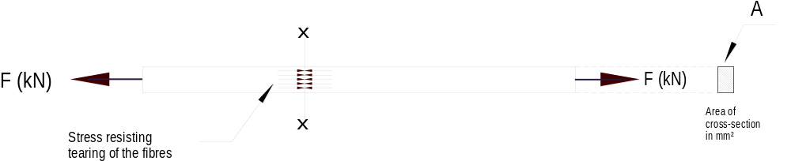The steel bar shown below has a cross section area A (mm²) and is pulled out at each end by forces F. (Note that the total force in the member is F kN not 2F kN. At the plane x-x there exists a state of stress between the fibres on one side of plane x-x and those on the other.

This stress is evenly distributed over the cross-section and set up along the whole length of the bar and not in plane x-x only, just as in a chain resisting forces are set up by every link. Each square millimetre of cross-section provides the same resistance to the pulling apart tendency

Compressive stress
Similar to the tension stress but the forces acting towards each other putting the bar in compression. Here the cross section is resisting the tendency of the fibres to be crushed.

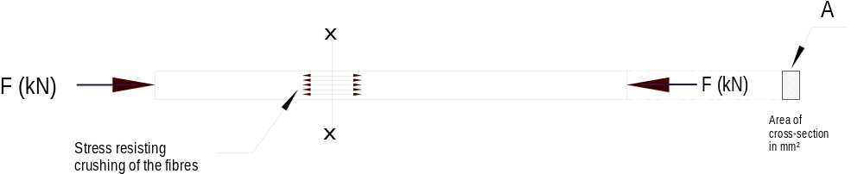

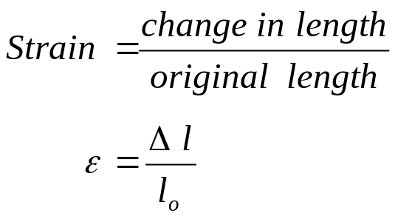Strain: deformation or change in shape of a material caused by an external loading. Strain is the ratio of the change in length (Δl) per unit length or original length (l_{o}).

Hooke’s law

Robert Hooke (1635-1703) found that stress is proportional to strain, provided the elastic limit of the material is not exceeded.

The ratio of stress to strain is a constant and characteristic of the material within the elastic limit. This ratio is known as modulus of elasticity (E) or Young’s modulus. E is a measure of the stiffness of the material. The unit of the modulus of elasticity is the gigapascal (Gpa).

Elasticity
All material bodies will deform. As the stress increased the deformation also increases and if the load on the material is removed at any stage up to the elastic limit it will return to its original shape and dimension (original length).

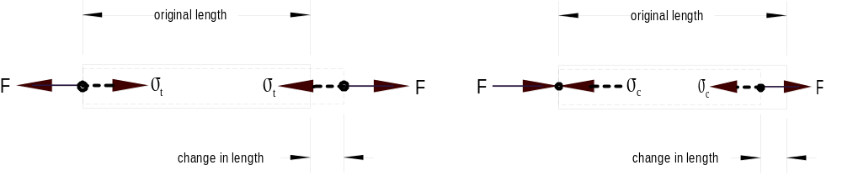
Conventionally tensile stresses are considered positive (+) and compressive stresses negative (-)

Modulus of elasticity
In a tensile test a graph is produced of stress against strain as the load is gradually applied. The first portion of the graph will be a straight line as shown below.

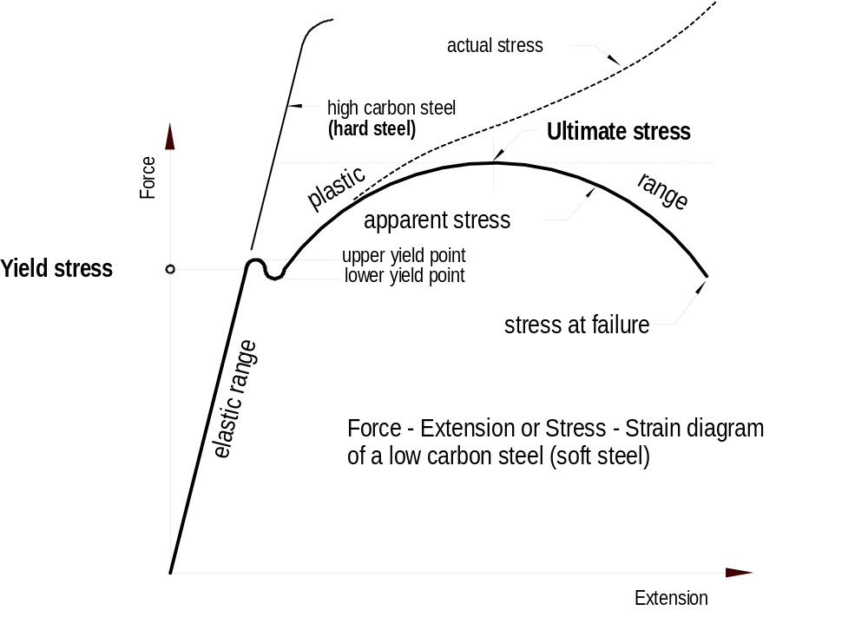

The slope of this straight line is the constant of proportionality known as the MODULUS OF ELASTICITY

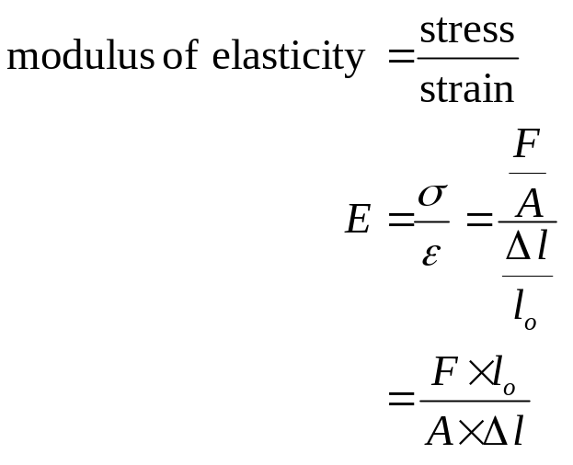Where: F = applied axial force
l_{o} = original lenth
A = area of cross-section
Δl = change in length
E = modulus of elasticity

Calculation example
Determine the increase in length of a steel rod four (4) metre long and 20 mm diameter when subjected to a tensile load of 85 kN. (E = 200 Gpa)

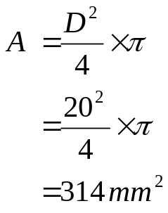
Area of cross-section

A = diameter squared over four times pi
or
A = radius squared times pi

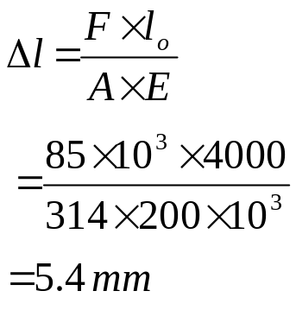Re-arranging the equation from above and making Δl to the subject of the formula:

