Performance of columns

Slenderness ratio, effective length and radius of gyration

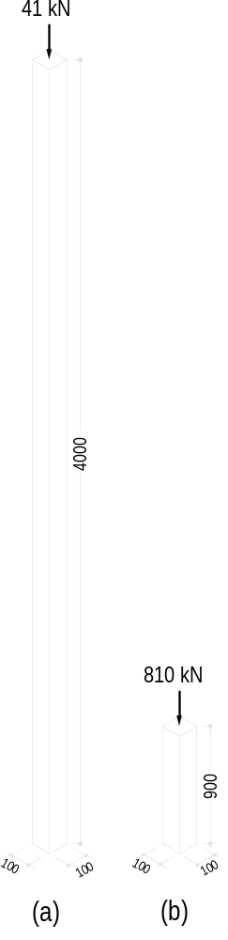Along with load-bearing walls, columns are the most common of all vertical support elements. (Even a load-bearing wall, can be considered as a column extended in one plane.)A column is a vertical structural member basically in compression. If a long slender column is heavily loaded it will deflect readily near the centre of its length. This phenomenon is called buckling, and occurs when the stress is well below those allowed for short columns. Short columns, axially loaded, will not buckle but fail by shearing. A column is also called a strut and can be either short or slender, depending on the mode of failure.

Short column
The length is less than the critical buckling length and it fails by shearing.

Slender columns
The length is greater than the critical buckling length and it fails by buckling.

As shown in Figure 1 the short column can be loaded until the ultimate resistance to crushing strength of the material is reached. The load of slender columns, on the other hand, depends on the slenderness ratio and is usually much less than that of short columns. Generally the higher the slenderness ratio the lower is the allowable stress.

The Euler* buckling load of the slender 100 x 100 mm timber column shown in Figure 1(a) is 41 kN and for the short column Figure 1(b) is 810 kN. The short column will not buckle but fail by shearing. (E_{Timber} = 8 GPa)
*(Euler Swiss mathematician 1707-1783)
Figure 1
The slenderness of a column depends on the height or length, the shape and size of its cross-section and how the ends are supported (pinned or fixed or a combination of both).
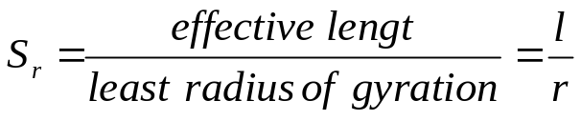
The effective length is the actual length of a column multiplied by a factor related to the end fixing of the column. These factors are shown in Figure 2.
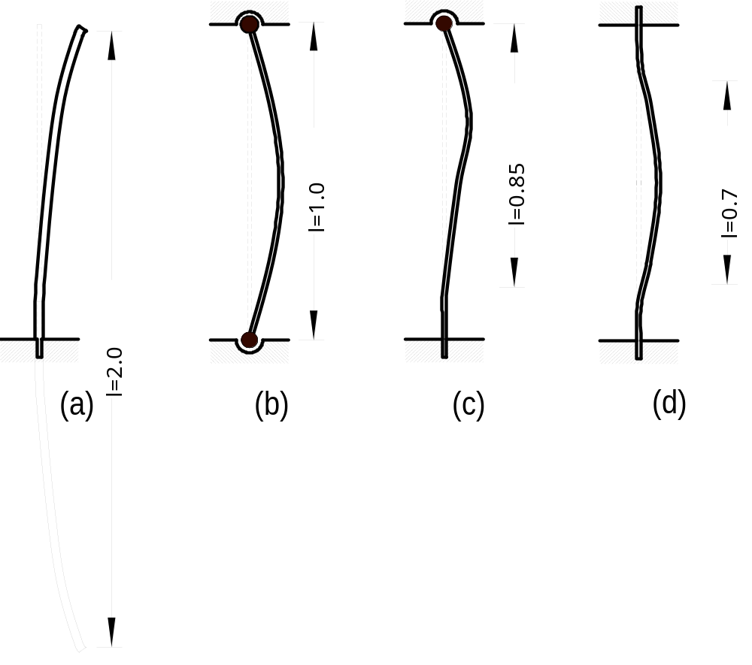

Figure 2

- One end fixed and the other free (Factor 2.0)
- Both end pinned (Factor 1.0)
- One end pinned the other fixed (Factor 0.85)
- Both end fixed (Factor 0.7)

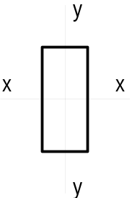The cross-section has also an important influence on the load carrying capacity of a column. A square column support more load than a rectangular section of equal area and equal length, because the rectangular section will buckle about the axis with the least dimension. We know that the moment of inertia for the rectangular section as shown in Figure 3 is smaller about the y-y axis and greater about the x-x axis.

Figure 3
The radius of gyration is calculated by taking the square root from the moment of inertia (usually I_{yy}) of the section divided by its area.
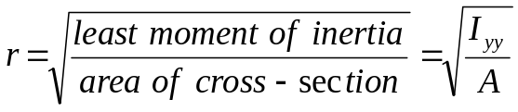

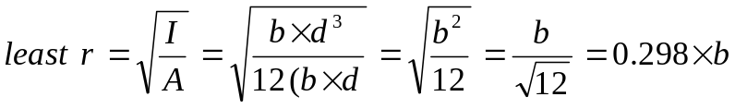For rectangular section the slenderness ratio is taken as the effective length divided by the least width because of the relationship between I and A.

Steel columns are usually not of solid rectangular cross-section and therefore the least radius of gyration must be used instead of the least width.

Material
The load carrying capacity also depends on the material of which the columns are made. Concrete columns are stronger than timber post and steel is superior to concrete. Structural steel has a strength of 300 MPa, the strength of concrete range between 15 MPa and 100 MPa and the strength of timber varies between the species. Structural timber is usually stress graded and the grade according to the timber framing code ranges from F5 (5 MPa) to F34 (34 MPa).

Eccentricity
The load should be directly axial applied to columns to avoid bending. The stress in the column can then be easily calculated by using the well known formula
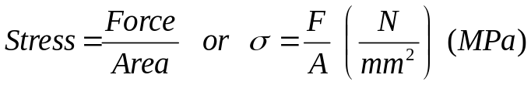
However, often the load is not axial applied but off centre (eccentric) and bending stress is induced as well as a direct compressive stress. The bending stress must then be added to the direct stress to make up the combined stress

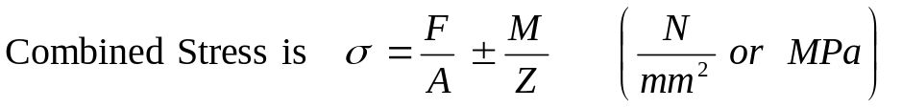
If the load is not axially applied then the moment times the eccentricity (P × e) must be added to the compressive stress as shown in the example below. If the load is not applied on one of the x-x or y-y axis then all four corner of the column may have different magnitude of stress.
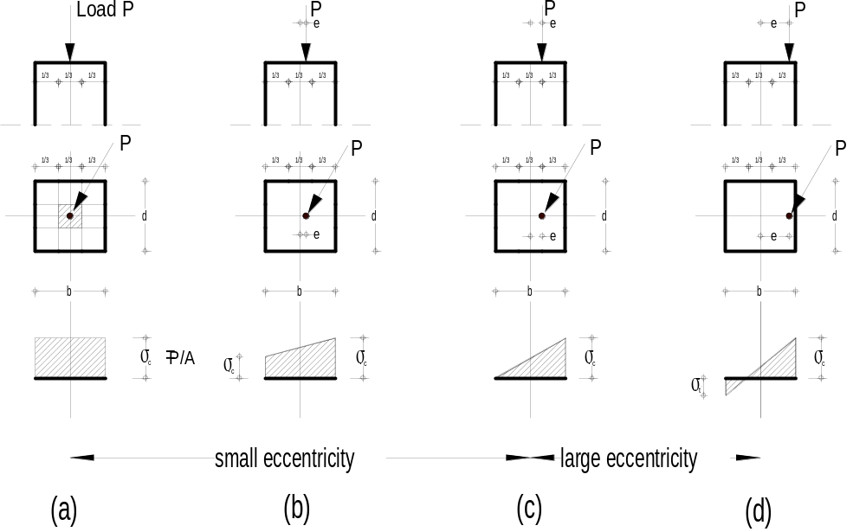

Figure 4

Figure 4 illustrates the stress that a column experiences as a load, P, is applied with increasing eccentricity along one of its axis. Note how the form of the stress prism changes from an even distribution to very uneven distribution. As the load moves away from the centroidal axis one side of the column receives more compression than the other side. As long as the applied load remains within what is known as the core (the middle third) of the section, the column cross-section will only have compressive stress (see Figure 4 (a), (b) and (c). As soon as the applied load moves out of the core tension stress will occur.

It is important to know the magnitude and distribution of the internal stress to select an appropriate column size and material because tensile stress is problematic in concrete and masonry.

