LOADS ON BUILDINGS

LOAD TYPES

The determination of the loads acting on a structure is a complex problem. The nature of the loads varies essentially with the architectural design, the materials, and the location of the structure. Loading conditions on the same structure may change from time to time, or may change rapidly with time.

Loads are usually classified into two broad groups: dead loads and live loads. Dead loads (DL) are essentially constant during the life of the structure and normally consist of the weight of the structural elements. On the other hand, live loads (LL) usually vary greatly. The weight of occupants, snow and vehicles, and the forces induced by wind or earthquakes are examples of live loads. The magnitudes of these loads are not known with great accuracy and the design values must depend on the intended use of the structure.
In structural analysis three kinds of loads are generally used:

(a) Concentrated loads that are single forces acting over a relatively small area, for example vehicle wheel loads, column loads, or the force exerted by a beam on another perpendicular beam.
(b) Line loads that act along a line, for example the weight of a partition resting on a floor, calculated in units of force per unit length.
(c) Distributed (or surface) loads that act over a surface area. Most loads are distributed or are treated as such, for example wind or soil pressure, and the weight of floors and roofing materials.

Dead Loads
The structure first of all carries the dead load, which includes its own weight, the weight of any permanent non-structural partitions, built-in cupboards, floor surfacing materials and other finishes. It can be worked out precisely from the known weights of the materials and the dimensions on the working drawings. Although the dead load can be accurately determined, it is wise to make a conservative estimate to allow for changes in occupancy; for example, the next owner might wish to demolish some of the fixed partitions and erect others elsewhere.

Live Loads
All the movable objects in a building such as people, desks, cupboards and filing cabinets produce an imposed load on the structure. This loading may come and go with the result that its intensity will vary considerably. At one moment a room may be empty, yet at another packed with people. Imagine the `extra' live load at a lively party!

Wind Load
Wind has become a very important load in recent years due to the extensive use of lighter materials and more efficient building techniques. A building built with heavy masonry, timbers and slates will not be affected by the wind load, but the structural design of a modern steel clad industrial building is dominated by the wind load, which will affect its strength, stability and serviceability. The wind acts both on the main structure and on the individual cladding units. The structure has to be braced to resist the horizontal load and anchored to the ground to prevent the whole building from being blown away, if the dead weight of the building is not sufficient to hold it down. The cladding has to be securely fixed to prevent the wind from ripping it away from the structure.

Snow Load
The magnitude of the snow load will depend upon the latitude and altitude of the site. In the lower latitudes no snow would be expected while in the high latitudes snow could last for six months or more. In such locations buildings have to be designed to withstand the appropriate amount of snow. The shape of the roof also plays an important part in the magnitude of the snow load. The steeper the pitch, the smaller the load. The snow falling on a flat roof will continue to build up and the load will continue to increase, but on a pitched roof a point is reached when the snow will slide off.

Earthquake Load
Earthquake loads affect the design of structures in areas of great seismic activity, such as north and south American west coast, New Zealand, Japan, and several Mediterranean countries. Only minor disturbances have been recorded in east Asia and Australia.

Thermal Loads
All building materials expand or contract with temperature change. Long continuous buildings will expand, and it is necessary to consider the expansion stresses. It is usual to divide a reinforced concrete framed building into lengths not exceeding 30 m and to divide a brick wall into lengths not exceeding 10 m. Expansion joints are provided at these points so that the structure is physically separated and can expand without causing structural damage.

Settlement Loads
If one part of a building settles more than another part, then stresses are set up in the structures. If the structure is flexible then the stresses will be small, but if the structure is stiff the stresses will be severe unless the two parts of the building are physically separated.

Dynamic Loads
Dynamic loads, which include impact and aerodynamic loads, are complex. In essence, the magnitude of a load can be greatly increased by its dynamic effect.
CALCULATION OF LOADS

Actual loadings in a building are typically either concentrated or uniformly distributed over an area. The former need no further consideration other than as necessary to characterise them as a force vector. In the latter, however, some modelling is needed when the area considered is actually made up of an assembly of one-way line and surface elements. These elements would pick up different portions of the total load acting over the surface, depending on their arrangement.

Consider the simple structural assembly shown in Figure 3 (a). Eight pre-cast concrete elements are supported by three beams Both external beams have to carry the weight of a half concrete element The middle beam carries the weight of one element (½ of the left and right element as illustrated in Figure 3 (b)). The reactions from all the elements supported by a beam then become loads acting on the beam. Note that these loads form a continuous line load on the beam. Loads of this type are expressed in terms of a load or force per unit length (i.e. N/m) and are commonly encountered in the structural analysis process.

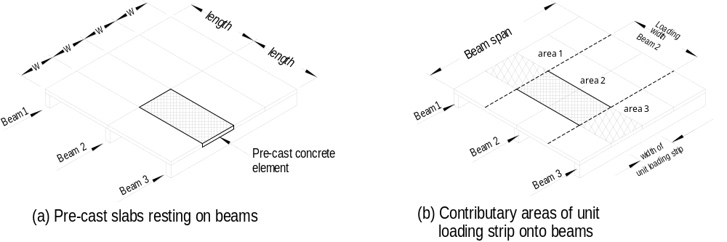

Figure 3 Loading on beams

Another way of looking at this same loading is to think in terms of contributory areas. Each of the beams can be considered as supporting an area of the extent indicated in Figure 4 (a) and (b). The width of each area is often called the load strip. When the member is looked at in elevation, the load acting over the width of the load strip is considered to be transferred to the support beam. If the uniformly distributed load is constant and the load strip is of a constant width, the amount of load carried per unit length by the support beam is simply the load per unit area multiplied by the width of the load strip. This process is illustrated in Figure 4 . The result is again a continuous line load describable in terms of a load per unit length. This process is valid for equal uniformly distributed loads only.

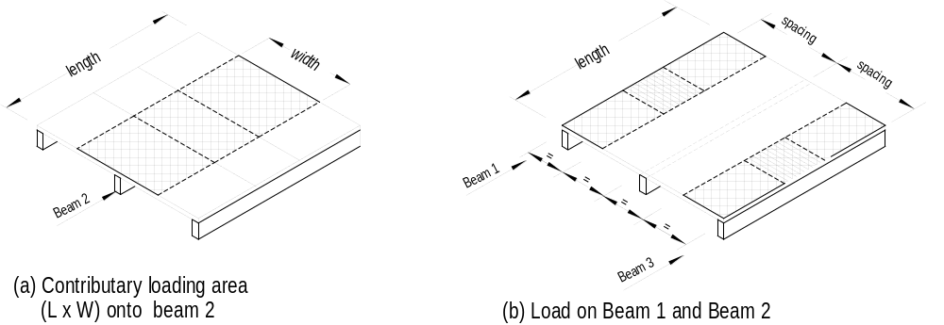

Figure 4 Contributary areas

The loading considered should, of course, include both live- and dead-load components. The exact value of the latter can be found by calculating the volume (contributary area × the thickness of the material and multiply it by the unit weights for that material. Determining these values can be tedious. An alternative is to use a unit weight, e.g. the weight for one square metre, typically expressed as a force per unit area, to represent the weight expressed as N/m²,. Since live loads are also expressed in terms of a force per unit area, the calculation process is facilitated, since both loads can be considered simultaneously. Some sample calculation are shown below.

SAMPLE DESIGN CALCULATIONS

For design purposes it is most appropriate to select a unit area for all loads (dead, live, wind etc.). This often simplifies the calculation because the unit area may be used for members with the same loading but different contributory areas.
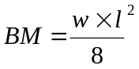 or 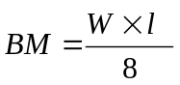
Bending moments must be calculated to design a member, and a factor in the equation for bending moments is the load figure. As can be seen the formula for a simple supported beam with a uniformly distributed load is:

Both small w and capital W are the load figures, the difference is that in the fist instance w refers to a 1 m wide load strip and W to the total load on the beam. To determine the load per unit area is the most appropriate procedure in structural design. The load per running metre can then easily be calculated by the load per unit area times the depth of the load strip, which depends on the distance between the spans of adjacent supporting members perpendicular to the member in question as indicated in Figure 3 (d) above.

It is convenient to determine first all the loadings per unit area which will occur frequently throughout the building. The advantage is that these figures can then be used for all different areas or floor levels with the same loading.

In our example we will determine some of the loads for an office building. First we calculate all unit loads.

FLAT ROOF
Tanking (Bituminous felt (5-ply) and 50 mm gravel1 1.20 kN/m²
50 mm Insulation 0.03 "
180 mm Concrete slab (0.18 x 25 kN/m³) 4.50 "
13 mm Gypsum plaster 0.22 "
DEAD LOAD 5.95 kN/m²
LIVE LOAD (SA 1170.1 & 4.8.1.1) 0.25 kN/m²
TOTAL LOAD 6.20 kN/m²

OFFICES
Carpet 0.05 kN/m²
200 mm Concrete slab 5.00 "
13 mm Gypsum plaster 0.22 "
DEAD LOAD 5.27 kN/m²
LIVE LOAD (AS 1170.1 Appendix B 6.11) 3.00 kN/m2
TOTAL LOAD 8.27 kN/m²

CORRIDORS AND PASSAGEWAYS
Carpet 0.05 kN/m²
40 mm Screed (0.04 x 22 kN/m³) 0.88 "
20 mm Sound insulation 0.05 "
200 mm Concrete slab (0.20 x 25 kN/m³) 5.00 "
13 mm Gypsum plaste 0.22 "
DEAD LOAD 6.20 kN/m²
LIVE LOAD (AS 1170.1 Appendix B 6.4) 4.00 kN/m²
TOTAL LOAD 11.20 kN/m²

STAIRS AND LANDINGS
Stairs
Concrete wedge (2 x 0.17 x 0.25 x 4 x 23.5 kN/m2) 2.08 kN/m²
160 mm Concrete slab (0.16 x 25 kN/m2) 4.00 "
DEAD LOAD 6.08 kN/m²
LIVE LOAD (AS 1170.1 Appendix B 6.4) 4.00 kN/m²
TOTAL LOAD 12.00 kN/m²

Landings
160 mm Concrete slab (0.16 x 25 kN/m2) 4.00 kN/m²
DEAD LOAD 4.00 kN/m²
LIVE LOAD (AS 1170.1 Appendix B 6.4) 4.00 kN/m²
TOTAL LOAD 8.00 kN/m²

Having compiled the required unit loding figures the load per running metre for a particular member can be calculated quite quickly by multiplying the unit load with the appropriate depth of the loading strip, or in case the total dead load on a member is needed by multiplying the unit load with the contributary area.

AUSTRALIAN STANDARD LOADING CODE (AS 1170 PART 1)

In the previous Unit the external loads on structures were classified in several different ways. The minimum design load on structures must be in accordance with the SAA Loading Code SA 1170 Parts 1 to 3. According to Part 1 `Dead and Live Loads and Load Combination', the structure must be designed for the worst load combination for strength, stability and serviceability for limit states design.

It is beyond the scope of this subject to consider all load combinations (strength limit stages, stability limit stages and serviceability stages) of the standard. We will only consider the following load combination for strength limit stage:

1. 1.25G + 1.5Q
2. 1.25G + W_{u} + R_{c}Q

Where G,Q,W_{u} are parts of dead, live, and wind loads, and have the following meaning:

G = dead load
Q = live load (including impact, if any)
W_{u} = wind load for strength limit stage
Ψ_{c} = life load combination factor (used in assessing the design load for strength limit stage)

There are some other live loads which are considered in this subject.

1. Handrails, balustrades and railings of private dwellings must resist a single force of 0.6 kN acting inward, outward or downward at any point on the handrail, a continuous load of 0.4 kN/m, and the wind load acting on or transmitted to the handrail.

All other handrails including parapets and railings to all roofs shall resist a static load of 0.75 kN/m acting inward, outward or downward or the appropriate wind load, whichever produces the most adverse effects.

2. For all non-trafficable roofs, either flat or pitched, each member providing support to the cladding thereof (including decking, purlins, beams and trusses) shall be designed to withstand the live load resultant from stacked materials or equipment used in repair or maintenance operations which shall be taken as 0.25 kPa on the plan projection, except that where the area supported by any structural member is less than 14.0 m2, the intensity of live loads on that member shall be determined as follows:
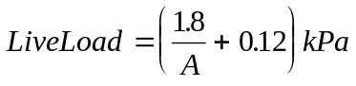0
where
A = the plan projection of the surface area of roof supported by the member under analysis, in square metres.

3. For flat or near-flat roofs and balconies which are intended to be available for pedestrian traffic or resort, the construction (including decking, purlins, beams and trusses) shall be designed to support the following uniformly distributed live load or a concentrated load of 1.8 kN, whichever load gives the more adverse effect -

(a) for houses: 3 kPa (for 10.0 m2 or less) varying linearly to 1.5 kPa (for 40.0 m² or greater);

(b) for all other buildings: 4 kPa (for 10.0 m2 or less) varying linearly to 3 kPa (for 40.0 m² or greater);

Cantilevered sections of trafficable roofs shall be designed for the live load corresponding to the area of 10.0 m² or less.

Paragraph 3. represents clause 4.8.2 of the AS1170.1. You will find that reference to this clause is made in Appendix B (Floor Live Loads).

Students who want more depth of information may refer to Part 1 and Part 2 of the Loading Code.

