CALCULATION OF LOADS

Actual loadings in a building are typically either concentrated or uniformly distributed over an area. The former need no further consideration other than as necessary to characterise them as a force vector. In the latter, however, some modelling is needed when the area considered is actually made up of an assembly of one-way line and surface elements. These elements would pick up different portions of the total load acting over the surface, depending on their arrangement.

Consider the simple structural assembly shown in Figure 3 (a). Eight pre-cast concrete elements are supported by three beams Both external beams have to carry the weight of a half concrete element The middle beam carries the weight of one element (½ of the left and right element as illustrated in Figure 3 (b)). The reactions from all the elements supported by a beam then become loads acting on the beam. Note that these loads form a continuous line load on the beam. Loads of this type are expressed in terms of a load or force per unit length (i.e. N/m) and are commonly encountered in the structural analysis process.

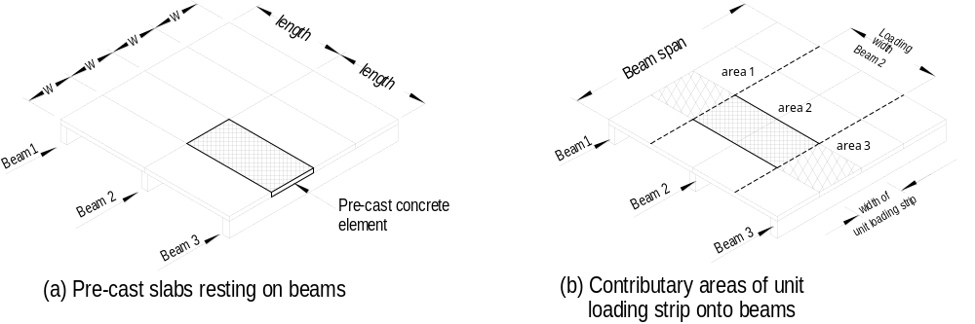

Figure 3 Loading on beams

Another way of looking at this same loading is to think in terms of contributory areas. Each of the beams can be considered as supporting an area of the extent indicated in Figure 4 (a) and (b). The width of each area is often called the load strip. When the member is looked at in elevation, the load acting over the width of the load strip is considered to be transferred to the support beam. If the uniformly distributed load is constant and the load strip is of a constant width, the amount of load carried per unit length by the support beam is simply the load per unit area multiplied by the width of the load strip. This process is illustrated in Figure 4 . The result is again a continuous line load describable in terms of a load per unit length. This process is valid for equal uniformly distributed loads only.

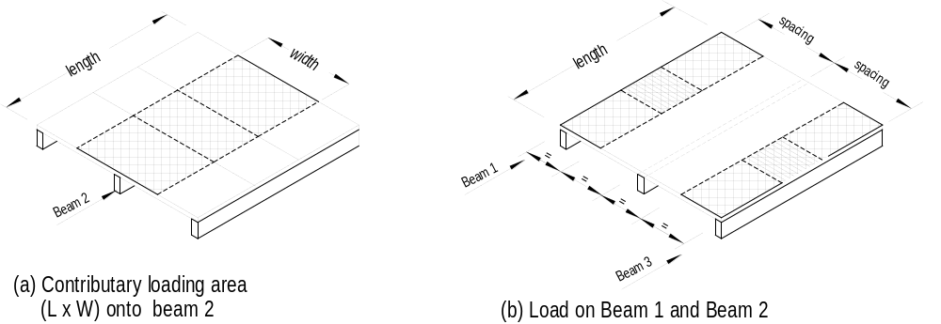

Figure 4 Contributary areas

The loading considered should, of course, include both live- and dead-load components. The exact value of the latter can be found by calculating the volume (contributary area × the thickness of the material and multiply it by the unit weights for that material. Determining these values can be tedious. An alternative is to use a unit weight, e.g. the weight for one square metre, typically expressed as a force per unit area, to represent the weight expressed as N/m²,. Since live loads are also expressed in terms of a force per unit area, the calculation process is facilitated, since both loads can be considered simultaneously. Some sample calculation are shown below.

SAMPLE DESIGN CALCULATIONS

For design purposes it is most appropriate to select a unit area for all loads (dead, live, wind etc.). This often simplifies the calculation because the unit area may be used for members with the same loading but different contributory areas.
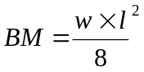 or 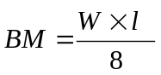
Bending moments must be calculated to design a member, and a factor in the equation for bending moments is the load figure. As can be seen the formula for a simple supported beam with a uniformly distributed load is:

Both small w and capital W are the load figures, the difference is that in the fist instance w refers to a 1 m wide load strip and W to the total load on the beam. To determine the load per unit area is the most appropriate procedure in structural design. The load per running metre can then easily be calculated by the load per unit area times the depth of the load strip, which depends on the distance between the spans of adjacent supporting members perpendicular to the member in question as indicated in Figure 3 (d) above.

It is convenient to determine first all the loadings per unit area which will occur frequently throughout the building. The advantage is that these figures can then be used for all different areas or floor levels with the same loading.

In our example we will determine some of the loads for an office building. First we calculate all unit loads.

FLAT ROOF
Tanking (Bituminous felt (5-ply) and 50 mm gravel1 1.20 kN/m²
50 mm Insulation 0.03 "
180 mm Concrete slab (0.18 x 25 kN/m³) 4.50 "
13 mm Gypsum plaster 0.22 "
DEAD LOAD 5.95 kN/m²
LIVE LOAD (SA 1170.1 & 4.8.1.1) 0.25 kN/m²
TOTAL LOAD 6.20 kN/m²

OFFICES
Carpet 0.05 kN/m²
200 mm Concrete slab 5.00 "
13 mm Gypsum plaster 0.22 "
DEAD LOAD 5.27 kN/m²
LIVE LOAD (AS 1170.1 Appendix B 6.11) 3.00 kN/m2
TOTAL LOAD 8.27 kN/m²

CORRIDORS AND PASSAGEWAYS
Carpet 0.05 kN/m²
40 mm Screed (0.04 x 22 kN/m³) 0.88 "
20 mm Sound insulation 0.05 "
200 mm Concrete slab (0.20 x 25 kN/m³) 5.00 "
13 mm Gypsum plaste 0.22 "
DEAD LOAD 6.20 kN/m²
LIVE LOAD (AS 1170.1 Appendix B 6.4) 4.00 kN/m²
TOTAL LOAD 11.20 kN/m²

STAIRS AND LANDINGS
Stairs
Concrete wedge (2 x 0.17 x 0.25 x 4 x 23.5 kN/m2) 2.08 kN/m²
160 mm Concrete slab (0.16 x 25 kN/m2) 4.00 "
DEAD LOAD 6.08 kN/m²
LIVE LOAD (AS 1170.1 Appendix B 6.4) 4.00 kN/m²
TOTAL LOAD 12.00 kN/m²

Landings
160 mm Concrete slab (0.16 x 25 kN/m2) 4.00 kN/m²
DEAD LOAD 4.00 kN/m²
LIVE LOAD (AS 1170.1 Appendix B 6.4) 4.00 kN/m²
TOTAL LOAD 8.00 kN/m²

Having compiled the required unit loding figures the load per running metre for a particular member can be calculated quite quickly by multiplying the unit load with the appropriate depth of the loading strip. The total dead load on a member is calculated by multiplying the unit load with the contributary area.

AUSTRALIAN STANDARD LOADING CODE (AS 1170 PART 1)

The minimum design load on structures must be in accordance with the SAA Loading Code SA 1170 Parts 1 to 3. According to Part 1 `Dead and Live Loads and Load Combination', the structure must be designed for the worst load combination for strength, stability and serviceability for limit states design.

