Structures 1 (Module ABC096)

TEST No 3

Note: these test questions may be used again and you should not scribble on it.
Make sure you return it with your answer-paper.

Question 1
Explain the difference between simple stress ( 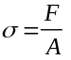) and bending stress ( 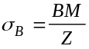)? (You should describe it in simple terms in a short paragraph. Use sketches to illustrate your answer.)
(15 marks)

Question 2
Calculate all loads (live load & dead load) for the two storey building components shown in the Figure below. Using the information opposite the figure calculate the load for a one metre strip of brickwork including roof load and suspended concrete slab. (Remember only a one metre strip of brickwork need to be analysed.)
The contributory load from the roof (including wall plate) is 800 kg per linear metre.
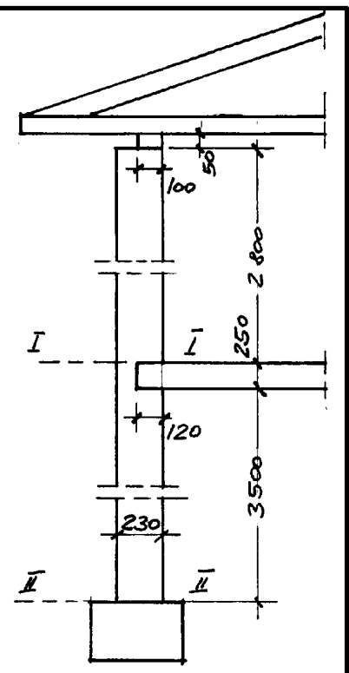
The live load for non-trafficable roofs accordind to AS 1170.1 is 0.38 kPa and the contributary area is 7 m².

The brickwork consist of solid standard clay bricks 230 mm thick. The weight taken from the AS 1170 Part 1, Table A2 is 0.19 kN/m² per 10 mm of thickness.

The concrete floor slab spans 6 metre, and is supported by two walls. The thickness of the slab is 250 mm. The density of the reinforced concrete is 2500 kg/m³. Neglect the portion of the brickwork in the region of the concrete slab

According to AS 1170.1 Appendix B a floor live load of 1.5 kPa must be included.
The calculation must be so set out that they can be easily read and readily checked. All working should be logically arranged and in a sequetial order. Start with the roof load and work down to the foundation. Show all working on the left-hand side and all loading figures on the right-hand side in kN.
(30 marks)

Question 3

Calculate simple compressive stress in the joint I-I; and II-II of the brick wall using the above figures and the formula . The location of the joints are shown in the figure above.
(10 marks)

Question 4

Determine the width of the footing if the bearing capacity of the soil is 130 kPa. Assume 3.5 kN for the weight of the strip footing and add this to your load.
(15 marks)

Question 5

Comptession members should be loaded centrally, and if they are not loaded centrally the column will be subjected to bending as well (Refer to question 1).
(a) Study the support reactions of the roof load and the slab load onto the brickwall and and make suggestion how to spread the load equally over the cross-sectional area. Use Sketches to illustrate your answer.
(15 marks)

(b) The formula can not be used to calculate the stress in the brickwork for the question above. Explain why and state what formulas are needed to calculate the actual stress in the joint I-I and II-II.
(15 marks)

End of Test

