THE THREE STATIC EQUATIONS

The load applied to a structure is transmitted to supports. The supports in turn will supply the necessary reactive forces to maintain equilibrium.
Figure 2.4 (a), (b) and (c) shows the different types of supports.
The fixed-end or built-in support shown in (a) is capable of supplying three reactive forces: (1) horizontal,
(2) vertical, and
(3) a fixing moment.
The pinned supports shown in (b) can supply two reactive forces,
(1) horizontal,
(2) vertical, and
the roller bearing shown in (c) can only supply a vertical reaction.

A structure is a body in static equilibrium without any dynamic effects. The term statically determinate structure means that structural analysis can be carried out by statics alone. If this is not so, the structure is statically indeterminate. (Statically indeterminate structures are beyond the scope of this subject.)
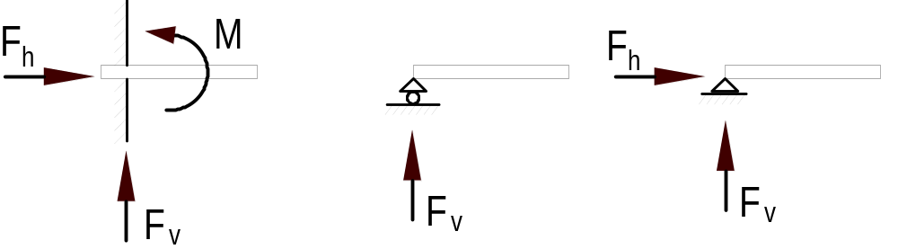 a) c) b)
Figure 1 Types of support

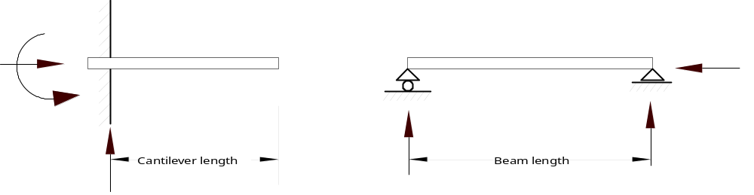In simply supported beams the reactive forces cannot be more than three. If there are more than three support reactions then the structure is statically indeterminate. In other words, a beam must be either built-in at one end with no support whatsoever at the other (e.g. a cantilever), or the supports must consist of a pin at one end and a roller bearing at the other. These two cases are shown in Figure 2 (a) and (b).

(a) cantilever (b) simple supported
Figure 2 Statically determinate structures

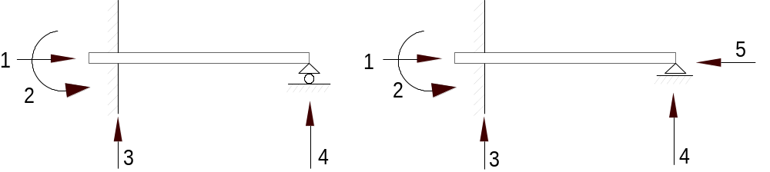The beam shown in Figure 3 (a) which is built-in at one end and simply supported at the other, is a statically indeterminate structure to the first degree since there are four reactive forces and these cannot be obtained from the three equations of static equilibrium. The beam shown in Figure 3 (b) which is build in at one end and pinned at the other is statically indeterminate to the second degree since there are five reactive forces and we have only three equations for static equilibrium at hand.

(a) left build-in - right roller support (b) left build-in – right constraint
Figure 3 Statically indeterminate structures

A structure having all its members and loads in one plane is termed a plane structure and only plane structures will be used throughout this subject.

We should remember that all analyses are based on some assumptions not quite in accordance with the facts. It is impossible for an actual structure to correspond fully to the idealised structure on which the analysis is based.

In structures we are working with simply supported beams only and these structures can be completely analyse by the following three equations:
ΣF_{x} = 0
ΣF_{y} = 0
ΣM_{z} = 0
Structures that can be completely analysed by the use of these equations are known as statically determinate or simply determinate.

The Common Prefixes and Units

Prefix & Symbol Meaning Value Factor
micro (μ) one millionth 0.000 001 10⁻⁶
milli (m) one thousandth 0.001 10⁻³
centi (c)* one hundredth 0.01 10⁻²
deci (d)* one tenth 0.1 10⁻¹
kilo (k) a thousand 1000 10³
mega (M) a million 1,000,000 10⁶
giga (G) a thousand million 1,000,000,000 10⁹

* The prefixes `centi' and `deci' are only used with the metre. Centimetre is a recognised unit of length but centigram is not a recognised unit of mass.

Tables of measures for mass, length, area and volume are set out below
MASS SI Base unit: kilogram (kg)  1000 micrograms (μg) = 1 milligram (mg)  1000 milligrams (mg) = 1 gram (g)  1000 grams (g) = 1 kilogram (kg)  1000 kilograms (kg) = 1 megagram (Mg)  = 1 tonne (t) | LENGTH SI Base unit: metre (m)  1000 micrometres (μm) = 1 millimetre (mm)  10 millimetres (mm) = 1 centimetre (cm)  10 centimetres (cm) = 1 decimetre (dm)  100 centimetres (cm) = 1 metre (m)  1000 millimetres (mm) = 1 metre (m)  1000 metres (m) = 1 kilometre (km)
AREA SI unit: square metre (m²)
100 square millimetres (mm²) = 1 square centimetre (cm²)
10 000 square centimetres (cm²) = 1 square metre (m²)
10 000 square metres (m²) = 1 hectare (ha)
100 hectares (ha) = 1 square kilometre (km²)

VOLUME SI unit: cubic metre (m³)
1000 cubic centimetres (cm³) = 1 cubic decimetre (dm³)
= 1 litre (L)
1000 cubic decimetres (dm³) = 1 cubic metre (m³)
= 1 kilolitre (kL)

Or alternatively, for use with liquids and gases:
1 cubic centimetre (cm³) = 1 millilitre (mL)
1000 millilitres (mL) = 1 litre (L)
1000 litres (L) = 1 kilolitre (kL)
= 1 cubic metre (m³)
1000 kilolitres (kL) = 1 megalitre (ML)

DIMENSIONAL ANALYSIS
Dimensional analysis is a mathematical method that is of considerable value in problems which occur in architectural structures.

If an equation is to represent something that is physically real the terms on both sides must be of the same sort (for example, all forces) as well as the two sides being numerically equal, otherwise the equation is meaningless. Every term must have the same dimensions so that like is compared with like.

This is shown in the following example with the deflection formula for a simple supported beam with a uniformly distributed load. The deflection (δ) must be m (or mm). Inserting all units on the other side of the equation and after cancelling the same unit m must be the only unit left on this side. If this is not the case than something must be wrong, and one should check all figures in the equation.
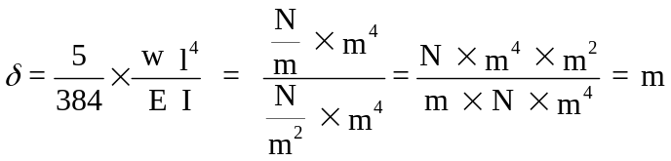
As said before both terms must have the same dimensions; then the equation is dimensionally correct and could represent a real event. As can be seen from the above equation, the unit for deflection results in m and is therefore correct.

This principle of homogeneity of dimensions can be used to check whether an equation has been correctly formed.

A check on dimensions will not show whether any pure numbers in the equation are correct.

Geometrical Coordinate
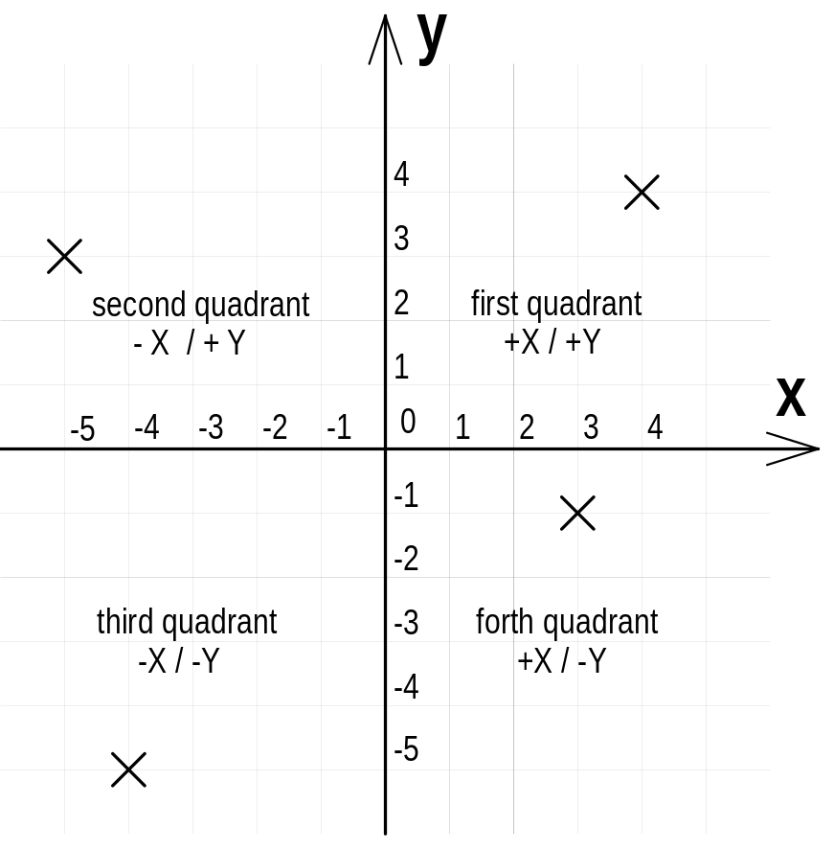Coordinates refer to a set of numbers to place a fixed point in space. For example, a point in the Cartesian plane is uniquely determined by its X-axis coordinate and its Y-axis coordinate. The Cartesian plane is used to resolve a force system or to manipulate forces.

Zero (0) is at the origin of the Cartesian plane and the coordinates are shown along the x-axis and y-axis. The point in the first quadrant has the coordinates
X = +4, Y = +4
in the second quadrant has the coordinates
X = -5, Y = +3
in the third quadrant has the coordinates
X = -4, Y = -5
and in the fourth quadrant has the coordinates
X = +3, Y = -1

The Cartesian plane is used for the graphical “resolution” of forces. As all forces are vectors their magnitude and direction is easily recognised if they are drawn to scale in the Cartesian plane as shown above.

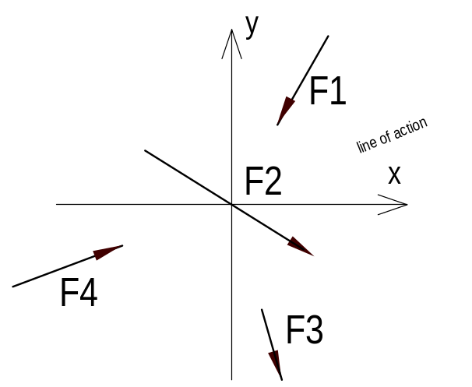

Concurrent coplanar force system

A concurrent coplanar force system is a system of two or more forces whose lines of action all intersect at a common point. However, all of the individual vectors might not actually be in contact with the common point.

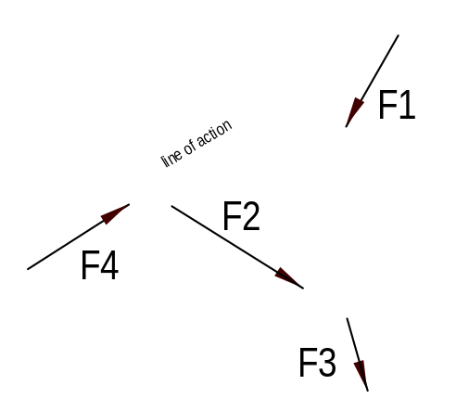

Non-concurrent coplanar force system

Non-concurrent coplanar force system consists of a number of vectors that do not meet at a single point. These systems are basically a jumble of forces and take considerable care to resolve.

Parallel coplanar force system
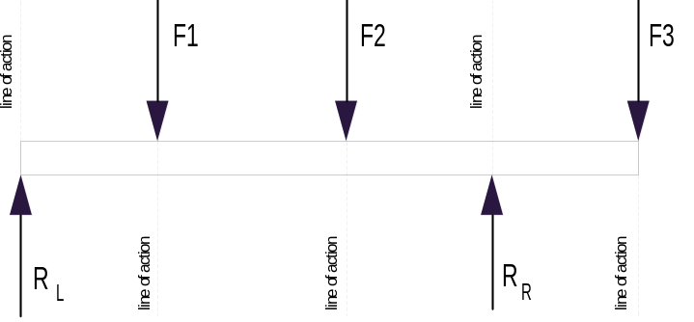
A parallel coplanar force system consists of two or more forces whose lines of action are all parallel. This is commonly the situation when simple beams are analysed under gravity loads. The resolution of the forces can be done graphically but the preferred method is the analytical method.

Forces associated with levers

The force associated with a lever is a moment of a force (the turning effect of a force. The moment of a force, with respect to a given point, in the same plane, is the product of the force and the perpendicular distance from the point (hinge) to the line of action of the force.
Moment = Force x lever arm
or = Force x distance
M = F x d
Where M = moment of the force about the hinge.
F = force (must be in newtons)

d = perpendicular distance from the hinge to the line of action of
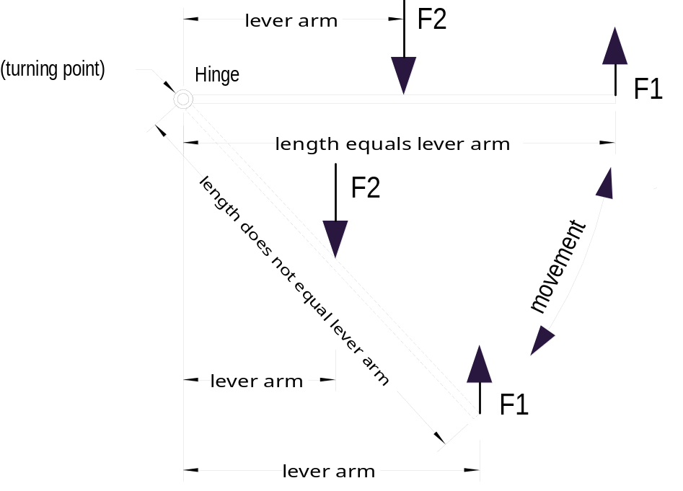 the force

