MODULE ABC 086 - STRUCTURES 1

TEST NO. 1

STUDENT’S NAME _________________________ DATE ___/___/____

INSTRUCTIONS TO STUDENTS

1. Answer ALL questions.

2. PART A - Question 1 to 10 are Multiple-Choice type.
Answers MUST be shown with an (X) on the answer sheet provided.
Each correct answer carries One (2) mark.
If you believe more than one answer is correct then choose the best answer.
Total available marks for this section is 20.

3. PART B - Questions 11 to 17 involve short answers and calculations. Answers MUST be shown with any required calculations in the space provided. Your
calculations must show in detail all required steps and should be logically laid out include the correct unit to receive any marks.
Total available marks for this section is 80

NOTE: -

1. ALL TEST PAPERS MUST BE RETURNED WITH ALL ANSWER SHEETS.

2. MAXIMUM POSSIBLE MARKS ARE: PART 1 20%
PART 2 80%
TOTAL 100%

3. THE RESULT OF THIS TEST WILL BE SCALED TO FORM 50% OF THE FINAL ASSESSMENT.

STRUCTURES 1 / TEST 2

PART A - MULTIPLE CHOICE QUESTIONS

ANSWER ALL QUESTIONS

PART A

For Questions 1 to 10 select the most appropriate response which BEST answers the question or statement. (Two Marks for each correct answer)

Mark ALL answers on this paper

1. For a force system to be STATIC it must
a) be acted on by gravity
b) be in a state of equilibrium
c) have the reactive force greater than the active force
d) have no reactive force

2. Stress is
a) only related to member subjected to tension
b) the internal effect of an external force on a member
c) the same as strain
d) All the above

3. Strain is
a) the same as stress but measured in different units
b) equal in magnitude to stress but opposite in direction
c) related to the change in shape of a member under a load
d) All the above

4. Structural materials all have
a) stress equal to strain
b) strain proportional to stress
c) E = Stress x Strain
d) the same E value

5. Which material should not be used in a situation where tension is likely to occur
a) Steel
b) Reinforced Concrete
c) Timber
d) All are suitable

6. Which material should not be used if not protected from fire
a) Steel
b) Concrete
c) Timber
d) All are suitable

7. Which material can be subjected to the greatest compressive force
a) Steel
b) Reinforced Concrete
c) Timber
d) All are suitable

8. Which material is most suited to use under water
a) Steel
b) Reinforced Concrete
c) Timber
d) All are suitable

Questions 9 and 10 13 refer to the following diagram
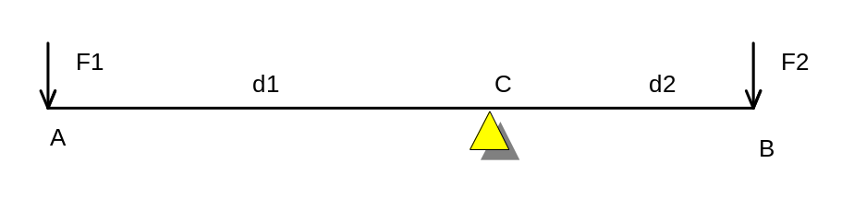
9. If F1 = 8 kN , d1 = 2.1m and d2 = 900 mm then F2 = ?
a) 3.43 kN
b) 15.12 kN
c) 18.7 kN
d) 3429N

10. To be in equilibrium the force system must have
a) F1 + F2 = 0
b) F1 x F2 = d1 x d2
c) F1 + F2 = d1 + d2
d) F1 x d1 = F2 x d2

END OF PART A

MULTIPLE CHOICE QUESTIONS
PART B - Short answers, calculations and sketches.

Answer the following questions in the space provided.

11. Stress = _________________ Unit of Stress is ________

12. Strain = _________________ Unit of Strain is ________
(8 marks)

13. The 3 conditions required for a force system to be in equilibrium are
(or the three static equations)

a)________________________, b)____________________ ,

c)
(6 marks)

14. Refer to the following graph and then place the appropriate letter A) B) C) D) etc. against the each statement below
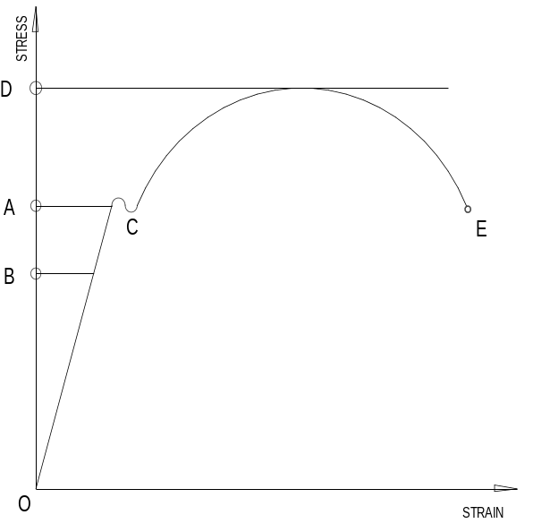
a) The yield point is represented by point

b) The ultimate stress is represented by point

c) The plastic range is represented by
(to indicate the range two letters must be shown)

d) The elastic range is represented by
(to indicate the range two letters must be shown)

e) The permissible stress is represented by point

f) The elastic limit is represented by point

(12 marks)

15. The design of a retaining wall is usually the concern of the engineer. However, students need to know how a retaining wall can fail.

As the result of the combined action (vertical and horizontal force) a tetaining wall can fail in three ways.

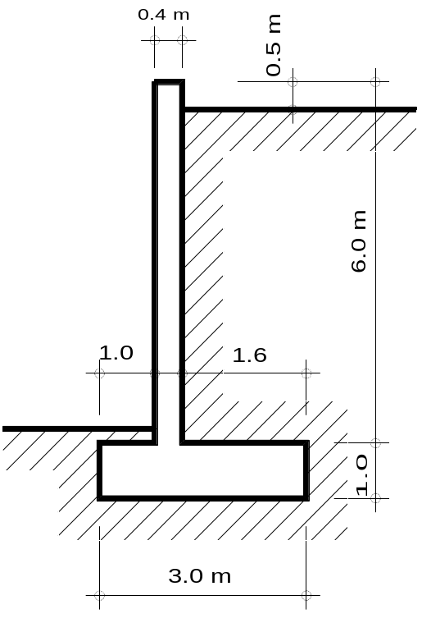
(a) List the three ways in which the wall may fail and write a short paragraph on each of the above possible failures

(12 marks)

16. Use Moments to determine the support reactions in for a simply supported 5m long timber beam (size 200x50 mm) with a 4 kN load located 1.5 meters from the left support point. Include self weight of the beam. (weight of timber = 10 kN/m²)

(Don’t forget the load calculation weight of beam)

4 kN
w = weight of timber beam

1.5 m 3.5 m

5.0 m

(14 Marks)

15. Calculate the Design Load on an underpurlin spanning 3.6 m. The rafter (spacing 0.6 m) are supported as shown below. The rafters are supporting a concrete tiled roof with tile battens weighing 60 kg/m².
Assume:- Maximum uplift due to wind load is 1.2 kPa.
Timber = 10 kN/m³.

Rafter 100/50

Underpurlin 100/75

2.8 m 2.4 m

(28 marks)
END OF PART B
END OF TEST NO. 1

