STRUCTURES 1 Module ABC 086

TEST No 4

Time allowed two hours, answer all questions

Question 1
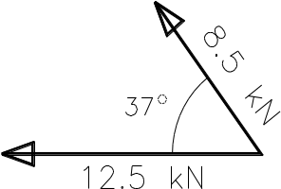

Find the resultant of the two forces shown in Fig. 1 using either the graphical or analytical method.
(8 marks)
Fig. 1

Question 2

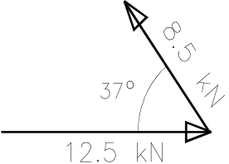
For the two forces shown Figure 2 find the force that will create equilibrium. (Magnitude and angle to the horizontal must be found.
(8 marks)
Fig 2

Question 3

A loaded wheelbarrow is required to roll over an obstruction as shown. Would it be easier to push or pull the wheelbarrow over the obstruction? Give reasons for your answer.

Fig. 3
(8 marks)

Question 4

Figure 5 below shows part of a carport structure, consisting of reinforced concrete slab with concrete beams and columns. All necessary dimensions are shown to calculate the dead load. The waterproofing of the slab is done with mastic asphalt weighing 10 kg/m². The live load which need to be included is according to AS 1170.1 is 3 kPa
(Mass of reinforced concrete = 2500 kg/m³)
As can be seen the slab spans continuous over four supports, from external wall to external wall and two middle supports consisting of concrete beams. The beams are supported by concrete columns.
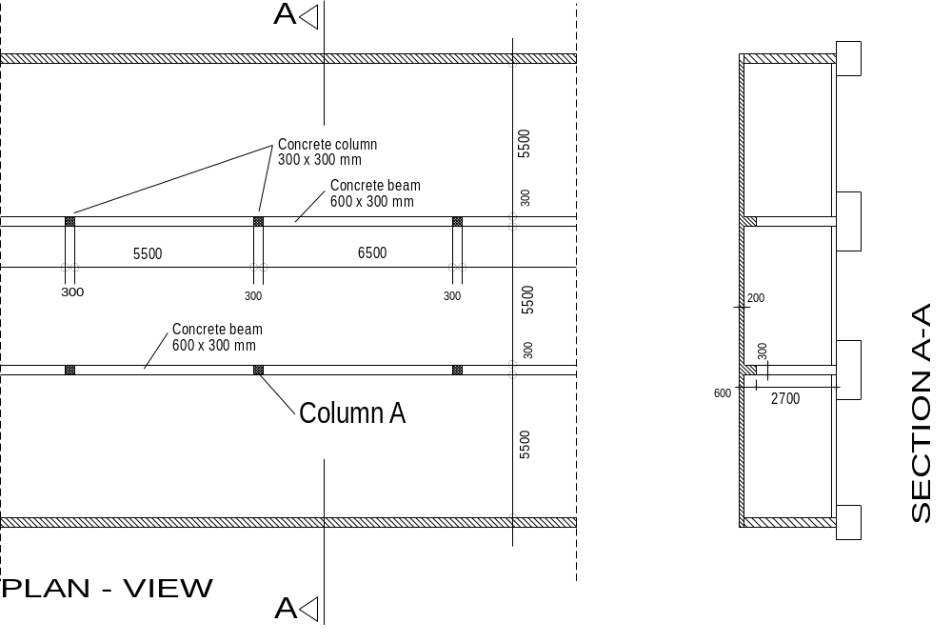
Fig. 4

(a) calculate the dead and live load which Column A will impose on the pad footing
(30 marks)

(b) What will be the length of a square footing if the bearing capacity of the soil is 200 kPa. The estimated weight of the footing is 17 kN.
(10 marks)

Question 5

Clearly indicate the position of the necessary structural reinforcement in the figures below. The main reinforcement and the secondary (distribution bars) must be shown. Use a ruler for this purposes and state how much concrete coverage (distance from formwork to bar reinforcement) is needed. You will receive full marks only if the reinforcement is neatly drawn in.
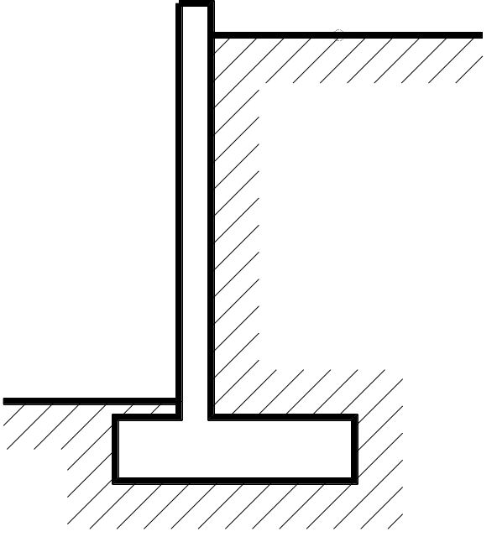
Figure 5 - Retaining Wall
(12 marks)

DETAIL A

(12 marks)
Figure 6 - Concrete Slab

Show beam reinforcement and
portion of slab reinforcement

DETAIL A
(12 marks)

END OF TEST

