Labeling the Spaces of the Truss
Once the reactions of the truss are determined, the first step in performing a graphic analysis is the labeling of the spaces of the truss; the exterior areas between loads and reactions and the interior areas of the truss panels. This is usually done by starting on the left side and proceeding clockwise around the outside of the truss. Next letters are placed in the panels from left to right
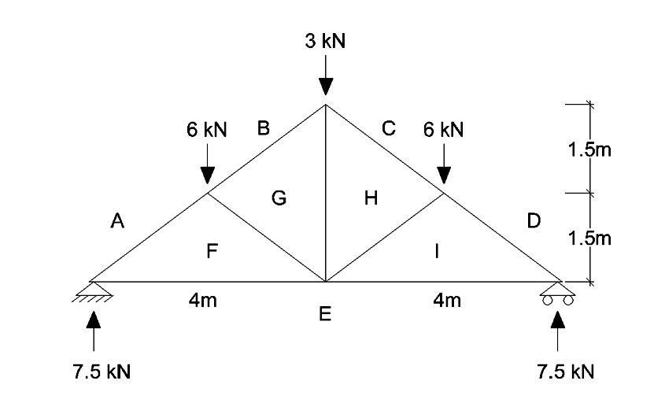

Creating the Load Lines
Now we begin to create the load line. This is a closed force polygon of the external forces acting on the truss. If only vertical forces exist (as in the present example), the force polygon is a straight vertical line. Pick a convenient point to begin and label this point A. It refers to the area of the truss above labeled A. On the Maxwell diagram, however, it represents the tail or starting point of the force vector AB , that is, the external load between area A and area B. In this case AB is a force of 6 kN acting down.
A scale of 1 kN = 1 cm will be used to construct the vector diagram. Any scale can be used. The larger the scale, the greater the accuracy of the graphical analysis.
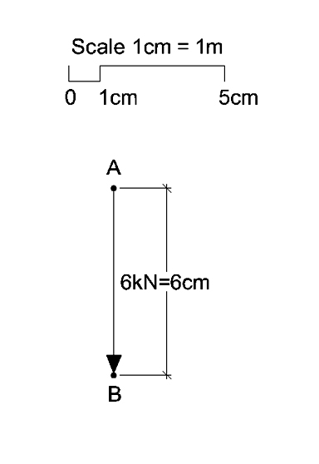
The completed load line is shown below. Note that the reactions are also external forces represented by the vectors DE and EA. They act in the upward direction as previously determined. The load line has closure, that is, it returns to point A. This is an indication of the equilibrium of the external force system.
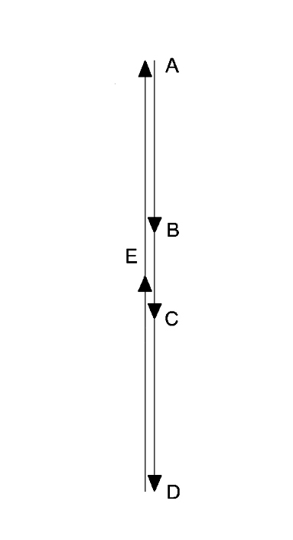

Creating the Force Polygons
Now we begin to create the force polygon that represents the member forces acting on each joint in the truss. We begin at the joint on the left support. As in the method of joints, we must begin the analysis at a joint that has only two unknown member forces. In this case member forces AF and FE . The location of point A on the Maxwell diagram indicates the position of the tail of the member force vector AF. Just as in the load diagram above, vectors in the force polygon must be parallel to the direction in which they act. In other words they are parallel to the members in the truss that they represent. Therefore the member force vector AF begins at point A and is parallel to the sloping member in the truss that it represents. The length of the vector represents the magnitude of the member force, which is unknown at this time.
Likewise, the member force vector FE must be parallel to the lower chord of the truss and must end at point E. That is the tip of the vector is at point E. With this knowledge we draw construction lines parallel to the truss members and find their intersection. The intersection of these lines represents the tip of vector AF and the tail of vector FE.
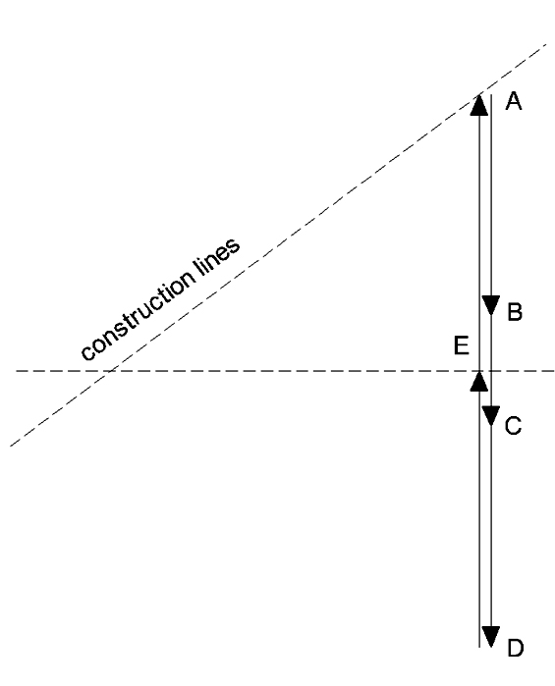 | 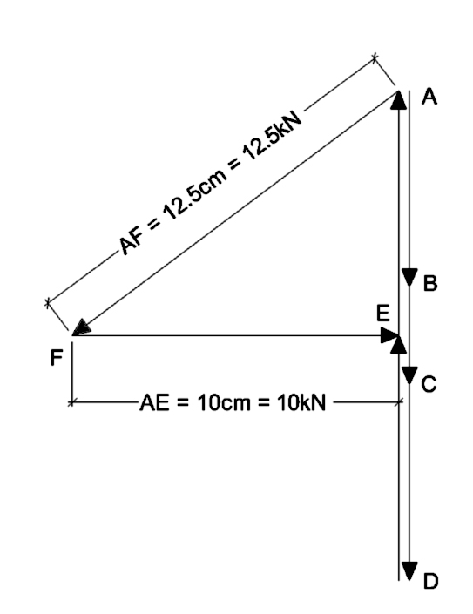
The lengths of the vectors AF and FE can be measured using the scale 1 cm = 1 kN to find their magnitudes which are 12.5 kn and 10 kn respectively. Once the member forces AF and FE are determined, the next joint with no more than two unknown member forces can be considered. This would be the joint at the 6 kN load on the left. We again construct lines parallel to the truss geometry representing the unknown member forces BG and GF. These lines will determine point G by their intersection.
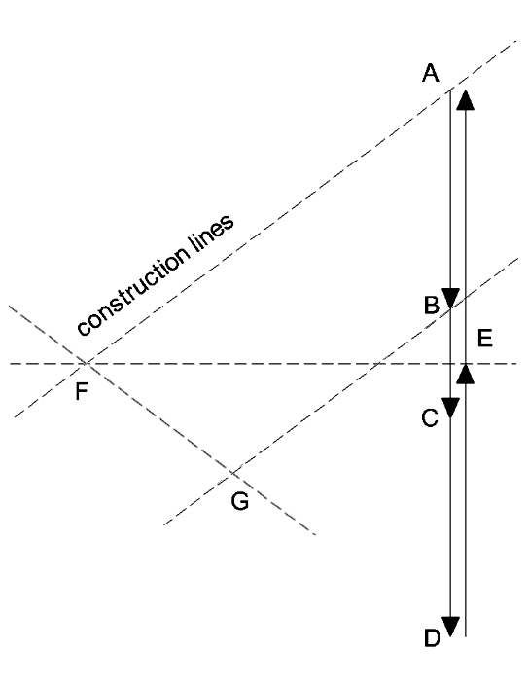 | 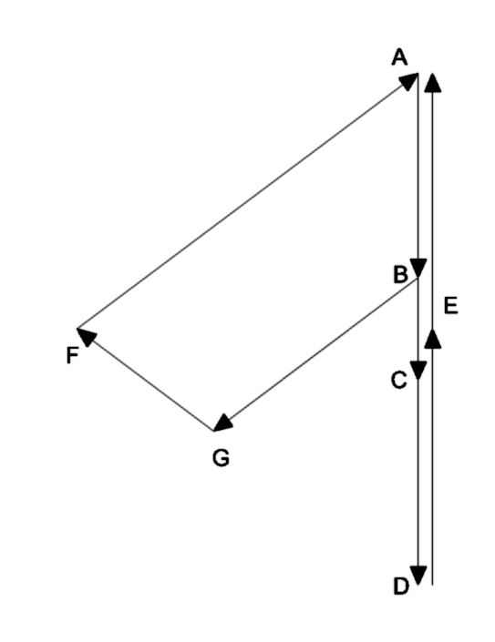
We can proceed in this manner to all of the other truss joints to complete the force diagram (Maxwell Diagram).

Maxwell Diagram
In the completed Maxwell Diagram, the magnitude of any force can be determined by measuring the distance between the two points according to the scale of the Maxwell Diagram (eg. 1 cm = 1 kN).

Determining the Sign of the Member Force
The sign (compression or tension) can be determined by going around a particular joint in a clockwise direction and following the vector polygon. The correct direction of each vector, with respect to the joint, is the direction of motion in moving from point to point on the diagram. A direction which is into the joint is compression, while away from the joint is tension.
For example, member force BG is represented on the Maxwell Diagram by vector BG. Going clockwise around joint 2, we go from B to G on the truss diagram.
On the Maxwell Diagram, we go from point B to point G (the direction of the vector BG) which is in the direction towards the bottom left on the diagram .
On the truss diagram in the same direction along member BG. This direction is into joint 2 which indicates member force BG in coompressive.
