Trusses

Determinate (perfect) and indeterminate (imperfect) trusses
The simplest form of a truss is a triangle. The triangle is a structurally rigid configuration and consists of three members that are pinned together. Trusses form a network of triangles, which have all pinned connections.
How many members are required for a truss with j joints?

M = 2j - 3
m = Number of members
j = number of joints

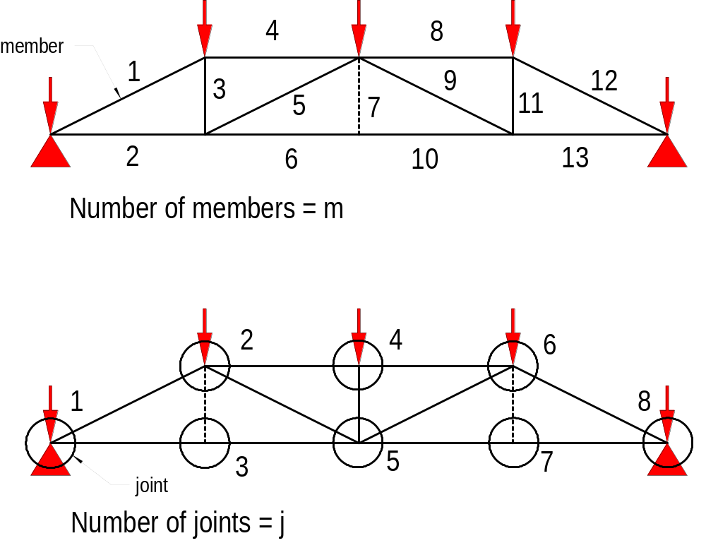

Arrangement of members in a truss

All members have pinned type connection and subjected to compression or tension only. Loads should be induced at the notes. Bending in truss members should be avoided.

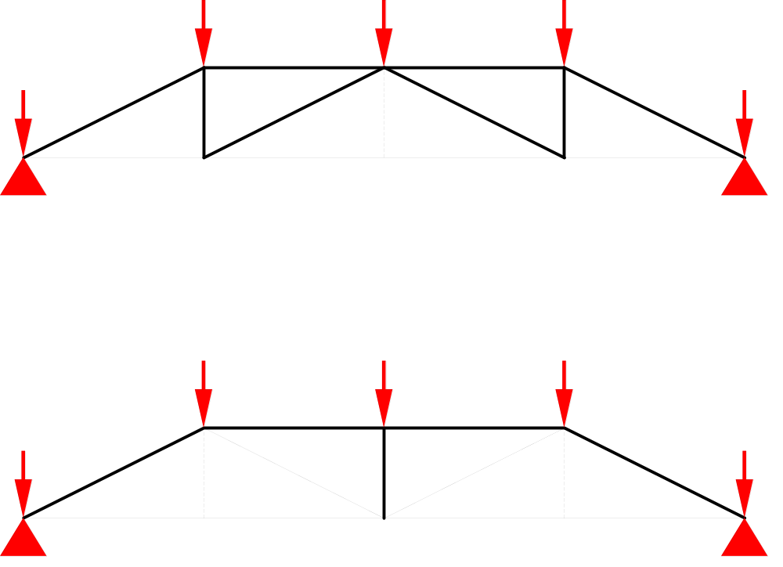

----- = redundant member

A correctly triangulated truss has just sufficient members to prevent the truss from being unstable. All joints in a truss are considered as hinged joints. Trusses should be designed with the longer members in tension.

The trusses below are identical but the members are arranged in a different fashion. As can be seen the longer diagonal members should be in tension rather than in compression

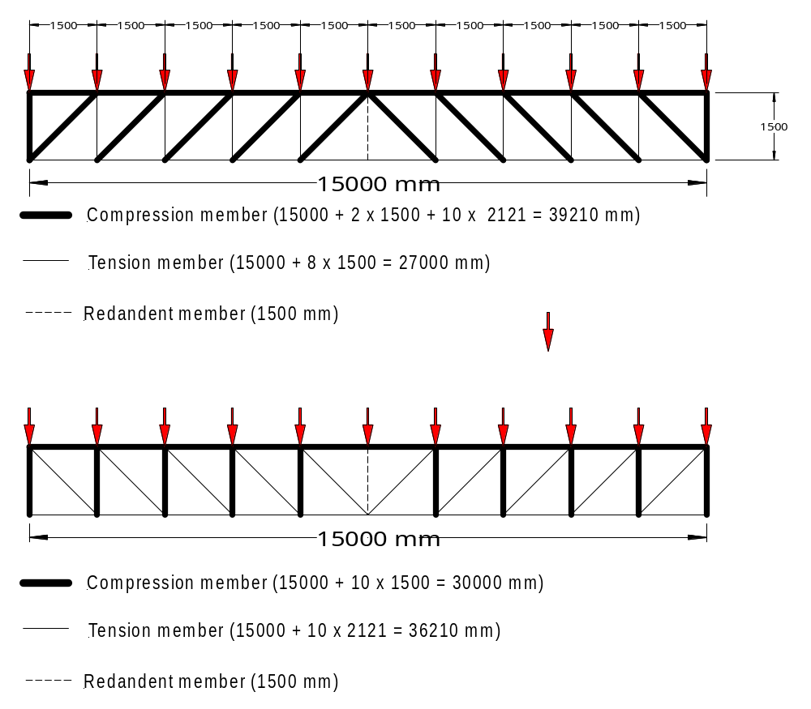

The objective in truss design is to minimise the member and wherever possible tension members should be used. For all tension members we can utilise the full strength of the material. For compression members, which are subjected to buckling, the stress must be reduced according to the slenderness ratio.

