Trigonometry

Sinus and Cosinus
The most appropriate method to do this is using trigonometrical ratios, like sin, cos, tan of an angle. The ratio for sin and cos range between 0 and 1.
sin 0° = 0 and cos 0° = 1 and
sin 90° = 1 and cos 90° = 0
Look at the unit circle shown in Figure 1 (a). The sin (cos) of an angle is the relationship of the vertical and horizontal component of the given angle. Using the right angle triangle, shown in Figure 1 (b), we can calculate the sides of any rectangle triangle. The following formulas are used for the calculation of the sides:
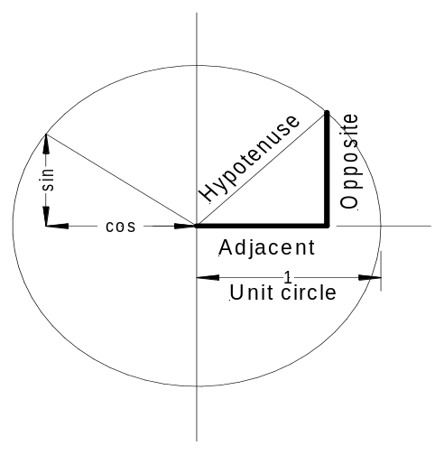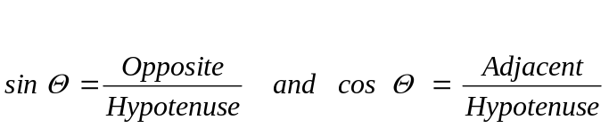

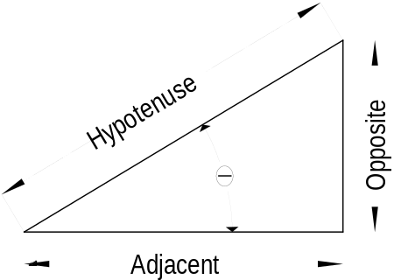

- (b)
Figure 1

Force vectors are in most cases shown at a given angle, they equate to the hypotenuse of the right angle triangle. We need to find the horizontal and vertical component of the force vector.
The vertical component is Opposite = Hypotenuse × sin Θ , and
The horizontal component Adjacent = Hypotenuse × cos Θ
Those statements are always true if you select the angle of the force to the horizontal reference line. If the angle to the vertical is given use the supplement angle (90° - Θ)

Tangent and Cotangent
If the hypotenuse is not needed or given than we can calculate the length of the vertical or horizontal or the angle using tan or cot.
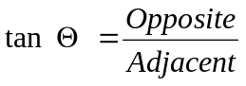 Again the tan of an angle is
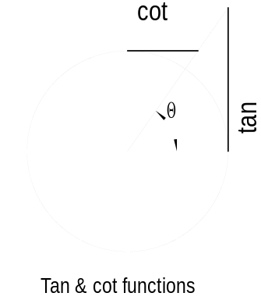
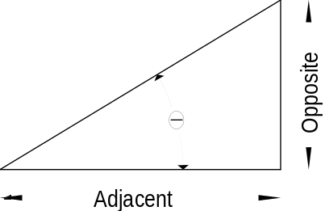

Figure 2

