Fishbone (Ishikawa) Diagram

Definition: A graphic tool used to explore and display opinion about sources of variation in a process. (Also called a Cause-and-Effect or Fishbone Diagram.)

Purpose: To arrive at a few key sources that contribute most significantly to the problem being examined. These sources are then targeted for improvement. The diagram also illustrates the relationships among the wide variety of possible contributors to the effect.

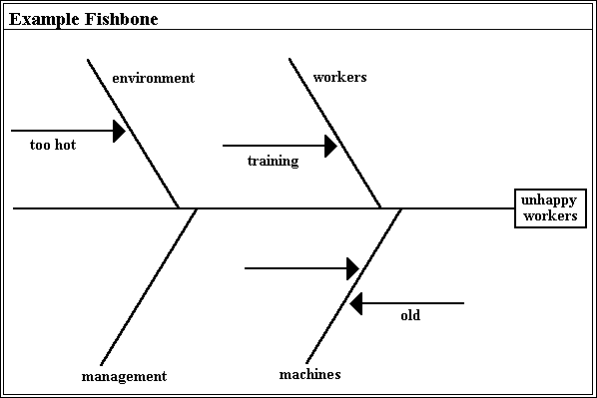
The figure below shows a simple Ishikawa diagram. Note that this tool is referred to by several different names: Ishikawa diagram, Cause-and-Effect diagram, Fishbone diagram, and Root Cause Analysis. The first name is after the inventor of the tool, Kaoru Ishikawa (1969) who first used the technique in the 1960s.

<Picture: Ishikawa Diagram>

The basic concept in the Cause-and-Effect diagram is that the name of a basic problem of interest is entered at the right of the diagram at the end of the main "bone". The main possible causes of the problem (the effect) are drawn as bones off of the main backbone. The "Four-M" categories are typically used as a starting point: "Materials", "Machines", "Manpower", and "Methods". Different names can be chosen to suit the problem at hand, or these general categories can be revised. The key is to have three to six main categories that encompass all possible influences. Brainstorming is typically done to add possible causes to the main "bones" and more specific causes to the "bones" on the main "bones". This subdivision into ever increasing specificity continues as long as the problem areas can be further subdivided. The practical maximum depth of this tree is usually about four or five levels. When the fishbone is complete, one has a rather complete picture of all the possibilities about what could be the root cause for the designated problem.

The Cause-and-Effect diagram can be used by individuals or teams; probably most effectively by a group. A typical utilisation is the drawing of a diagram on a blackboard by a team leader who first presents the main problem and asks for assistance from the group to determine the main causes that are subsequently drawn on the board as the main bones of the diagram. The team assists by making suggestions and, eventually, the entire cause and effect diagram is filled out. Once the entire fishbone is complete, team discussion takes place to decide what are the most likely root causes of the problem. These causes are circled to indicate items that should be acted upon, and the use of the tool is complete.

The Ishikawa diagram, like most quality tools, is a visualisation and knowledge organisation tool. Simply collecting the ideas of a group in a systematic way facilitates the understanding and ultimate diagnosis of the problem. Several computer tools have been created for assisting in creating Ishikawa diagrams. A tool created by the Japanese Union of Scientists and Engineers (JUSE) provides a rather rigid tool with a limited number of bones. Other similar tools can be created using various commercial tools.

Only one tool has been created that adds computer analysis to the fishbone. Bourne et al. (1991) reported using Dempster-Shafer theory (Shafer and Logan, 1987) to systematically organise the beliefs about the various causes that contribute to the main problem. Based on the idea that the main problem has a total belief of one, each remaining bone has a belief assigned to it based on several factors. These include the history of problems of a given bone, events and their causal relationship to the bone, and the belief of the user of the tool about the likelihood that any particular bone is the cause of the problem.

How to Construct:

1.Place the main problem under investigation in a box on the right. 2.Have the team generate and clarify all the potential sources of variation. 3.Use an affinity diagram to sort the process variables into naturally related groups. The labels of these groups are the names for the major bones on the Ishikawa diagram. 4.Place the process variables on the appropriate bones of the Ishikawa diagram. 5.Combine each bone in turn, insuring that the process variables are specific, measurable, and controllable. If they are not, branch or "explode" the process variables until the ends of the branches are specific, measurable, and controllable.

Tip:
- Post diagrams to stimulate thinking and get input from other staff.
- Self-adhesive notes can be used to construct Ishikawa diagrams. Sources of variation can be rearranged to reflect appropriate categories with minimal rework.
- Insure that the ideas placed on the Ishikawa diagram are process variables, not special caused, other problems, tampering, etc.
- Review the quick fixes and rephrase them, if possible, so that they are process variables.

References:
•Bourne, et. al. (1991) •Shafer, and Logan. (1987)

