**Contour line interpolation methods**

There are different methods to find the measurement for the contour line intersection on grid lines. For most ordinary contour-line drawings, one of several rapid methods of interpolation is used. In each case it is assumed that the slope between the two points (RL) of known elevation is uniform.

1. **Interpolation by Estimating**



Figure 1

It is obvious that when two grid points are at RL=9.500 and RL=8.500, then a contour line of RL=9.000 would be half way in between. As can be seen in Figure 1 a dashed line has been drawn between the RL’s. In surveying we assume that the ground between two measured stations is a straight line.

For low accurateness contour plans interpolation can be done by estimating

**2 Interpolation by Calculation**

Two methods can be used:

1. Calculation using Similar triangles
2. Formula to find proportional distance

These methods should be done for higher precision contour lines. All examples refer to Lot 71. A detail of the Lot 71 is shown on page 4.

1. **Calculation using Similar triangles**



Figure 2

The relationship length to height in a similar triangle is shown in the equation below.

$$\frac{20}{1.6}=\frac{d_{1}}{0.4}=\frac{d_{2}}{0.9}=\frac{d_{3}}{1.4}$$

All triangles are similar if their corresponding angles are congruent (are the same size). If triangles are similar, then the ratios of corresponding sides are equal as can be seen in the example above. (All the example are taken from Lot 7, RS’s for Grid point D & J)

1. **Formula to find proportional distance**

$$Distance Proportion = \frac{Contour elevation-low elevation}{high elevation-low elevation}$$

Example from Figure 2 for d1 location ofRL= 12.000. The proportion figure needs to be multiplied by the distance between the RL’s for grid points D & J which is 20 m (Lot 71)

*dp1 = 0.25 x 20 =* ***5.00*** *metre measured from le*

*dp2 = 0.5625 x 20 =* ***11.25*** *metre measured from le*

*dp3 = 0.875 x 20 =* ***17.50*** *metre measured from le*

These are the same results as with method a) similar triangles. The measurements are taken from RL point **A** (low elevation).

**3 A combination of method 1 and 2 can also be used.**

The combination method can be use for all exercises as wee as in examinations.

**4 Interpolation by Calculation and Measurement**

This method can be used for calculating the intersection of the contour lines. In some instances the grid is not drawn to scale. In this instance this method must be used if drawings are not to scale.

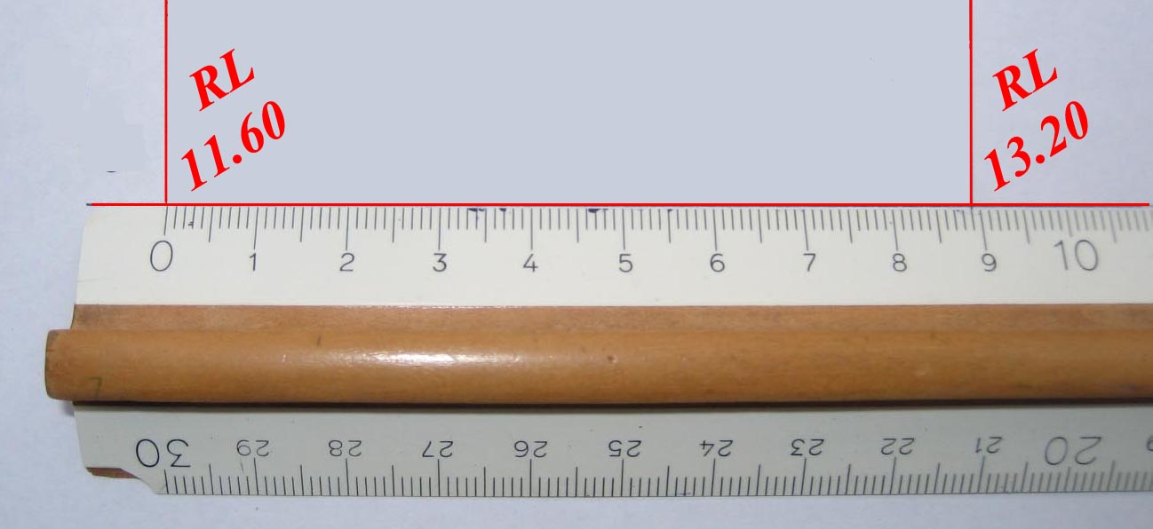Using the figures from similar triangle above you need to multiply the figures by the measurement of 89 mm (as shown on the ruler).

d1 = 0.2500

d2 = 0.5625

d3 = 0.8750

Figure 3

To get the intersection of the contour lines between RL 11.60 and RL 13.20 multiply the above figures by 89 mm. Remember to measure from the low elevation (RL 11.60) towards the high elevation (RL 13.20).

The distances d1 to d3 are measured from RL 11.60 towards RL 13.20

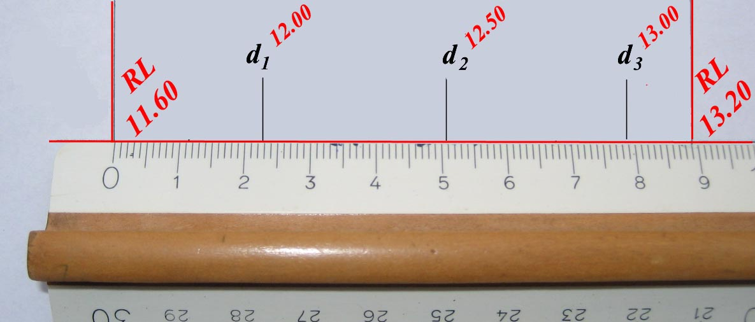 d1 = 0.2500 x 89 = 22.25mm; d2 = 0.5625 x 89 = 50.06 m; d3 = 0.8750 x 89 = 77.88 mm

Figure 4

**5 Graphic Interpolation**

Mathematical computation for the location of each line is time-consuming and would be used only in situations where contour lines had to be located with a high degree of accuracy.

The graphic interpolations avoid any mathematical computation and may suit students who dislike calculation.



The same example is used to demonstrate this method. As there are more contour lines intersect the grid line the process is more complex. If only one contour line intersects, then the middle part coloured in **blue** in figure 5 is missing.

Figure 5

To locate contour line intersections on the line Point A (RL11.6) to Point B (RL13.2) do the following:

1. Use a blank A4 paper and redraw the grid line length Point A to Point B using the specified scale (Example Lot 7, RS’s for Grid point D & J)
2. Draw a perpendicular line down from **A** to **c** 0.4 long (12.00 – 11.60). The 0.4 figure is derived from 12.00 (next contour line interval) minus 11.60 (RL A). ***The perpendicular line length can be to any scale unit to make a more accurate length reading possible.***
3. Then draw a perpendicular line upwards from **B** to **d** 1.2 long. Now 13.2 – 11.6 =1.6 (difference between the two levels) minus 0.4 gives the figure 1.2.
4. Connect the end points as shown in Figure 5 **line 1** (solid).
5. Scale the distance from Point B to the intersection **e** of the grid line. This dimension is 5 metres.
6. From the intersection **e** draw a perpendicular line **0.5** units down to point **f**
7. From end point **f** draw a parallel line to intersect grid line at point **g**. The dimension to **g** is 11.25 metres
8. From the intersection **g** draw a perpendicular line **0.5** units down to point **h**
9. From end point **h** draw a parallel line to intersect grid line at point **i**. The dimension to **g** is 17.5 metres

The dimensions on **d** to **RL Point 13.20** indicate the contour line interval.

This example is a part portion of the Lot 71. All above calculations refer to this plan.



**⇓**

If anyone knows another system please let me know.