**Two Peg Test Assessment**

Student ID: Surname: First name:

Assessment date: Time: Weather:

All instruments are subject to errors. The checking of the instrument (level) is therefore important. The main error is where the line of sight is not parallel to the horizontal line of collimation. In this case your levels will not be correct. A test for checking the level is known as the two peg test. This test determines the amount of error and if an error occurs notify the technician (the level must be serviced).

**How to check the level?**

1. On the ground, two points A and B are marked a distance of approximately 50 metres apart. In sandy soil two pegs are used, on hard surfaces nails or paint may be used.

The level is set up half way between the two points and carefully levelled. A levelling staff is placed at Peg A and a staff reading is taken then the level is placed on Peg B and a reading is taken. The staff reading at A is 1.540 and at B 1.268. The difference between the readings is 0.272. See recordings in Table Figure 1 below.

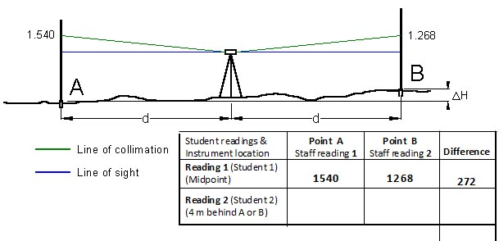

Figure 1

1. Then the level is move approximately 3 to 5 metres behind one of the pegs. Then take the staff reading at A and B again. Reading at A is 1.0621 and at B is 1.092 and the difference is 0.529. In this example a big error exists (line of sight does not coincide with line of collimation).



Figure 2

The difference between Student 1 reading and Student 2 reading gives the apparent difference in height between A and B. If the level is in perfect adjustment then there should not be any difference between the readings.

In the above case the difference between reading Student 1 and reading Student 2 is 257 mm, which indicates that the level must be serviced and adjusted.

**Assessment task**

Two peg level check

1. Depending on the exercise area use pegs or a spray can to mark two points
2. The points should be set up at a distance of 40 metres apart
3. Use pegs on grass or sandy soil and use a spray can to mark points on a hard surface.
4. Set up the level midway between the points.
5. Take the staff reading (three (3) decimal places) at point A and B and record them in row one  
   (1) of the table
6. Calculate the difference between the two readings and record it in the table
7. Move the level to a distance of approximately 4 metres opposite the staff position behind the point A or B
8. Take the staff another reading for both point A & B again and record them in row two (2) in the table
9. Again calculate the difference between the two readings and record it in the table
10. Check whether the differences between the readings are the same or not

If this is not the case and difference is not within the specified value then you need to repeat the test.

**Example**

This example must be completed before you do the **Assessment task**

Readings obtained from a two peg test carried out with an automatic level. A staff is placed on two pegs A and B at 50 metre apart.

Staff reading are at **A = 1.283 m** and Staff reading at **B = 0.860 m** (Student 1)

With the level position 4 m behind peg A

Staff reading are at **A = 1.612 m** and Staff reading at **B =1.219 m** (Student 2)

Calculate the collimation error of the level (difference between reading 1 & 2)

Collimation error is mm (Difference between readings)

**Assessment**

For this assessment two students are required to do the test.

1. Student 1

set up the level midpoint and take the staff reading for point 1 and 2. Student 2 holds the staff. Record the readings to three decimal in the Table below.

1. Then student 1 moves to the student 2 and takes the staff.
2. Student 2

moves now the level opposite to position A or B at 4 metre distance behind the point and takes the staff reading 1 and 2. Record the readings to three decimal in the Table below.

1. Then calculate the difference between the readings and record the figure in the Table. Check whether it’s within the specified limit.
2. The specified limit is three (3) millimetre. If the collimation error is greater than 3 mm the test must be repeated.
3. Make a sketch of the set out points, labelled the points and include your readings and your partners.

|  |  |  |  |
| --- | --- | --- | --- |
| Student readings &  Instrument location | **Point A**  Staff reading **1** | **Point B**  Staff reading **2** | **Difference** |
| **Reading 1** (Student 1)  (Midpoint) |  |  |  |
| **Reading 2** (Student 2  (4 m behind A or B) |  |  |  |

The specified value (difference between Staff reading 1 & Staff reading 2) should not exceed three (3) mm.

In case you need to repeat the test record the readings in the table below.

|  |  |  |  |
| --- | --- | --- | --- |
| Student readings &  Instrument location | **Point A**  Staff reading **1** | **Point B**  Staff reading **2** | **Difference** |
| **Reading 1** (Student 1)  (Midpoint) |  |  |  |
| **Reading 2** (Student 2  (4 m behind A or B) |  |  |  |

Difference between A minus B is mm

In the space below comment on the following issues:

* Comment on collimation (are they within the specified limits)
* describe in detail how you set up the level (tripod, mounting, circular bubble and function of the knobs). Improper setup of the level will have erroneous results
* task required for student 1 to do his part of the exercise (reading problems (cross-hair visibility,

upper lower stadia line readings, distance to staff A & B, etc)

* task required for student 2 to do his part of the exercise (reading problems, cross-hair visibility, upper lower stadia line readings, distance to staff A & B, etc)
* include sketch showing position of instrument & staff, reading 1 & reading 2

Please write here your comments

Sketch

**No**.**1 No.2 No.3**

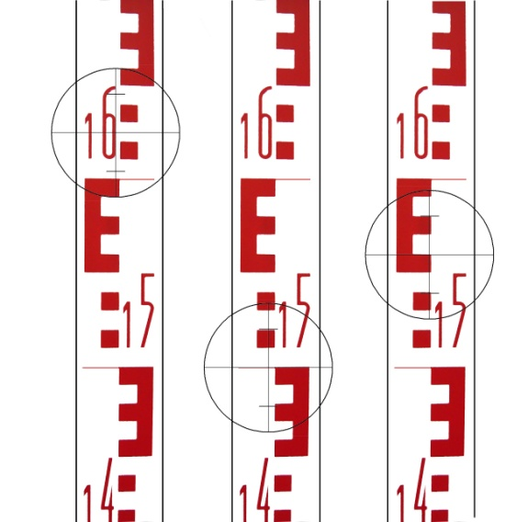

**'E' type levelling staff readings**

Each ‘block’ represents one centimetre or 10 mm

Each **E** represents 5 centimetres or 50 mm

Each 10 centimetre or 100 mm section alternates back and forth

Reading **No 1 = 1.625**

Reading **No 2 = 1.500**

Reading **No 3 = 1.560**

There is a video from Matt Shelly showing how to set up a level and how to read a Staff/rod. Please watch the video to familiarise yourself with the set up and staff reading.

<http://www.youtube.com/watch?v=czPibdRDDUU>