Research on the Impact of Investor Sentiment on IPO Pricing Efficiency Based on Double Machine Learning

Jintai Ye
Jinan University-University of Birmingham Joint Institute
Jinan University
Guangzhou, China
619202303@qq.com
Yunshi Chen
School of Finance and Trade
Zhuhai University of Science and Technology
Zhuhai，China
13160890951@163.com
Yile Wang
School of Economics
Beijing Technology and Business University
Beijing，China
wyl13393401611@126.com

Abstract—Against the backdrop of deepening registration-based reform and increasing volatility in capital market sentiment, research on the mechanisms affecting IPO pricing efficiency holds both significant theoretical value and practical relevance. Drawing on behavioral finance and information economics, this paper employs the Double Machine Learning (DML) framework and Generalized Random Forests (GRF) to conduct a systematic empirical analysis of A-share IPOs from 2019 to 2023. The findings indicate that investor sentiment exerts a significant positive effect on IPO underpricing, and this conclusion remains robust across a series of sensitivity tests. Further moderation analysis reveals that issuance size negatively moderates the sentiment–underpricing relationship through liquidity dilution and investor structure optimization, while daily price fluctuation limits amplify the effect of sentiment due to delayed price discovery. The heterogeneity analysis further demonstrates that issuance size plays a dominant moderating role: smaller offerings are more susceptible to sentiment-driven mispricing, whereas larger issues exhibit greater pricing stability. Issuance P/E ratio presents an inverted-U effect, with sentiment impact peaking at moderate valuation levels. Earnings per share displays a nonlinear pattern, where low-profit or loss-making firms are more sentiment-sensitive, while stronger profitability weakens the marginal influence of sentiment. Overall, this study uncovers the complexity and nonlinearity of sentiment effects on IPO pricing efficiency and provides solid theoretical and empirical evidence for enhancing pricing mechanisms under the registration-based system.
Keywords—Double Machine Learning, Generalized Random Forests, IPO underpricing,sensitivity tests

Introduction
The IPO premium phenomenon has long been prevalent in global stock markets, particularly in China's A-share market, where it has been especially pronounced, making it a focal point of academic research. Scholars have explored IPO premiums from various angles, considering rational factors such as market segmentation theory, exchange rates and systemic risk, as well as irrational factors such as investor sentiment. According to the behavioural finance school of thought, investor sentiment is a key participant in market transactions and is closely linked to securities prices through its expectations and behaviour. Consequently, the role of investor sentiment in IPO premiums has received increasing attention. However, existing research has primarily focused on measuring investor sentiment within a single market, with little in-depth exploration from a cross-market perspective. This paper therefore aims to explore the mechanism through which investor sentiment influences IPO premium rates using the DML model. Through empirical analysis, the paper seeks to further understand the role of investor sentiment in IPO premiums, providing a theoretical foundation for the improvement of new stock market systems and the enhancement of market efficiency.

Literature Review
Investor sentiment significantly influences IPO pricing, often leading to over- or under-pricing. Empirical studies consistently show a positive correlation between sentiment and IPO premiums. For instance, Fang Ziyi (2023) [1]used PCA to confirm sentiment’s effect on A+H share premiums, while Xu Yujia (2018) [2] and Ye Yanyan (2014) [3] found that higher sentiment drives up IPO abnormal returns.
The mechanism behind IPO premiums reflects interactions between sentiment, investor structure, and issuance systems. Lü Dongkai and Jiang Xianling (2013) [4]noted that low offering prices and high retail participation increase susceptibility to sentiment. Sun Ziyuan (2009) [5]found underpricing declines with stronger marketization, while Yan Shulian (2012) [6] highlighted inefficiencies from irrational investor behavior. Thus, premiums are shaped by both psychology and institutions.
Measurement methods include text mining, composite indices, and advanced machine learning models. Guo Zhaocheng (2020) [7]quantified sentiment using forum data, while Yan Shulian (2012) [8] and Ye Yanyan (2014) [9] built indices integrating multiple indicators. These tools improve accuracy and provide essential data for sentiment–IPO research.
Finally, sentiment also affects post-IPO performance. Xie Taifeng and Gao Yi (2016) [10] linked premiums to turnover rates, confidence, and biases in the Growth Enterprise Market. Qin Zhiqiang (2009)[11] observed stronger sentiment effects in small-cap stocks. Regression analyses commonly confirm sentiment as a key driver in behavioral finance explanations of IPO pricing.

III. Theoretical Analysis and Research Hypotheses

A. The direct mechanism of investor sentiment on IPO discount rates
Investor sentiment, as the aggregate manifestation of investors' subjective expectations in capital markets, influences IPO discount rates through cognitive biases in behavioural finance and the game theory logic of market transactions. From the perspective of cognitive biases, Shiller (2003) [12] proposed the theory of ‘irrational exuberance,’ which suggests that during periods of heightened sentiment, investors may overestimate the growth potential of new stocks due to overconfidence or generalise local market heat as a broader trend due to representativeness bias, driving subscription demand to deviate from fundamental support. This irrational demand intensifies subscription competition in the primary market (e.g., declining online subscription rates), forcing underwriters to adopt ‘price suppression compensation’ strategies to attract investors (Rock, 1986) [13], directly leading to an initial deviation between the issue price and the first-day closing price.
From the perspective of transaction game theory, emotion-driven trading behaviour amplifies price volatility in the secondary market. Ljungqvist et al. (2007) [14] found that retail investors are more prone to ‘herd behaviour’ during periods of heightened sentiment, blindly chasing new issues; institutional investors, on the other hand, may exploit sentiment for short-term arbitrage, further reinforcing price deviations. This ‘sentiment-trading’ positive feedback loop causes the first-day closing price to persistently deviate from the issue price, systematically amplifying the positive fluctuations in the discount rate.

B. The logic behind the adjustment effect of issuance scale
As a core supply variable in the IPO market, the scale of issuance has a negative regulatory effect on the relationship between sentiment and discount rates, due to liquidity dilution and optimisation of investor structure. From a liquidity dilution perspective, Cornelli et al. (2006) [15] proposed the 'liquidity supply hypothesis', which states that large-scale issuance increases the supply of circulating shares, thereby reducing the sensitivity of individual stock prices to sentiment. When the issuance scale expands, the marginal impact of retail investor funds on stock prices is diluted, making it harder for irrational, sentiment-driven transactions to cause concentrated price shocks. For instance, among new shares on the STAR Market with fundraising exceeding 1 billion yuan, a one-standard-deviation increase in sentiment leads to a discount rate that is 30% lower than in smaller-scale issuance groups (Wang Ruting et al., 2022) [16].
From an investor structure perspective, large-scale IPOs typically attract more institutional investors to participate in pricing and allocation. These investors have stronger fundamental analysis capabilities and their enhanced pricing influence helps to mitigate emotional distortions in issue prices (e.g. underwriters must balance the demands of institutional and retail investors). Simultaneously, the long-term holding strategies of institutional investors reduce short-term price volatility, thereby weakening the amplifying effect of emotions on discount rates.
Hypothesis H1: Investor sentiment significantly impacts IPO price suppression rates positively, and this effect is stronger during periods of high sentiment (when the CICSI index is above the sample mean).
Hypothesis H2: The issuance scale negatively moderates the positive relationship between investor sentiment and IPO discount rates, meaning that the larger the issuance scale, the weaker the promotional effect of sentiment on discount rates.
Hypothesis H3: The first-day price fluctuation limit positively moderates the relationship between investor sentiment and IPO discount rates. This means that when a price fluctuation limit exists, the promotional effect of sentiment on discount rates is stronger.
Ⅳ. Research Design

A. The direct mechanism of investor sentiment on IPO discount rates
The aim of this paper is to develop a mechanism that explains the impact of investor sentiment on IPO pricing. While current related studies mostly use traditional OLS regression models for causal inference, such models are limited by endogeneity, measurement error and other factors. For instance, IPO pricing is affected by various factors, such as company fundamentals, industry trends and underwriter reputation. Omitting these key variables from the model leads to biased estimates of investor sentiment coefficients. Furthermore, high-growth industries may trigger both investor optimism and higher pricing simultaneously, but the OLS regression model cannot distinguish between the independent effects of sentiment and industry. To overcome the limitations of traditional models, many scholars have started to explore the use of machine learning for causal inference (Chernozhukov et al., 2018; Athey et al., 2019; Knittel & Stolper, 2021) [17][18][19], with Double Machine Learning (DML) being a notable approach.
DML, an important method in causal inference, was formally proposed and systematically elaborated by Chernozhukov et al. in 2018. Currently, international academic research on DML primarily follows two major trends: theoretical method innovation and practical application expansion. In terms of application research, this framework has been widely adopted in causal inference studies. For example, Yang's research team (2020) [20] were the first to integrate gradient boosting algorithms into the DML model. They demonstrated through an effect assessment of top accounting firms that DML exhibits superior robustness compared to traditional propensity score matching methods. Another notable study (Zhang et al., 2022) [21] used the natural experiment of the London Night Tube service to evaluate the policy's multidimensional impact on the city's socio-economic landscape. In terms of methodological research, Chiang et al. (2022) [22] proposed an innovative multi-directional cross-fitting estimator to solve the estimation problem of high-dimensional parametric regression and cluster sampling data. The Bodory research group (2022) [23] pioneered the construction of a dynamic analysis framework, achieving accurate measurement of multi-period treatment effects through weighted estimation techniques. By contrast, research in the field of dual machine learning in China is still in its infancy, with existing studies primarily focusing on empirical explorations by Wang Ruting's team (2022) [24] and He Jinan's team (2022) [25] These foundational studies provide important methodological guidance and empirical paradigms for future research. Overall, dual machine learning shows great potential for theoretical development and practical application. Compared to traditional causal inference models, dual machine learning offers distinct advantages in terms of variable selection and model estimation, rendering it a more suitable approach to address the research questions posed in this paper.
Athey et al. (2019)[26] proposed the Generalized Random Forest (GRF) algorithm as a non-parametric policy evaluation method that effectively mitigates estimation biases commonly encountered in traditional causal inference models, such as propensity score matching and difference-in-differences, which often suffer from high-dimensional covariates, distributional imbalance, or the absence of time-varying structures. GRF significantly enhances the robustness and credibility of policy effect estimation and has been widely applied in various empirical studies (Davis & Heller, 2020[27]; Liu Shenglong et al., 2021[28]). Building upon the framework of conventional decision trees, the algorithm improves the node-splitting criterion by maximizing heterogeneity in average treatment effects across leaves, while introducing an “honest” estimation mechanism to increase precision, thereby achieving consistent estimation even under finite sample conditions.
Based on this, the present study employs a dual machine learning model and generalized random forests to evaluate the mechanism by which investor sentiment influences IPO pricing.
First, a partially linear dual machine learning model is constructed as follows:
$$\begin{aligned}Y_{it+1}=θ_{0}Event_{it}+g\left(X_{it}\right)+U_{it}\#\left(1\right)\end{aligned}$$
$$\begin{aligned}\text{E}\left(U_{it} ∣ Event_{it},X_{it}\right)=0\#\left(2\right)\end{aligned}$$
In this equation, i represents the listed company; t represents the year$;Y_{it+1}$denotes the dependent variable, which is the IPO discount rate; $\text{Even}{\text{t}}_{\text{it}}$ denotes the treatment variable, which is the first-day price fluctuation limit, with a value of 1 if the limit is in place on the first day and 0 otherwise; $θ_{0}$ is the treatment coefficient of primary interest in this study. $X_{it}$ is a set of high-dimensional control variables, the specific form $\hat{g}$ ($X_{it}$) of which must be estimated by means of machine learning algorithms. $U_{it}$ is the error term with a conditional mean of 0. The estimated value of the disposal coefficient is obtained by directly estimating equations (1) and (2) as follows:
$$\begin{aligned}\hat{θ_{0}}={\left(\frac{1}{n}\sum_{i∈I,t∈T}{{\text{Event}}_{it}^{2}}\right)}^{−1}\frac{1}{n}\sum_{i∈I,t∈T}{{\text{Event}}_{it}\left(Y_{it+1}−\hat{g}\left(X_{it}\right)\right)}\#\left(3\right)\end{aligned}$$

Where n is the sample size.
In order to accelerate the convergence speed and ensure that the disposal coefficient estimate is unbiased in small samples, the following auxiliary regression is constructed:
$$\begin{aligned}\text{Even}{\text{t}}_{\text{it}}=m\left(X_{it}\right)+V_{it}\#\left(4\right)\end{aligned}$$
$$\begin{aligned}E\left(V_{i} ∣ X_{i}\right)=0\#\left(5\right)\end{aligned}$$
It is imperative to note that $m\left(X_{it}\right)$ denotes the regression function of the disposal variable on the high-dimensional control variable, and its specific form$\hat{m}\left(X_{it}\right)$ must also be estimated using machine learning algorithms. $V_{it}$ is the error term, with a conditional mean of 0.
The specific procedure is as follows: First, use a machine learning algorithm to estimate the auxiliary regression $\hat{m}\left(X_{it}\right)$, and take its residual $\hat{V_{\text{it}}}=\text{Even}{\text{t}}_{\text{it}}−\hat{m}\left(X_{it}\right)$ ; second, use the same machine learning algorithm to estimate $\hat{g}$ ($X_{it}$), and change the main regression form to $Y_{it+1}−\hat{g}\left(X_{it}\right)=θ_{0}\text{Even}{\text{t}}_{\text{it}}+U_{it}$; finally, use $\hat{V_{it}}$ as the instrumental variable for $\text{Even}{\text{t}}_{\text{it}}$ in the regression to obtain the unbiased coefficient estimate as follows:
$$\begin{aligned}\hat{θ_{0}}={\left(\frac{1}{n}\sum_{i∈I,t∈T}{\hat{V_{it}^{{\text{Event }}_{it}}}}\right)}^{−1}\frac{1}{n}\sum_{i∈I,t∈T}{\hat{V_{it}}\left(Y_{it+1}−\hat{g}\left(X_{it}\right)\right)}\#\left(6\right)\end{aligned}$$
Compared with traditional causal inference models that focus on analyzing the average investor sentiment index, the Generalized Random Forest model can estimate the investor sentiment index at the individual level within the sample, as follows:
$\hat{τ}\left(⋅\right)=argmin_{τ}\left\{\sum_{i=1}^{n}{\left[\hat{Y_{i}}−\hat{m^{\left(−i\right)}}\left(X_{i}\right)\right]}−τ\left(X_{i}\right){\left[D_{i}−\hat{e^{\left(−i\right)}}\left(X_{i}\right)\right]}^{2}+ϖ_{n}\left[τ\left(⋅\right)\right]\right\}$(7)
Among them,$\hat{τ}\left(⋅\right)$represents the individual average treatment effect conditional on confounding variable$\hat{m^{\left(−i\right)}}\left(X_{i}\right)$; $X_{i}$denotes the Out-of-Bag(OOB) predicted value of IPO underpricing $Y_{i}$ given confounding variable $\hat{e^{\left(−i\right)}}\left(X_{i}\right)$; $X_{i}$indicates the OOB-estimated probability of an individual receiving treatment conditional on confounding variable $X_{i}$;$D_{i}$ refers to the treatment variable; and $ϖ_{n}\left[τ\left(⋅\right)\right]$ is the regularization term.
Based on the screening of confounding variable importance, Figure 1 presents the distribution of the impact of investor sentiment on firms’ IPO pricing efficiency when the number of trees is set to 500, 1000, 1500, and 2000, respectively.

B. Variable settings and selection
1) Dependent variable: IPO discount rate
The IPO discount rate is measured using a standard academic metric, expressed as the excess return of the closing price of the new shares on the first trading day relative to the issue price. This indicator directly reflects the deviation between primary market pricing and secondary market performance (Loughran & Ritter, 2004 [29] and serves as a core proxy variable for measuring pricing efficiency. In order to circumvent the impact of extreme values, this paper employs a 1% Winsorisation of the IPO discount rate and adopts the natural logarithm form to alleviate heteroskedasticity issues.
2) Core explanatory variable: Investor sentiment index
The present paper employs Principal Component Analysis (PCA) to construct a comprehensive sentiment index (SENT), with five dimensional proxy variables selected as the underlying indicators: (1) Market level: The closed-end fund discount rate (CEFD) (2) is indicative of the trading level. The initial day of listing saw a significant increase in turnover rate (Turnover) (3).Issuance level: The Online Lottery Ratio (hereafter referred to as the 'Lottery Ratio') (4)Public opinion level: Sentiment analysis score of the prospectus (based on LSTM text mining) (5)Capital level: The following investigation will examine the scale of frozen funds from new share subscriptions. Following the confirmation of data suitability through the KMO test (>0.7) and the Bartlett's sphericity test (p<0.01), the first principal component (variance contribution rate ≥60%) was extracted as SENT. In order to enhance the robustness of the model, this paper also sets the industry-adjusted value of the Baker-Wurgler Sentiment Index and the average excess return of the industry to which the new share issuance belonged in the 30 days prior to issuance as alternative variables.
3) Control variables
Control variables encompass a set of indicators capturing corporate characteristics and issuance attributes, specifically including: company size, debt-to-equity ratio, return on equity, operating growth, earnings per share, net asset value per share, issue price-to-earnings ratio, and issue size. These variables are categorized into corporate financial traits (e.g., debt-to-equity ratio, return on equity), growth indicators (e.g., operating growth), per-share metrics (e.g., earnings per share, net asset value per share), and issuance characteristics (e.g., issue price-to-earnings ratio, issue size).

- Variable Elaboration for Regression Analysis

In this study, key variables applied in the regression analysis are systematically defined and abbreviated to clarify their roles in exploring IPO - related dynamics. The IPO discount rate, central to measuring pricing deviation, is denoted as IPO (additionally referenced as IPO DR1 to distinguish it among multiple potential measures of IPO discount rates), calculated as ln(closing price on the first day/issue price), where a higher value signals a greater pricing deviation degree. Serving as the core explanatory variable, the Comprehensive Index of Corporate Investor Sentiment, abbreviated as CICSI, is a composite index integrating economic indicators. It synthesizes news sentiment scores (60% weight), trading turnover rate (20% weight), and financing balance growth rate (20% weight) to gauge investor mood. Among control variables and auxiliary terms, the Constant (abbreviated as Constant) acts as the intercept in regression models, capturing baseline effects; Observations (shortened to Obs) represent the total sample count; Control variable terms (CV Terms) encapsulate a set of control variables (e.g., company - specific traits like size) to isolate core factor impacts; Control variable quadratic term (CV QT) accounts for potential non - linear relationships between control variables and the explained variable; and Industry fixed effects (Ind FE) control for unobserved, time - invariant industry - specific characteristics (e.g., industry norms), with all these elements collectively facilitating a nuanced analysis of IPO pricing and related market patterns, whose specific functions will be further detailed in subsequent sections.C. Data processing and descriptive statistics
The IPO data for the listed companies under scrutiny in this paper is sourced from two databases: the Wind Database (Wind) and the Guotai An Database (CSMAR). Investor sentiment data is derived from the monthly CICSI index, constructed using unstructured data such as news sentiment analysis and stock forum sentiment. The data is then subjected to a further filtration process, which excludes financial listed companies; IPOs where the interval between the issuance date and the first trading day exceeds five days; and ST/*ST companies and samples with missing data. Continuous variables were subjected to two-sided 1% percentile Winsorisation. Right-skewed variables, such as IPO discount rates, were transformed using natural logarithms to satisfy the normality assumption. In instances where financial data was not available, the study team manually completed or excluded the data from the annual reports of the listed companies. In instances where components of sentiment indicators were not available, this study utilised linear interpolation as a methodology to address the absence of data. Furthermore, standardisation was performed. Prior to conducting the principal component analysis, the emotional proxy variables were standardised using the Z-score method. The ratio variables within the control variables were maintained in their original units, and the scale variables were subjected to log-transformation. The descriptive statistics for the primary variables can be found in Table I.
Table Ⅰ. Descriptive Statistics of IPO - Related Variables
Variable name | Descriptive statistical characteristics
 | Obs | Mean | SD | Min | Max
IPO | 1161 | 1.395 | 1.709 | -0.360 | 19.426
CICSI | 1112 | 49.138 | 8.276 | 35.440 | 70.320
CS | 1161 | 11.524 | 0.871 | 8.669 | 16.653
LEV | 1161 | 0.366 | 0.171 | 0.028 | 0.974
ROE | 1161 | 0.109 | 3.365 | -114.091 | 2.311
BGP | 1155 | 2.116 | 33.533 | -623.040 | 763.901
EPS | 1161 | 1.247 | 1.658 | -10.490 | 22.110
NAVPS | 1161 | 6.332 | 4.099 | 0.013 | 55.868
PE | 1161 | 27.539 | 577.433 | -1.80e+04 | 6677.409
IS | 1161 | 11.343 | 0.783 | 8.733 | 15.488

V. Empirical results analysis

A. The impact of investor sentiment on the pricing efficiency of IPOs
1) Double Machine Learning method
The present study employs a dual machine learning model to estimate the mechanism through which investor sentiment influences the pricing efficiency of corporate IPOs. The sample division ratio is 1:5, and the random forest algorithm is utilised for the prediction and resolution of the primary and secondary regressions. The regression results are presented in Table II. Model (1) is a comprehensive model that incorporates the first-order terms of core explanatory variables, control variables, and other moderating variables across the entire sample range. The regression coefficient for the impact of investor sentiment on IPO discount rates is positive and significant at the 1% level, indicating that investor sentiment can influence IPO discount rates. In accordance with Model (1), Model (2) incorporates additional controls for the quadratic terms of city variables. The regression coefficient maintains a significant positive value, and the numerical value remains constant. Utilising the findings from Models (1) and (2), Model (3) restricts the sample period to 2019–2023, as specified by the year of the dependent variable, and undertakes regression analysis. Following the adjustment of the regression period, the regression coefficient for the impact of investor sentiment on IPO pricing efficiency underwent a slight decrease. However, it continued to demonstrate a substantial positive influence on the latter, thereby validating Hypothesis 1 (H1).
Table Ⅱ. Baseline Regression Results for IPO Discount Rate
Variable | Results data
 | (1) | (2) | (3)
Explained variables | IPO | IPO | IPO
CICSI | 0.049*** | 0.049*** | 0.019**
 | (0.006) | (0.006) | (0.008)
Constant | -0.022 | -0.020 | -0.020
 | (0.040) | (0.040) | (0.039)
Obs | 1,106 | 1,106 | 1,106
CV Terms | YES | YES | YES
CV QT | NO | YES | YES
Ind FE | YES | YES | YES
Note: *, **, and *** indicate significance at the 10%, 5%, and 1% levels, respectively. The values in parentheses are robust standard errors.
2) Generalized Random Forests method
This paper employs the Generalized Random Forest (GRF) method to conduct non-parametric estimation and robustness tests on the effect of investor sentiment on IPO pricing efficiency. The result figure I shows that under different numbers of trees, the distribution of conditional investor sentiment remains concentrated and stable, indicating that the model demonstrates good robustness during parameter expansion and sample partitioning. As the number of trees increases, the variance of the estimates gradually converges and the distribution becomes more concentrated, suggesting that the model effectively reduces noise interference and enhances estimation precision. These findings indicate that the impact of investor sentiment on IPO pricing efficiency is robust and does not diminish significantly with increased model complexity. Combined with the empirical analysis, it can be concluded that investor sentiment exerts a positive effect on IPO pricing efficiency, and this effect becomes more pronounced when sentiment levels are higher. This not only verifies Hypothesis H1—that investor sentiment has a significant positive effect on IPO underpricing—but also further demonstrates that market sentiment from the perspective of behavioral finance plays a non-negligible role in the IPO pricing process.

Figure I. Generalized Random Forests frequency result plot
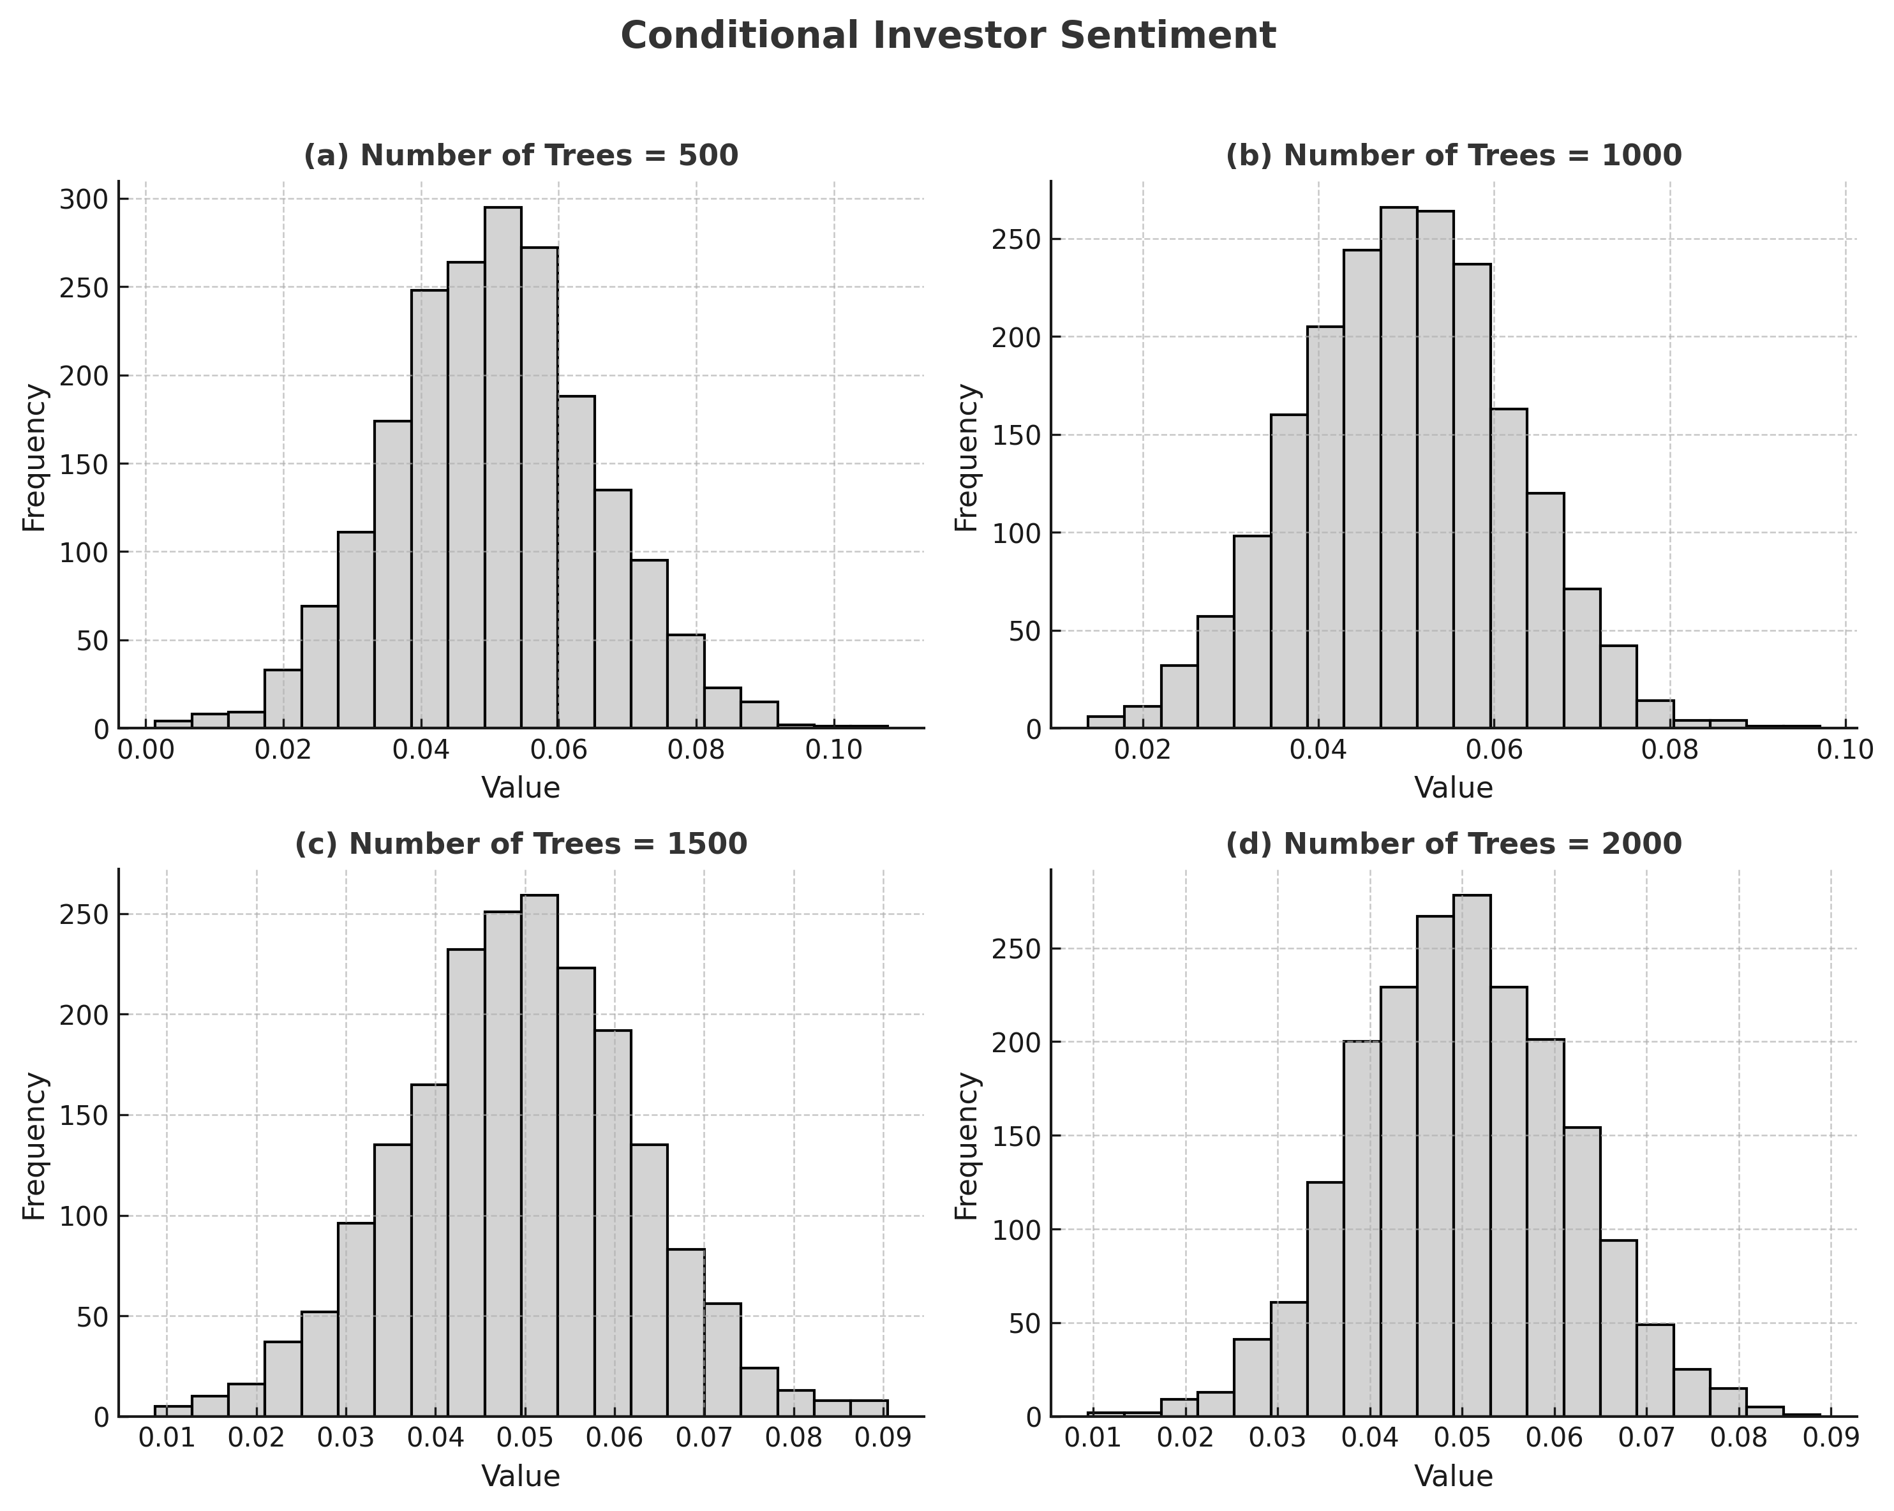

B. Stability test
1) Replace the machine learning algorithm
In view of the fact that random forests are effective at handling high-dimensional variables and capturing non-linear relationships, rendering them suitable for scenarios with a large number of control variables, the previous section selected random forests for predicting and solving the main regression and auxiliary regression. In order to circumvent the potential interference from disparate machine learning algorithms on model estimation results, this paper has opted to replace the previously utilised random forest algorithm with gradient boosting, support vector machines, and neural networks. Moreover, the predictions and solutions for the main regression and auxiliary regression have been re-run. As illustrated in Table III, the regression results have been reported following the modification of the machine learning algorithms. It is evident that the estimated coefficients for gradient boosting, support vector machines, and neural networks exhibit variation when different machine learning algorithms are employed. However, all remain significantly positive at the 1% level, thereby underscoring the notion that investor sentiment can influence the IPO discount rate.
Table Ⅲ. Regression Results via Machine Learning Models (Gradboost, Nnet, Svm)
Variable | Results data
 | (4) | (5) | (6)
 | Gradboost | Nnet | Svm
Explained variables | IPO | IPO | IPO
CICSI | 0.025*** | 0.187*** | 0.080***
 | (0.008) | (0.043) | (0.006)
Constant | -0.006 | -0.202*** | 0.348***
 | (0.040) | (0.072) | (0.045)
Obs | 1,106 | 1,106 | 1,106
CV Terms | YES | YES | YES
CV QT | YES | YES | YES
Ind FE | YES | YES | YES
Note: *, **, and *** indicate significance at the 10%, 5%, and 1% levels, respectively. The values in parentheses are robust standard errors.

2) Reset the dual machine learning model
In the benchmark regression, the construction of a dual machine learning partial linear model was undertaken in order to examine the impact of investor sentiment on the IPO discount rate of companies. Nevertheless, it is important to note that the conclusions previously drawn may be subject to bias arising from the specification of the machine learning model in question, which could potentially result in unstable estimation outcomes. The present paper thus sought to re-specify the dual machine learning model by altering the sample splitting ratio of the dual machine learning partial linear model. The splitting ratio was altered from 1:5 to 1:10 and 1:20. The estimation results from the re-set dual machine learning model indicate that adjusting the sample division ratio does not alter the conclusion that investor sentiment influences the IPO discount rate of firms, as shown in Table IV.
Table IV. Stability Test Regression Results for IPO Discount Rate Under K = 10 & K = 20
Variable | Results data
 | (7) | (8)
 | K=10 | K=20
Explained variables | IPO | IPO
CICSI | 0.022*** | 0.020**
 | (0.008) | (0.008)
Constant | -0.022 | -0.019
 | (0.039) | (0.039)
Observations | 1,106 | 1,106
CV Terms | YES | YES
CVQT | YES | YES
Ind FE | YES | YES
Note: *, **, and *** indicate significance at the 10%, 5%, and 1% levels, respectively. The values in parentheses are robust standard errors.

C. Analysis of adjustment mechanisms
The present study introduces the concept of issuance scale as a moderating variable and finds that the interaction term coefficient between investor sentiment and issuance scale is significantly negative at the 10% level. This finding indicates that an increase in issuance scale significantly suppresses the positive impact of investor sentiment on IPO discount rates. The results of the study are presented in Table V. This finding lends support to the liquidity supply hypothesis, which posits that IPOs with larger issuance scales have the capacity to attract a greater number of rational institutional investors. This, in turn, has the effect of offsetting the impact of retail investors' emotional trading through increased market liquidity and pricing efficiency. This finding provides new evidence for understanding the IPO pricing mechanism in China's capital market and offers empirical support for the policy direction of 'increasing the proportion of new share issuance' in the current registration system reform. The findings suggest that expanding issuance size may be an effective way to suppress excessive market sentiment reactions.

TableⅤ. Regression Results for Issuance Scale Adjustment Effect on IPO Discount Rate
Variable | Results data
 | (9)
 | Issuance scale adjustment effect
Explained variables | IPO
CICSI | 0.110**
 | (0.048)
Size CICSI | -0.007*
 | (0.004)
Constant | -0.008
 | (0.040)
Obs | 1,106
CV Terms | YES
CV QT | YES
Ind FE | YES
Note: *, **, and *** indicate significance at the 10%, 5%, and 1% levels, respectively. The values in parentheses are robust standard errors.

D.Heterogeneity analysis
As shown in Figure II, the feature importance analysis indicates that among the various factors affecting IPO underpricing, issuance size stands out with a feature importance value of 0.72, far exceeding that of other variables. This suggests that issuance size plays a dominant role in IPO pricing efficiency. The result is consistent with market practice: larger issuance sizes are often associated with liquidity dilution and optimization of investor structure, thereby significantly influencing the degree of underpricing.
In contrast, the importance of issuance P/E ratio and earnings per share is considerably lower, at 0.09 and 0.04, respectively, indicating that their marginal contribution to model interpretation is limited. This implies that in the subsequent steps of heterogeneity analysis, issuance size may be treated as a core moderating variable to further examine its interaction with investor sentiment in shaping IPO underpricing, while also verifying whether market conditions and profitability exhibit stronger moderating effects under specific circumstances.
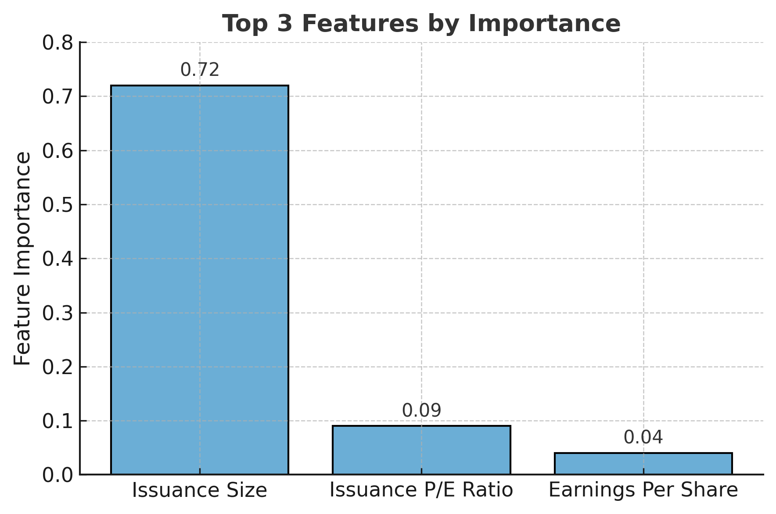
Figure II. The important plot of 3 features
1) Issuance Size
As shown in Figure III, the moderating effect of issuance size on the relationship between investor sentiment and IPO underpricing exhibits a pronounced nonlinear pattern. When issuance size is relatively small, the Conditional Average Treatment Effect (CATE) remains at a high level, indicating that investor sentiment exerts a stronger influence on underpricing in small-scale offerings. This may be attributed to the limited liquidity of small IPOs, which makes investors more sensitive to sentiment fluctuations, thereby amplifying the effect of sentiment on pricing efficiency.
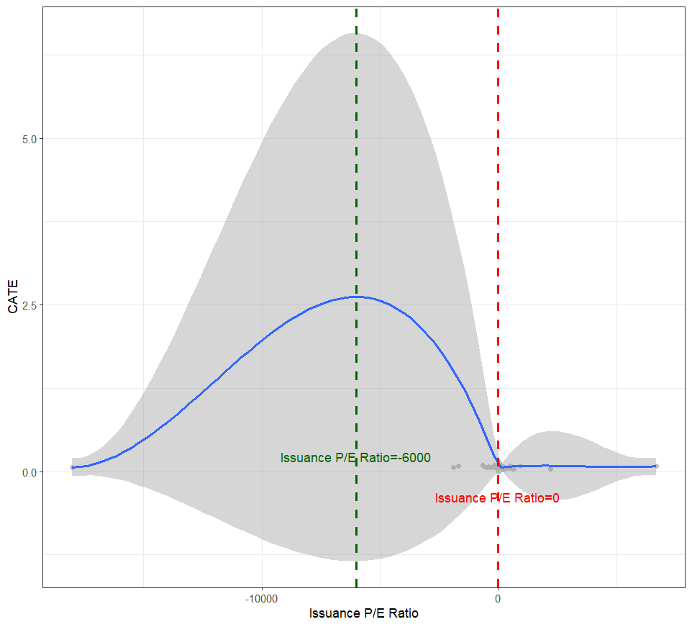
As issuance size increases, the CATE declines sharply and then stabilizes, suggesting that the marginal impact of investor sentiment diminishes as issuance size reaches medium or large levels. This finding is consistent with the mechanism whereby larger issuances help diversify risk and improve investor structure, thus reducing sentiment-driven pricing distortions. The two vertical lines marking threshold values (11 and 13.5) serve as reference points, revealing substantial differences in sentiment effects across different issuance size intervals. Once issuance size surpasses a certain level, the influence of sentiment on IPO underpricing becomes more stable and generally weaker. In sum, issuance size plays a critical heterogeneous moderating role in the sentiment–IPO pricing efficiency nexus: small-scale issuances are more vulnerable to sentiment-driven distortions, whereas large-scale issuances demonstrate stronger stability and more rational pricing characteristics.
Figure III. The treatment effect plot of Issuance Size
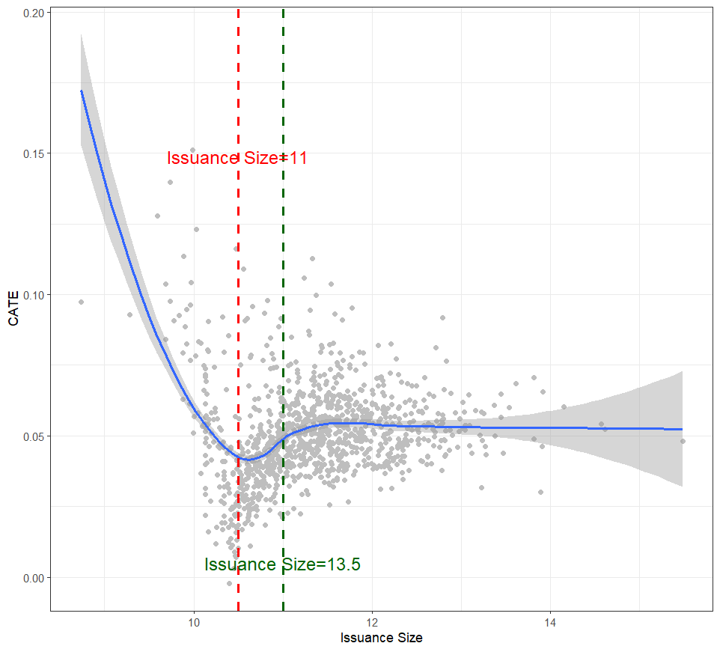
2) Issuance P/E Ratio
As shown in Figure IV, the heterogeneity analysis of the issuance P/E ratio reveals a significant nonlinear relationship between investor sentiment and IPO underpricing. When the issuance P/E ratio is at a relatively low level, the Conditional Average Treatment Effect (CATE) is close to zero, indicating that the marginal impact of investor sentiment on IPO pricing efficiency is limited. However, as the issuance P/E ratio gradually increases, the CATE rises sharply and peaks at a moderate valuation level, suggesting that under moderate pricing conditions, investor sentiment has the most pronounced effect on IPO underpricing. This phenomenon may stem from the fact that moderate valuations are more easily amplified by market sentiment, causing prices to deviate from fundamentals.
When the issuance P/E ratio continues to rise, the CATE declines rapidly and approaches zero, implying that at high valuation levels, the influence of investor sentiment on IPO pricing diminishes substantially. This may be because excessively high valuations drive investors toward greater rationality, thereby constraining the scope for sentiment-driven pricing. Overall, issuance P/E ratio exerts an inverted-U moderating effect on the sentiment–IPO pricing efficiency nexus: sentiment effects are relatively weak at both low and high valuation stages, but most pronounced at moderate valuation levels. This finding underscores the complexity and nonlinearity of IPO pricing mechanisms and highlights the need to fully account for the heterogeneous role of valuation levels when studying sentiment effects.

Figure IV. The treatment effect plot of Issuance P/E Ratio

3)Earnings Per Share

As shown in Figure V, the moderating effect of earnings per share (EPS) on the relationship between investor sentiment and IPO underpricing exhibits certain volatility and nonlinear characteristics. First, when EPS is negative or at a relatively low level, the Conditional Average Treatment Effect (CATE) remains relatively high and shows an upward trend. This indicates that when firms have weak profitability or are in a loss-making position, investors rely more heavily on market sentiment, thereby amplifying the role of sentiment in the pricing process.
Second, when EPS is close to zero, the CATE drops sharply to its lowest point, suggesting that at the break-even threshold, the market tends to rely more on fundamentals for pricing, and the influence of sentiment is suppressed. Third, as EPS gradually increases, the CATE rises again and stabilizes at a certain level, although with narrower fluctuations. This implies that while sentiment continues to exert a positive effect on IPO pricing as profitability improves, its strength is weaker compared to firms with low earnings, reflecting an enhanced role of rational market behavior.
Overall, EPS exerts a nonlinear moderating effect on the sentiment–IPO underpricing relationship: firms with low profitability or losses are more easily driven by sentiment, whereas firms with stronger profitability remain influenced by sentiment, but to a lesser extent. This finding reveals the interaction mechanism between firm fundamentals and market sentiment, emphasizing the important heterogeneous role of profitability in IPO pricing efficiency.

Figure V. The treatment effect plot of Earnings Per Share
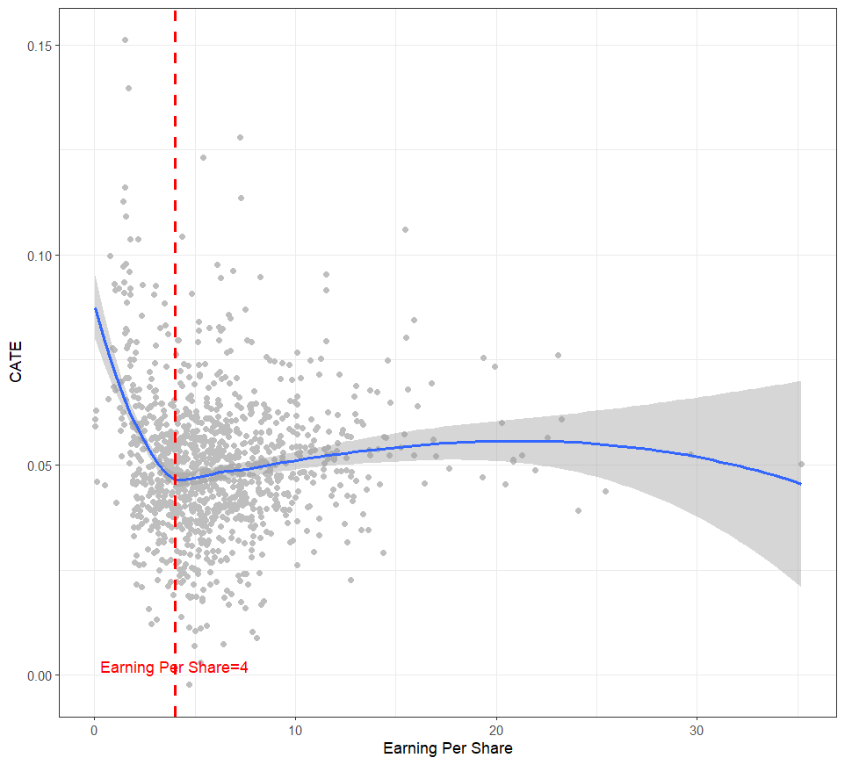
VI. Empirical results analysis
The phenomenon of IPO underpricing is prevalent in global capital markets and is particularly pronounced in China’s A-share market, continuously attracting considerable attention from both academia and industry. Traditional financial theories fail to fully account for this phenomenon, while behavioral finance perspectives suggest that investor sentiment may play a critical role in influencing IPO pricing efficiency. Against this backdrop, this study employs investor sentiment data and IPO underpricing data from China’s A-share market between 2019 and 2023, utilizing Double Machine Learning (DML) and Generalized Random Forests (GRF) to systematically examine the impact of investor sentiment on IPO pricing efficiency. Furthermore, the study investigates the heterogeneity of issuance size, issuance P/E ratio, and earnings per share (EPS).
The empirical results demonstrate that investor sentiment has a significant positive effect on IPO underpricing, and this conclusion remains robust after controlling for endogeneity and conducting multiple robustness checks. Further analysis reveals that firm-specific characteristics exert heterogeneous moderating effects on the relationship between sentiment and IPO pricing efficiency. Specifically, issuance size plays a pivotal differentiating role: smaller offerings are more susceptible to sentiment fluctuations, while larger issues exhibit stronger stability and more rational pricing. Similarly, issuance P/E ratio displays an inverted-U moderating effect—sentiment exerts limited influence at both low and high valuation levels but reaches its peak at moderate levels, indicating the strongest sentiment-driven impact. Earnings per share also reflects a nonlinear moderating pattern: firms with weak profitability or in loss-making positions are more sentiment-driven, whereas highly profitable firms remain influenced by sentiment to a lesser extent.
Based on these findings, this paper proposes the following policy recommendations:
First, increase the proportion of new share issuance and expand issuance scale. The core objective is to establish a flexible issuance mechanism that dynamically adjusts supply according to market conditions, thereby meeting the financing needs of high-quality enterprises while maintaining supply-demand balance. Implementation should particularly support technology innovation and strategic emerging industries, accompanied by the improvement of market-oriented pricing mechanisms and stabilization tools, as well as necessary buffer measures and investor protection systems to preserve both vitality and stability in the market.
Second, design differentiated trading mechanisms for new shares. Regulators may categorize listed firms into growth, mature, and special types according to firm characteristics and risk profiles, and apply differentiated price fluctuation limits accordingly: wider ranges for growth firms to strengthen price discovery, stable limits for mature firms, and transitional arrangements for special firms. In addition, liquidity adjustment factors and circuit breakers should be introduced, along with reinforced market-making responsibilities, enhanced investor suitability management, and stricter disclosure requirements, thereby improving pricing efficiency while containing risks.
Third, strengthen the monitoring of abnormal trading activities. Establish intelligent real-time monitoring systems to detect behaviors such as frequent cancellations and abnormal volatility, and implement tiered supervision with watchlists for high-frequency accounts. A comprehensive framework for the identification and management of abnormal transactions should be developed, with manipulative behaviors placed under priority supervision. By promoting cross-agency data sharing and fast-response mechanisms, regulatory effectiveness can be enhanced to balance market dynamism with risk prevention, thereby fostering the healthy development of the IPO market.

References
[1] Fang Ziyi. A Study on the Impact of Investor Sentiment Differences on the A+H Share Premium [D]. Chengdu: Southwest University of Finance and Economics, 2023. DOI: 10.27412/d.cnki.gxncu.2023.001615. (Pages: Full text)
[2] Xu Yujia. Study on the Impact of Investor Sentiment on IPO Premiums in the A-share Market [D]. Nanning: Guangxi University, 2018. DOI: CNKI: CDMD: 2.1018.132444. (Pages: Full text)
[3] Yan Shulian. Analysis of IPO Market Investment Behaviour Based on Investor Sentiment [D]. Chengdu: Southwest University of Finance and Economics, 2012. (Pages: Full text)
[4] Lyu Dongkai, Jiang Xianling. A Study on the Anomaly of IPO Issue Price Premium and Investor Sentiment [J]. Economics and Management, 2023, 27(1): 32-36. (Pages: 32-36)
[5] Lü Jialing. A Study on Investor Sentiment and IPO Undervaluation [D]. Wuhan: Wuhan University of Technology, 2019. DOI: 10.27381/d.cnki.gwlgc.2019.001814. (Pages: Full text)
[6] Sun Ziyuan. Research on the Initial Returns and Long-term Trends of IPOs Based on Discounts and Premiums [D]. Beijing: China University of Mining and Technology, 2009. (Pages: Full text)
[7] Guo Zhaocheng. An Empirical Study on the Impact of Investor Sentiment on Individual Stock Returns in China’s A-Share Market [D]. Shanghai: Shanghai University of Finance and Economics, 2020. DOI: 10.27296/d.cnki.gshcu.2020.001427. (Pages: Full text)
[8] Ye Yanyan. An Empirical Study on the Impact of Investor Sentiment on IPO Undervaluation [D]. Jinan: Shandong University, 2014. (Pages: Full text)
[9] Xie Taifeng, Gao Yi. Study on the Impact of Investor Sentiment on IPO Premium in China’s Growth Enterprise Market [J]. Financial Theory and Practice, 2016, (4): 63-67. (Pages: 63-67)
[10] Qin Zhiqiang. A Study on Stock Premium Based on Investor Sentiment [D]. Qingdao: Qingdao University, 2009. (Pages: Full text)
[11] He Jinan, Peng Fangping, Xie Xiuying. Mixed Ownership Reform, Political Connections, and Enterprise Innovation: Based on Dual/Unbiased Machine Learning Methods [J]. Research on Science and Technology Management, 2022, (11): 116-126. (Pages: 116-126)
[12] Shiller, R. J. Irrational Exuberance (1st ed.) [M]. Princeton: Princeton University Press, 2000. (Pages: Full text)
[13] Rock, K. Why new issues are underpriced [J]. Journal of Financial Economics, 1986, 15(1-2): 187-212. (Pages: 187-212)
[14] Ljungqvist, A., Nanda, V., & Singh, R. Hot markets, investor sentiment, and IPO pricing [J]. Journal of Business, 2007, 79(4): 1667-1702. (Pages: 1667-1702)
[15] Cornelli, F., Goldreich, D., & Ljungqvist, A. Investor sentiment and pre-IPO markets [J]. Journal of Finance, 2006, 61(3): 1187-1216. (Pages: 1187-1216)
[16] Wang Ruting, Peng Fangping, Li Wei, Wang Chunli. Can breaking rigid redemption reduce corporate financing costs? [J]. Management World, 2022, (4): 42-56. (Pages: 42-56)
[17] Athey, S., Tibshirani, J., & Wager, S. Generalized Random Forests [J]. Annals of Statistics, 2019, 47(2): 1148-1178. (Pages: 1148-1178)
[18] Chernozhukov, V., Chetverikov, D., Demirer, M., Duflo, E., Hansen, C., Newey, W., Robins, J. Double/Debiased Machine Learning for Treatment and Structural Parameters [J]. Econometrics Journal, 2018, 21(1): C1-C68. (Pages: C1-C68)
[19] Knittel, C. R., & Stolper, S. Machine Learning about Treatment Effect Heterogeneity: the Case of Household Energy Use [R]. AEA Papers and Proceedings, 2021, 111: 440-444. (Pages: 440-444)
[20] Yang, J., Chuang, H., & Kuan, C. Double Machine Learning with Gradient Boosting and Its Application to the Big N Audit Quality Effect [J]. Journal of Econometrics, 2020, 216(1): 268-283. (Pages: 268-283)
[21] Zhang, Y., Li, H., & Ren, G. Quantifying the Social Impacts of the London Night Tube with a Double/Debiased Machine Learning Based Difference-in-Differences Approach [J]. Transportation Research Part A: Policy and Practice, 2022, 163: 288-303. (Pages: 288-303)
[22] Chiang, H. D., Kato, K., Ma, Y., & Sasaki, Y. Multiway Cluster Robust Double/Debiased Machine Learning [J]. Journal of Business & Economic Statistics, 2022, 40(3): 1046-1056. (Pages: 1046-1056)
[23] Bodory, H., Huber, M., & Laffers, L. Evaluating (Weighted) Dynamic Treatment Effects by Double Machine Learning [J]. Econometrics Journal, 2022, 25(3): 628-648. (Pages: 628-648)
[24] Loughran, T., & Ritter, J. R. Why has IPO underpricing changed over time [J]. Financial Management, 2004, 33(3): 5-37. (Pages: 5-37)
[25]He Jin’an, Peng Fangping, & Xie Xiuying. (2022). Mixed-Ownership Reform, Political Connections, and Corporate Innovation: Based on Double/Debiased Machine Learning Methods. Science and Technology Management Research, (11), 116–126.
[26]Athey S.， Tibshirani J.， Wager S.，2019，Generalized Random Forests［J］， Annals of Statistics，47（2），1148~1178.
[27]Davis J. M. V.， Heller S. B.，2020，Rethinking the Benefits of Youth Employment Programs: The Heterogeneous Effects of Summer Jobs［J］， Review of Economics and Statistics，102（4），664~677.
[28]Liu, S., Zhang, X., & Yang, Z. (2021). The impact of Internet use on rural household income. The Journal of Quantitative & Technical Economics, 38(4), 103–119.

