Consent
Welcome to this study in economic decision-making.
You will receive a fixed 7 euros show-up fee, and you may earn additional payments depending on your performance in the tasks. This is an individual decision-making study, so other people’s decisions do not influence your payoff.
Participation to this study is voluntary, and you may leave at any time. To ensure a fair and quiet session, please refrain from talking to other participants. Using mobile phones or other devices during the experiment is prohibited. The session will last about 90 minutes.
By clicking “Start”, you confirm that you have read this information and consent to participate in the study.
Instructions
This study is composed of three parts. In each part you participate in 12 rounds of decision-making. In each round, you will be asked to make two choices. We refer to these as “Consumption choice” and “Price belief”. Either of these choices can be relevant to your final payoff. The three parts differ by the timing when you make these choices. The specific instruction for each part will be given to you at the beginning of each part.

Consumption choice:
Each round represents two time periods, called Period 1 and Period 2. In each round, you will receive an endowment of virtual goods in both periods. We denote the endowment in Period 1 by $E_{1}$ and the endowment in Period 2 by $E_{2}$.
These endowments will be either
- $E_{1}=15$ and $E_{2}=5$
or
- $E_{1}=5$ and $E_{2}=15$
In 6 rounds, you will get the first endowment profile, and in the other 6 rounds, you will get the second endowment profile. However, the order in which these profiles appear is random.
Your task is to choose how much to consume in Period 1. We denote this consumption choice by $C_{1}$. Based on your Period 1 consumption choice, your consumption in Period 2 (denoted $C_{2}$) is automatically determined. The latter depends on the price in Period 2.
The price of consumption goods in Period 1 is fixed at $P_{1}=1$.
The price of consumption goods in Period 2, $P_{2}$, is randomly determined. It will be either:
  - $P_{2}=0.5$ (50 % lower than $P_{1}$),
or
  - $P_{2}=2$ (100 % higher than $P_{1}$).
The two possible price levels for $P_{2}$ have an equal probability (50% chance).
Consumption payoff:
Your consumption payoff points earned each round are calculated with
$$"Consumption Payoff" = C_{1}× C_{2}$$
You will be given tables showing the possible payoff points you can earn for various integer $C_{1}$ choices, depending on the endowment profile you receive and on the period 2 price, $P_{2}$.
You can also insert numbers with up to one decimal in the box below the table. The associated payoff points will be shown to you in the same line.
Saving and Borrowing:
You can save or borrow using money. Your Period 1 saving or borrowing is determined by how your consumption choice $C_{1}$ compares to your Period 1 endowment $E_{1}$.
- If you consume fewer units than your Period 1 endowment ($C_{1}< E_{1}$), you save $E_{1}- C_{1}$ units of money, that you can carry over to Period 2. You may think of this as selling $E_{1}- C_{1}$ units of the good at price $P_{1}=1$. These savings will be used to buy additional consumption goods in Period 2 at the price $P_{2}$. Then, your Period 2 consumption will be:
$$C_{2}=E_{2}+\frac{E_{1}- C_{1}}{P_{2}}$$
- If you consume more units than your Period 1 endowment ($C_{1}> E_{1})$, you borrow $C_{1}- E_{1}$ units of money, that you must repay in Period 2. You may think of this as buying $C_{1}- E_{1}$ units of the good at price $P_{1}=1$. These borrowings will be repaid by selling a part of your endowment in Period 2 at the price $P_{2}$. Then, your Period 2 consumption will be
$$C_{2}=E_{2}-\frac{C_{1}- E_{1}}{P_{2}}$$
There is no interest earned on saving, nor is there any interest charged on borrowing.
Constraints on your consumption choice
Your consumption choice is restricted to be in the range:
$1{≤C}_{1}≤ E_{1}+\frac{E_{2}- 1}{2}$ .
This restriction makes sure that you consume at least 1 unit of the good in each period even if you have to repay your borrowing and that you will always be able to repay your borrowing whatever the price in Period 2 will be.
Price belief:
In each round you will receive a hint for the randomly chosen price level for Period 2. The timing, when you receive this hint, differs between the three parts.
This hint consists of a graph containing 400 red and blue dots. Figure below shows an example. Every round, there will be a different hint graph.
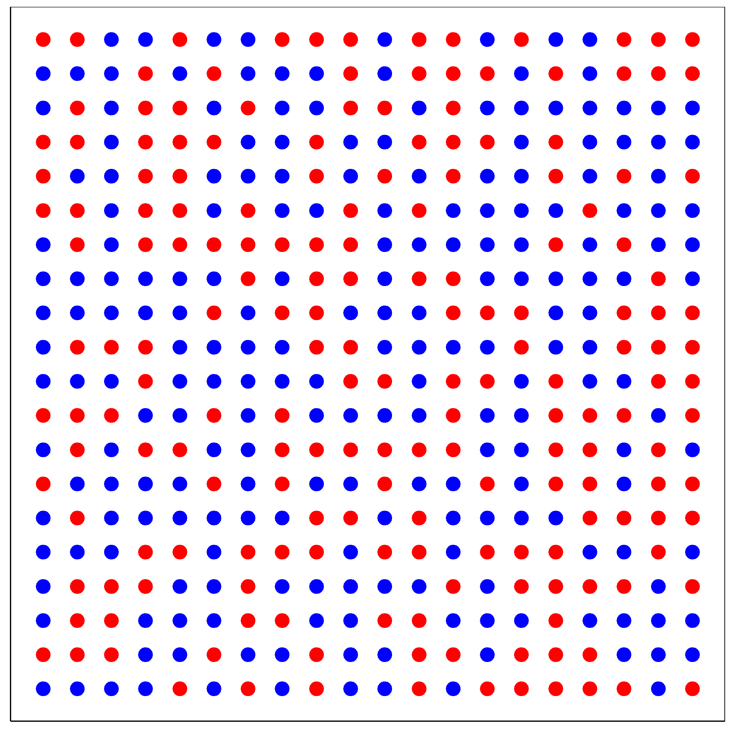
Figure: Example hint.
If a majority of the dots (>200) are colored blue, the price level $P_{2}=0.5$.
If a majority of the dots (>200) are colored red, the price level $P_{2}=2$.
The number of blue and red colored dots will never be equal. When you click the “Get hint” button, you will only have 8 seconds to see this graph. After you saw the graph, you will be asked to state your belief about whether the majority of dots is red.
You can state your belief using a slider or type the probability that you attribute to the majority of dots being red. This probability is denoted by $R$. Selecting 100% would indicate that you are certain that more than half of the dots are red. Selecting 0% would indicate that you are certain that more than half of the dots are blue. However, if you are uncertain, you may state any probability between 0% and 100%.
Belief payoff:
You can earn a bonus payoff of 2 Euros that is determined by how close your stated probability is to the actual outcome. More specifically, you will receive 2 Euros with probability $R^{2}$ if the majority of dots was red. If the majority of dots was blue, you receive 2 Euros with the probability ${(1-R)}^{2}$. This rule makes sure that it is in your own interest to state your true belief.
Final payoff:
At the end of the experiment, one of the 36 rounds will be randomly selected and your consumption payoff points from that round will determine your final monetary payoff. Another one of the 36 rounds will be randomly selected for the reward on your stated belief.
For both chosen rounds, we will remind you of your decisions and show you the actual outcomes. For the consumption choice, we will show you the actual Period 2 price level and the computer will calculate your resulting payoff points. For beliefs, the computer will run a lottery to determine whether you earned the 2 Euros bonus using your stated probability. You will only see the actual outcomes for these two randomly chosen rounds.
Training rounds:
On the next screen, we will ask you a few questions about these instructions to ensure you understand them. Then, there will be two training rounds. These rounds are designed to familiarize you with the consumption decision screen. There will not be a price hint. Your decisions during these rounds will not affect your final payoff. We will provide feedback on your consumption decisions during these training rounds.

Specific rules for the three parts:
Part 1 instructions
In this part, each round will start with the price hint. You have to check the hint by clicking on the “Get hint” button so that you can see the matrix with red and blue dots for 8 seconds. Then you must state the probability that you attribute to the majority of dots being red.
Once you confirmed the stated probability that you attribute to the majority of dots being red, you will be informed about your endowment profile and the potential payoffs associated with the various possible consumption choices for both prices. You will also see your own stated belief for $P_{2}=2$.
After selecting and confirming your consumption choice, the next round starts with a new price hint.
This procedure is repeated for 12 rounds.
Part 2 instructions:
In this part, each round will start with an information about your endowment profile in this period. You will also see the table with the possible consumption choices and the potential payoffs associated with these choices for both prices. However, you cannot yet make your consumption choice. Before you can do that, you will get the hint for the price level in Period 2.
To proceed, you must click on the button “I saw my endowment profile and want to proceed”. After you clicked this button, you will get the price hint for this round.
Once you confirmed the stated probability that you attribute to the majority of dots being red, you will be reminded about your endowment profile and the potential payoffs associated with the various possible consumption choices for both prices. You will also see your own stated belief for $P_{2}=2$. Now you can make a consumption choice.
After confirming your consumption choice, the next round starts with an information about next period’s endowment.
This procedure is repeated for 12 rounds.
Part 3 instructions:
In this part, each round will start with an information about your endowment profile in this period. You will also see the table with the possible consumption choices and the potential payoffs associated with these choices for both prices. In this part, you have to make your consumption choice before you get the hint for the period 2 price.
Recall that the probabilities for the price in Period 2 being $P_{2}=0.5$ or $P_{2}=2$ are 50% each. Thus, both events are equally likely.
After selecting and confirming your consumption choice, you will get the price hint for this round.
Once you confirmed the stated probability that you attribute to the majority of dots being red, the next round starts with an information about next period’s endowment and a new consumption choice.
This procedure is repeated for 12 rounds.

