Consent
Welcome to this study in economic decision-making.
You will receive a fixed 7 euros show-up fee, and you may earn additional payments depending on your performance in the tasks. This is an individual decision-making study, so other people’s decisions do not influence your payoff.
Participation to this study is voluntary, and you may leave at any time. To ensure a fair and quiet session, please refrain from talking to other participants. Using mobile phones or other devices during the experiment is prohibited. The session will last about 90 minutes.
By clicking “Start”, you confirm that you have read this information and consent to participate in the study.
Instructions
This study is composed of three parts. In each part you participate in 12 rounds of decision-making. In each round, you will be asked to make two choices. We refer to these as “Consumption choice” and “Price belief”. Both of these choices may affect your final payoff. The specific instruction for each part will be given to you at the beginning of each part.

Consumption choice:
Each round represents two time periods, called Period 1 and Period 2. In each round, you will receive an endowment of virtual goods in both periods. We denote the endowment in Period 1 by $E_{1}$ and the endowment in Period 2 by $E_{2}$.
These endowments will be either
- $E_{1}=15$ and $E_{2}=5$
or
- $E_{1}=5$ and $E_{2}=15$
In 6 rounds, you will get the first endowment profile, and in the other 6 rounds, you will get the second endowment profile. However, the order in which these profiles appear is random.
Your task is to choose how much to consume in Period 1. We denote this consumption choice by $C_{1}$. Based on your Period 1 consumption choice, your consumption in Period 2 (denoted $C_{2}$) is automatically determined. The latter depends on the price in Period 2.
The price of consumption goods in Period 1 is fixed at $P_{1}=1$.
The price of consumption goods in Period 2, $P_{2}$, is randomly determined. It will be either:
  - $P_{2}=0.5$ (50 % lower than $P_{1}$),
or
  - $P_{2}=2$ (100 % higher than $P_{1}$).
The two possible price levels for $P_{2}$ have an equal probability (50% chance).
Consumption payoff:
Your consumption payoff points earned each round are calculated with
$$"Consumption Payoff" = C_{1}× C_{2}$$
You will be given tables showing the possible payoff points you can earn for various integer $C_{1}$ choices, depending on the endowment profile you receive and on the period 2 price, $P_{2}$.
You can also insert numbers with up to one decimal in the box below the table. The associated payoff points will be shown to you in the same line.
Saving and Borrowing:
You can save or borrow using money. Your Period 1 saving or borrowing is determined by how your consumption choice $C_{1}$ compares to your Period 1 endowment $E_{1}$.
- If you consume fewer units than your Period 1 endowment ($C_{1}< E_{1}$), you save $E_{1}- C_{1}$ units of money, that you can carry over to Period 2. You may think of this as selling $E_{1}- C_{1}$ units of the good at price $P_{1}=1$. These savings will be used to buy additional consumption goods in Period 2 at the price $P_{2}$. Then, your Period 2 consumption will be:
$$C_{2}=E_{2}+\frac{E_{1}- C_{1}}{P_{2}}$$
- If you consume more units than your Period 1 endowment ($C_{1}> E_{1})$, you borrow $C_{1}- E_{1}$ units of money, that you must repay in Period 2. You may think of this as buying $C_{1}- E_{1}$ units of the good at price $P_{1}=1$. These borrowings will be repaid by selling a part of your endowment in Period 2 at the price $P_{2}$. Then, your Period 2 consumption will be
$$C_{2}=E_{2}-\frac{C_{1}- E_{1}}{P_{2}}$$
There is no interest earned on saving, nor is there any interest charged on borrowing.
Constraints on your consumption choice
Your consumption choice is restricted to be in the range:
$1{≤C}_{1}≤ E_{1}+\frac{E_{2}- 1}{2}$ .
This restriction makes sure that you consume at least 1 unit of the good in each period even if you have to repay your borrowing and that you will always be able to repay your borrowing whatever the price in Period 2.
Price belief:
In each round you will receive a hint for the randomly chosen price level for Period 2. The timing, when you receive this hint, differs between the three parts.
This hint consists of a graph containing 400 red and blue dots. Figure below shows an example. Every round, there will be a different hint graph.
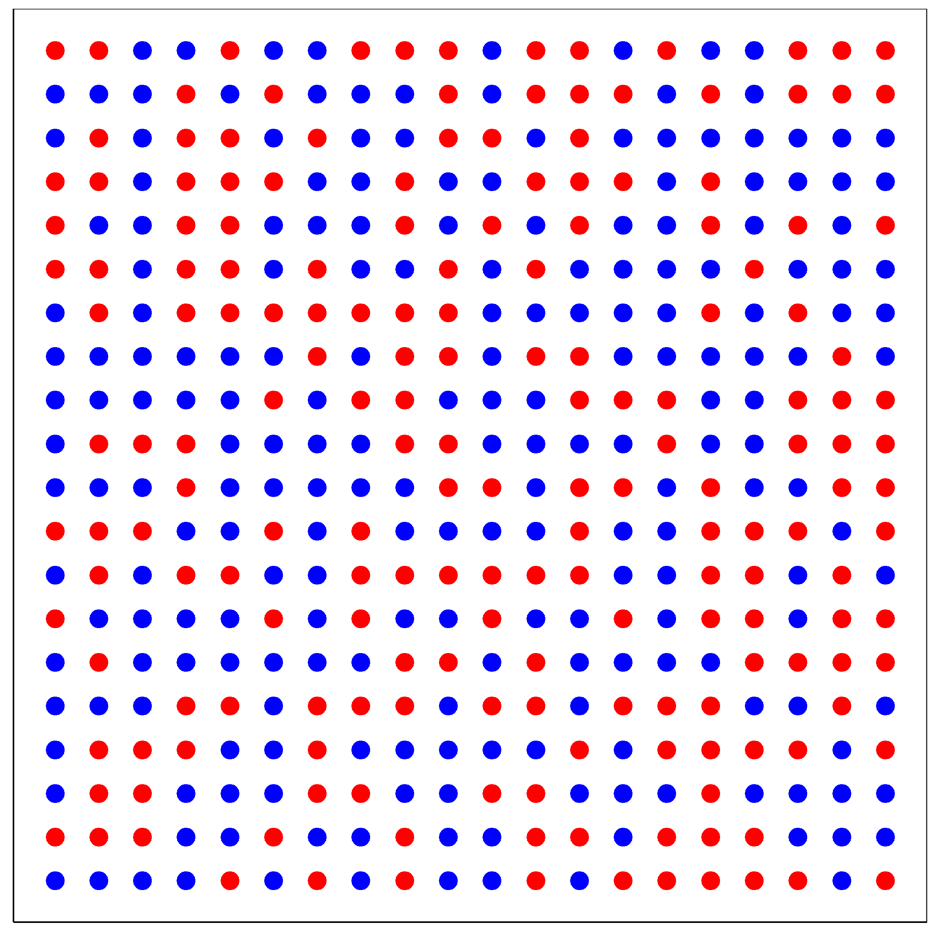
Figure: Example hint.
If a majority of the dots (>200) are colored blue, the price level $P_{2}=0.5$.
If a majority of the dots (>200) are colored red, the price level $P_{2}=2$.
The number of blue and red colored dots will never be equal. When you click the “Get hint” button, you will only have 8 seconds to see this graph. After you saw the graph, you will be asked to state your belief about whether the majority of dots is red.
You can state your belief using a slider or type the probability that you attribute to the majority of dots being red. This probability is denoted by $R$. Selecting 100% would indicate that you are certain that more than half of the dots are red. Selecting 0% would indicate that you are certain that more than half of the dots are blue. However, if you are uncertain, you may state any probability between 0% and 100%.
Belief payoff:
You can earn a bonus payoff of 2 Euros that is determined by how close your stated probability is to the actual outcome. More specifically, you will receive 2 Euros with probability $R^{2}$ if the majority of dots was red. If the majority of dots was blue, you receive 2 Euros with the probability ${(1-R)}^{2}$. This rule makes sure that it is in your own interest to state your true belief.
Final payoff:
At the end of the experiment, one round in each part will be randomly selected and your consumption payoff points from these rounds will determine your final monetary payoff. We will transform payoff points to euro with 1 to 20 ratio (100 points = 5 euros). Another round in each part will be randomly selected for the reward on your stated belief.
For both chosen rounds, we will remind you of your decisions and show you the actual outcomes. For the consumption choice, we will show you the actual Period 2 price level and the computer will calculate your resulting payoff points. For beliefs, the computer will run a lottery to determine whether you earned the 2 Euros bonus using your stated probability. You will only see the actual outcomes for these randomly chosen rounds.
Training rounds:
On the next screen, we will ask you a few questions about these instructions to ensure you understand them. Then, there will be two training rounds. Your decisions during these rounds will not affect your final payoff. These rounds are designed to familiarize you with tasks. We will provide feedback on your decisions during these training rounds.
Comprehension questions
Question 1: Other people's decisions will influence my payoff. (True/False*)
Feedback message if answer is incorrect: “This is an individual decision-making study, so other people’s decisions do not influence your payoff.”
Question 2: Suppose Period 1 endowment is 5. How many points do you borrow if you decide to consume 9 units? (Nothing, 4*, 14, 10)
Feedback message if answer is incorrect: “If you consume more units than you have in your endowment in Period 1, then you borrow $C_{1}- E_{1}$ units of money which you will repay at the price level in Period 2. In this example, the endowment is 5 and consumption is 9, resulting in a 4 unit loan.”
Question 3: Without the hint, the probability of price of consumption good to increase is 50%. (True*/False)
Feedback message if answer is incorrect: “In Period 1, the price of the consumption good is 1. In Period 2, the price can decrease to 0.5 (a 50% decrease) or increase to 2 (a 100% increase), and these outcomes are equally likely. Therefore, the probability that the price of the consumption good will increase is 50%.”
Question 4: When you click on “Get hint” button, the hint will be shown for … (8 seconds*, 30 seconds, 1 minute, unlimited time).
Feedback message if answer is incorrect: “The price hint in each round will be shown only for 8 seconds. Each round, there will be a new hint.”
Question 5: The price will increase if the majority of the dots are red (True*/False).
Feedback message if answer is incorrect: "If there are more red dots than blue dots, then the price in Period 2 will be 2."
Specific rules for the three parts
Part 1 instructions
In this part, each round will start with the price hint about Period 2. You have to check the hint by clicking on the “Get hint” button so that you can see the matrix with red and blue dots for 8 seconds. Then you must state the probability that you attribute to the majority of dots being red.
Once you confirmed the stated probability that you attribute to the majority of dots being red, you will be informed about your endowment profile and the potential payoffs associated with the various possible consumption choices for both prices. You will also see your own stated belief for $P_{2}=2$.
After selecting and confirming your consumption choice, the next round starts with a new price hint.
This procedure is repeated for 12 rounds.
Part 2 instructions:
In this part, each round will start with an information about your endowment profile in this period. You will also see the table with the possible consumption choices and the potential payoffs associated with these choices for both prices. However, you cannot yet make your consumption choice. Before you can do that, you will get the hint for the price level in Period 2.
To proceed, you must click on the button “Get hint”. After you clicked this button, you will see the price hint for this round for 8 seconds.
Once you stated and confirmed the probability that you attribute to the majority of dots being red, you will be reminded about your endowment profile and the potential payoffs associated with the various possible consumption choices for both prices. You will also see your own stated belief for $P_{2}=2$. Now you can make a consumption choice.
After confirming your consumption choice, the next round starts with an information about next period’s endowment.
This procedure is repeated for 12 rounds.
Part 3 instructions:
In this part, each round will start with an information about your endowment profile in this period. You will also see the table with the possible consumption choices and the potential payoffs associated with these choices for both prices. In this part, you have to make your consumption choice before you get the hint for the period 2 price.
Recall that the probabilities for the price in Period 2 being $P_{2}=0.5$ or $P_{2}=2$ are 50% each. Thus, both events are equally likely.
After selecting and confirming your consumption choice, you will get the price hint for this round.
Once you stated and confirmed the stated probability that you attribute to the majority of dots being red, the next round starts with an information about next period’s endowment and a new consumption choice.
This procedure is repeated for 12 rounds.

Post-experimental questionnaire
Page 1:
Question 1: What is your age? [open-ended]
Question 2: What is your gender? (female, male, other)
Question 3: What is the highest degree or level of education you have completed? (Abitur/Fachabitur, Berufsausbildung, Bachelor, Diplom/Master/Magister, other)
Page 2:
Question 4: Please rate the following statements: [Likert 1-7]
- I often start out expecting the worst, even though I will probably do OK.
- I worry about how things will turn out.
- I often worry that I won’t be able to carry through my intentions.
- I spend lots of time imagining what could go wrong.
- I imagine how I would feel if things went badly.
- In these situations, sometimes I worry more about looking like a fool than doing really well.
Page 3:
Question 5: How do you see yourself: are you generally a person who is fully prepared to take risks or do you try to avoid taking risks? Please tick a box on the scale, where the value 0 means: ‘not at all willing to take risks’ and the value 10 means: ‘very willing to take risks’.” [Likert 0-10]
Question 6: Please rate the following statement: “Debt is an integral part of today’s life.” [Likert 1-6]
Question 7: What do you think how does the average participant in this experiment rate the following statement? “There is no excuse for borrowing money.” [Likert 1-6]
Question 8: Have you ever taken out a loan? [Never, Once, 2-3 times, more than 3 times]
Page 4:
Question 9: Imagine you put 100 € into a savings account with a fixed interest rate of 2% per year. You leave the money there for 5 years and do not make any further deposits or withdrawals. How much will you have on the account after 5 years? [More than 110 €, Exactly 110 €, Less than 110 €, Don’t know]
Question 10: Imagine the interest rate on your savings account is 1% per year and inflation is 2% per year. After 1 year, with the money in this account, you would be able to buy… [More than today, Exactly the same as today, Less than today, Don’t know]
Question 11: Suppose inflation turns out to be higher than people expected when they signed their loan and savings contracts. Who benefits the most from this situation? [People with large fixed-rate debts (e.g. mortgages), People with savings, People with no debts or savings, Don’t know]
Final payment screen
Thank you for taking part in this study. Your total payment is: __ euros.
Below you see how your final payment has been determined. For each part, one round was randomly selected for your consumption payoff and one round was randomly selected for your belief payoff.

Part 1:
Consumption payoff
- Selected round: ___
- Your endowment was E1=__, E2=__
- In this round, your Period 1 consumption choice was: ___
- The actual Period 2 price level was: ___
- Your resulting Period 2 consumption was: __
- Your resulting consumption payoff in this round is: ___ points
Belief payoff
- Selected round: ___
- Your stated belief about the chance of the high price was: ___%
- The actual price level was: __
- Your probability to win the 2-euro belief bonus was: ___%
- The computer has run the lottery based on your stated probability.
- Result of the belief lottery: You [won/did not win] the 2-euro belief bonus in this part.

Part 2:
Consumption payoff
- Selected round: ___
- Your endowment was E1=__, E2=__
- In this round, your Period 1 consumption choice was: ___
- The actual Period 2 price level was: ___
- Your resulting Period 2 consumption was: __
- Your resulting consumption payoff in this round is: ___ points
Belief payoff
- Selected round: ___
- Your stated belief about the chance of the high price was: ___%
- The actual price level was: __
- Your probability to win the 2-euro belief bonus was: ___%
- The computer has run the lottery based on your stated probability.
- Result of the belief lottery: You [won/did not win] the 2-euro belief bonus in this part.

Part 3:
Consumption payoff
- Selected round: ___
- Your endowment was E1=__, E2=__
- In this round, your Period 1 consumption choice was: ___
- The actual Period 2 price level was: ___
- Your resulting Period 2 consumption was: __
- Your resulting consumption payoff in this round is: ___ points
Belief payoff
- Selected round: ___
- Your stated belief about the chance of the high price was: ___%
- The actual price level was: __
- Your probability to win the 2-euro belief bonus was: ___%
- The computer has run the lottery based on your stated probability.
- Result of the belief lottery: You [won/did not win] the 2-euro belief bonus in this part.

Summary of your total payment
- Total consumption payoff points: ___ points
→ Converted at 100 points = 5 euros: ___ euros
- Total belief bonuses: ___ euros
- Fixed participation fee (show-up fee): 7 euros
Your total payment is: __ euros.

