Term 2-Week 2-Day 2-Important Terminologies and Exercises

Exercise 1. Quick Recap: Visual Flashback!
Directions: Read each statement. Say True if it is correct and False if it is incorrect.
1. Arrows showing the direction of wind are examples of vectors.
2. One visual may contain both a vector and a viewpoint.
3. A photograph taken from directly above is an example of a vector.
4. A viewpoint is the angle or perspective from which something is seen.
5. “Where does it go?” tells a viewpoint.

Exercise 2. Motivational Activity: What Seems Wrong?
Directions: Look at the poster carefully. Observe the details. Tell what seems wrong. Write everything that is wrong.
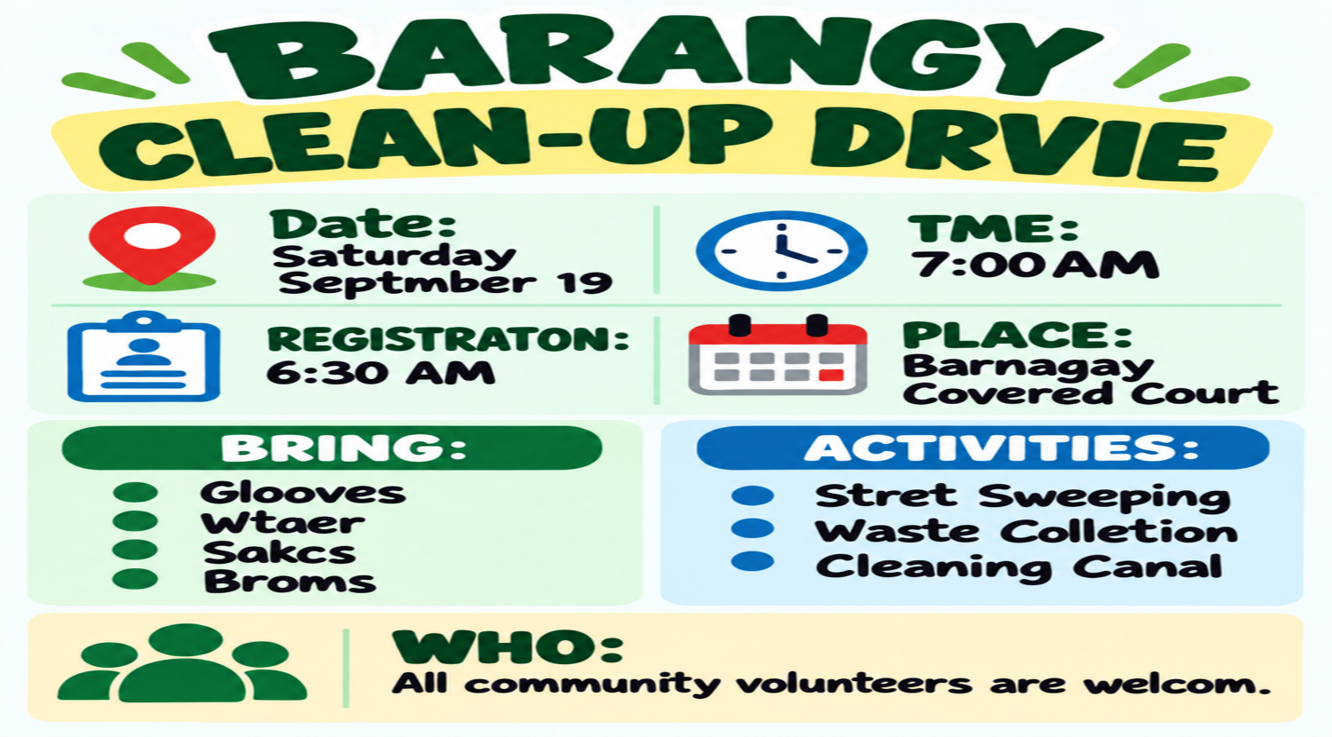
1. _________________________ 2. ___________________________ 3. __________________________
4. _________________________ 5. ___________________________ 6. __________________________
7. _________________________ 8. ___________________________ 9. __________________________
10.________________________ 11.___________________________12.__________________________
13.________________________14.___________________________15.__________________________
16.________________________

Unlocking Content Vocabulary
Key Terms to Know:
1. Layout – the way text, pictures, and other visual elements are arranged on a page or screen.
2. Hierarchy – an arrangement that shows which information should be noticed first, next, and last.
3. Emphasis – special attention given to important information so that it stands out.

Exercise 3. Expressing One’s Ideas
Directions: Answer each question in complete sentences. These are the criteria in rating your answers:
Content=5 Grammar/Mechanics=3 Neatness=2
1.What examples of technical editing are shown? Describe each.
2.What does technical editing do to the information presented?

TECHNICAL EDITING IN INFORMATIONAL TEXTS

Informational texts do not depend only on words. The way information is arranged and presented can help readers understand its meaning more easily. For this lesson, technical editing refers to the careful visual organization and presentation of information.

It may use: headings; labels; charts; graphs; organized layout; emphasis on important information.

I. TECHNICAL EDITING ORGANIZES INFORMATION

Technical editing helps arrange related information so readers can follow it more easily.

Example: Heading

Instead of: Dengue prevention remove standing water use mosquito nets clean containers

Technical editing may arrange it as:

DENGUE PREVENTION
-Remove standing water.
-Use mosquito nets.
-Clean containers regularly.

What does the editing do? It organizes the information into a clear hierarchy.
Readers immediately know: the main topic; the important details; the order of information.

II. TECHNICAL EDITING CLARIFIES INFORMATION
Technical editing may use labels, charts, and graphs to make information easier to understand.

Example: Labels

A science diagram may contain several parts.
Without labels, readers may not know what each part represents.
With labels, readers can immediately identify the parts being discussed.
Technical editing helps by making information clearer.

Example: Chart

Instead of presenting several pieces of information in one long sentence, a chart can arrange them into clear rows or columns.
Technical editing helps by organizing related information.

Example: Graph

A graph can visually present changes or differences so information is easier to follow.
Technical editing helps readers see information more clearly.

III. TECHNICAL EDITING GUIDES ATTENTION

A clear layout and proper emphasis help readers know what information deserves attention first.

Example:

TYPHOON WARNING
SIGNAL NO. 3

Residents should remain indoors.
Making the warning more noticeable helps readers locate the important information immediately.

Technical editing is not simply decoration. A heading, label, chart, graph, layout, or emphasized detail should help the reader understand the information.

Remember: MESSY INFORMATION → TECHNICAL EDITING → CLEARER MEANING

Exercise 4. Drill: Visual Glow-Up: Spot the Edit!
Directions: Look at each Before-and-After visual. Determine the technical editing used in the after version. Then, answer each question below in complete sentences.
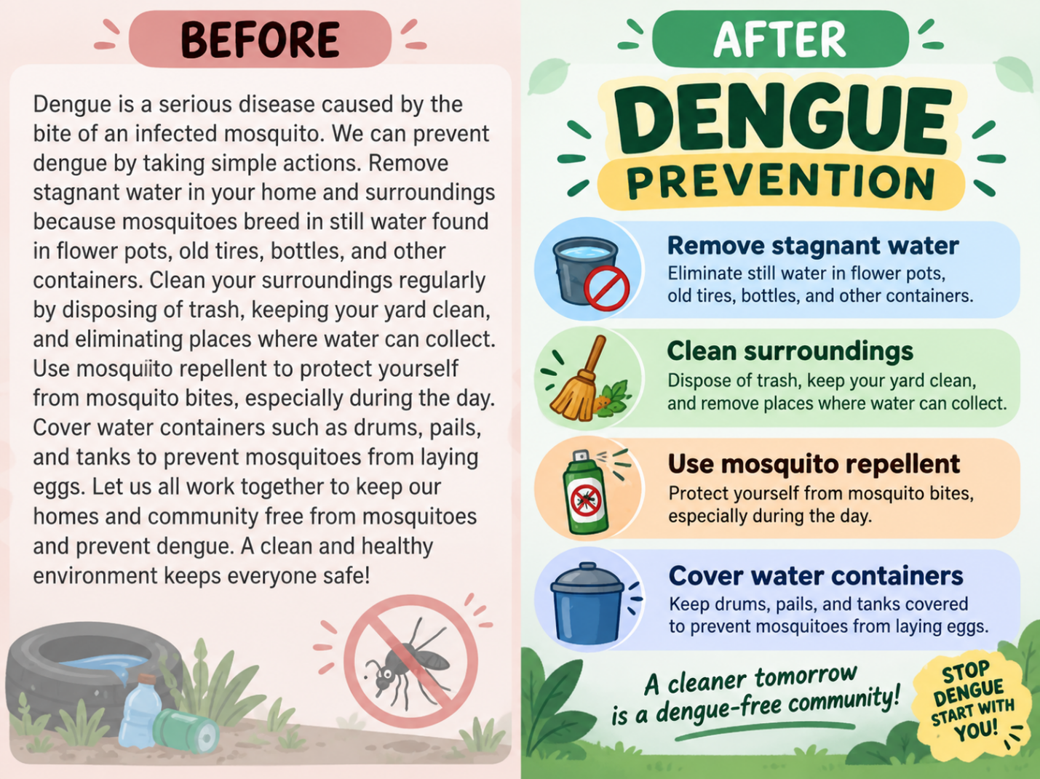

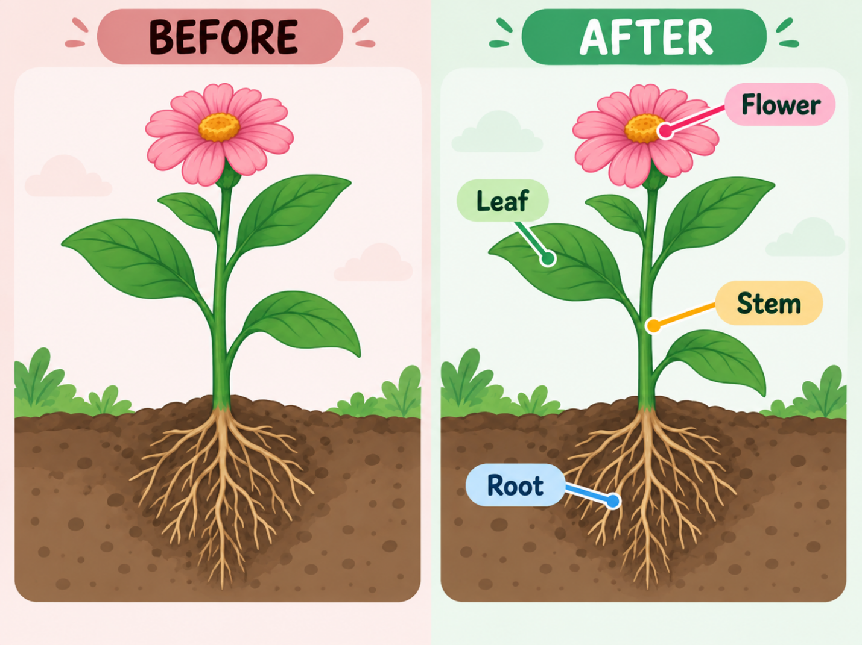

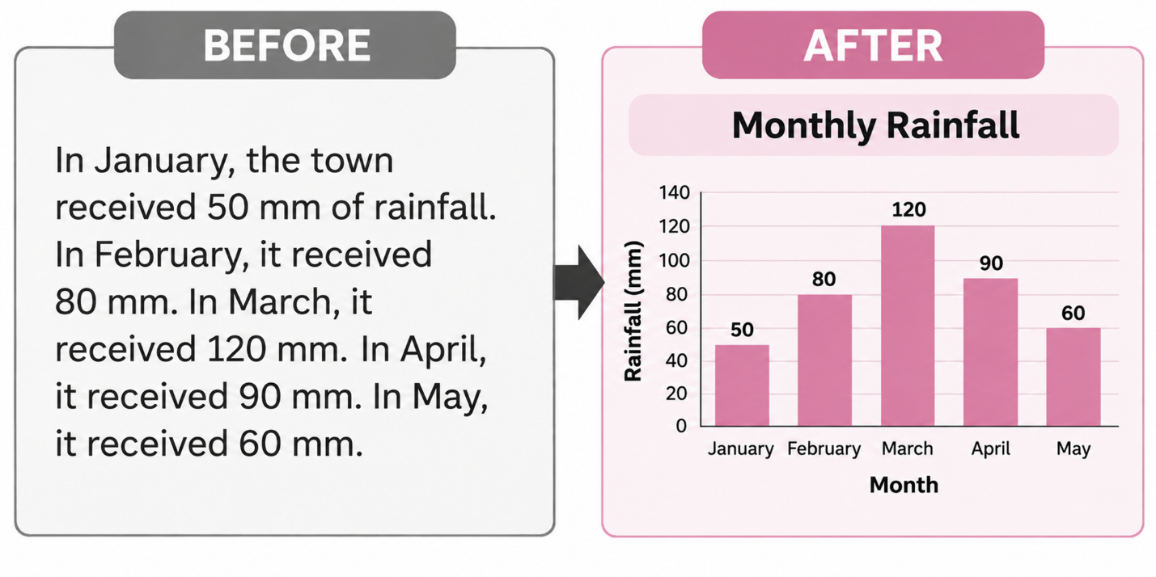
1.What was added in the after version to organize the dengue information?
2.What was added in the after version to identify the parts of the plant?
3.What was used in the after version to present the rainfall amounts more clearly?

Exercise 5. Squad Challenge: Technical Editing Rescue!
Directions: Complete each group of words in order to complete each thought or meaning.

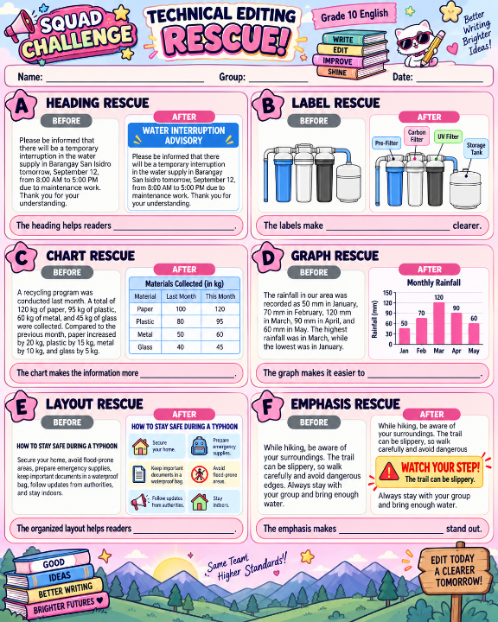

Exercise 6. Answering Questions:
Directions: Answer all the questions in complete sentences.

1. What improvement appeared most often across your six Rescue Captions?
2. Based on the activity, which editing features helped readers follow the information more easily?
3. What is the main role of technical editing in an informational text?
4. A typhoon advisory contains important safety information, but everything is crowded together and the warning level is difficult to notice. Why does clear technical editing matter in this situation?

Exercise 7. Hashtag of the Day!
Directions: Create one short hashtag that describes how technical editing helps present meaning.

#TechnicalEditing = __________________

Exercise 8. Multiple Choice
Directions: Read and analyze the questions carefully. Write the letter of your answer on your paper.
1. A dengue poster places the heading DENGUE PREVENTION above the safety reminders.
The heading helps readers identify the _____.
A. color B. images C. main topic D. safety procedure
2. A plant diagram adds labels beside the flower, leaf, stem, and root.
Determine the result of adding the labels.
A. The parts are named. B. The colors become brighter.
C. The pictures become larger. D. The diagram gains more decoration.
3. A weather report changes monthly rainfall information from a paragraph into a bar graph.
What can readers determine more easily?
A. the title B. the months shown C. the report section D. the differences in monthly rainfall
4. A typhoon advisory displays EVACUATE NOW in large, bold letters.
Which result comes from this editing choice?
A. More color appears. B. The warning stands out.
C. Every detail receives equal attention. D. The advisory no longer needs other instructions.
5. A clean-up announcement separates information under Date, Time, Place, and Things to Bring. Select
the main benefit of this layout.
A. It adds icons. B. It increases the text size.
C. It makes details easier to locate. D. It removes the need for complete information.

Exercise 9. One Poster, Three Clues!
Directions: Study the informational poster. Determine three technical editing features that you notice.
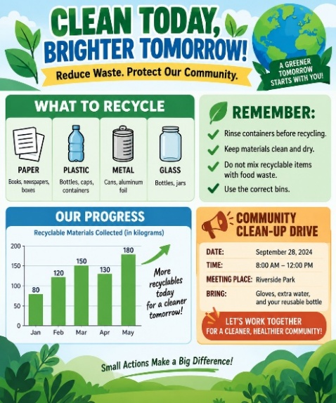

Technical Editing Feature
1. _______________________
2. _______________________
3. _______________________

Technical Editing Feature:
1. _________________________ 2. _________________________ 3. ____________________________

