🚀 Quick Start: ProteinFold Lab
Everything you need to run the lab. Keep this on the back of your worksheet.

① Open it  Your teacher gives you a file or link. Double-click index.html (or open the link). It opens in Chrome, Edge, Safari, or Firefox. No login, no internet needed. | ② Pick a tab  Click a tab at the top: 1 Build & Fold, 2 Mutation Lab, or 3 Denature Lab. Your worksheet tells you when to switch. | ③ Experiment  Change one thing, then wait about 5 seconds and read the bars. Drag the model to spin it. Tap or hover a bead for its name.

Tab 1 · Build & Fold  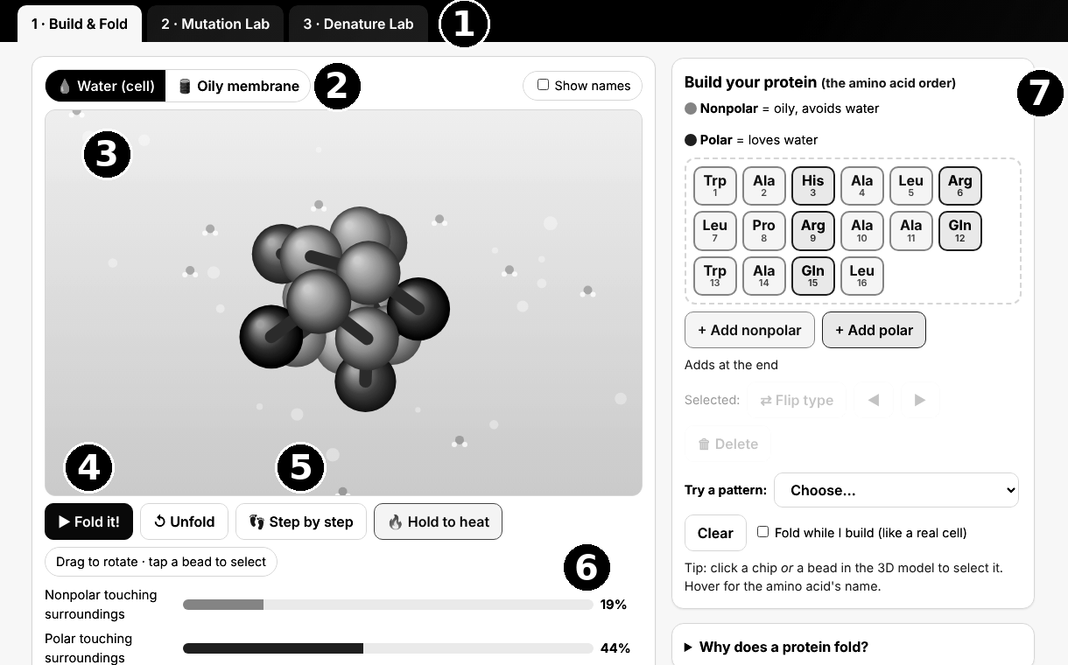
  1 | Tabs switch between labs.
  2 | Water / Oily membrane: where the protein folds.
  3 | The model. Drag to spin it. Hover or tap a bead to see its amino acid.
  4 | ▶ Fold it! starts folding. Unfold resets the chain.
  5 | 👣 Step by step. Forward ▶ adds one amino acid, ◀ Back removes the last.
  6 | Bars: how much of each bead type touches the surroundings. Lower nonpolar = better core.
  7 | Build panel: + Add a bead, click a chip to flip, move, or delete it, or Try a pattern.

Tab 3 · Denature Lab  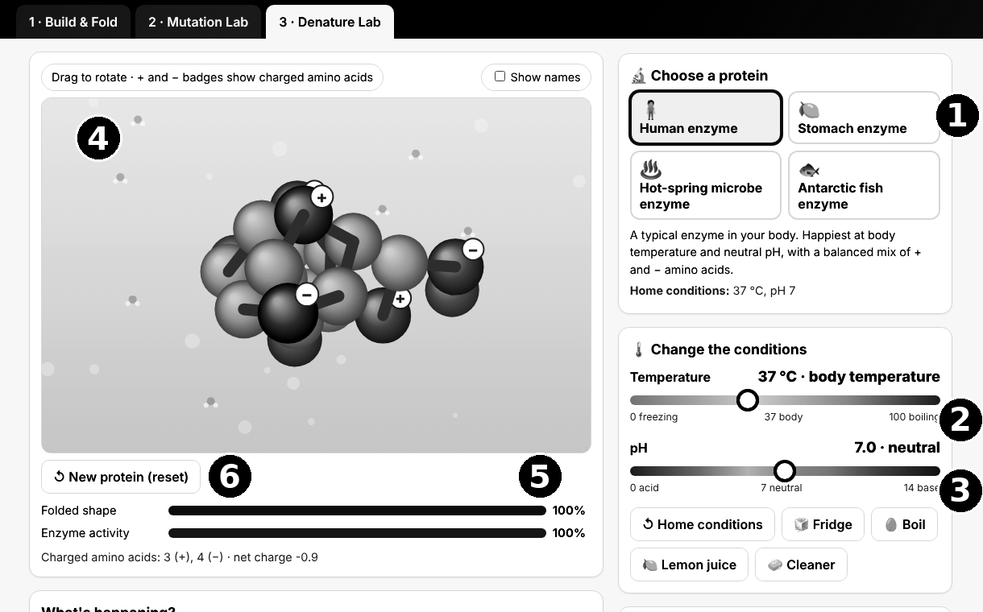
  1 | Choose a protein. Each handles heat and pH differently.
  2 | Temperature slider. Drag it, then wait.
  3 | pH slider. Low = acid, high = base.
  4 | The model. + and − badges are charged amino acids.
  5 | Bars: folded shape and enzyme activity. 100 % = working.
  6 | ↺ New protein (reset). Press it after boiling; a clumped protein stays clumped.

Tab 2 · Mutation Lab  ▶ Fold both folds the normal and mutant chains side by side.  👣 Step by step grows both chains together; watch for the swap at amino acid 6.  Click a chip in the mutant row to flip its type. Red halos = oily beads stuck outside. | If something looks off  Nothing moves? Refresh the page (F5 or ⟳).  Results differ from a classmate’s? Normal. Folding starts from a random shape.  Boiled protein stuck? Press ↺ New protein (reset).

