🧬 ProteinFold Lab
Build it. Fold it. Break it. (30-minute version)

Name: ______________________________ | Date: __________________ | Period: ________

Mission: A protein works because of its 3D shape, and that shape comes from the order of its amino acids. You will watch proteins fold, swap one amino acid, and then break a protein with heat and pH.

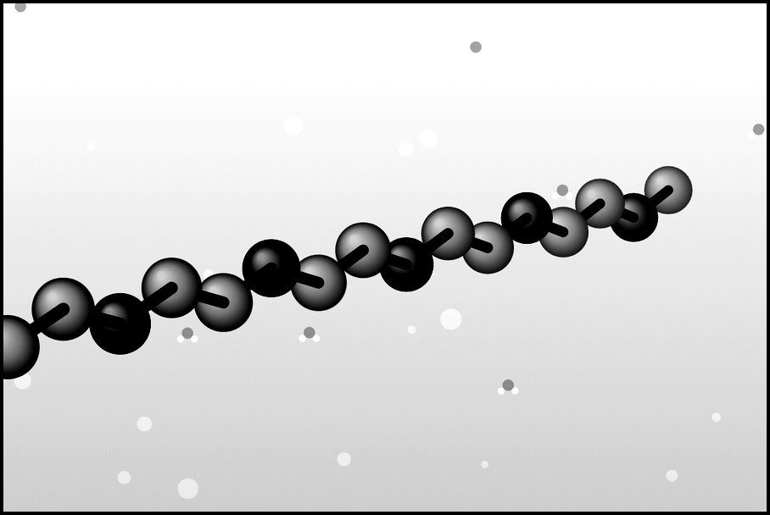  1. Chain of amino acids | ➜ | 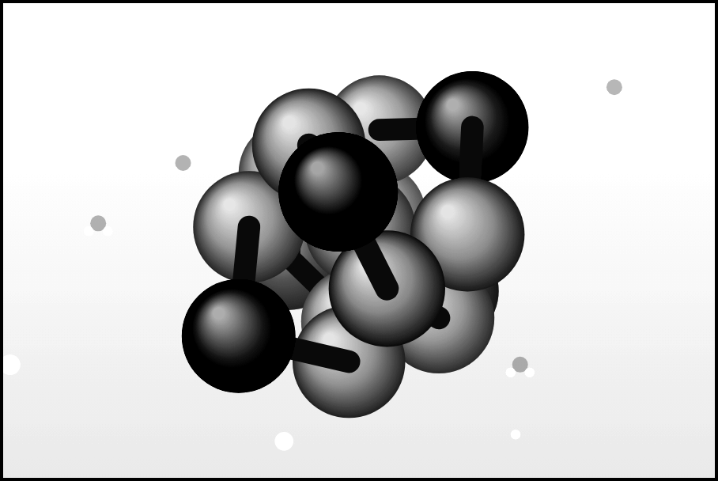  2. It folds | ➜ | 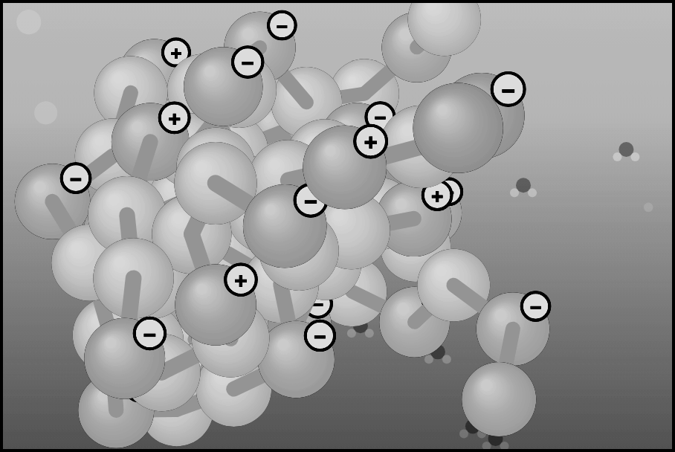  3. Denatured, clumped
● Nonpolar  Oily, avoids water. Orange on screen, gray in print. | ○ Polar  Attracted to water. Blue on screen, black in print. | Hydrophobic core  Middle of a fold where nonpolar amino acids hide. | Denature  Protein loses its shape and job; the order stays.

PART 1 · Build & Fold Tab 1 · about 9 minutes

Do: On 1 · Build & Fold, choose a pattern under “Try a pattern,” press Fold it!, wait 5 seconds, then read the two bars under the model. For the last row, click Oily membrane first and fold the core-and-shell pattern again.
Pattern and place | Which beads end up in the middle? (circle) | Nonpolar touching surroundings | Polar touching surroundings
Alternating N P N P … in water | nonpolar · polar | _______ % | _______ %
Core-and-shell N N P … in water | nonpolar · polar | _______ % | _______ %
Core-and-shell N N P … in oily membrane | nonpolar · polar | _______ % | _______ %
1. Which water pattern hid more nonpolar beads? Use your numbers and say why the pattern helped.

2. In the membrane, which beads hid in the middle? Explain why this is the opposite of water.

PART 2 · Mutation Lab Tab 2 · about 6 minutes

Sickle cell disease starts with one changed amino acid: position 6 goes from Glu (polar) to Val (nonpolar). Do: Open 2 · Mutation Lab, press Fold both, wait 5 seconds, and record.
 | Normal protein | Mutant protein
Nonpolar touching water | _______ % | _______ %
Red-halo beads (oily beads stuck outside) | _______ | _______
3. A red-halo bead is an oily bead on the outside. Why could that cause trouble in a watery cell?

4. In one sentence: how can changing a single amino acid change a protein’s shape?

PART 3 · Denature Lab Tab 3 · about 12 minutes

Weak bonds hold a fold: the oily core, hydrogen bonds, and salt bridges between + and − charged amino acids. Do: Open 3 · Denature Lab, choose the Human enzyme, and let it fold. Change one slider at a time, wait 5 seconds, and read the bars. + and − badges show charged amino acids.
A. Temperature (pH 7)
Temperature | Folded shape % | Enzyme activity % | What did you see? (circle)
4 °C | ______ % | ______ % | folded · unfolded · clumped
37 °C | ______ % | ______ % | folded · unfolded · clumped
70 °C | ______ % | ______ % | folded · unfolded · clumped
100 °C (wait 5 s) | ______ % | ______ % | folded · unfolded · clumped

B. pH Press ↺ New protein first (boiling clumps it for good!), then set 37 °C.
pH | Folded shape % | Charges: (+) and (−) | What did you see? (circle)
pH 2 | ______ % | (+) ____ (−) ____ | folded · unfolded
pH 7 | ______ % | (+) ____ (−) ____ | folded · unfolded
pH 12.5 | ______ % | (+) ____ (−) ____ | folded · unfolded
5. Why does heat unfold a protein? Name the kind of bonds it breaks.

6. At 4 °C the activity was low but the shape was fine. At 100 °C both were low. Which one can be fixed by returning to 37 °C? Explain.

7. At pH 2 the charges changed. Use like charges repel and salt bridges to explain why the protein fell apart.

8. Choose the Stomach enzyme (home pH 2) and slide the pH up to 7. What happens, and why does that make sense for an enzyme that lives in the stomach?

Wrap-up: finish the sentences
A protein’s shape depends on ________________________________________________________ .
Heat and extreme pH denature a protein because _____________________________________________ .

