🧬 ProteinFold Lab
Build it. Fold it. Break it.

Name: ______________________________ | Date: __________________ | Class period: ________

Your mission: Proteins do almost every job in your cells, and each one works because of its 3D shape. That shape comes from the order of amino acids in the chain. In the ProteinFold Lab you will build proteins, watch them fold, swap an amino acid, and then break proteins with heat and pH.

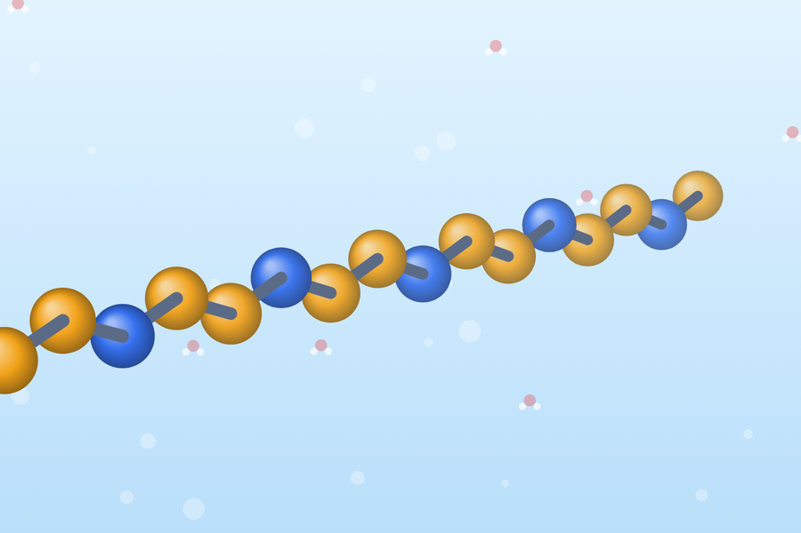  1. A chain of amino acids | ➜ | 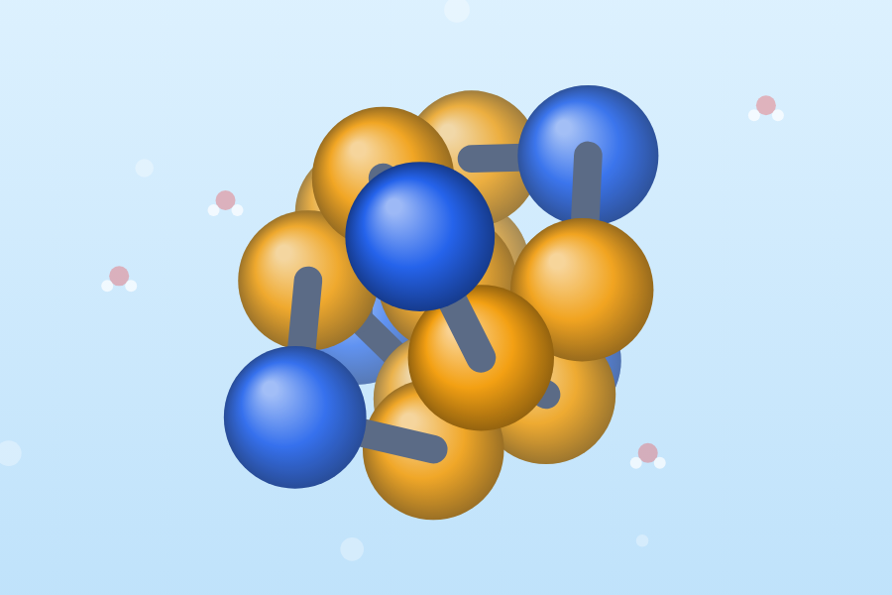  2. It folds into a shape | ➜ | 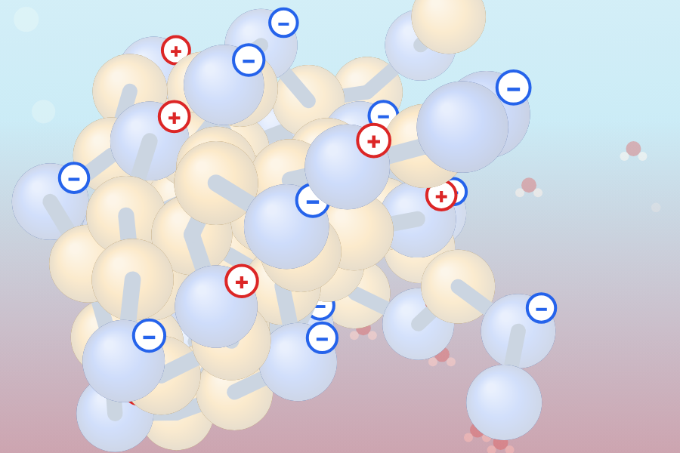  3. Denatured and clumped

● Nonpolar  Oily side chain that avoids water (hydrophobic). Orange beads. | ● Polar  Side chain attracted to water. Blue beads. | Hydrophobic core  The middle of a folded protein where nonpolar amino acids hide from water. | Denature  A protein loses its shape (and its job), but its amino acid order stays the same.

PART 1 · Build & Fold Tab 1 · about 15 minutes

Steps: (1) Stay on 1 · Build & Fold. Under “Try a pattern” pick a pattern, then press ▶ Fold it! (2) Watch the beads and drag the model to spin it. (3) Read the two bars under the model and fill in one row below. For the last row, build your own chain of 12+ amino acids with the + Add buttons.
Pattern | Where did the orange beads end up? | Nonpolar beads touching water | Polar beads touching water
Alternating N P N P … | inside · outside · mixed | _______ % | _______ %
Oily half + polar half | inside · outside · mixed | _______ % | _______ %
Core-and-shell N N P … | inside · outside · mixed | _______ % | _______ %
My own design (write it: N/P) | inside · outside · mixed | _______ % | _______ %

Now click 🛢️ Oily membrane and fold the core-and-shell pattern again. Then press 👣 Step by step and Forward ▶ a few times to watch a chain grow one amino acid at a time.
Q1 Which pattern hid the most nonpolar beads from water? Use your numbers and describe the pattern.

Q2 In water the orange beads hide in the middle. In the membrane the blue beads hide in the middle. Explain why.

Q3 What did the chain do each time you pressed Forward ▶ and a new amino acid was added?

PART 2 · Mutation Lab Tab 2 · about 10 minutes

Sickle cell disease starts with ONE changed amino acid. In β-globin, position 6 changes from Glu (polar) to Val (nonpolar). The lab folds a normal chain and a mutant chain side by side.
Steps: (1) Open 2 · Mutation Lab, press 👣 Step by step, and press Forward ▶ until you reach amino acid 6. What does the panel say? (2) Press ✕ Exit, then ▶ Fold both and record. Press 🎲 New random start, fold again, and record. (3) Click a chip in the mutant row to make your own swap, fold both, and record.
Run | Normal: nonpolar exposed | Mutant: nonpolar exposed | Normal: red-halo beads | Mutant: red-halo beads
Run 1 (sickle swap) | _____ % | _____ % | _____ | _____
Run 2 (new random start) | _____ % | _____ % | _____ | _____
My own swap at position # ____ | _____ % | _____ % | _____ | _____
Q4 A red-halo bead is an oily bead stuck on the outside. Why could that cause trouble for proteins in a watery cell?

Q5 Runs 1 and 2 used the same chains but gave different numbers. What does that tell you about running an experiment only once?

Q6 In one sentence: how can changing a single amino acid change a protein’s shape?

PART 3 · Denature Lab Tab 3 · about 20 minutes

A protein’s fold is held by weak bonds: the oily core, hydrogen bonds, and salt bridges between + and − charged amino acids. Heat and pH can break them. Open 3 · Denature Lab, choose the 🧍 Human enzyme, and wait for it to fold. Move one slider at a time, wait about 5 seconds, then read the bars. Red + and blue − badges show charged amino acids.
Experiment A: Temperature (keep pH at 7)
Temperature | Folded shape % | Enzyme activity % | What does the protein look like? (circle)
4 °C | ______ % | ______ % | folded · starting to unfold · denatured
37 °C | ______ % | ______ % | folded · starting to unfold · denatured
60 °C | ______ % | ______ % | folded · starting to unfold · denatured
70 °C | ______ % | ______ % | folded · starting to unfold · denatured
100 °C | ______ % | ______ % | folded · starting to unfold · denatured

Experiment B: pH First press ↺ New protein (reset): the boiled protein from Experiment A stays clumped! Then keep temperature at 37 °C.
pH | Folded shape % | Charged amino acids (+) and (−) | What does the protein look like? (circle)
pH 2 | ______ % | (+) ____ (−) ____ | folded · starting to unfold · denatured
pH 5 | ______ % | (+) ____ (−) ____ | folded · starting to unfold · denatured
pH 7 | ______ % | (+) ____ (−) ____ | folded · starting to unfold · denatured
pH 9 | ______ % | (+) ____ (−) ____ | folded · starting to unfold · denatured
pH 12.5 | ______ % | (+) ____ (−) ____ | folded · starting to unfold · denatured
Q7 At about what temperature did the folded shape drop below 50%? Why would heat do this?

Q8 At 4 °C the activity was low but the shape was fine. At 100 °C both were low. Which problem could be fixed by warming or cooling back to 37 °C? Explain.

Q9 At pH 2 the charges changed. Use the words like charges repel and salt bridges to explain why the protein fell apart.

Q10 Hold the temperature at 100 °C until the proteins clump. What everyday example is this like? Could you cool it down to fix it?

Experiment C: Meet four proteins Use the “Choose a protein” card. Try to denature each one.
Protein | Home conditions | What denatured it? | Why is it built for its home?
🧍 Human enzyme | 37 °C, pH 7
🍋 Stomach enzyme | 37 °C, pH 2
♨️ Hot-spring microbe | 75 °C, pH 7
🐟 Antarctic fish | 4 °C, pH 7

🏆 Check off the challenges you finish  ☐ Heat wave ☐ Acid attack ☐ Base attack  ☐ Chill out ☐ Point of no return ☐ Bring it back  ☐ Hot-spring survivor ☐ Stomach meets intestine  ☐ Too warm for a fish ☐ Meet them all | ✍️ Wrap-up: finish the sentences  A protein’s shape depends on ______________________________ .  Heat denatures a protein because ______________________________ ______________________________ .  A change in pH denatures a protein because ______________________________ ______________________________ .

⭐ Bonus challenge: design the best protein  Back in Tab 1, build a chain of 14+ amino acids that buries as many nonpolar beads as you can. Fold it a few times and keep your best result.  My sequence (N/P): ________________________________________  Nonpolar beads touching water: ________ % Folds tried: ______  Why do you think this pattern worked so well? | ✏️ Sketch your folded protein

