Student Control System



1. ***Introduction***
   1. ***Purpose***

The main objective of this project is to be able to facilitate the teacher's work, this creating a system in which students have control, through their grades, their attendance, and the average of their grades, creating a system that has security. The system is mainly aimed at teachers and students where the director is also the one who has control of the system and how it is managed.

* 1. ***System Scope***
* **Name:** Student Control System (SCS)
* **What the system can do and cannot do**: The System will register the attendance of each student, as well as register all teachers and students, dividing them by classes and subjects, it will average all the student's grades and what it will not do is allow students to modify their grades, they only have the possibility of seeing, they will not be able to modify their attendance either and their id will be generated automatically through personal data provided by the student
* **Benefits, objectives and goals:** The main objective is to facilitate the storage of the information of the notes, since it is an easier way to have an accurate record of each student, the goal to be reached is to be able to demonstrate that through the development and implementation of several Programming knowledge is created an efficient tool for teachers and students respectively.
* Referencias de nivel superior si existe (preguntar)
  1. ***Definitions, acronyms and abbreviations***
* SCS: Student Control System
  1. ***References***
* For this paper we used the following document:

|  |  |
| --- | --- |
| Document Title | Reference |
| Standard IEEE 830-1998 | IEEE |

* 1. ***Document Overview***

The content that will be reviewed in this respective paper is the explanation of the entire system that is being developed based on what needs are proposed for both teachers and students with their respective subject and how we are going to innovate the system that leads the teacher in front of the register of his classes.

1. ***General Description***

El The client has requested a system that has full control of the grades, where all the registered subjects can be taken together with their grades for each respective average. The largest user will be the main one who keeps track of everything, both for teachers and students, on the other hand, teachers can edit notes, delete or update depending on needs and students have restrictions, they should only be able to see their notes, without being able to edit them in any way, for that a user is created in which the record is kept.

* 1. ***Product Overview***

The record will be through averages made from homework, class work and tests. This to be able to generate a last note where the three mentioned above will be averaged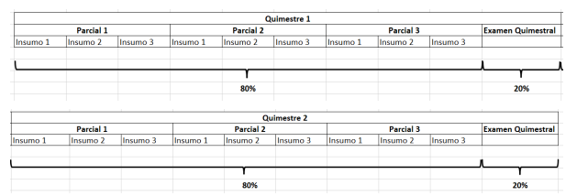

To calculate the semester grade, you must take an average of the three partial grades obtained, this value is multiplied by 0.80, since we are talking that the three partials are equivalent to 80% and the semester exam is multiplied by 0.20, since that we are talking about that the quarterly exam is equivalent to 20% of the quarterly average and then we sum those two grades. To conclude we must simply add the 2 semester grades and divide them by 2 and we will obtain our final average.

* 1. ***Product Functions***

We all know how important grades are for a teacher and for a student at high school, not only because it is the most important requirement for a student to graduate, but also so that the teacher in charge of the subject can have an individual academic follow-up of the students, to know if the knowledge imparted by this same teacher is being useful for the students. Thanks to all of these scorecards; teachers can choose another method of teaching, becoming very beneficial for both students and teachers. Taking all this into account, we will now see the most common methodology that teachers use to control grades in schools. (The same method that we will use for our system)

The system will also make an order so that teachers can be guided at the time of uploading the grades of each of their students, for this the system orders from the first surname of the student, thus facilitating the work of the teacher. Likewise, to be able to send and visualize their grades, students will be asked to enter certain data such as their full names, e-mail address, age and gender, and teachers will also be asked to enter their data to use the system such as their full names, their ID number and the subject they are teaching together with the course to which the grades are indicated.

* 1. ***User Description***
* **Principal:** It is the highest authority that leads and directs students and teachers respectively, having a record of each change within the system.
* **Teacher**: He is in charge of the subjects, his class and his respective students, as well as registering, updating or deleting data based on his need.
* **Student**: The student will only be able to review their notes respectively. If you want to make any kind of change, this cannot be done through the system, it goes outside the system and you would have to contact your respective teacher.
  1. ***Restrictions***
* **Policies of the educational institution**: In this case, the client's policy is to always respect the respective regulations of the school, based on teachers and students and to show due respect.
* **Hardware Restrictions:** There are no specific hardware restrictions because the program is quite basic and can run on computers with very minimal resources.
* **Other applicattions interfaces:** (preguntar qué es lo que se pone en este apartado)
* **Parallel operations:**

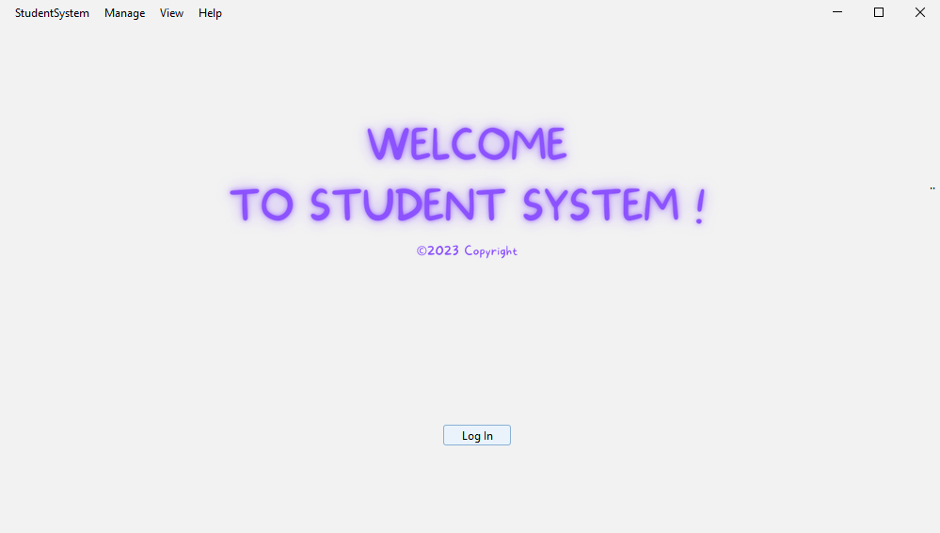

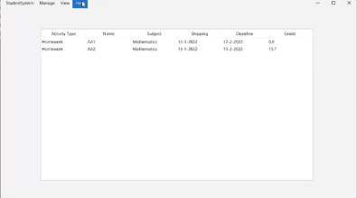

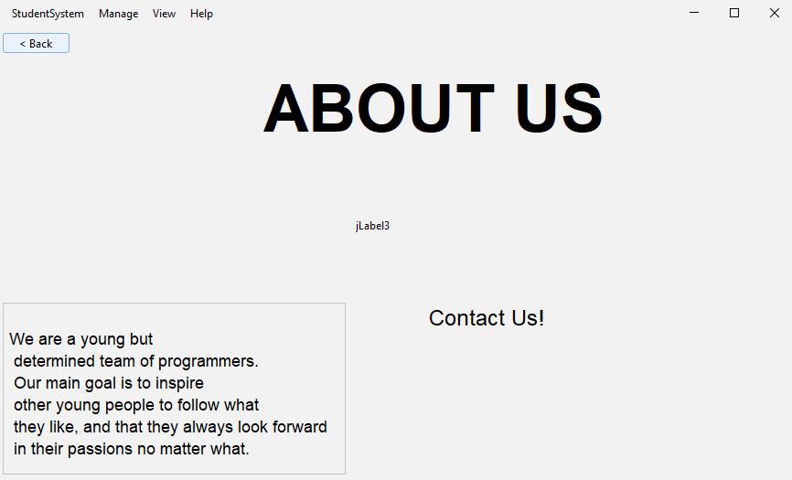

* **Control functions:** adjuntar imágenes de que todo sale como el diagrama que hicimos, ósea referente al programa
* **Programming Languages**: For this project mainly the Java language has been used (no se si hay más, ahí ponen o algo :p)
* **Communication Protocols:** (no entiendo muy bien esto, dejo una imagen de lo que encontré para que más o menos sea una idea porque no entiendo)

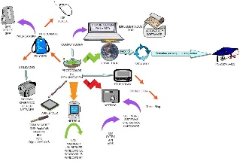

* ***Application criticality:***
* ***Security Considerations:***

Regarding security, the security of the system can be confirmed, since for that it is managed with a LogIn that will allow access by students and students respectively, without information being leaked and the students having another power.

* 1. ***Assumptions and dependencias***

The system is mainly based on the Windows 10 operating system, if you change to a higher system such as Windows 11 there would be no problem, however, if you already change to another operating system such as MacOs, it may be a problem in the interfaces.

* 1. ***Future Requirements***

It depends on the learning learned in the semester, a new section could be created within the system where tasks could be created within the system so that students can upload the work, once done the teachers could have the possibility of grading and sending the note to students so they can review, also add some observation if required..

1. ***Specific Requirements***

The main requirement is to be able to have a specific record and control of the students.

* 1. ***External Interfaces***

The main interfaces that will be used will be the registration of the users that in this case are the students, the power to enter the system that is with a login interface, also the power to recover a password, record the grades and average the grades.

* 1. ***Functions***

To begin with, the principal will have a specific access where they will manage their teachers and their students, be able to review and even be able to make changes if needed.

The teacher has control of the student data, through the system he will be able to enter the grades of each student so that it can be averaged depending on the activity, since the system is designed to make four averages, 3 general and one specific, the first average will be of the tasks sent by the teacher, the second will be of the class work done and the third will be of the tests done. The fourth and most important will be the average of the partials.

The student will have limited access to this system, he will enter the system through an automatically generated id and a password made by the student himself.

* 1. ***Efficiency Requirements***

The system will have a very efficient and fast system, since by storing enough data and numbers, it will be proposed to support large loads of information.

* 1. ***Design Restrictions***

As such, there is no system restriction in terms of hardware, since it is a basic and friendly system that does not require much of a computer.