**Task 2 - Creating the Contact Manager API Controllers**

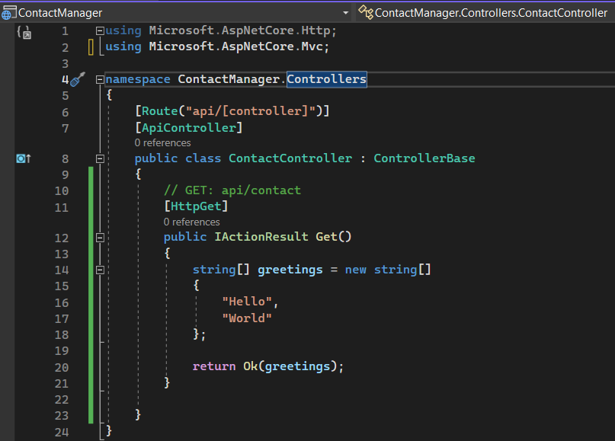

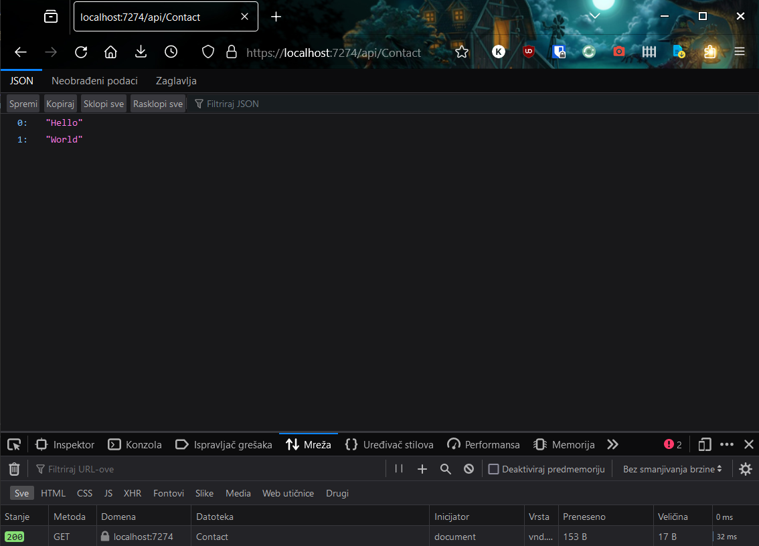

#### Task 3 - Creating the Contact Models and Augment the Contact Controller

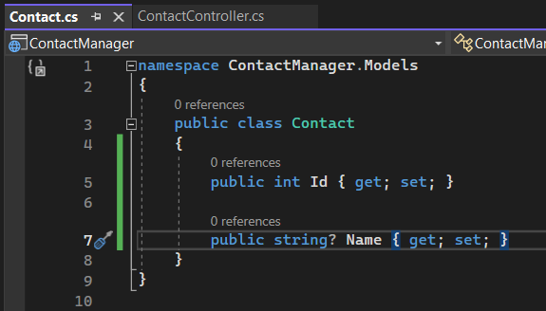

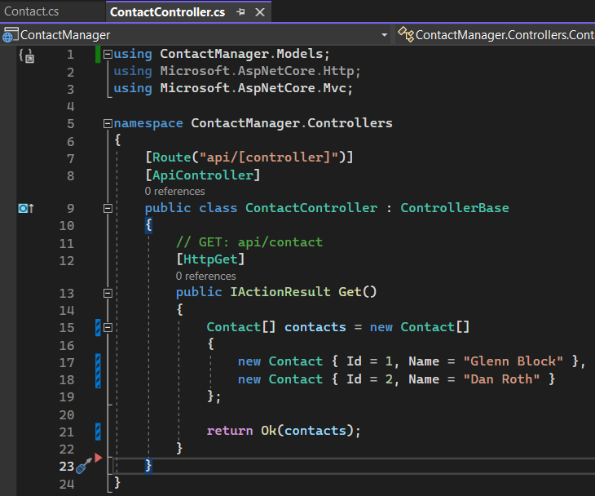

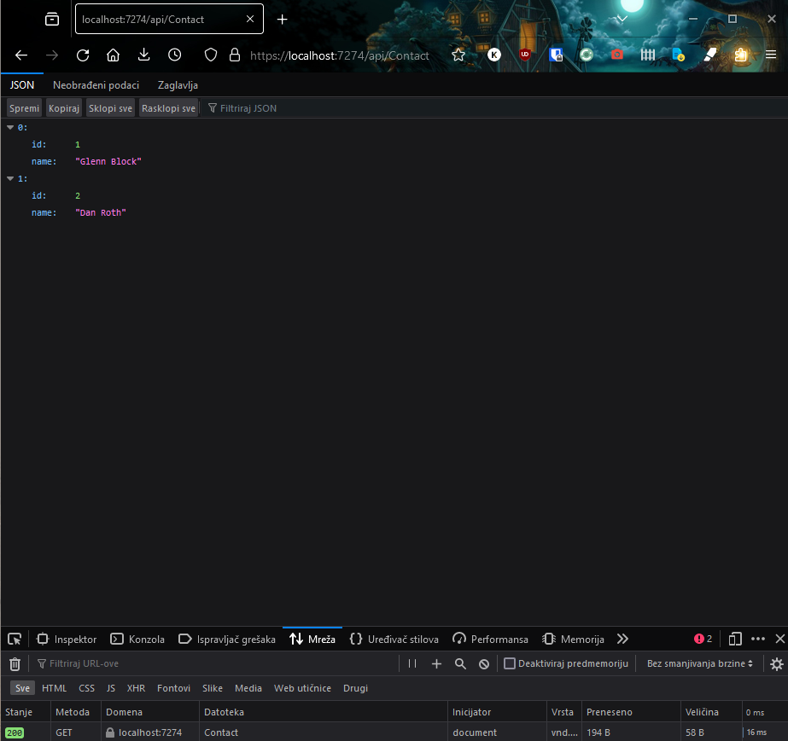

Git Bash:

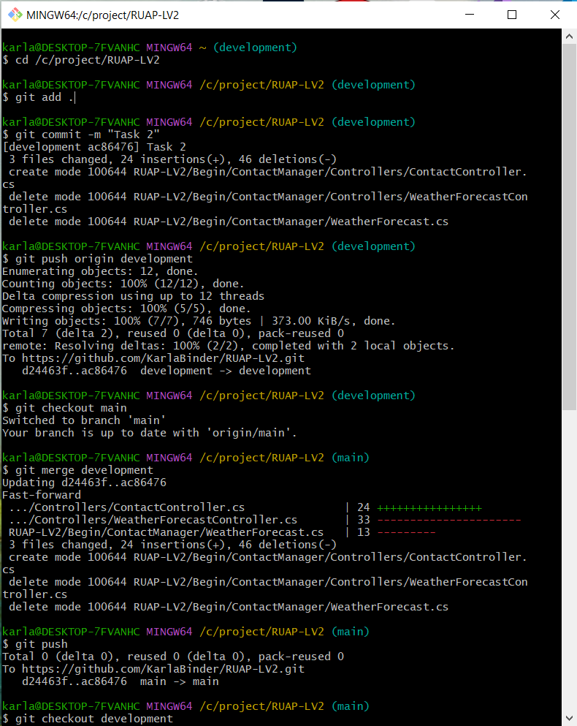

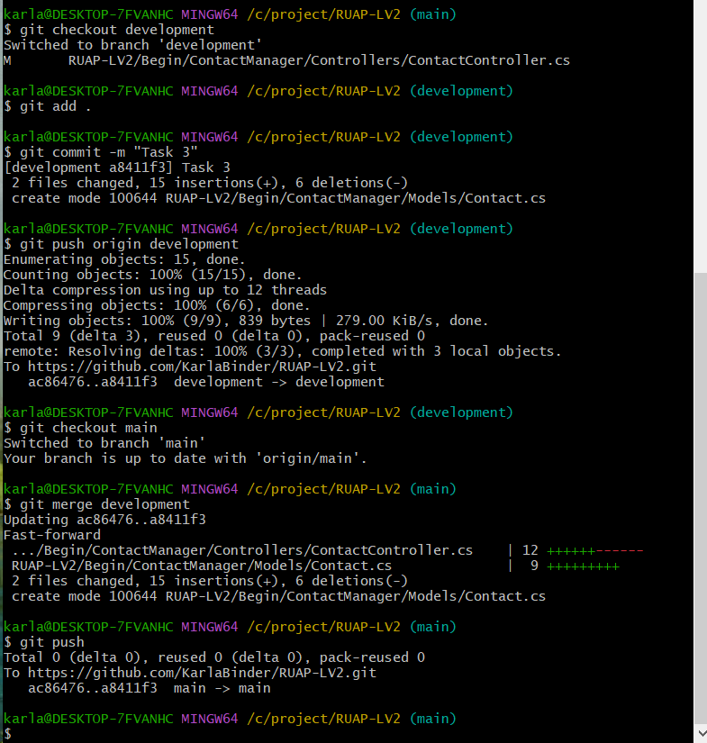

Napomena: Task 1 sam napravila na satu pa nemam snimljen postupak na git bash-u.

Karla Binder