Money Transfer Bill Pay Details

1. Go to dashboard and click on Bill Pay.

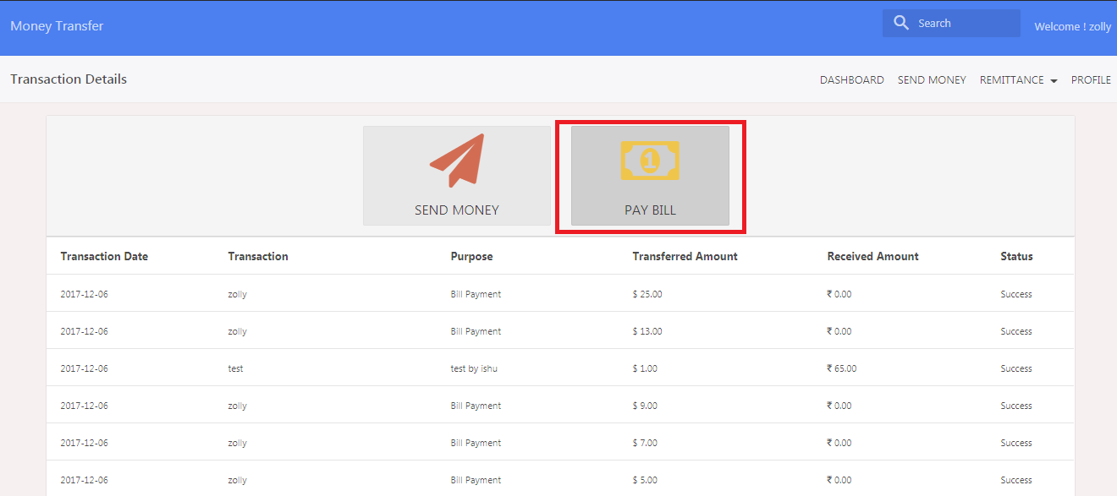

1. It’s showing below screen.

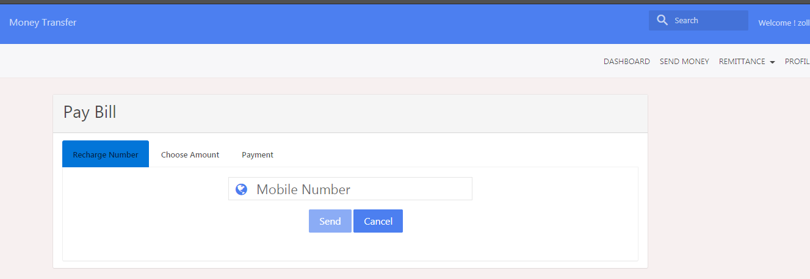

1. Enter mobile number and its showing country code and country flag.

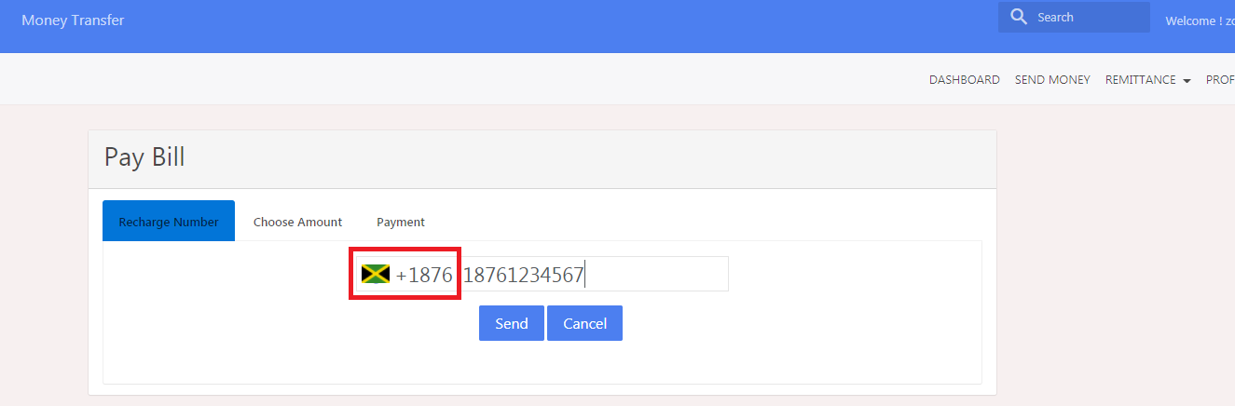

1. If user entered mobile number and pay nation does not provide info for that mobile number than Send button is not enabled and its showing error message on below screen, please see below screen shot.

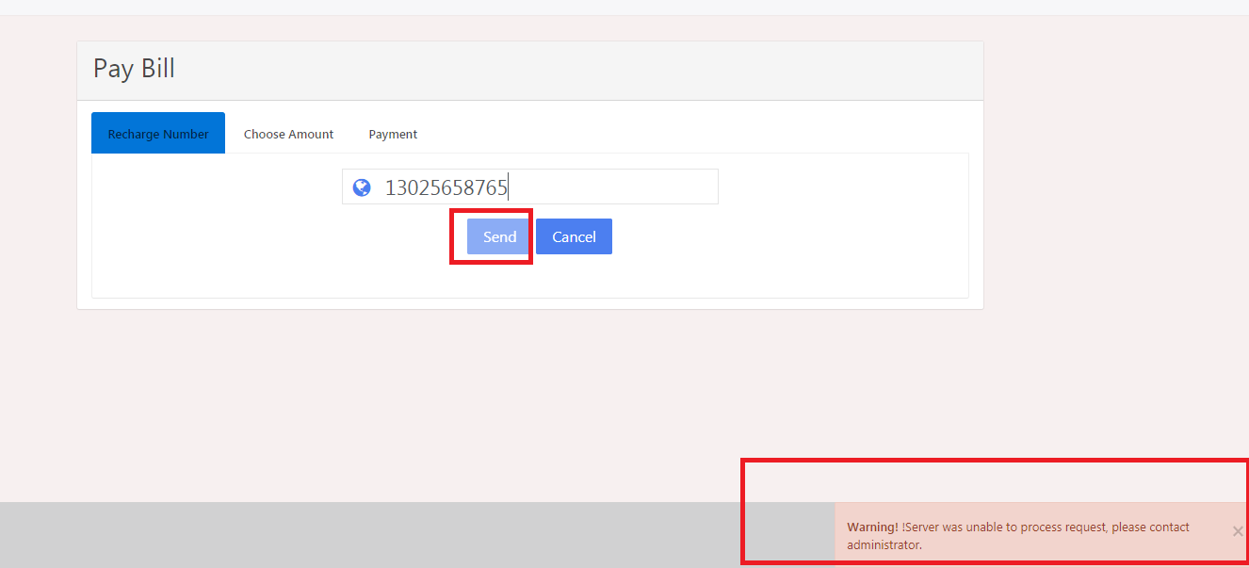

1. We entered mobile 18761234567 and it’s showing country flag and country code in front of mobile number.



1. Click on Send button.
2. Choose amount.

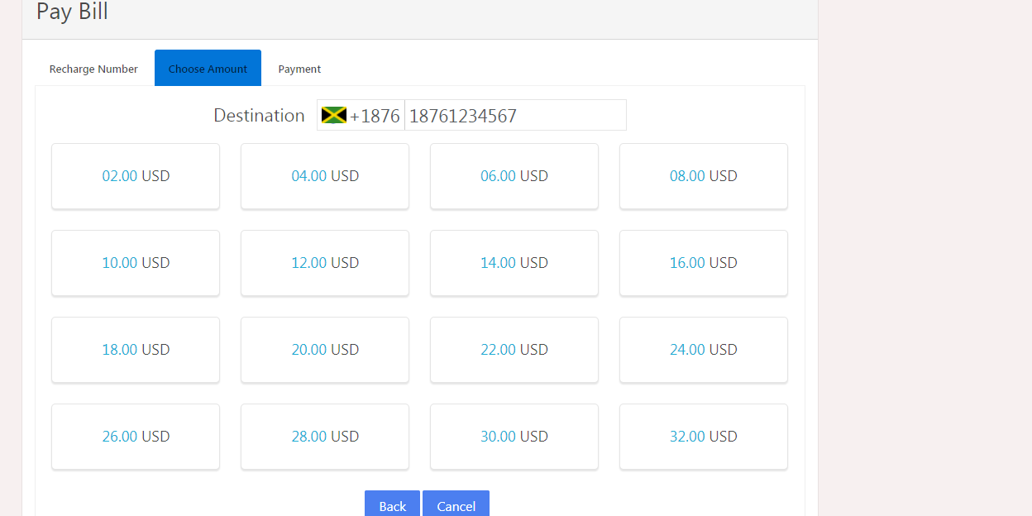

1. It’s showing payment screen.

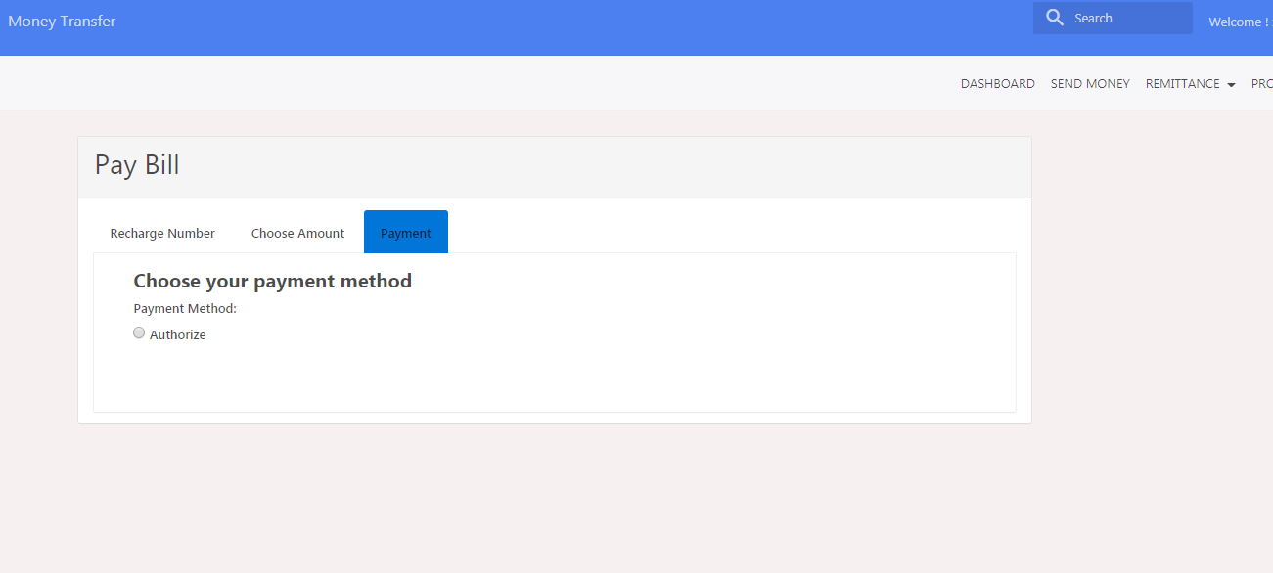

1. Choose authorize and fill credit card details

Note: - please use random mobile number and test credit card number.

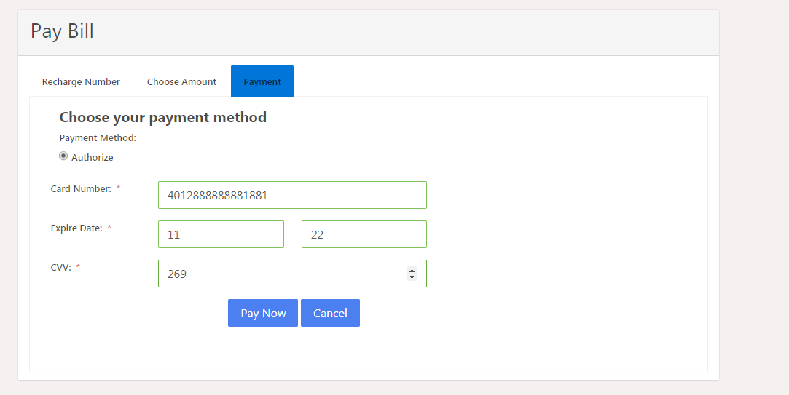

1. Fill credit card details and click on Pay Now button and its showing confirmation message.

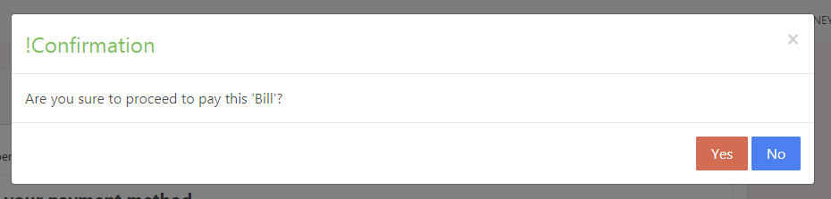

1. Click on Yes and its showing Thank you screen with payment details.

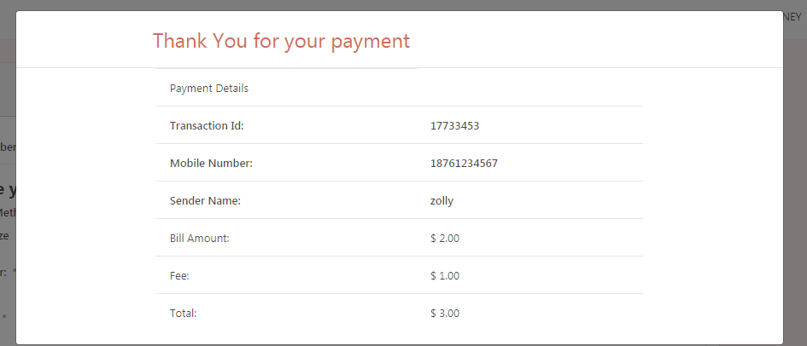

1. Now see on dashboard payment details.

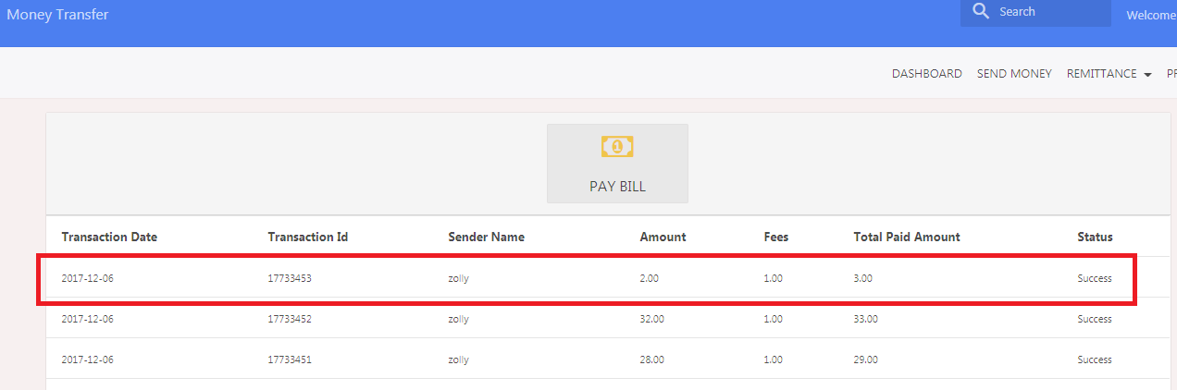

Please use below Mobile number in random order to check bill pay functionality:-

18761234567

18761234568

18761234569

18761234570

521234567890

521234567891

521234567892

521234567893

521234567894

50312345678

50312345679

50312345680

Test Credit Cards Details are as below:-

5555555555554444

5105105105105100

4111111111111111

378282246310005

371449635398431

Expiry Month and Year:-

01/25

02/33

07/25

09/22

10/23

11/29

cvv:-

123

569

874

963

587

456