Supervised Vs. Unsupervised Learning

Supervised Learning trains on labeled data. Also known as Machine Learning
Has a loss function that compares true vs prediction
It's used to train regression, classification, and image object detection

Unsupervised learning doesn't have labeled data. It's also known as deep learning
It extracts it's own features. The data is unlabeled!
Used for clustering, dimensionality reduction, and anomaly detection.

Attributes (or dimensions, features, variables): a data field,
representing a characteristic or feature of a data point.
5 types: Nominal, Binary, Ordinal

Nominal: categories, states, or 'names of things'
Binary: Nominal attribute with only 2 states (0 or 1)
Asymmetric binary: outcomes not equally important
Symmetric binary: both outcomes equally important
Numeric Types: Numbers!
Interval: equal sized units (C or F)
Ratio: inherent zero-point. (Kelvin)
Discrete: classification.
Continuous: regression.

3 basics:
1. Explanatory - clustering, frequency pattern mining, dimensionality reduction
There are all Unsupervised
2. Prediction - regression
3. Generative - GAN, GPT models

Dimensionality reduction
algorithms include PCA, auto encoders.

Base algorithms:
Linear regression, Logistic regression, k-nearest, decision tree, random forest, naive bayes, SVM, NN.

Gradient Descent.
Keep changing Theta0 and Theta1 in small steps to minimize the cost function
Please see image.

Schocastic Gradient Descent: a subset of features
Mini-batch Gradient Descent: 16, 32, 64.

Multivariate linear Regression

Features Scaling and learning Curve:
Features should have similar scale.
A solution is Z-Normalization. Using mean and standard deviation.
For each feature, minus the mean divided by the std.

Logistic Regression:
Equation:
sigmoid = 1/(1+e&-z)
z = T(theta) * X
g(T(theta)X) = 1/(1 + e^(-T(theta)X))
Problems:
Vanishing Gradient
Probability:
if h(x) > 0.5, y = 1ish
if h(x) < 0.5, y = 0ish

Logistic Cost Function Defined below:
J(θ)=−m1​∑i=1m​[y(i)log(hθ​(x(i)))+(1−y(i))log(1−hθ​(x(i)))]
Don't memorize it, but completely understand it.

Generalization:
Don't use an overly complicated model
Divide into Train and Test
k-fold cross validation: data is split into k divides.
Train and test use different divisions each epoch.

We learned two hyperparameter: batch size, and learning rate.

Classifier Evaluation Matrix: Confusion matrix.

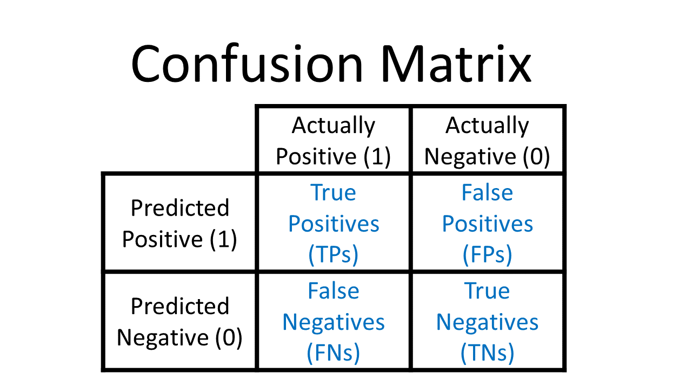
Class Imbalance Problem:
Small classes are hard to learn on.

The confusion matrix can help us
understand which classes the model is failing.

Definition:
1. Precision: what percent of positives were right? TP/(TP+FP)
2. Recall: What percent labled positive as a whole? TP/(TP+FN)

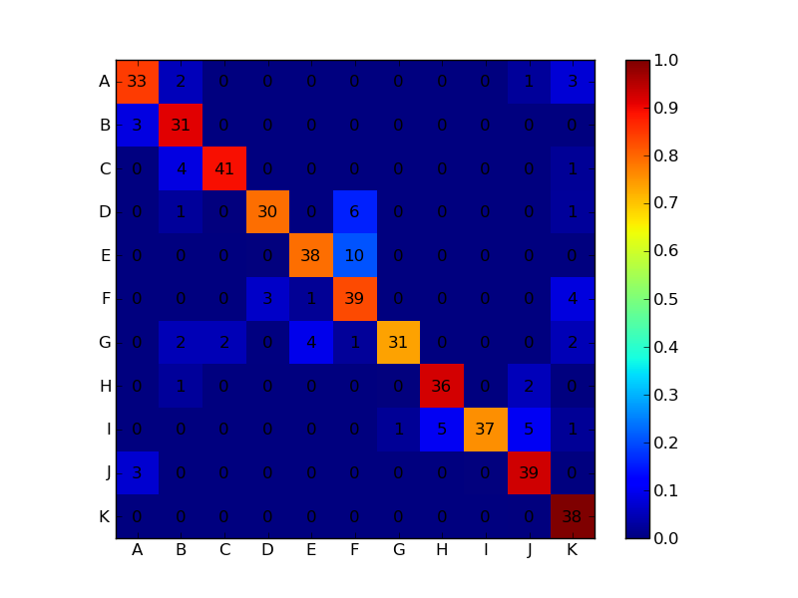
import seaborn as sn
import pandas as pd
import matplotlib.pyplot as plt

array = [[13,1,1,0,2,0],
[3,9,6,0,1,0],
[0,0,16,2,0,0],
[0,0,0,13,0,0],
[0,0,0,0,15,0],
[0,0,1,0,0,15]]

df_cm = pd.DataFrame(array, range(6), range(6))
# plt.figure(figsize=(10,7))
sn.set(font_scale=1.4) # for label size
sn.heatmap(df_cm, annot=True, annot_kws={"size": 16}) # font size

plt.show()
ROC CURVES AND F1-SCORE

Inverse relationship between precision and recall.
F measure (F1-score) F1 = (2xPrecision * Recall) / (Precision + Recall)
The F1-Score is a scale out if there is class imbalance. Best way to combine precision and recall. Domain is between 0 and 1.
We can then combine the F1 scores using different methods. Use the mean for now. You can also add weights to each class. We can also compute a global F1-score.
Example of an F1-Score:
from sklearn.metrics import f1_score
f1 = f1_score(true_labels, predicted_labels)

ROC curves:

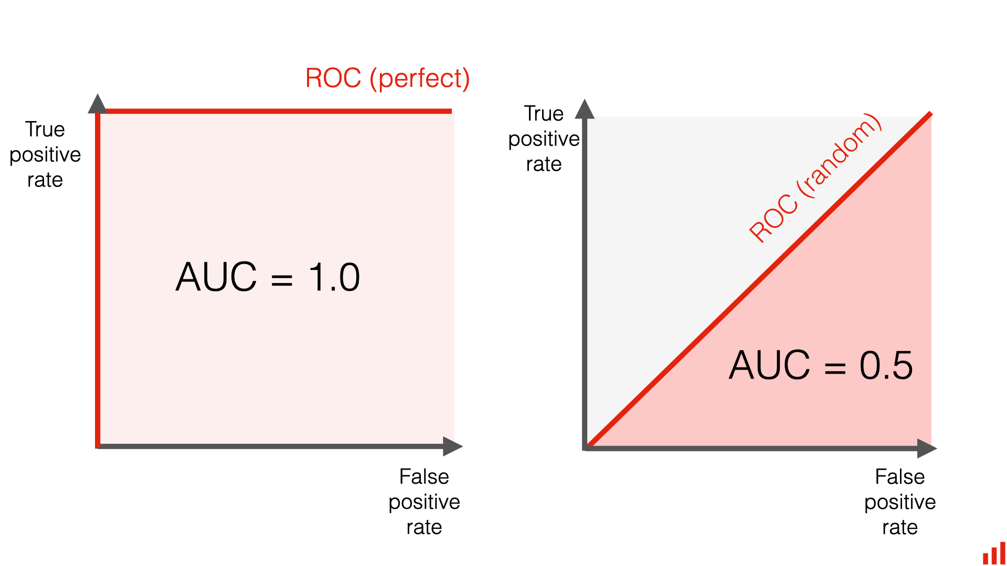
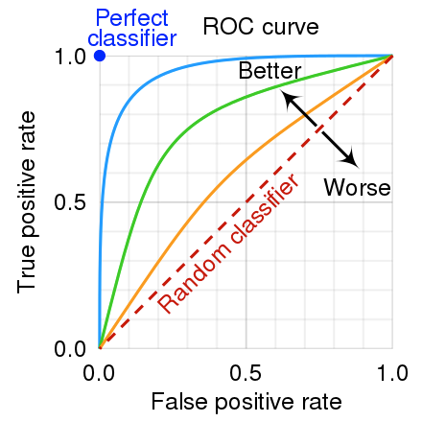

SEE the example ROC.py in this directory.

K Means Clustering.
Given k, the k-means algorithm is implemented in four steps:
1. Partition objects into k nonempty subsets
2. Compute seed points as the centroids. Find Mean Points of the clusters
3. Assign each object to the cluster with the nearest seed point
4. Go back to Step 2, stop when the assignment does not change.
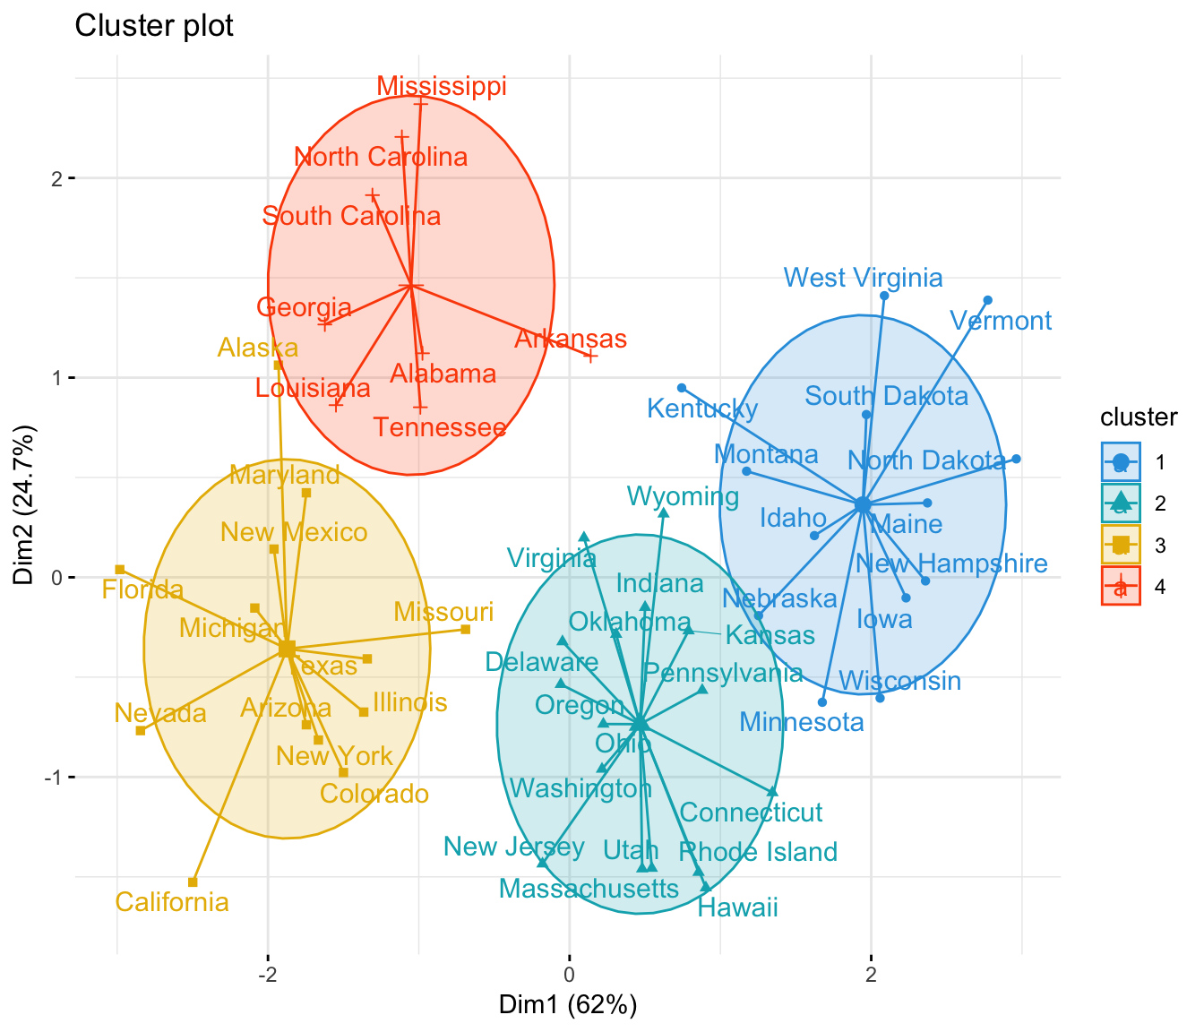

Principle Component Analysis (PCA)

The main idea behind PCA is to transform the original variables into a new set of uncorrelated variables called principal components.
STEPS:
1. Standardize Data
2. Covariance Matrix calculation
3. Eigenvalues and Eigenvector Computation
4. Rank by values in descending order. Grab top K eigen vectors.
5. The new data is dimensionally reduced.
PCA helps reduce computational load on PC.
