Normalization:
z-normalization ( x = (x – mu) / sigma)

Vanishing/exploding Gradient Problem:
Gradients can either EXPLODE or vanish.
Initialization: make sure you properly init your weights
Deep networks
Activation functions: Sigmoid can have vanishing gradient.

SOLUTIONS:
Weight Initialization:
He Initialization (ReLU)
Xavier Initialization (tanh)
Gradient Checking:
Compute if the gradient is too small, or too big.

Optimization Topics

Batch gradient descent:
One learning step, forward and backwards propagation for all m training examples

Stochastic gradient descent:
One learning step: forward and backward propagation for 1 training example

Mini-batch gradient descent:
m training examples are divided into multiple mini batches s. Each s, forward and backwards for each learning step.
N = num batches, s = size of batches (32, 64, etc)

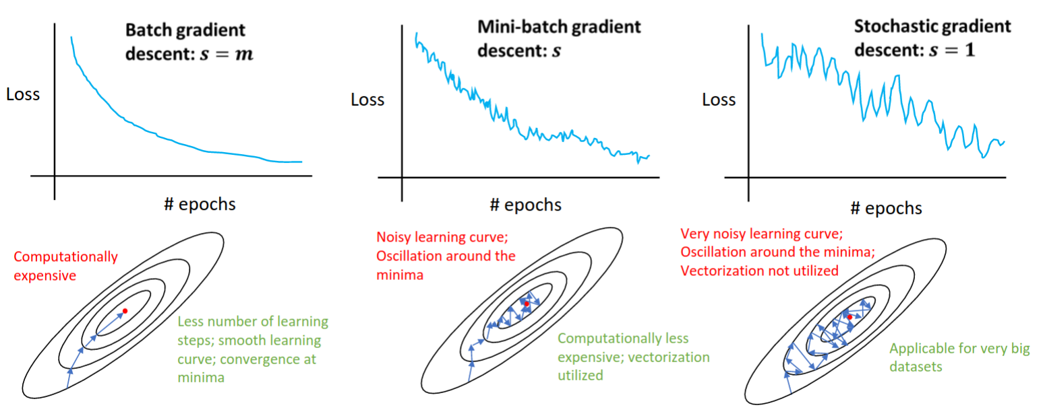
Gradient Descent with Momentum:
It smooths out the gradient learning curve. It averages out the gradient line.

Adam: The complete Solution:
Combination of Momentum and RMSprop
Bias Correction:
Efficient Memory Usage
Robust Performance
Adam has two hyperparams:
B1: momentum hp -> 0.9
B2: RMS hp -> 0.999
Most important hyperparmeters: batch size and learning rate

Learning Rate Decay:
After so many epochs, decay the learning rate.

